NAME: Sameet Siraj Ali ROLLNO: 25K-0857

Network Configuration

- From the Devices panel, add the following to the workspace:
  - 1 Switch
  - 5 PCs
  - 1 Network Printer
- Connect all devices to the Switch using Copper Straight-Through cables.

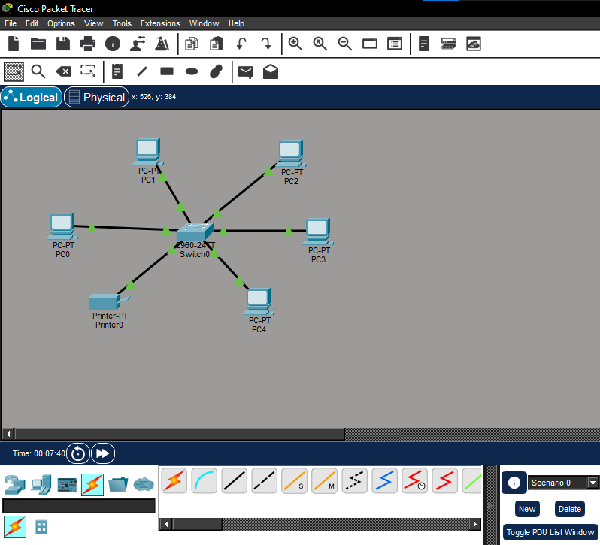
Assign IP Addresses
- Click each PC then
- Click on desktop
- Click on IP Configuration
- Assign the following IPs:
Device | IP Address | Subnet Mask
PC1 | 192.168.1.2 | 255.255.255.0
PC2 | 192.168.1.3 | 255.255.255.0
PC3 | 192.168.1.4 | 255.255.255.0
PC4 | 192.168.1.5 | 255.255.255.0
PC5 | 192.168.1.6 | 255.255.255.0
Printer | 192.168.1.10 | 255.255.255.0

Assigning IP address to PC1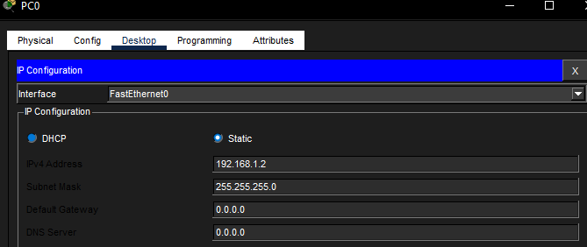
Assigning IP address to PC2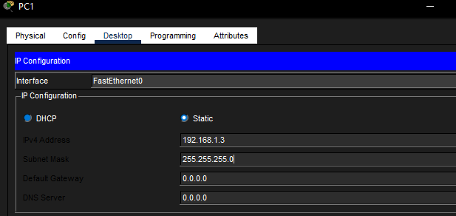Assigning IP address to PC3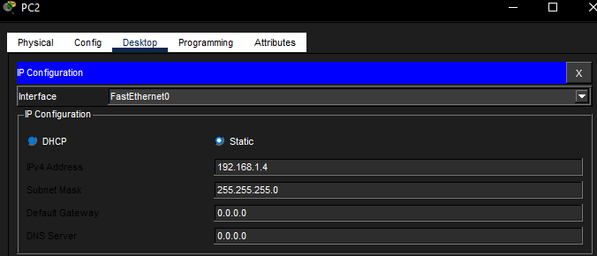Assigning IP address to PC4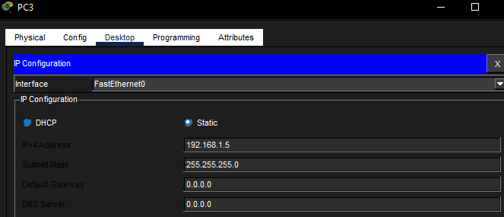
Assigning IP address to PC5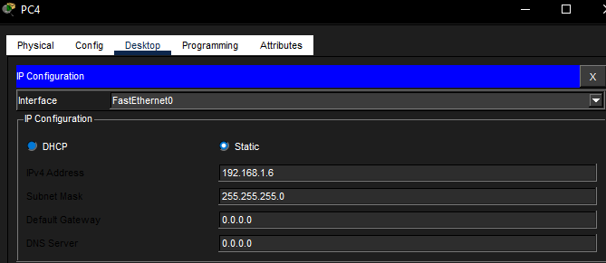Assigning IP address to printer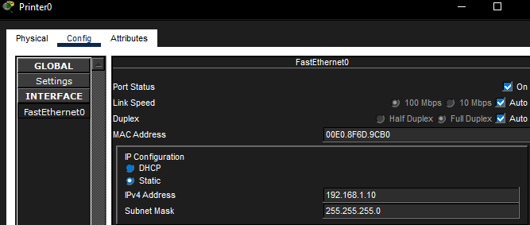

Configure Network Devices
- Test connectivity by clicking each PC's Command Prompt.
- Use the ping command to test.
Example: (For pc 1 type ping 192.168.1.3)
- Ensure all PCs can ping each other successfully.

FOR PC1
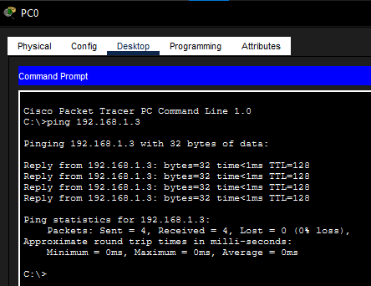
FOR PC2
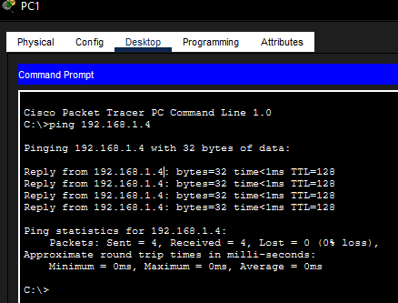

FOR PC3
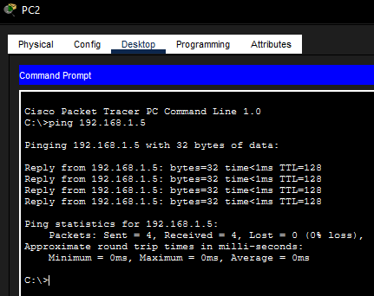
FOR PC4
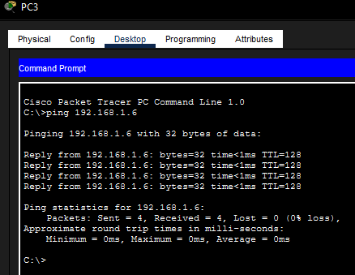

FOR PC5
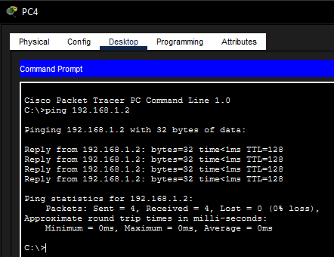

Set Up Printer Sharing
- Click the Printer
- Click on Desktop
- Click on IP Configuration.
- Set the IP: 192.168.1.10
- Subnet Mask: 255.255.255.0
- Test printing by ensuring each PC can ping the printer.
( PC1 - PC5 Command Prompt - 192.168.1.10 )
- This confirms that the printer is available for all PCs, simulating printer sharing.

FOR PC1
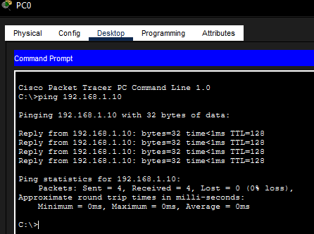

FOR PC2
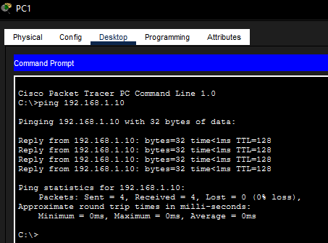

FOR PC3
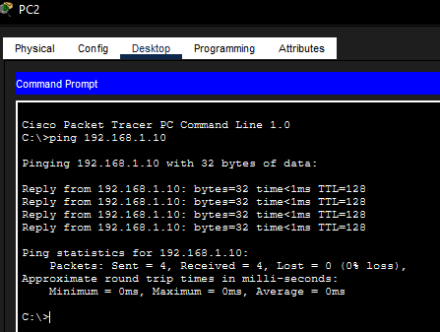
FOR PC4
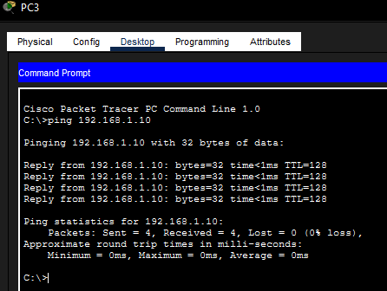

FOR PC5
