Link to GitHub: <https://github.com/Fastcar-MB55/Week24_Restaurant_GraphQL>

Query restaurant

Mutation setrestaurants

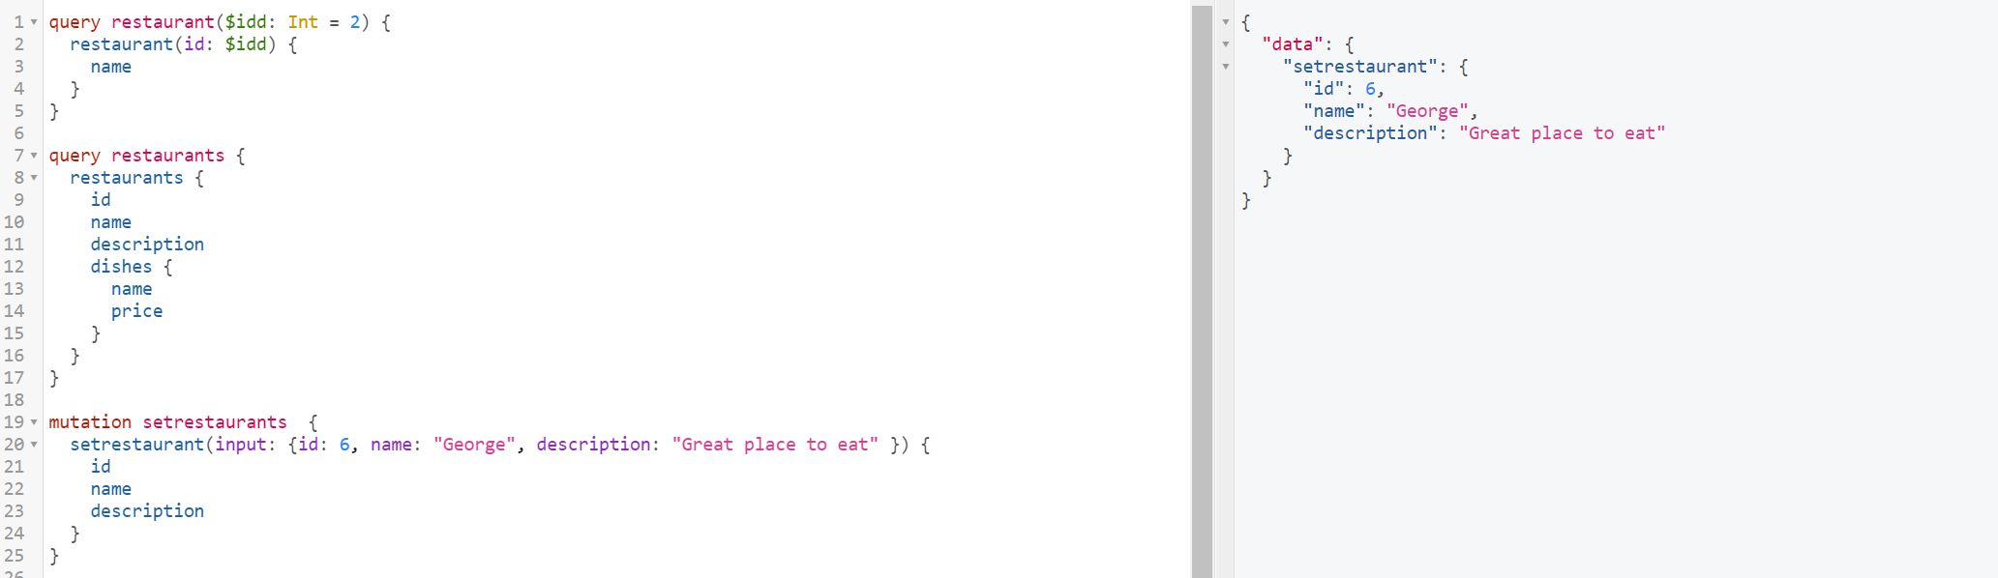

Query restaurants

Mutation deleterestaurants

Mutation editrestaurants

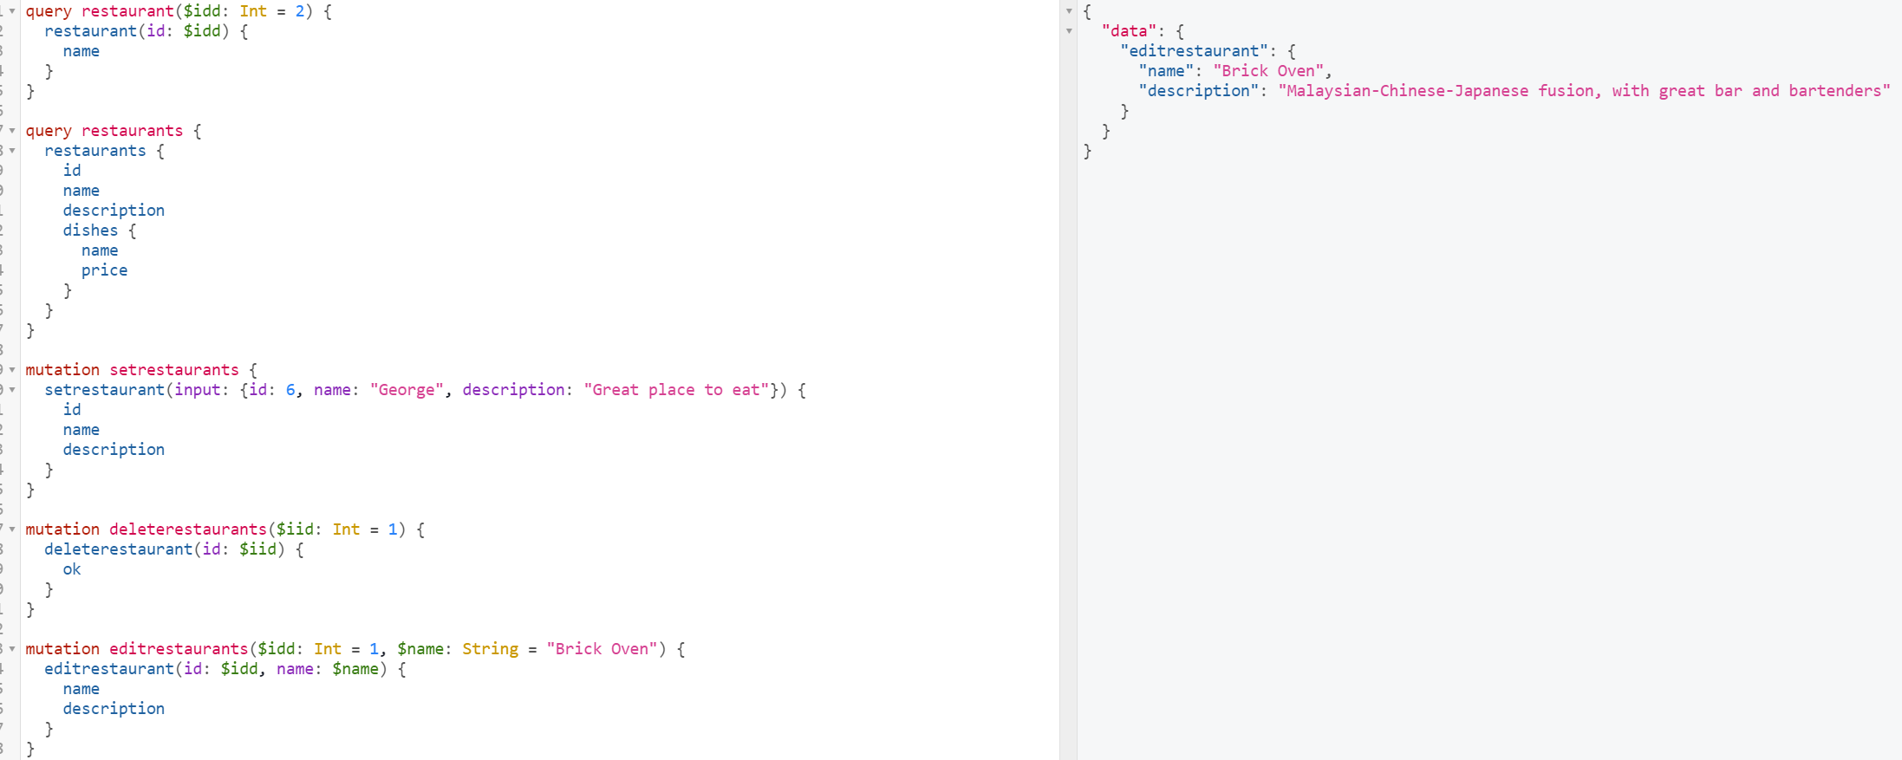

Query getrestaurants

Changes to support input/export and require in same file

Index.js

Package.json

