**CONTEXT**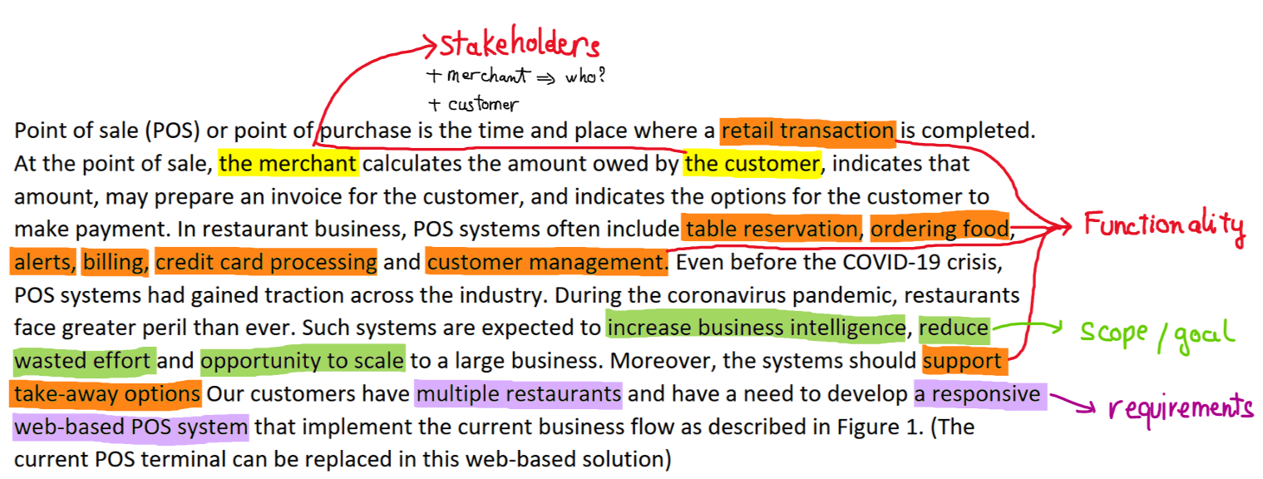

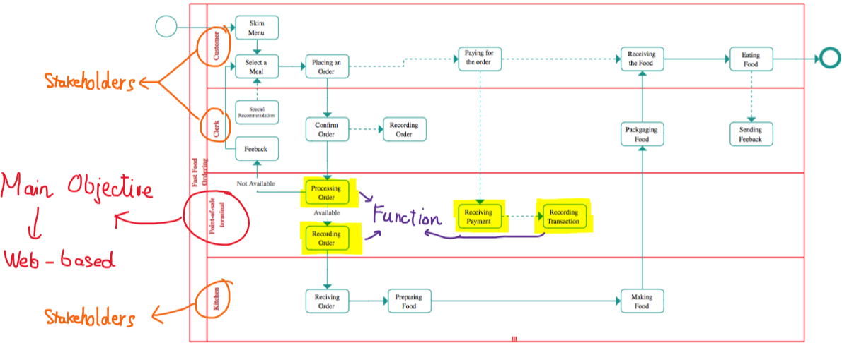

* **Type of program: Web-based POS**
* **Stakeholders**
* Users
* Restaurant employees + owners
* Clerks
* Kitchen
* Bank
* Owners
* Web admins
* **Requirements**
* Non-direct contact between clerks and customers
* Use Web technologies and QR code
* Must work on mobile, tablet and desktop.
* Must be extendable to multiple restaurants in the future (for now only 1 restaurant)
* Holds for 300 transactions per day
* **Scope/Goal**
* Increase business intelligence
* Reduce wasted efforts
* Opportunity to scale to a large business