Task 1: Requirement elicitation

1.1Identify the context of this project. Who are relevant stakeholders? What are expected to be done? What are the scope of the project?

**Type of program:** Web-based POS

**Stakeholders:**

* Users
* Restaurant employees
* Owners
* Clerks
* Kitchen
* Bank
* Owners
* Web admins

**Requirements:**

* Non-direct contact between clerks and customers
* Use Web technologies and QR code
* Must work on mobile, tablet and desktop.
* Must be extendable to multiple restaurants in the future (for now only 1 restaurant)
* Holds for 300 transactions per day

**Scope/Goal:**

* Increase business intelligence
* Reduce wasted efforts
* Opportunity to scale to a large business

1.2 Describe all functional and non-functional requirements of the desired system. Draw a use-case diagram for the whole system

**Functional requirements:**

* Help customers place orders: select, change or delete meal (in case of mistakes).
* Retrieve and confirm the meal and price ordered by customers.
* Handle payment by credit card: provide customers with the payment page after order.
* Print receipt.
* Provide customers with feedback options.
* Record transaction after receiving payment from customers.
* Manage the users: handle login and logout.
* Customers can scan QR code for the website/menu of the restaurant. -Customers can search, order things of the restaurant.
* Customer can choose the method they want to pay.
* The system can help the customer to check their order.
* The system can calculate the money the customers have to pay, confirm payment, and transfer money to the restaurant.
* Support take-away options.

**Non-functional requirements:**

* Allow non-direct contact between Clerks and Customers.
* Not required to install apps.
* Usable from a mobile device, a tablet device or a normal computer/ laptop.
* Extendable to use in multiple restaurants in the future.
* Current transactions: about 300 orders per day.
* Being able to thrive and work during the coronavirus pandemic.
* Each function must respond within 1.0 second.
* Secure the payment.
* The system should be maintainable when there is any error occur.
* The system should be extendable to use in multiple restaurants in the future.

Use-case diagram for the whole system:

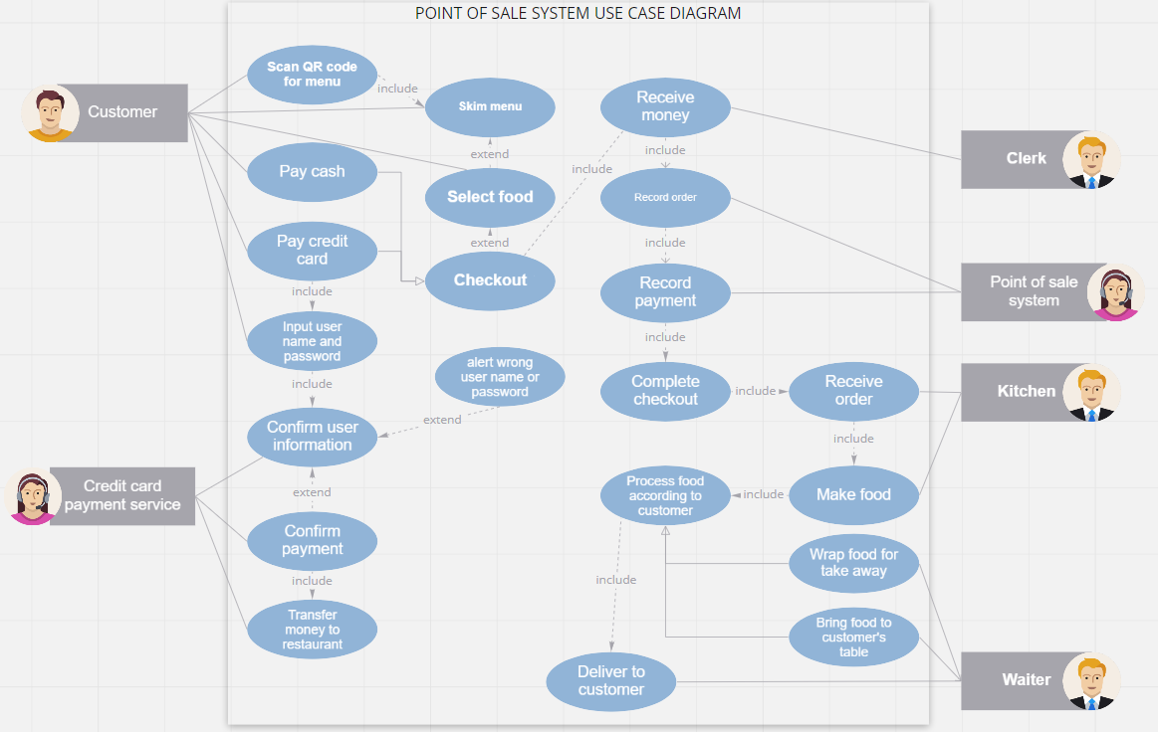

1.3: Choose one specific feature, i.e. food ordering, table reservation, customer management. Draw its use-case diagram and describe the use-case using a table format

* Use-case diagram for the food ordering feature:

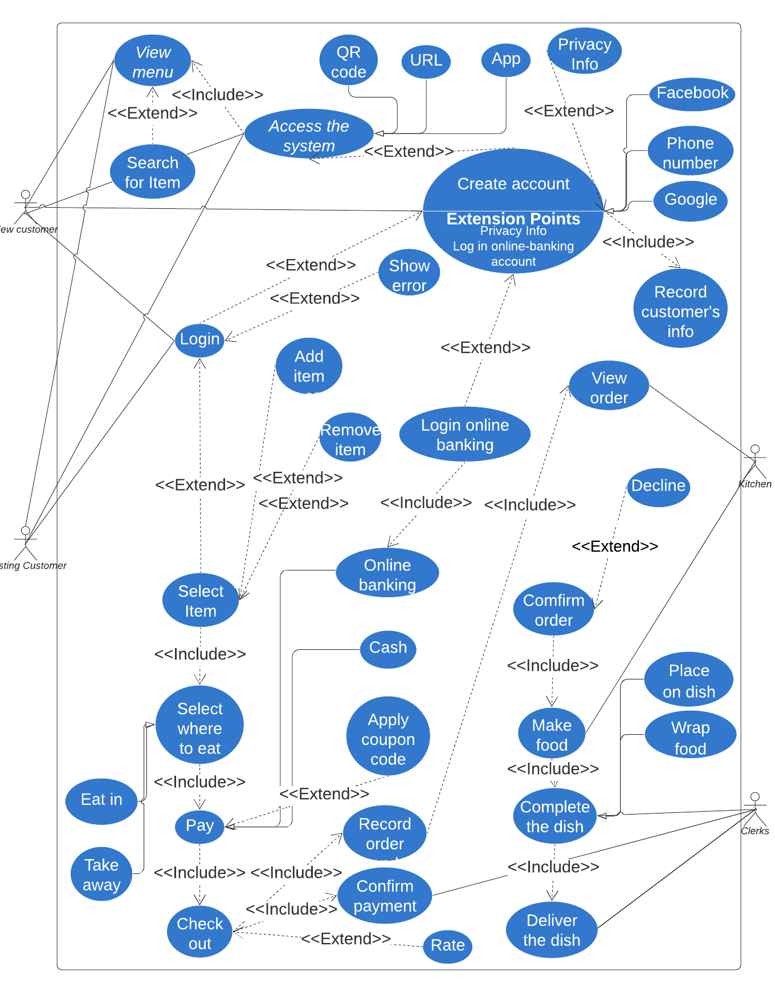

|  |  |
| --- | --- |
| Name | Ordering food |
| Actor | Registered customers, the kitchen, clerks, |
| Description | Registered users can order food, choose where to eat and pay in many ways. |
| Preconditions | Users need to access to home page. |
| Normal flow | 1. User access the home page of the website by QR code, URL or app.  2. User must login to their account, if user doesn’t have an account yet, user must create an account, and then login.  3. User views and selects items.  4. User selects where to eat.  5. User pays.  6. User checks out the system.  7. The kitchen receives and confirms the order.  8. The kitchen process the food.  9. Clerk delivers the dishes to the customers. |
| Exceptions | Exception 1: at step 4: If user did not select where to eat, can’t go to next steps.  Exception 2: at step 5: If user hasn’t logged into their bank account but attempt to pay by online banking method, the system will show error.  Exception 3: at step 7: The kitchen can decline the orders. |
| Alternative flow | Alternative 1: at exception 1: Website will notify that user hasn’t select where to have their dishes.  Alternative 2: at exception 2: Website will ask and forward you to the page where you can log in your bank account.  Alternative 3: at step 3: Users can search for specific items.  Alternative 4: at step 5: Users can apply coupon codes. |

Task 2: System modeling

Task 2.1. Draw an activity diagram to capture **Major (not all)** functional requirements of the desired system

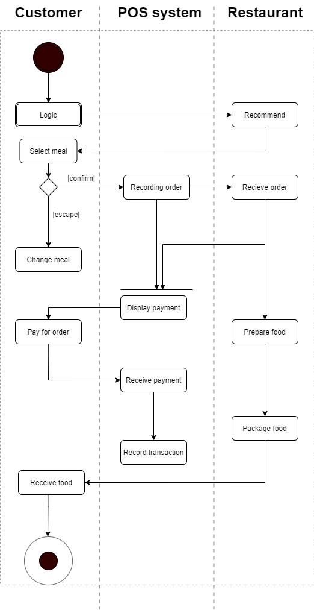  
Task 2.2. Draw a sequence diagram for use-case in Task 1.3.

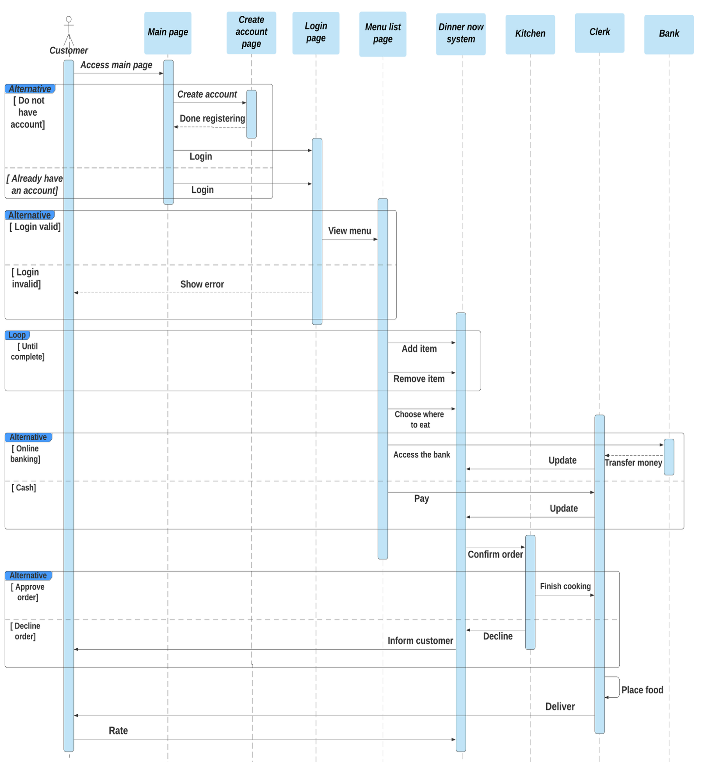

Task 2.3. Draw a class diagram

