Fp-api-catalog

==============

By `Jack Henderson`_

In this tutorial, we will create a simple web app that uses several web apis (e.g. facebook, google, meetup, salesforce, mailchimp, etc... Features such as “login using” and api calls are supported.

.. contents:: Sections:

:local:

:depth: 1

Prerequisites

-------------

This tutorial assumes you have already installed `Visual Studio 2015 <http://go.microsoft.com/fwlink/?LinkId=532606>`_ and the latest `ASP.NET 5 <http://go.microsoft.com/fwlink/?LinkId=627627>`_ runtime and tooling.

.. note:: For additional information about installing ASP.NET 5 on other platforms, see :doc:`/getting-started/index`.

Create an ASP.NET Web Application

---------------------------------

Start Visual Studio 2015. From the **File** menu, select **New** > **Project**.

Select the **ASP.NET Web Application** project template. It appears under **Installed** > **Templates** > **Visual C#** > **Web**. Name the project ``FPApiCatalog`` and click **OK**.

.. image:: fp-api-catalog/_static/1.png

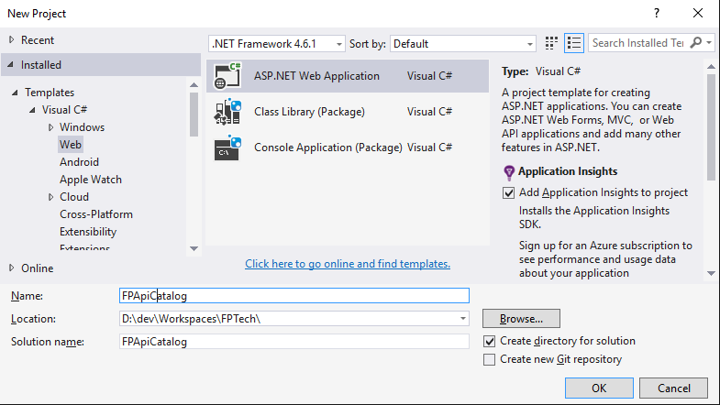

.. image:: fp-api-catalog/_static/2.png

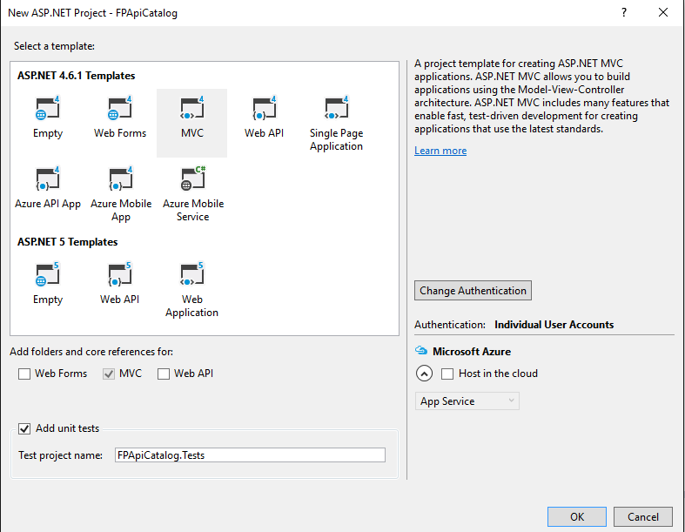

Setup website for SSL

---------------------

Set for SSL in project

.. image:: fp-api-catalog/_static/3.png

Require SSL in controller

.. image:: fp-api-catalog/_static/4.png

Add client records for app to major APIs

----------------------------------------

Test: Use port 44300, Production: Use Azure (or other host) settings

Google

^^^^^^

Facebook

^^^^^^^^

Twitter

^^^^^^^

Meetup

^^^^^^

Salesforce

^^^^^^^^^^

Add code to login using major APIs

----------------------------------

Additional Resources

--------------------

- :doc:`/conceptual-overview/aspnet`

- :doc:`/conceptual-overview/understanding-aspnet5-apps`

- :doc:`/fundamentals/index`