Salesforce – Demo 1

===================

By `Jack Henderson`_

In this tutorial, we will create a simple Salesforce web app. It will allow you to login using your Salesforce userid and password, and view data from the Salesforce data store.

.. contents:: Sections:

:local:

:depth: 1

Prerequisites

-------------

Before you start, make sure that you have a Salesforce developer id (client id) and account for testing your applications :doc:`/getting-started/create-salesforce-account`. This tutorial assumes you have already installed `Visual Studio 2015 <http://go.microsoft.com/fwlink/?LinkId=532606>`_ and the latest `ASP.NET 5 <http://go.microsoft.com/fwlink/?LinkId=627627>`_ runtime and tooling.

.. note:: For additional information about installing ASP.NET 5 on other platforms, see :doc:`/getting-started/index`.

Download, install, and configure force.com developer edition

------------------------------------------------------------

`force.com developer edition: <<https://developer.salesforce.com/signup>>`_

.. image:: salesforce-demo1/_static/1.png

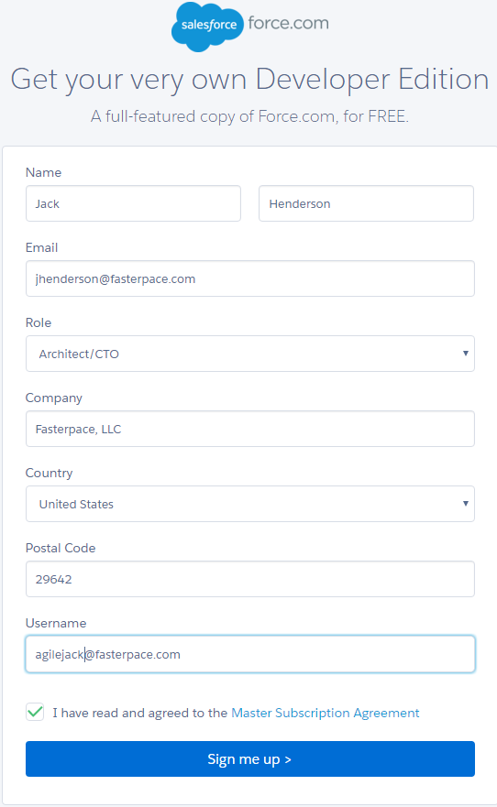

Start Visual Studio 2015. From the **File** menu, select **New** > **Project**.

Select the **ASP.NET Web Application** project template. It appears under **Installed** > **Templates** > **Visual C#** > **Web**. Name the project ``ContosoBooks`` and click **OK**.

.. image:: salesforce-demo1/_static/1.png

Additional Resources

--------------------

- :doc:`/conceptual-overview/aspnet`

- :doc:`/conceptual-overview/understanding-aspnet5-apps`

- :doc:`/fundamentals/index`