AtomicDVP
  - Tokenised Corporate Asset Settlement MVP
Reference architecture, controls, MPC approval design and demonstration guide

This guide explains a controlled Delivery versus Payment (DvP) demonstration for tokenised corporate assets. It shows who performs each action, how the MPC policy service uses two independent key-shares, and why settlement is allowed only after both payment and asset conditions are satisfied.
MVP decision | Scope
Source of truth | Drunix / Hyperledger Fabric chaincode
Controlled adapters | Mock CBDC, KYC/Risk, issuer or oracle verification and MPC policy service
Atomicity rule | Both payment and asset legs settle together, or both are released
Privacy rule | Only hashes, provider references and decisions are recorded on-chain; sensitive documents and private key material stay off-chain

1 Purpose and operating model
The marketplace lets a verified seller list an issuer-authorised tokenised corporate asset. A verified buyer selects that asset, completes wallet-time compliance screening, accepts the fixed trade terms, and participates in MPC approval. The Fabric ledger remains the authoritative record of asset status, trade status and settlement evidence.
The demo is intentionally controlled. Its adapters simulate external interfaces and failure handling; it does not claim live CBDC, NPCI, banking, PAN, Aadhaar, KYC or regulatory-system integration.

2 Participants and trust boundaries
Participant | Responsibility in the MVP | Trust boundary
Buyer | Connects an identity, passes screening, reviews the order and provides the user MPC key-share approval. | Controls the user share; never exposes it to the marketplace.
Seller | Lists a tokenised asset and authorises its lock for a specific trade. | Retains ownership until successful settlement.
Issuer | Mints or authorises the asset token, attests core metadata and may provide the policy key-share. | Authoritative for issuance and asset terms.
Regulator | May define policy criteria or provide an approval key-share when the policy requires oversight. | Does not receive private user key material.
Custodian | May verify custody status and provide the policy key-share for custody-controlled assets. | Controls its own service-held key-share.
Oracle or verifier | Optional independent provider for registrar, custody, corporate-action or authorised reference data. | Supplies an attestation/reference, not a private key.
MPC policy service | Evaluates policy and coordinates threshold approval from the user share plus one authorised policy share. | Returns an approval reference only; no key material reaches app or ledger.
Drunix Fabric network | Validates state transitions and records authoritative trade and settlement evidence. | Does not custody private key shares.

3 Asset verification model
The issuer is the primary authoritative party for issuance and metadata. Where policy requires extra assurance, an oracle or approved verifier can confirm custody status, registrar data, corporate-action status, or a regulator-approved reference. The MVP supports issuer-only attestation and issuer attestation with an external verification reference.
On-chain evidence | Off-chain information
metadataHash, attestationProvider, attestationRef, verificationStatus | Full KYC documents, personally sensitive identifiers, source documents and private key shares
Only ACTIVE verified assets can be listed or settled | Services retain their data according to their own access and retention controls

4 Reference architecture

Architecture interaction diagram
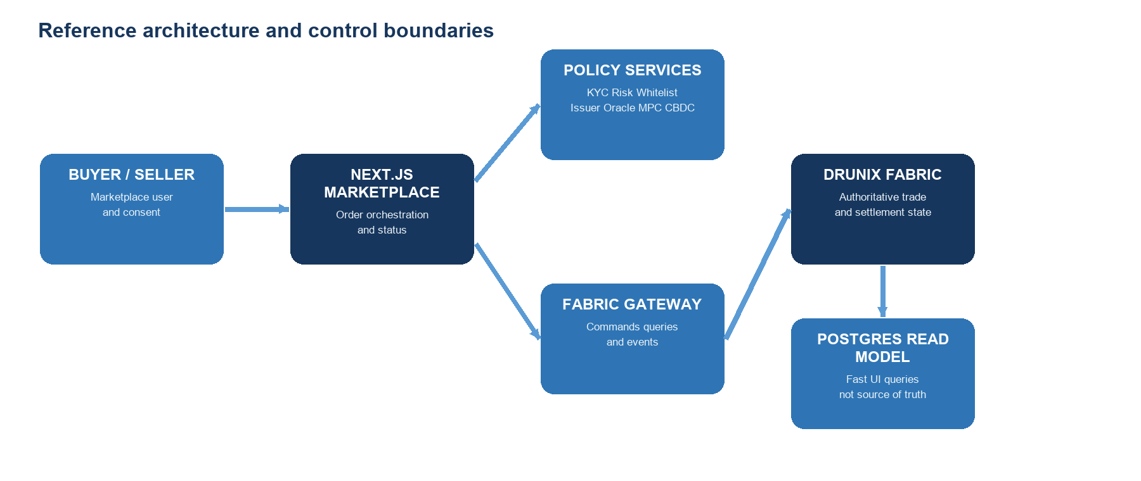
The marketplace backend orchestrates off-chain adapter calls but is not the source of truth. It submits commands through the Fabric Gateway and consumes chaincode events to update a PostgreSQL read model used by the interface.
Layer | Components | What it does
Experience | Next.js marketplace, buyer and seller views | Shows listing, consent, approval progress and settlement status.
Control services | KYC/Risk/Whitelist, issuer or oracle, MPC policy service, mock CBDC adapter | Return signed or referenced decisions required to progress the trade.
Ledger integration | Fabric Gateway and event listener | Submits commands and projects ledger events into the read model.
Authoritative ledger | Drunix Hyperledger Fabric chaincode | Enforces state transitions and stores evidence references.
Read model | PostgreSQL | Supports fast user-interface queries; it is not authoritative for settlement.

5 Seller listing and buyer purchase flow
Stage | Real-time behaviour | Control
1 Seller connects | Seller authenticates with a Fabric identity and requests to list an asset. | Seller role and ownership are verified.
2 Asset verified | Issuer attestation is validated; an external reference is checked when policy requires it. | Metadata hash and verification state must be ACTIVE.
3 Asset listed | Marketplace shows verified asset, seller, issuer, value and risk disclosure. | Only available verified inventory is displayed.
4 Buyer connects | Buyer identity is authenticated and wallet-time screening begins. | No checkout access until compliance is valid.
5 Wallet screening | KYC, sanctions/AML, wallet whitelist and transaction-risk rules execute. | Deny, expiry or flagging blocks the trade.
6 Checkout review | Buyer reviews asset, seller, amount, expiry and consent. | Terms are fixed before funds reservation.

6 MPC approval design
MPC means Multi-Party Computation. Instead of placing one complete signing key in one system, the approval authority is split into separate key-shares. For this MVP, the settlement policy requires two approvals: one user key-share from the buyer and one policy key-share from an authorised issuer, regulator or custodian service.

MPC user interaction diagram
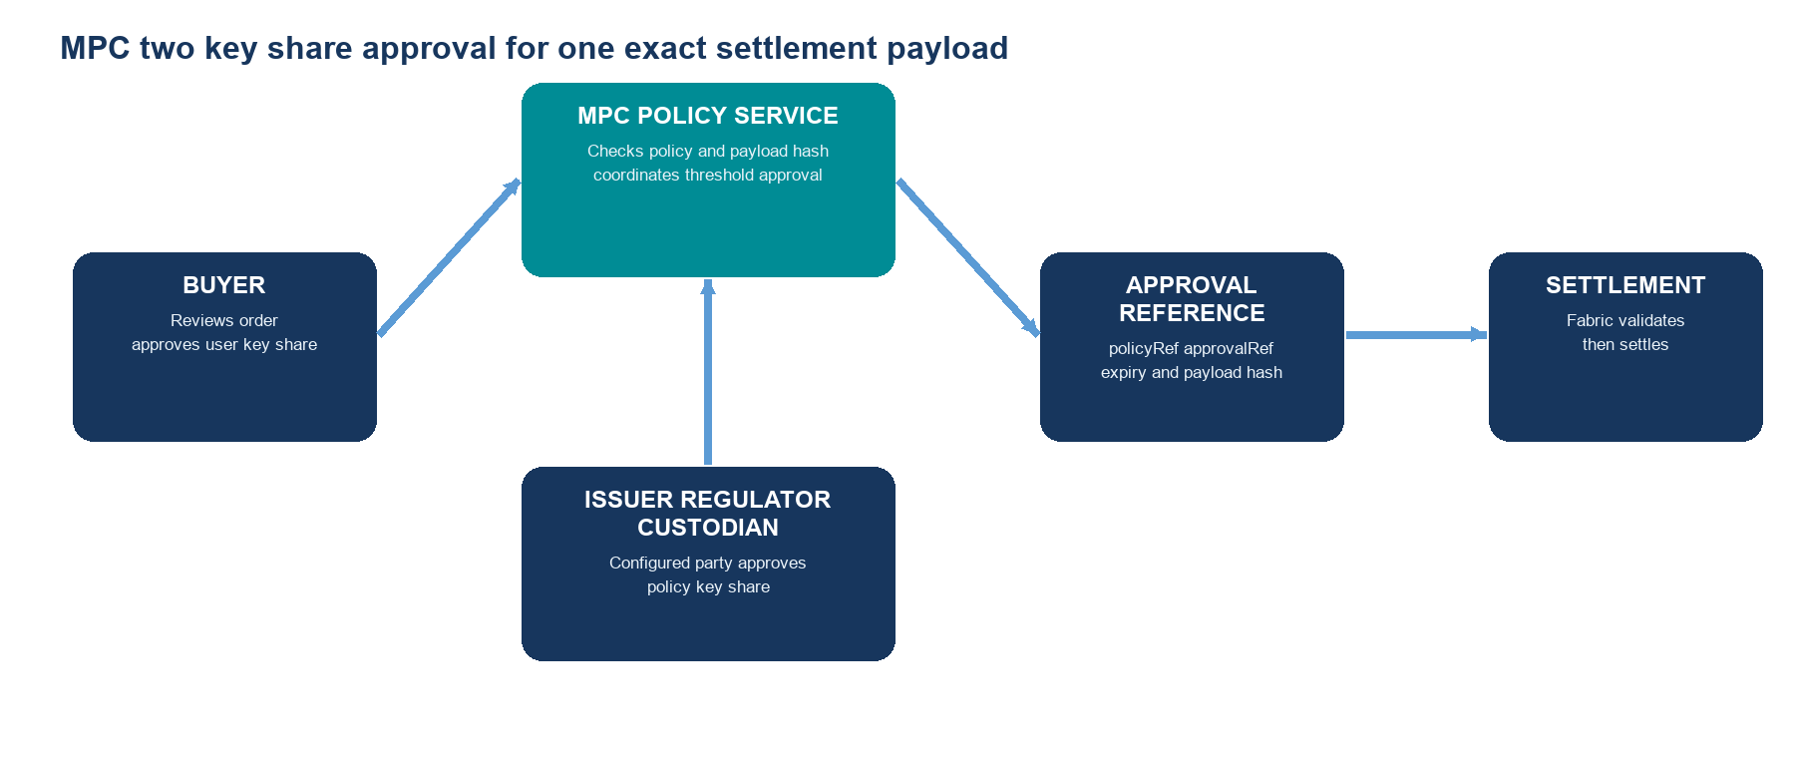
Component | What it does | What it never does
Buyer user key-share | Confirms that the buyer accepts the exact trade payload: asset, amount, currency, seller and expiry. | Does not send its private share to the marketplace, ledger or policy party.
Issuer policy key-share | Confirms issuer policy such as asset eligibility, transfer conditions or approved investor status. | Does not gain access to the buyer share.
Regulator policy key-share | Used only when the configured policy requires regulatory oversight or a supervisory rule. | Does not execute a trade merely by observing it.
Custodian policy key-share | Used for custody-controlled assets to confirm custody and release conditions. | Does not replace buyer consent.
MPC policy service | Checks policy, coordinates threshold approval and returns policyRef, approvalRef, expiryAt and payloadHash. | Does not expose, reconstruct or store usable private key material in the application or Fabric ledger.

Policy rule: buyer approval alone is insufficient. A valid settlement needs the buyer user key-share plus exactly the policy share required by the configured policy. The eligible policy party is issuer, regulator or custodian depending on the asset and jurisdictional rule. The resulting approval is bound to a payload hash and expiry so it cannot be reused for a different order.

7 Atomic settlement sequence

Settlement sequence
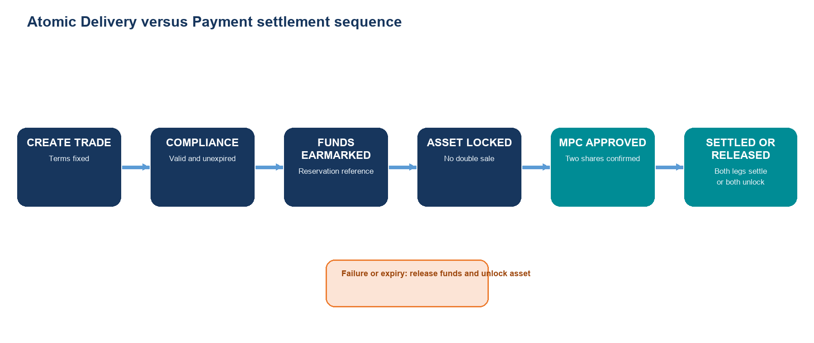
Step | Trade state | Action and outcome
1 | CREATED | Buyer and seller identities are present; trade terms and expiry are recorded.
2 | COMPLIANCE APPROVED | Valid wallet-time KYC/Risk/Whitelist attestation is recorded by hash and provider reference.
3 | FUNDS EARMARKED | CBDC adapter reserves the required mock funds and returns a reservation reference.
4 | ASSET LOCKED | Asset is locked to the trade and cannot be sold or transferred elsewhere.
5 | MPC APPROVED | Buyer and required policy party complete threshold approval for the exact trade payload.
6 | SETTLED | Payment is debited and Fabric chaincode updates ownership; a single settlement event is emitted.
Failure | FAILED | If debit or policy validation fails, reservation is released and ownership remains with seller.
Expiry | EXPIRED | Expired trade releases the reservation and asset lock.

8 Chaincode records and validation
Record | Core fields
AssetToken | assetId, issuerId, ownerId, faceValue, currency, status, metadataHash, attestationProvider, attestationRef, verificationStatus
Trade | tradeId, buyerId, sellerId, assetId, amount, currency, status, expiryAt, createdAt, settlementRef
ComplianceAttestation | tradeId, decision, riskScore, providerRef, expiryAt, signedPayloadHash
PaymentReservation | tradeId, payerId, amount, currency, status, providerRef
MpcApproval | tradeId, policyRef, approvalRef, requiredPolicyRole, expiryAt, payloadHash

SettleTrade validates an active and unexpired ASSET_LOCKED trade; approved and unexpired compliance; required buyer and seller roles; matching locked asset and value/currency; a valid payment reservation; ACTIVE asset verification; and an MPC approval with a matching payload hash, permitted policy role and unexpired approval reference. A successful settlement emits one settlement event.

9 Demo script
Demo moment | What to show and explain
List asset | Seller selects List asset. Explain that issuer or verifier attestation must be ACTIVE before a buyer can purchase.
Connect buyer | Buyer selects Buy token. Show KYC, AML/Risk and whitelist checks at wallet connection, before checkout.
Verify source | Show issuer or oracle attestation as a hash and provider reference rather than a sensitive document.
MPC approval | Show buyer review and user approval, then issuer, regulator or custodian policy approval. Explain that neither share is shown or stored in the UI.
Atomic settlement | Show Verifying, Funds earmarked, Asset locked, MPC approved and Atomic settlement in order.
Failure test | Run Simulate debit failure. Explain that reservation is released and seller retains ownership: no one-sided settlement.

10 Production boundary
This is a controlled MVP. Mock adapters demonstrate interfaces and failure handling without asserting access to production CBDC, NPCI, banking, KYC, identity or regulatory systems. A production launch requires approved provider contracts, credentials, legal and regulatory review, Fabric network governance, secure MPC key custody, audit controls, monitored policy operations and a mutually agreed cross-system settlement mechanism.

