[2.2.1 A user tour](http://ruby.railstutorial.org/chapters/a-demo-app" \l "sec-a_user_tour)

Visiting the root url <http://localhost:3000/> shows the same default Rails page shown in [Figure 1.3](http://ruby.railstutorial.org/chapters/beginning#fig-riding_rails), but in generating the Users resource scaffolding we have also created a large number of pages for manipulating users. For example, the page for listing all users is at [/users](http://localhost:3000/users), and the page for making a new user is at [/users/new](http://localhost:3000/users/new). The rest of this section is dedicated to taking a whirlwind tour through these user pages. As we proceed, it may help to refer to [Table 2.1](http://ruby.railstutorial.org/chapters/a-demo-app#table-user_urls), which shows the correspondence between pages and URLs.

|  |  |  |
| --- | --- | --- |
| **URL** | **Action** | **Purpose** |
| [/users](http://localhost:3000/users) | **index** | page to list all users |
| [/users/1](http://localhost:3000/users/1) | **show** | page to show user with id **1** |
| [/users/new](http://localhost:3000/users/new) | **new** | page to make a new user |
| [/users/1/edit](http://localhost:3000/users/1/edit) | **edit** | page to edit user with id **1** |

Table 2.1: The correspondence between pages and URLs for the Users resource.

We start with the page to show all the users in our application, called [index](http://localhost:3000/users); as you might expect, initially there are no users at all ([Figure 2.4](http://ruby.railstutorial.org/chapters/a-demo-app#fig-demo_blank_user_index_rails_3)).

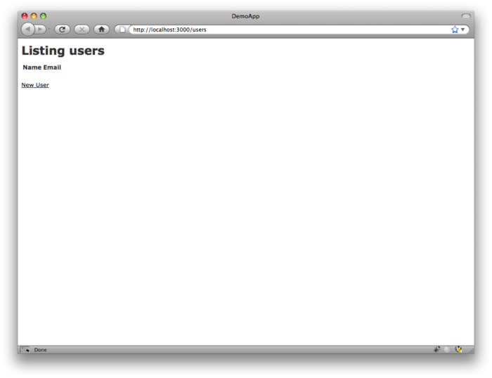

Figure 2.4: The initial index page for the Users resource ([/users](http://localhost:3000/users)). [(full size)](http://railstutorial.org/images/figures/demo_blank_user_index_rails_3-full.png)

To make a new user, we visit the [new](http://localhost:3000/users/new) page, as shown in [Figure 2.5](http://ruby.railstutorial.org/chapters/a-demo-app#fig-demo_new_user_rails_3). (Since the http://localhost:3000 part of the address is implicit whenever we are developing locally, I’ll usually omit it from now on.) In [Chapter 7](http://ruby.railstutorial.org/chapters/sign-up#top), this will become the user signup page.

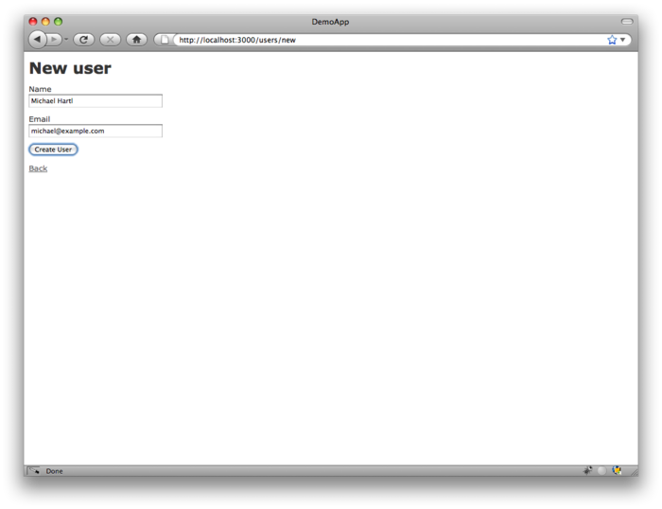

Figure 2.5: The new user page ([/users/new](http://localhost:3000/users/new)). [(full size)](http://railstutorial.org/images/figures/demo_new_user_rails_3-full.png)

We can create a user by entering name and email values in the text fields and then clicking the Create User button. The result is the user [show](http://localhost:3000/users/1) page, as seen in [Figure 2.6](http://ruby.railstutorial.org/chapters/a-demo-app#fig-demo_show_user_rails_3). (The green welcome message is accomplished using the *flash*, which we’ll learn about in [Section 7.4.2](http://ruby.railstutorial.org/chapters/sign-up#sec-the_flash).) Note that the URL is [/users/1](http://localhost:3000/users/1); as you might suspect, the number **1** is simply the user’s **id** attribute from[Figure 2.2](http://ruby.railstutorial.org/chapters/a-demo-app#fig-demo_user_model). In [Section 7.1](http://ruby.railstutorial.org/chapters/sign-up#sec-showing_users), this page will become the user’s profile.

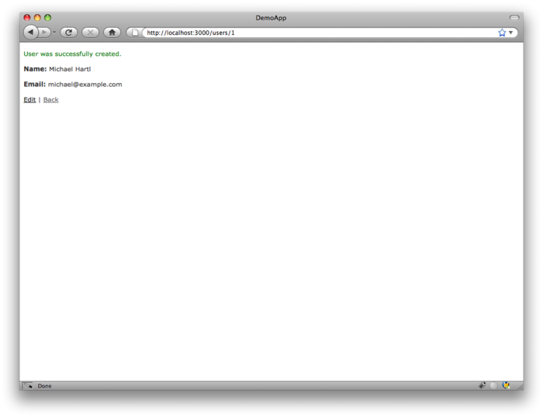

Figure 2.6: The page to show a user ([/users/1](http://localhost:3000/users/1)). [(full size)](http://railstutorial.org/images/figures/demo_show_user_rails_3-full.png)

To change a user’s information, we visit the [edit](http://localhost:3000/users/1/edit) page ([Figure 2.7](http://ruby.railstutorial.org/chapters/a-demo-app#fig-demo_edit_user_rails_3)). By modifying the user information and clicking the Update User button, we arrange to change the information for the user in the demo application ([Figure 2.8](http://ruby.railstutorial.org/chapters/a-demo-app#fig-demo_update_user_rails_3)). (As we’ll see in detail starting in [Chapter 6](http://ruby.railstutorial.org/chapters/modeling-users#top), this user data is stored in a database back-end.) We’ll add user edit/update functionality to the sample application in[Section 9.1](http://ruby.railstutorial.org/chapters/updating-showing-and-deleting-users#sec-updating_users).

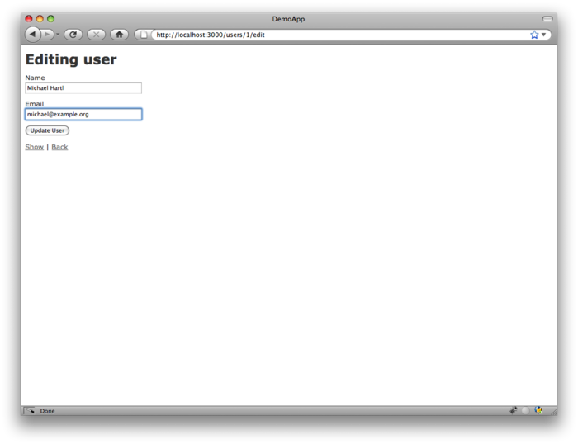

Figure 2.7: The user edit page ([/users/1/edit](http://localhost:3000/users/1/edit)). [(full size)](http://railstutorial.org/images/figures/demo_edit_user_rails_3-full.png)

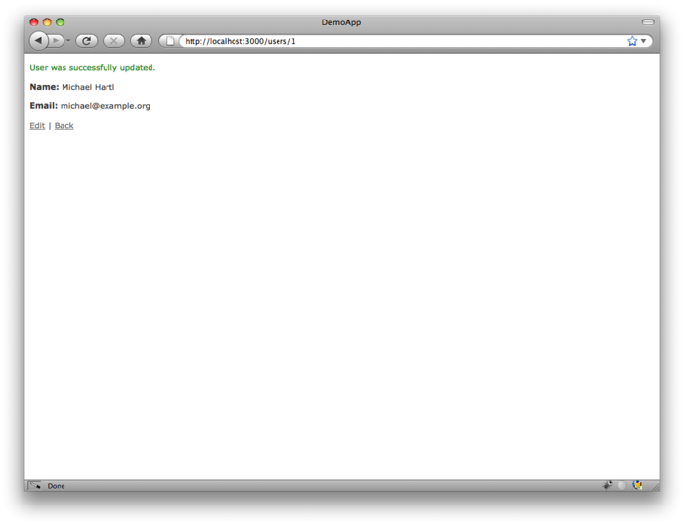

Figure 2.8: A user with updated information. [(full size)](http://railstutorial.org/images/figures/demo_update_user_rails_3-full.png)

Now we’ll create a second user by revisiting the [new](http://localhost:3000/users/new) page and submitting a second set of user information; the resulting user [index](http://localhost:3000/users) is shown in [Figure 2.9](http://ruby.railstutorial.org/chapters/a-demo-app#fig-demo_user_index_two_rails_3). [Section 7.1](http://ruby.railstutorial.org/chapters/sign-up#sec-showing_users) will develop the user index into a more polished page for showing all users.

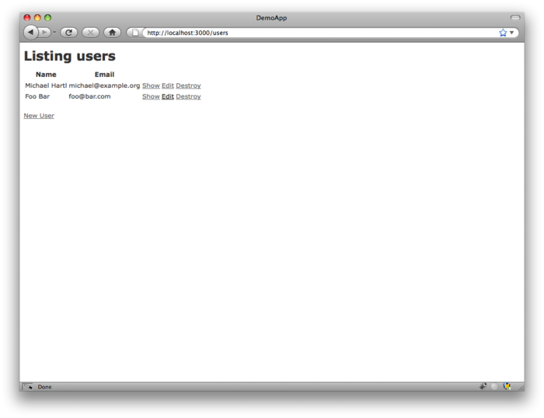

Figure 2.9: The user index page ([/users](http://localhost:3000/users)) with a second user. [(full size)](http://railstutorial.org/images/figures/demo_user_index_two_rails_3-full.png)

Having shown how to create, show, and edit users, we come finally to destroying them ([Figure 2.10](http://ruby.railstutorial.org/chapters/a-demo-app#fig-demo_destroy_user_rails_3)). You should verify that clicking on the link in [Figure 2.10](http://ruby.railstutorial.org/chapters/a-demo-app#fig-demo_destroy_user_rails_3) destroys the second user, yielding an index page with only one user. (If it doesn’t work, be sure that JavaScript is enabled in your browser; Rails uses JavaScript to issue the request needed to destroy a user.) [Section 9.4](http://ruby.railstutorial.org/chapters/updating-showing-and-deleting-users#sec-destroying_users) adds user deletion to the sample app, taking care to restrict its use to a special class of administrative users.

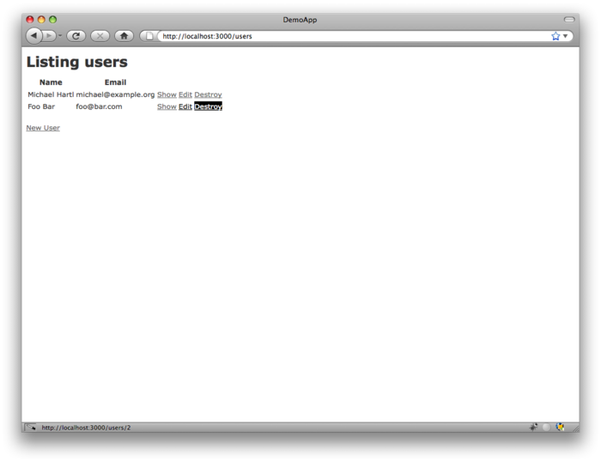

Figure 2.10: Destroying a user. [(full size)](http://railstutorial.org/images/figures/demo_destroy_user_rails_3-full.png)