**Meeting Minutes of Group17**

**Meeting ID**: Formal Meeting 2 of UI Group

**Time**: 13:00 – 14:00, 2020/1/19

**Attended**: WANG Boya, YU Guohao, ZHU Hongyi

**Absence**: None

**Venue:** Online

**Minutes Taker:** WANG Boya

1. **Finished Task:**

* Most UI files of teaching module, which are uploaded to github.

1. **Task Allocation of Front-end Development**
2. UI files: WANG Boya
3. UI interface coding: WANG Boya, YU Guohao
4. CSS coding: ZHU Hongyi
5. **Discussion of Attendance Export Function**
6. Support exporting attendance by one module/ one student/ one teaching session
7. Provide functions of “Save to Local” and “Print” for exporting.
8. UI Design:

* Export by one module

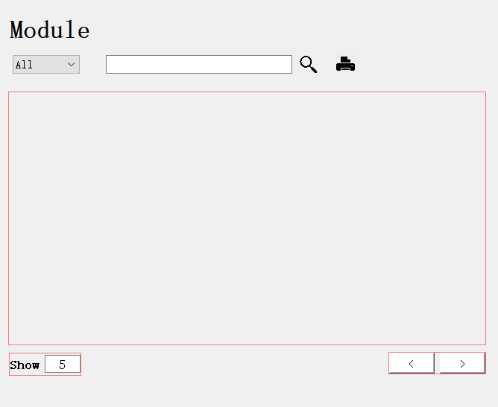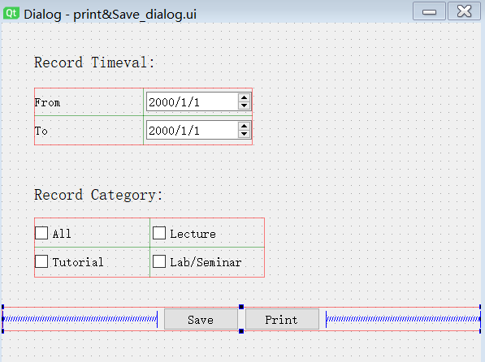

* Export by one student

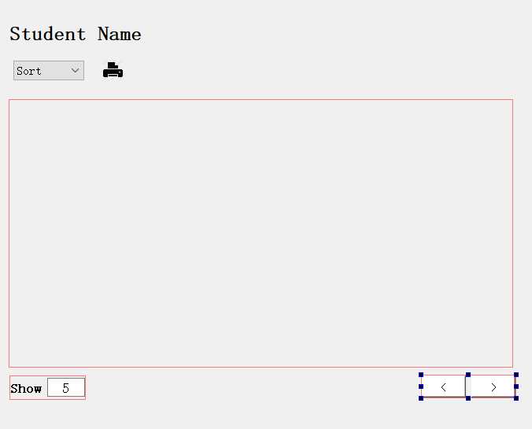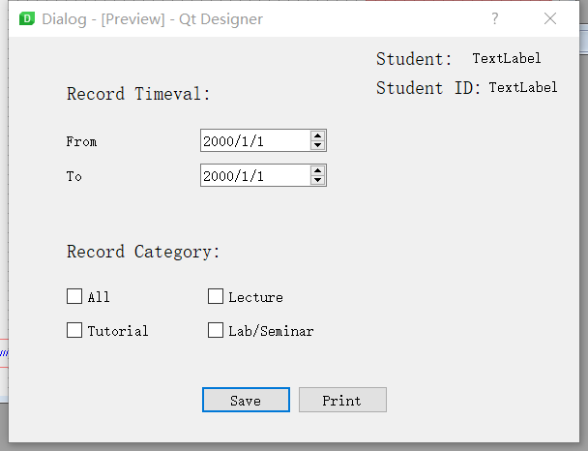

* Export by one teaching session: Display information of recorded session.

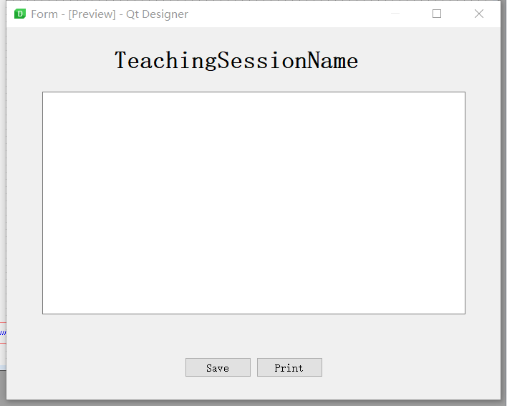

1. **Design of Admin Interface**

* Follow the original admin wireframing design to develop UI.
* Delete the preview function.