**Meeting Minutes of Group17**

**Meeting ID**: formal meeting 9

**Time**: 21:00 – 22:00, 2020/2/15

**Attended**: LI Mingchen, LI YiMing, WANG Boya, YU Guohao, ZHU Hongyi

**Absence**: LI Mingchen

**Venue:** online

**Minutes Taker:** Hongyi ZHU

1. **UI design**
2. Delete 4 buttons and related labels
3. change frames size and location
4. adjust labels’ location
5. fix one bug: only the name of one item will be showed when it is selected

1. add one hyperlink

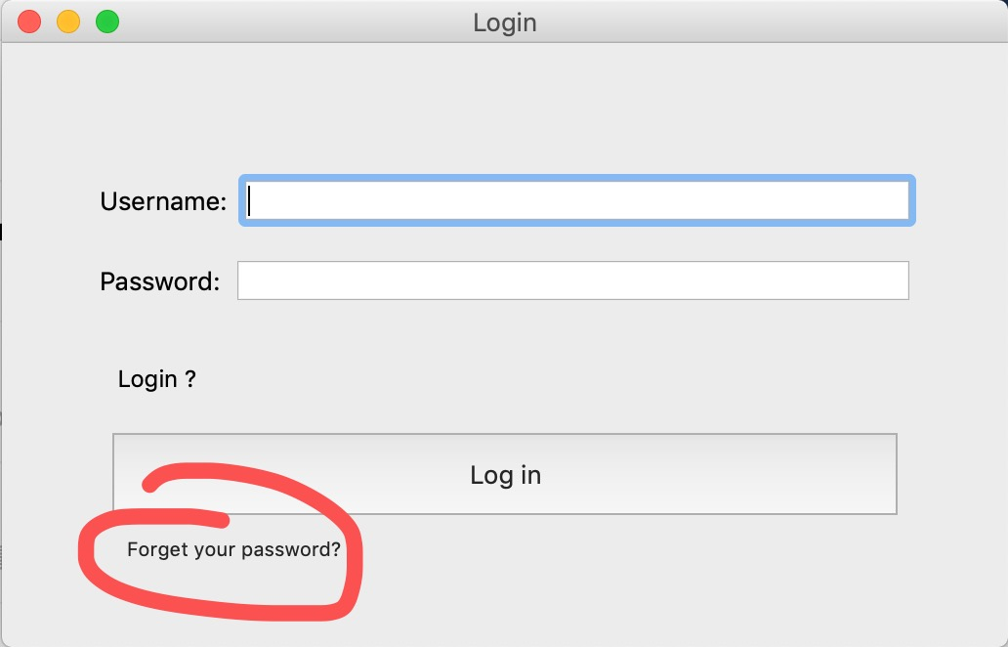

1. 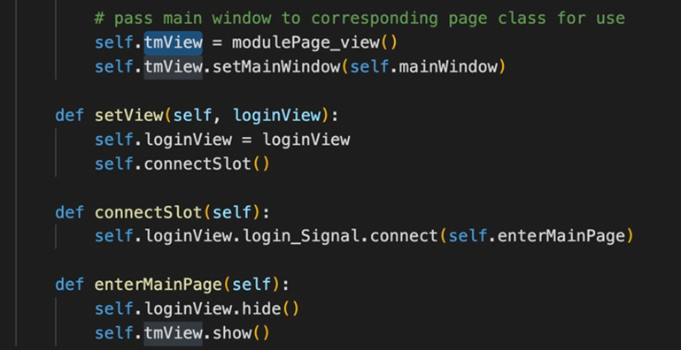change some functions’ name, make it clearly. Eg. tmView
2. load qss file into UI
3. **Database**
4. Decide whether we need cloud services
5. **Assigning task**
6. WANG Boya organize archives.
7. YU Guohao and ZHU Hongyi learn Latex
8. LI Mingchen and LI YiMing do the face recognition functions and build database