**Meeting Minutes of Group17**

**Meeting ID**: Formal Meeting 6 of UI Group

**Time**: 14:00 – 15:00, 2020/2/17

**Attended**: WANG Boya, YU Guohao, ZHU Hongyi

**Absence**: None

**Venue:** Online

**Minutes Taker:** WANG Boya

1. **Task Progress:**
2. ZHU Hongyi: Working on improvements of QSS

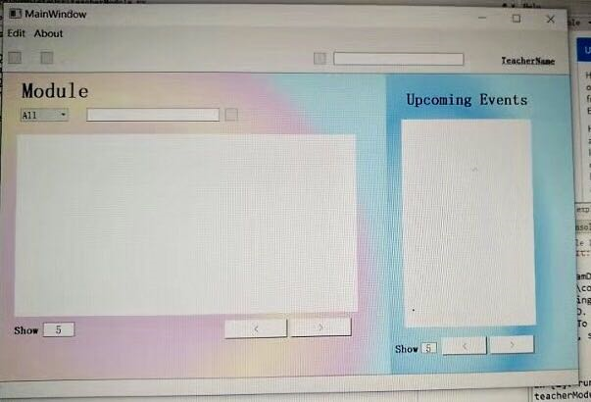

1. WANG Boya: Finished new admin UI file, modify recording page UI file.

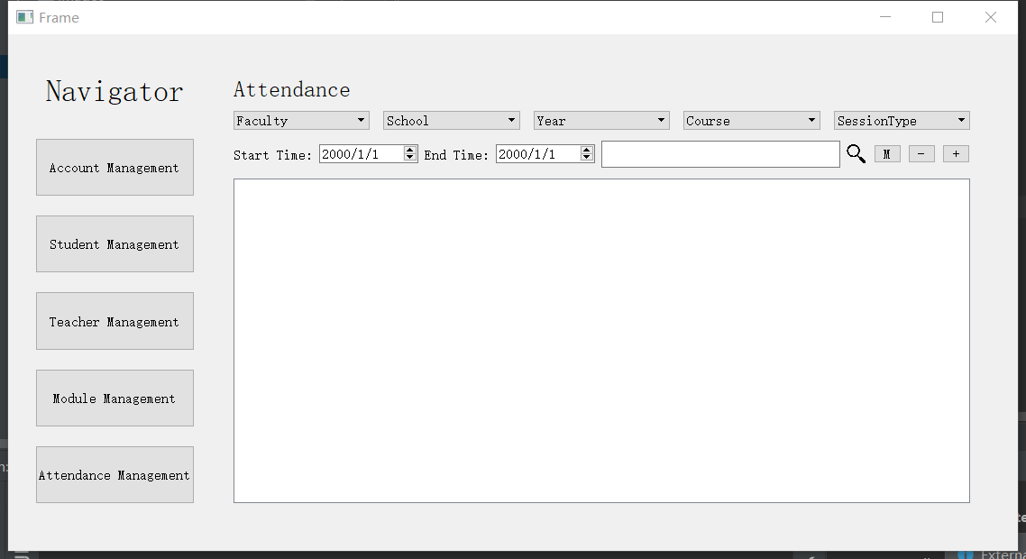

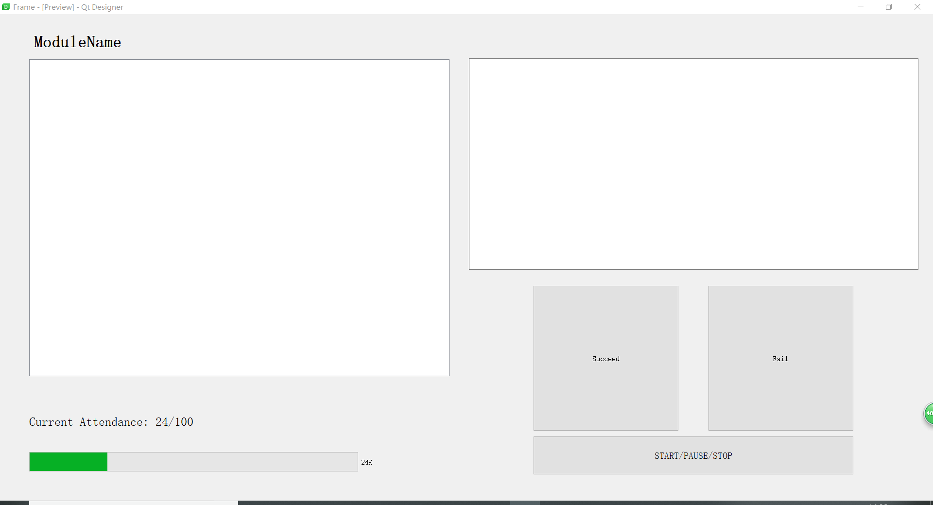

1. YU Guohao: Working on the modification of page jumping function.
2. **Background Information**

For the front-end work are nearly done. From now on members need to finish handover of front-back work and do other development work.

The UI design requires modification based on the implement-level requirements from all group members, hence the UI and page jumping require more time for further improvement.

1. **Task Allocation:**
2. ZHU Hongyi: Implement QSS on implemented UI files.
3. WANG Boya: Check and finish all of the rest UI files.
4. YU Guohao: Modify the page jumping implementation.