**Meeting Minutes of Group17**

**Meeting ID**: Formal Meeting 7 of UI Group

**Time**: 14:00 – 15:00, 2020/2/24

**Attended**: WANG Boya, YU Guohao, ZHU Hongyi

**Absence**: None

**Venue:** Online

**Minutes Taker:** WANG Boya

1. **Task Progress:**
2. ZHU Hongyi: Working on improvements of QSS
3. WANG Boya:

* Finished teacher profile and logout UI page.

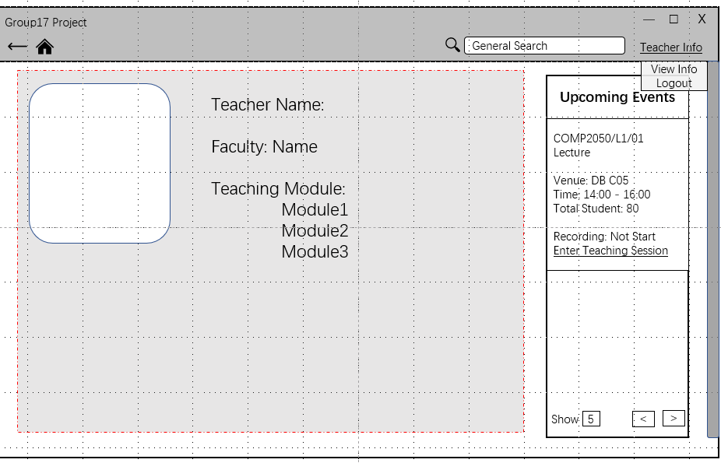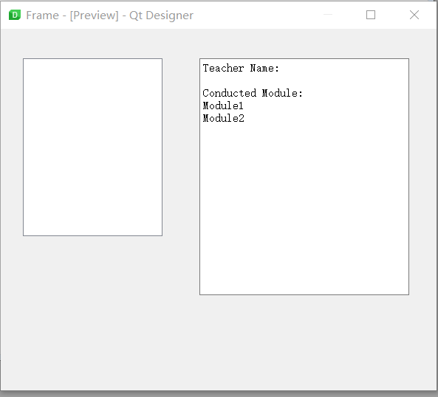

* Modify the print function to global one

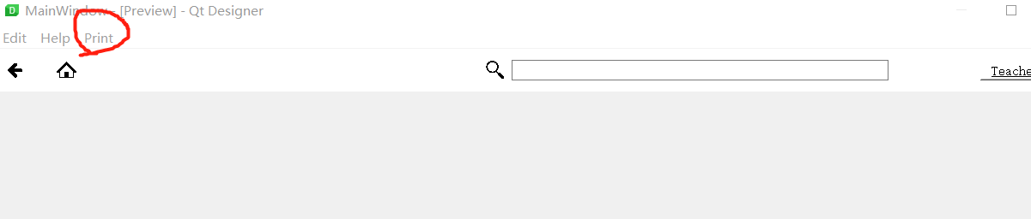

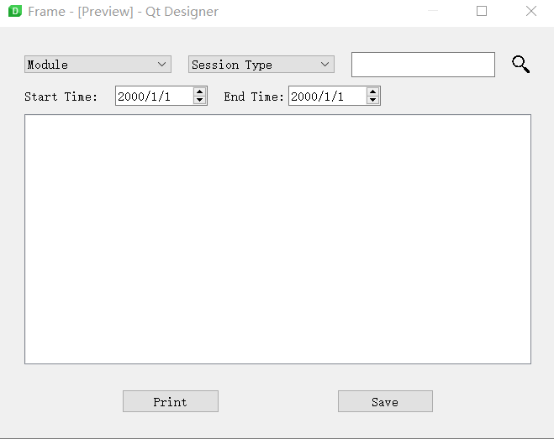

1. YU Guohao: Working on the modification of page jumping function.
2. **Task Allocation:**
3. ZHU Hongyi: Implement QSS on implemented UI files.
4. WANG Boya: Check and finish all of the rest UI files.
5. YU Guohao: Modify the page jumping implementation.