**Meeting Minutes of Group17**

**Meeting ID**: Formal Meeting 8 of UI Group

**Time**: 14:00 – 15:00, 2020/3/1

**Attended**: WANG Boya, YU Guohao, ZHU Hongyi

**Absence**: None

**Venue:** Online

**Minutes Taker:** WANG Boya

1. **Task Progress:**
2. ZHU Hongyi: Keep improving QSS.
3. WANG Boya:

* Modify student detail page. Use labels rather than textView for summary page.

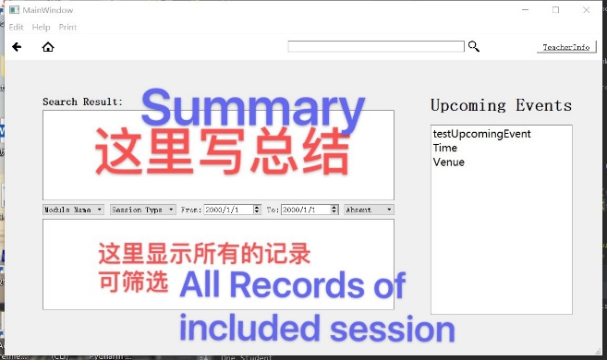

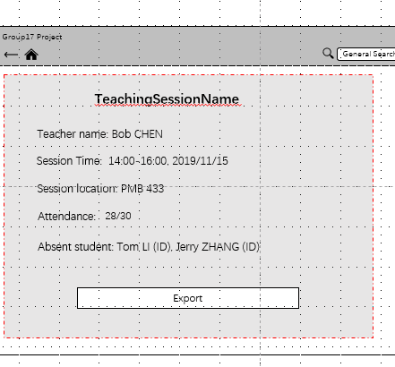

1. YU Guohao: Nearly finish page jumping of teacher part.
2. **Task Allocation:**
3. ZHU Hongyi: Keep improving QSS.
4. YU Guohao: Complete the page jumping implementation of teacher part.
5. UI Group: Submit final files to formal group github responsory and finish handover. (This is done on 5th, March,2020, added on 5th, March,2020. After then WANG Boya and YU Guohao are responsible for UI/coding cooperated modification; ZHU Hongyi is responsible for QSS maintenance.)