**Meeting Minutes of Group 17**

**Meeting ID**: informal meeting 1

**Time**: 13:00 – 13:30, 2019/10/18

**Attended**: LI Mingchen, LI YiMing, WANG Boya, YU Guohao, ZHU Hongyi

**Absence**: None

**Venue:** PB hall

**Minutes Taker:** Li Yiming

1. **Plan for next week**
2. Set up time plan for the project - Yiming and Boya
3. Draw use case diagram – Hongyi

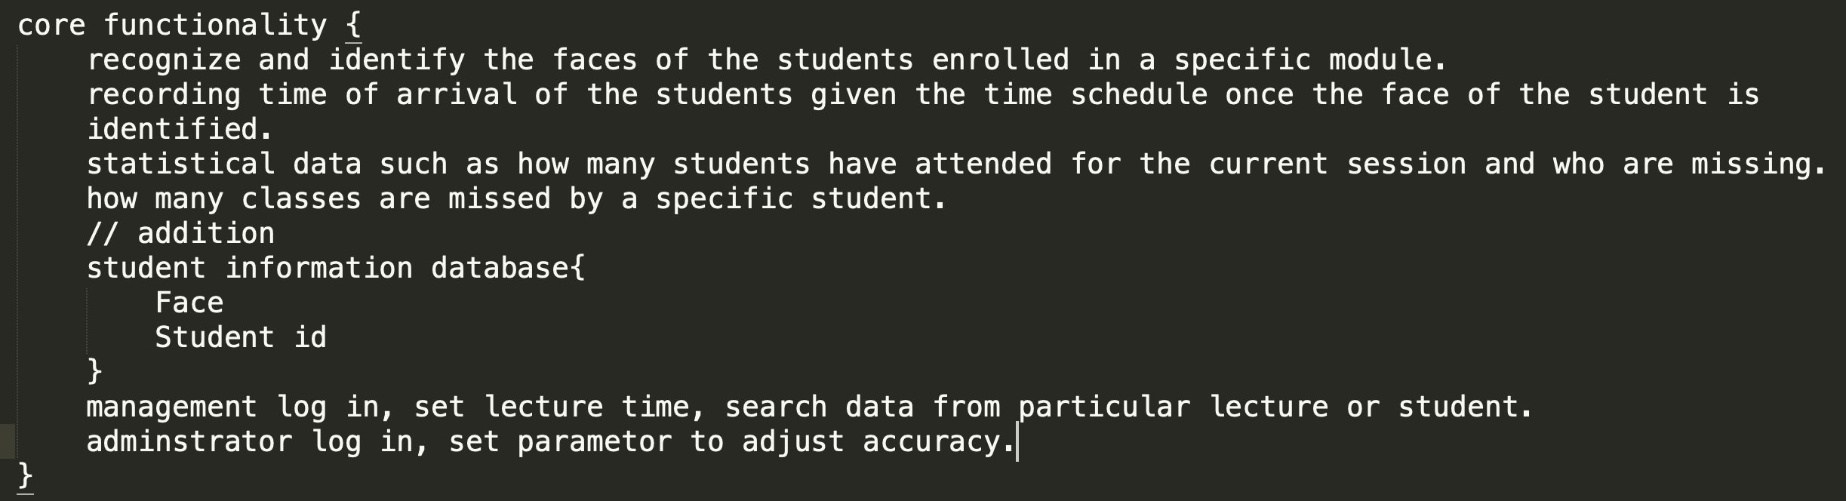

* recognize the faces
* identify the faces
* record time of arrival
* database for statistical data
* … (other use case)

1. Build website – Guohao and Mingchen

* Project title, team members and supervisor
* Project introduction
* Meeting minutes involved by links

1. Learn programming language

* Python (IDE, complier, file, format)