**Meeting Minutes of Group17**

**Meeting ID**: informal meeting 4

**Time**: 14:00 – 15:30, 2019/11/09

**Attended**: LI Mingchen, LI YiMing, WANG Boya, YU Guohao, ZHU Hongyi

**Absence**: None

**Venue:** Shizu

**Minutes Taker:** WANG Boya

1. **Check Requirement of Interim Report**

Task: To confirm with supervisor whether the background information and noted researches should be done.

1. **Instance UI Design for Teacher**
2. Design and composing reference: Moodle
3. Design features:

* To use partial page refresh
* To develop a general search that any input is available, and a partial search under located content to find target easier.

1. Design for teaching session:

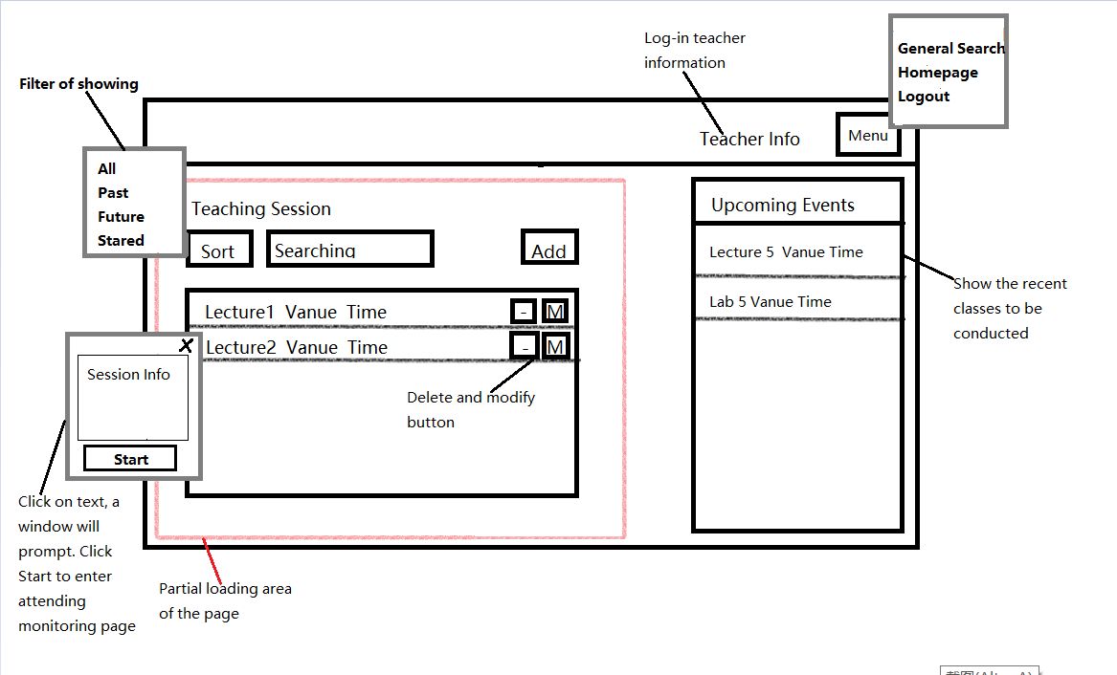

1. Design for recorded session:

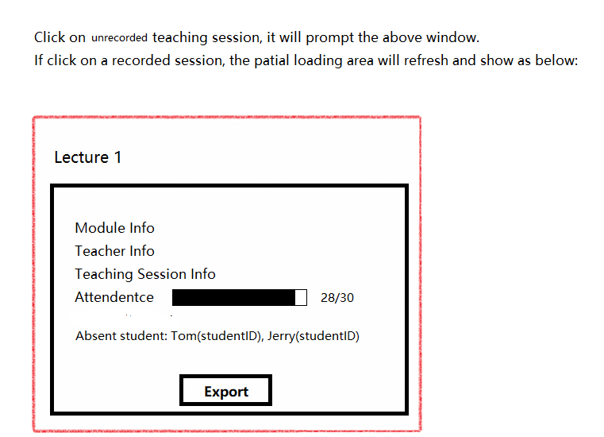

1. **Task before Next Meeting:**
2. Complete class diagram
3. Complete plane UI design for teacher class