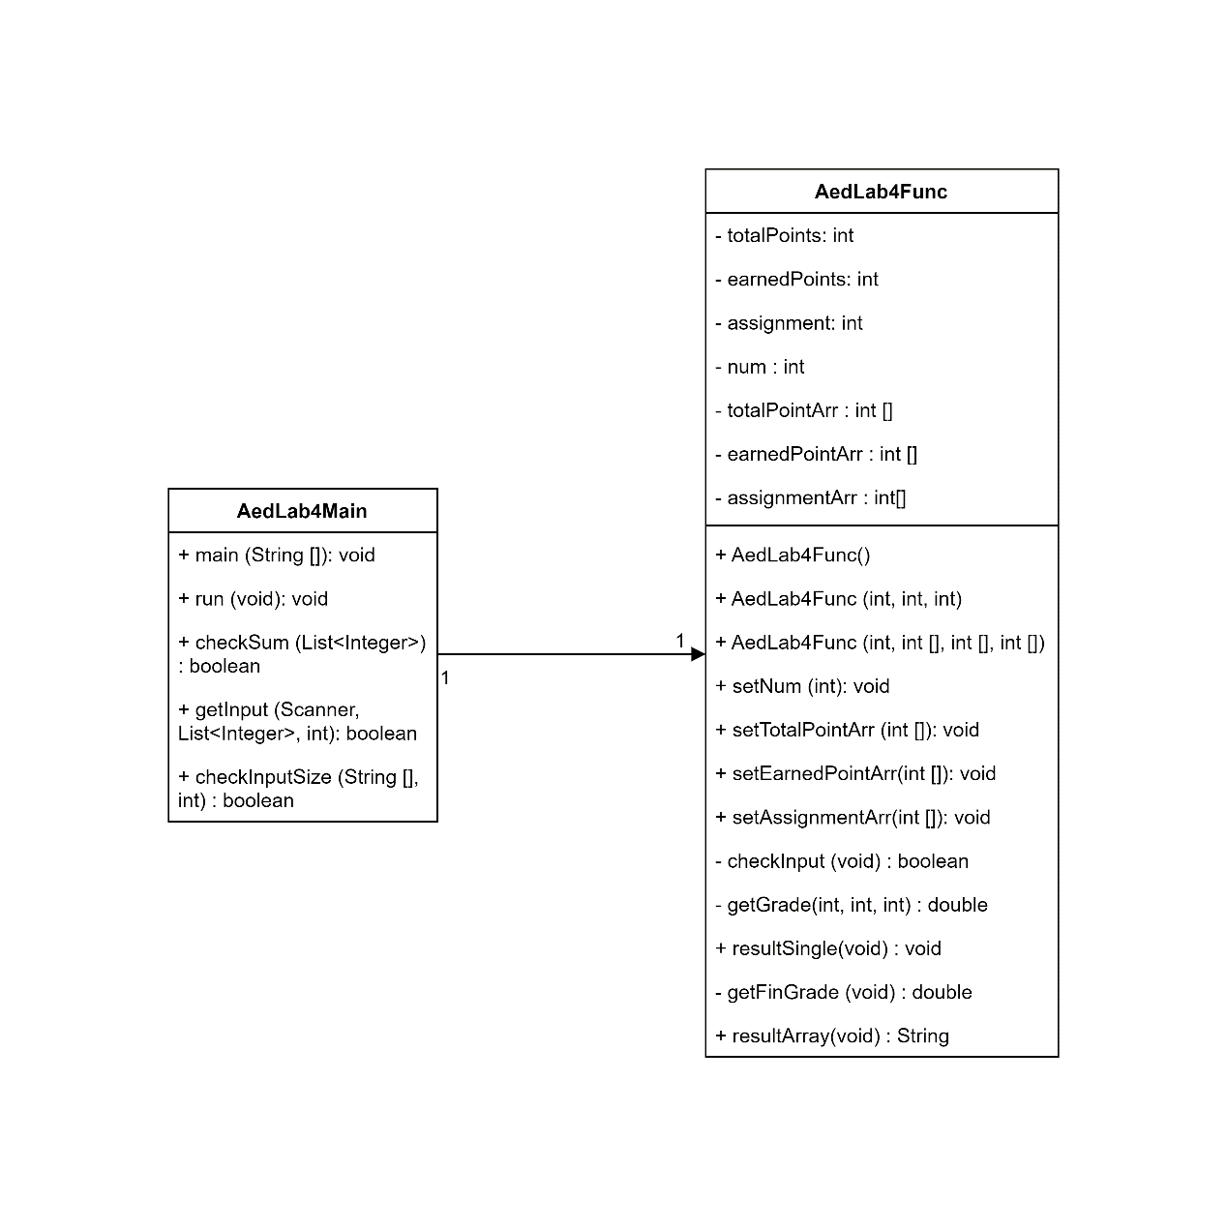

Above image is the UML class diagram for the weighted grading application.

The application has 2 main class: AedLab4Main and AedLab4Func.

The relationship between these 2 classes is 1-to-1 Association, AedLab4Main knows AedLab4Func, initial it and use its functions.

Methods in the AedLab4Main:

|  |  |
| --- | --- |
| Name & visible | public main |
| Parameter | String [] |
| Return | void |
| Description | The application starts from this function and also holds the exception throw. |

|  |  |
| --- | --- |
| Name & visible | public run |
| Parameter | void |
| Return | void |
| Description | The main function in this class, initialize the scanner and buffers for user typing and call the result function. |
| Name & visible | public checkSum |
| Parameter | List<Integer> list |
| Return | boolean |
| Description | Get the assignment percentage list and check whether its sum is 100. Return true if yes. |

|  |  |
| --- | --- |
| Name & visible | public getInput |
| Parameter | Scanner sc, List<Integer> buffer, int N |
| Return | boolean |
| Description | Get the input scanner, buffer list and the desired number of inputs. Read the input from Scanner as String, and split it into list, meanwhile checking the number of inputs is correct. Return true if number of input is correct and loading input success. |

|  |  |
| --- | --- |
| Name & visible | public checkInputSize |
| Parameter | String [] array, int N |
| Return | boolean |
| Description | Get the input string array and desired number of input. Return true if length of string array is equal to desired number of input. |

Attributes in the AedLab4Func:

|  |  |  |
| --- | --- | --- |
| Name & visible | Type | Description |
| private totalPoints | int | the total point of one assignment (for Assign1) |
| private earnedPoints | int | the earned point of one assignment (for Assign1) |
| private assignment | int | the assignment percentage (for Assign1) |
| private num | int | Number of assignments |
| private totalPointArr | int[] | array of total point for multi-assignments |
| private earnedPointArr | int[] | array of earned point for multi-assignment |
| private assignmentArr | int[] | The array of assignments percentage |

Functions in the AedLab4Func:

|  |  |
| --- | --- |
| Name & visible | public AedLab4Func |
| Parameter | void |
| Return | void |
| Description | basic constructor |
| Name & visible | public AedLab4Func |
| Parameter | int t, int e, int a |
| Return | void |
| Description | constructor accept the 3 int for totalPoint, earnedPoint and assignment. (for Assign1) |

|  |  |
| --- | --- |
| Name & visible | public AedLab4Func |
| Parameter | int n, int[] t, int[] e, int[] a |
| Return | void |
| Description | constructor accept the number of assignments and 3 int arrays for total points, earned point and assignments. |

|  |  |
| --- | --- |
| Name & visible | public setNum |
| Parameter | int num |
| Return | void |
| Description | Set the private attribute num |

|  |  |
| --- | --- |
| Name & visible | public setTotalPointArr |
| Parameter | int[] totalPointArr |
| Return | void |
| Description | Set the private attribute totalPointArr |

|  |  |
| --- | --- |
| Name & visible | public setEarnedPointArr |
| Parameter | int[] earnedPointArr |
| Return | void |
| Description | Set the private attribute earnedPointArr |

|  |  |
| --- | --- |
| Name & visible | public setAssignmentArr |
| Parameter | int[] assignmentArr |
| Return | void |
| Description | Set the private attribute assignmentArr |

|  |  |
| --- | --- |
| Name & visible | private checkInput |
| Parameter | void |
| Return | boolean |
| Description | Check whether the 3 attributes for assign 1 is valid. Return true if valid. |
| Name & visible | private getGrade |
| Parameter | int e, int t, int a |
| Return | double |
| Description | Get the weighted grade based on e / t * a. |

|  |  |
| --- | --- |
| Name & visible | public resultSingle |
| Parameter | void |
| Return | void |
| Description | Get the result for single grade (for Assign 1). |

|  |  |
| --- | --- |
| Name & visible | private getFinGrade |
| Parameter | void |
| Return | double |
| Description | Get the final weighted grade for multi-assignments |

|  |  |
| --- | --- |
| Name & visible | public resultArray |
| Parameter | void |
| Return | String |
| Description | Get the result for multi-assignments grades. Return the final level String. |

Discussion of the limitations:

1. The first limitation is that although we create global exception catch at the main function, there is only 2 customized alert prompts:

“Invalid Input Error:: number of input is different.”

“Invalid Input Error:: weights sum is not 100”

The rest errors are handled in raw prompts.

1. The error tolerance is not acceptable, once there is invalid input, user has to re-type all the information.
2. Although this application currently is simple and single thread program, maybe in the future, the AedLab4Func is running on the cloud and service need to be synchronized.
3. The input is String, split by comma. But after processing the type that inputs stored is int, other type of input will lead to exception prompt.
4. User Experience is not logic direct and straightforward, which still need extra information to help input.

Improvement for Corresponding limitations:

1. Handle more detailed different exceptions in each function, rather than directly throw them all from main function, to improve user experience and let user know the actual problem.
2. No longer directly exit the application when errored, but add the while(true) and check function to each input, once input is not valid, loop until it’s legal then break the infinite loop.
3. Change the array attributes in AedLab4Func to BlockedList or manually add Object synchronized lock to ensure the atomic change.
4. Better to change the stored data type from int to Double/double, so that the application can handle more complex points like decimals.
5. Combined with some graphics libraries like awt or swing making a GUI for users, so that the input format can be more straightforward.