IELTS SPEAKING PART 2 - A NATURAL TALENT
Describe a natural talent (sports, music, etc) you want to improve
You should say:
- What it is
- When you discovered it
- How you want to improve it
- And how you feel about it
Gộp đề
A person | A place | An object | An experience
A mother/father  (1 trong 2)  My best friend  Celeb | A tourist city  (chọn 1)  A park (nơi cụ thể)  A restaurant  A café | A book  A movie  A photo | A party (birthday), a holiday (Tet), an exam, a trip

Connected speech: kết nối phụ âm cuối của từ trước sang nguyên âm đầu của từ sau (o, a, u, e, i)
quick off the mark  /kwɪk ɔf ðə mɑrk/ | Phản xạ nhanh, xử lý tình huống tốt  I’m quick off the mark, so I can react fast when the ball changes direction (phản xạ bắt kịp bóng đổi hướng)
solid endurance  /ˈsɑlɪd ɛnˈdʊrəns/ | Endurance = sức chịu đựng, thể lực tốt = stamina  Solid = vững chắc, ổn định  I have solid endurance, so I can keep playing for hours without getting drained
without running out of steam  /wɪˈðaʊt rʌn aʊt əv stim/ | Run out of steam = drained  Không mệt  I can keep up my speed without running out of steam
push through fatigue  /pʊʃ θru fəˈtiɡ/ | Fatigue = drained  Push through = tiếp tục dù có khó khăn  Vượt qua mệt mỏi, không bỏ cuộc  Even though I’m drained, I can push through fatigue and finish strong
light on my feet  /laɪt ɑn maɪ fi:t/ | Di chuyển linh hoạt (thể thao, nhảy, võ thuật,…)  I’m light on my feet, so I can change direction quickly
have a knack for something  /hæv ə næk fɔr ˈsʌmθɪŋ/ | Có năng khiếu cho  I have a knack for picking up sports really fast. (học nhanh môn thể thao)  Pick up = learn
stand out from the crowd  /stænd aʊt frəm ðə kraʊd/ | Nổi bật giữa đám đông  In that competition, I stood out from the crowd because of my stamina
pick up new techniques  /pɪk ʌp nu tɛkˈniks/ | Học kỹ thuật mới  By joining a club, I can pick up new techniques from experienced players
stick to a schedule  /stɪk tə ə ˈskɛdʒuəl/ | Stick to = kiên trì theo  Tuân thủ thời gian biểu  I try to stick to a schedule, so I can pick up everything quickly
polish my skills  /ˈpɑlɪʃ maɪ skɪlz/ | Polish = đánh bóng -> cải thiện tốt hơn  Cải thiện kỹ năng  I’m working with a coach to polish my skills
track my progress  /træk maɪ ˈprɑɡrɛs/ | Progress = improvement  Theo dõi sự tiến bộ  I keep a journal to track my progress over time
build up stamina  /bɪld ʌp ˈstæmənə/ | Stamina = endurance  Xây dựng sức bền  I’m trying to build up my stamina by running every morning

Dặn về nhà: nộp ghi âm (nói đọc làm chó) nộp qua email: phidangielts@gmail.com
- What it is
- What is the natural talent you have? (e.g playing football, badminton, swimming, running...)
Speaking of a natural talent I want to improve, I would like to talk about…
- What specific skill are you naturally good at? (e.g., quick reflexes, strong stamina, agility...)
Fast reactions, quick off the mark, have strong stamina, never run out of steam, be flexible, have strong mental ability
One of my best qualities in this area is…
2. When you discovered it
- When did you first realize you had this talent?
Ngoài việc nói về cấp 2/3, còn có thể dùng “in my teenage years”, “during + dịp (during my summer camp)” “when I was around + tuổi”
I realized my talent + mốc thời gian
- What situation or event helped you notice it?
During my physical classes, play a match, try a game, engage in a tournament,…
There was this one moment when…
- What happened at that time?
Nổi bật hơn người khác Outperformed my classmates, nailed a match/game, stood out from the crowd
Nhận được tán thưởng (my teacher) praised me, (my friends) looked shocked,…
If my memory serves me right, (mô tả lại khoảnh khắc lúc đó)
3. How you want to improve it
- What are your plans to develop this talent?
Join a club, take private lessons, look for a mentor/coach/trainer polish my skills, step up the game, push myself harder
I’m planning to… (làm gì?) + (mục đích?)
- What specific actions will you take? (join a club, hire a coach, practice regularly, attend classes)
- What do you want to achieve?
Be better version, take part in a competition, boost my confidence, step out of my comfort zone
What I really want is to…
4. And how you feel about it
- How do you feel about having this natural talent?
Confident, grateful, motivate, proud of myself
To be fair, this natural talent makes me feel…
- What benefits does it bring to your life (health, confidence, stress relief)?
Build up my strength, have a sense of discipline, have positive energy, be optimistic
All in all, this talent brings a lot of benefits to my life. (nói rõ hơn).

How tennis rackets have changed
In 2016, the British professional tennis player Andy Murray was ranked as the world’s number one. It was an incredible achievement by any standard – made even more remarkable by the fact that he did this during a period considered to be one of the strongest in the sport’s history, competing against the likes of Rafael Nadal, Roger Federer and Novak Djokovic, to name just a few. Yet five years previously, he had been regarded as a talented outsider who entered but never won the major tournaments.
Of the changes that account for this transformation, one was visible and widely publicised: in 2011, Murray invited former number one player Ivan Lendl onto his coaching team – a valuable addition that had a visible impact on the player’s playing style. Another change was so subtle (nhẹ) as to pass more or less (hầu như) unnoticed (không chú ý). Like many players, Murray has long preferred a racket that consists of two types of string: one for the mains (verticals) and another for the crosses (horizontals). While he continued to use natural string in the crosses, in 2012 he switched to a synthetic string for the mains. A small change, perhaps, but its importance should not be underestimated.
The modification that Murray made is just one of a number of options available to players looking to tweak their rackets in order to improve their games. ‘Touring professionals have their rackets customised to their specific needs,’ says Colin Triplow, a UK-based professional racket stringer. ‘It’s a highly important part of performance maximisation.’ Consequently, the specific rackets used by the world’s elite are not actually readily available to the public; rather, each racket is individually made to suit the player who uses it. Take the US professional tennis players Mike and Bob Bryan, for example: ‘We’re very particular with our racket specifications,’ they say. ‘All our rackets are sent from our manufacturer to Tampa, Florida, where our frames go through a . . . thorough customisation process.’ They explain how they have adjusted not only racket length, but even experimented with different kinds of paint. The rackets they use now weigh more than the average model and also have a denser string pattern (i.e. more crosses and mains).
The primary reason for these modifications is simple: as the line between winning and losing becomes thinner and thinner, even these slight changes become more and more important. As a result, players and their teams are becoming increasingly creative with the modifications to their rackets as they look to maximise their competitive advantage.
Racket modifications mainly date back to the 1970s, when the amateur German tennis player Werner Fischer started playing with the so-called spaghetti-strung racket. It created a string bed that generated so much topspin that it was quickly banned by the International Tennis Federation. However, within a decade or two, racket modification became a regularity. Today it is, in many ways, an aspect of the game that is equal in significance to nutrition or training.
Modifications can be divided into two categories: those to the string bed and those to the racket frame. The former is far more common than the latter: the choice of the strings and the tension with which they are installed is something that nearly all professional players experiment with. They will continually change it depending on various factors including the court surface, climatic conditions, and game styles. Some will even change it depending on how they feel at the time.
At one time, all tennis rackets were strung with natural gut made from the outer layer of sheep or cow intestines. This all changed in the early 1990s with the development of synthetic strings that were cheaper and more durable. They are made from three materials: nylon (relatively durable and affordable), Kevlar (too stiff to be used alone) or co-polyester (polyester combined with additives that enhance its performance). Even so, many professional players continue to use a ‘hybrid set-up’, where a combination of both synthetic and natural strings are used.
Of the synthetics, co-polyester is by far the most widely used. It’s a perfect fit for the style of tennis now played, where players tend to battle it out from the back of the court rather than coming to the net. Studies indicate that the average spin from a co-polyester string is 25% greater than that from natural string or other synthetics. In a sense, the development of co-polyester strings has revolutionised the game.
However, many players go beyond these basic adjustments to the strings and make changes to the racket frame itself. For example, much of the serving power of US professional player Pete Sampras was attributed to the addition of four to five lead weights onto his rackets, and today many professionals have the weight adjusted during the manufacturing process.
Other changes to the frame involve the handle. Players have individual preferences for the shape of the handle and some will have the handle of one racket moulded onto the frame of a different racket. Other players make different changes. The professional Portuguese player Gonçalo Oliveira replaced the original grips of his rackets with something thinner because they had previously felt uncomfortable to hold.
Racket customisation and modification have pushed the standards of the game to greater levels that few could have anticipated in the days of natural strings and heavy, wooden frames, and it’s exciting to see what further developments there will be in the future.

Questions 1–7
Do the following statements agree with the information given in Reading Passage 1?
In boxes 1–7 on your answer sheet, write
TRUE if the statement agrees with the information
FALSE if the statement contradicts the information
NOT GIVEN if there is no information on this
1 People had expected Andy Murray to become the world’s top tennis player for at least five years before 2016. FALSE
2 The change that Andy Murray made to his rackets attracted a lot of attention. FALSE
3 Most of the world’s top players take a professional racket stringer on tour with them. NOT GIVEN
4 Mike and Bob Bryan use rackets that are light in comparison to the majority of rackets. FALSE
5 Werner Fischer played with a spaghetti-strung racket that he designed himself. NOT GIVEN
6 The weather can affect how professional players adjust the strings on their rackets. TRUE
7 It was believed that the change Pete Sampras made to his rackets contributed to his strong serve. TRUE

Dạng TRUE/FALSE/NOT GIVEN (hoặc YES/NO/NOT GIVEN)
- Đáp án theo thứ tự trong bài đọc
§ Câu dễ làm trước để locate vị trí câu khó
§ Dễ đoán được đáp án Not Given
- Đáp án thông thường có cả 3
§ Nếu thiếu 1 trong 3 sai ít nhất 1 câu
- Gạch keywords: tên riêng, thời gian, dữ liệu, nơi chốn, những từ cụ thể hóa (player “người chơi” -> top tennis player “người chơi hàng đầu”)
- Chỉ có 1 vị trí trong câu hỏi tạo nên đáp án: xác định để so sánh và đối chiếu với phần bài đọc
IELTS WRITING TASK 1 - COMPARATIVE CHARTS
PHẦN 1: GIỚI THIỆU COMPARATIVE CHARTS
IELTS WRITING TASK 1: CHARTS, MAPS, PROCESS, DESCRIBE AN OBJECT
DẠNG CHARTS ĐƯỢC CHIA LÀM 2 NHÁNH LỚN: COMPARATIVE CHARTS và CHARTS WITH TRENDS
Lưu ý: học charts theo 2 nhánh trên, không nên ưu tiên học theo hình dạng của charts (tròn, đường, bảng, cột,…)
Dấu hiệu nhận biết biểu đồ
Comparison | Trends
Khi biểu đồ chỉ có 1 mốc thời gian duy nhất hoặc không có thời gian | Khi biểu đồ có 2 mốc thời gian khác nhau trở lên

Đoạn | Nội dung
Introduction | Paraphrase lại đề bài
Overview | Tổng quan xu hướng lớn
Body 1 | Mô tả phần biểu đồ thứ nhất
Body 2 | Mô tả phần biểu đồ thứ hai
Ví dụ minh họa:
The bar chart below shows the percentage of British men and women in different age groups who did regular physical activity in 2015.
Summarise the information by selecting and reporting the main features, and make comparisons where relevant.
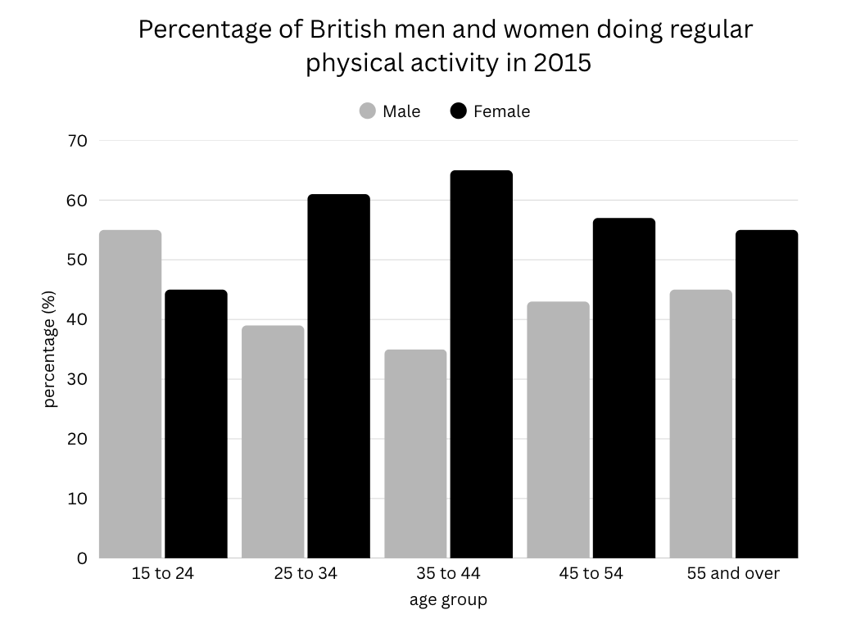
Practice:
- Loại biểu đồ là gì? (Pie, Bar, Line, Table...) -> a bar chart
- Có mốc thời gian không? -> 2015 (thì quá khứ)
- Có mối liên hệ giữa các thông tin trong biểu đồ không? -> phụ nữ tập thể dục nhiều hơn đàn ông (trừ 15 to 24)
PHẦN 2: CÁCH VIẾT INTRODUCTION VÀ OVERVIEW
QUANTIFIER (TỪ CHỈ LƯỢNG)
- Phần trăm: the percentage of, the proportion of, the rate of
The percentage of students choosing Science was higher in Japan.
- Danh từ đếm được (countable nouns): the number of, the quantity of (chỉ dùng cho vật tĩnh)
The number of households with cars was highest in the UK.
- Danh từ không đếm được (uncountable nouns): the amount of
The amount of coffee consumed was the greatest in Italy.
Lưu ý: tránh dùng từ a lot of (informal trong Speaking)
INTRODUCTION: paraphrase đề, giới thiệu đủ biểu đồ + năm/thời gian + đối tượng
The bar chart illustrates the rate of males and females in Britain in various age groups who took part in regular physical activity in 2015.
OVERVIEW: Tóm tắt xu hướng chính, đặc điểm nổi bật và điểm tương đồng/khác biệt lớn nhất, không có số liệu chi tiết.
Lưu ý: overview là linh hồn của task 1, examiner luôn tìm “clear overview” để cho điểm cao ở task achievement.
Nên | Không nên
Ai/nhóm nào cao nhất – thấp nhất  Sự chênh lệch rõ rệt giữa các nhóm  Điểm tương đồng (nếu có)  Ngoại lệ hoặc xu hướng phân bố (ví dụ: tỷ lệ giảm dần theo tuổi) | Số liệu chi tiết (%, số lượng, năm cụ thể)  Liệt kê quá nhiều thông tin nhỏ  Từ ngữ mô tả chi tiết
Công thức:
Overall, [đặc điểm chung nổi bật], while [đặc điểm đối lập chính]. It is also noticeable that [điểm đáng chú ý nhất / ngoại lệ].
Mẫu câu có thể áp dụng nhanh trong phần overview:
- Mẫu 1: So sánh nổi bật
Overall, [group A] had the highest percentage/number/amount, whereas [group B] recorded the lowest figure.
- Mẫu 2: Giới thiệu sự khác biệt tổng thể
It is clear that there were significant differences between [group A] and [group B] in terms of [category].
- Mẫu 3: Nêu điểm chung và ngoại lệ
Overall, most categories showed a similar pattern, with the exception of 15 to 24.
- Mẫu 4: Nhấn mạnh sự phân bố
Overall, the figures tended to be higher among [group type], while [other group] showed much lower proportions/numbers/amount.
PRACTICE: Work in groups to write comparative sentences about the data in the chart above.
PHẦN 3: CÁCH VIẾT BODY
TỪ VỰNG SO SÁNH HƠN
SO SÁNH HƠN (COMPARATIVE) | SO SÁNH BẰNG  (EQUAL/SIMILAR)
- be higher/lower than  - be larger/smaller than  - be greater/lesser than  - have more/fewer + N (C -> đếm được) + than  - have more/less + N (U -> không đếm được) + than  - be + more/less + adj + than (adj tùy bài, nhưng popular là 1 trong những adj đúng nhiều nhất) | be (almost/nearly) as + adj + as
Ví dụ:
- The percentage of men was higher than that of women.
- Science was more popular than art among students.
- Spending on housing was almost as large as that on food.
Practice:
Bài tập 1: điền từ thích hợp vào chỗ trống
(the percentage of / the number of / the amount of )
- The number of students choosing science was slightly higher than that for art.
- The number of people living in rural areas was lower than that in cities.
- The amount of water used by households increased slightly.
- The percentage of respondents who preferred coffee was 40%.
- The number of tourists visiting Vietnam remained stable.
Bài tập 2: Viết lại câu, dùng dạng so sánh hơn / kém / bằng phù hợp.
- Men spent 7 hours on leisure, women spent 5 hours.
→ Men spent more leisure time than women.
- France had 25% of car owners, Italy had 20%.
→ The figure for France was higher than that for Italy.
- Sales of books and magazines were 30% and 30%.
→ Sales of books were the same as those of magazines.
- The UK’s unemployment rate (4%) < Germany’s (8%).
→ The UK had a lower unemployment rate than Germany.
- 40% of students chose business, 15% chose science, 10% chose law.
→ Business was the most chosen/popular subject, while law was the least popular
Bài tập 3: viết lại câu dùng cấu trúc so sánh
- Japan has more internet users. Korea has fewer.
→ The percentage of internet users in Japan was higher than in Korea.
- Men and women spent about the same time on household work.
→ Men and women spent the same amount of time on household work.
- Transport had 40%, housing 30%, and leisure 10%.
→ Spending on transport was the highest, followed by housing and leisure.
- The USA’s figure was 50%, while Canada’s was 20%.
→ The figure for the USA was higher than that for Canada.
- Food (25%) and drinks (27%) were quite close.
→ The proportions of food and drinks were nearly the same.
CÁCH TRÌNH BÀY MỘT ĐOẠN BODY CHUẨN
Thành phần | Vai trò | Gợi ý
Câu mở đầu | Giới thiệu biểu đồ và nội dung sẽ mô tả | (Body 1) Looking at the bar chart in more detail, …  (Body 2) Turning to the other, …
Câu 2–3 | Mô tả 1–2 số liệu nổi bật (cao nhất/thấp nhất)
Các câu tiếp theo | So sánh các số liệu còn lại (nếu cần)
COHESIVE DEVICES => ảnh hưởng điểm Cohesion and coherence
Mục đích | Từ nối gợi ý
Bắt đầu mô tả chi tiết | To begin with / Looking at… / In terms of… / Regarding…
Chuyển sang nhóm khác | Meanwhile / In contrast / On the other hand / Turning to…
Bổ sung thông tin | In addition / Moreover / Also / Furthermore (tránh dùng besides vì informal trong speaking)  Tránh dùng firstly, secondly,… -> chỉ phù hợp trong WT2
Nhấn mạnh / đặc biệt | Notably / Particularly / Especially / It is worth noting that…
Diễn tiến theo thời gian | Over the period / During the following years / By + [năm] / From… to…
So sánh hoặc đối lập | While / Whereas / However / Compared to…
BÀI MẪU:
The bar chart compares the proportion of British men and women in five different age groups who engaged in regular physical activity in 2015.
Overall, women were generally more active than men in most age categories, except for the youngest group, where the opposite pattern was observed. It is also clear that participation rates among women tended to be higher and more consistent across age groups, while men’s figures fluctuated at lower levels.
In the 15–24 age group, men recorded the highest level of participation among all male categories, at 55%, which was 10 percentage points higher than that of women. From the 25–34 age group onward, the situation reversed, with female participation overtaking that of males. Specifically, 61% of women aged 25–34 exercised regularly compared to 39% of men, showing a noticeable gender gap of over 20%.
Among the older groups, female activity rates remained relatively stable, ranging from 55% to 65%, while male participation fluctuated between 35% and 45%. The greatest difference appeared in the 35–44 age range, where 65% of women exercised compared to only 35% of men. In contrast, the smallest gap was observed among those aged 55 and over, where the figures for men and women were relatively similar, at 45% and 55%, respectively.
HOMEWORK
The table below shows information about spending on health in five different countries in 2006.
Summarize the information by selecting and reporting the main features and make comparisons where relevant.
Write at least 150 words.
 | Total | Public spending | Private spending
Australia | 7.5% | 6% | 1.5%
Japan | 7.9% | 5.5% | 2.5%
UK | 9.5% | 7.5% | 2.6%
USA | 11.6% | 8.9% | 3%
Canada | 8.9% | 6.2% | 2.7%
Homework:
- Speaking part 2 (nộp ghi âm)
- Writing Task 1 viết bài
- Làm Reading/Listening trên LMS (đề thi thật)

