ITEC 3150, Homework #5 - JavaFX + File I/O + HashMap

Spring, 2016

Due Date: no later than 11:59 PM on Sunday, April 24, 2016 – NOTE: NO LATE HOMEWORK ACCEPTED FOR ANY REASON!!! – TURN IT IN EARLY !!!

Coding standards note: The coding standards are in a document in a D2L module titled Coding Standards. See Grading Criteria for points lost if not followed.

Competencies being graded:

1. Ability to read objects from a given binary file
2. Ability to create a HashMap
3. Ability to populate and print a ListView from an ArrayList
4. Use Java FX to create a readable GUI
5. Ability to read an English language problem description and design a multi class solution in Java
6. Ability to follow given coding standards- in D2L content under Coding Standards.

Problem Statement:

Write a program to read in a list of Animal objects. The file of animal is generated by running the given file-GenerateAnimalBinaryFile.java . Use Animal.java given. In your program, create a list of the Animal objects read in from the file. Refer to Homework 2 on how to do this

Once you have a list of Animals, create a HashMap <Animal, Color> of Animals associated with their favorite color. Determine their favorite color based upon the hashCode of the Animal object. Compress the hash code to a value between 0 and 9 – see Chapter 16 in-class on how to do this. Use the following list of Colors to index to associate the color in the HashMap.

|  |  |
| --- | --- |
| Index | Color |
| 0 | Color.BLUE |
| 1 | Color.RED |
| 2 | Color.GREEN |
| 3 | Color.YELLOW |
| 4 | Color.PURPLE |
| 5 | Color.BLACK |
| 6 | Color.BROWN |
| 7 | Color.MAGENTA |
| 8 | Color.BEIGE |
| 9 | Color.CYAN |

Use your chapter 16 in-class GUI to display the associated color from the HashMap as a color filled shape next to the list of animals – similar to this:

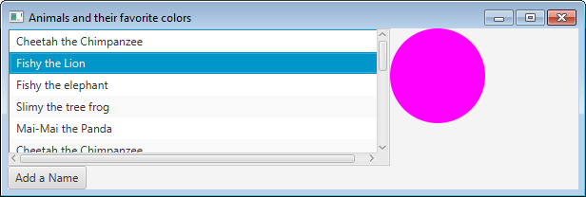

Change the Add A Name button to read “Add an Animal”. This should launch a new Stage which allows the user to enter all the attributes of an animal (See NameStage.java from Chapter 16 in-class for starting point) and upon completion adds the Animal and its favorite color to the ListView.

Grading Criteria

|  |  |
| --- | --- |
| Reads Animal objects from the given file | 10 |
| Correctly associates color | 10 |
| Correctly adds Animal objects and associated color to HashMap | 10 |
| Displays Animals and Colors on appropriate GUI | 20 |
| Correctly launches a GUI that allows user to enter a new Animal- must be separate Stage | 20 |
| New Animal is appropriately added to the List in original Stage | 15 |
| Meets coding standards | 15 |