SOFTWARE REQUIREMENT SPECIFICATION
Project Name (Code)

– Hanoi, May 2026 –
Table of Contents
I. Record of Changes. 3
II. Software Requirement Specification. 4
1. Overall Requirements. 4
1.1 Context Diagram.. 4
1.2 Main Business Processes. 5
1.3 User Requirements. 5
1.4 System Functionalities. 7
1.5 Entity Relationship Diagram.. 7
2. Use Case Specifications. 8
2.1 <<Feature Name1>>. 8
2.2 Xyz Feature. 10
3. Functional Requirements. 11
3.1 Feature Name1. 11
3.2 User Authentication. 11
3.3 System Administration. 12
4. Non-Functional Requirements. 13
3.1 External Interfaces. 13
3.2 Quality Attributes. 13
5. Requirement Appendix. 14
5.1 Business Rules. 14
5.2 System Messages. 14
5.3 Other Requirements….. 15

I. Record of Changes
Date | A*  M, D | In charge | Change Description
*A - Added M - Modified D - Deleted

II. Software Requirement Specification

1. Overall Requirements

1.1 Context Diagram
[Gives the overall description about the product with some introduction and the context diagram. The context diagram presents the boundary and connections between the system you’re developing and everything else in the universe. This identifies external entities (or terminators – software, hardware, human components, and other systems) outside the system that interface to it in some way, as well as data, control, and material flows between the terminators and the system.]

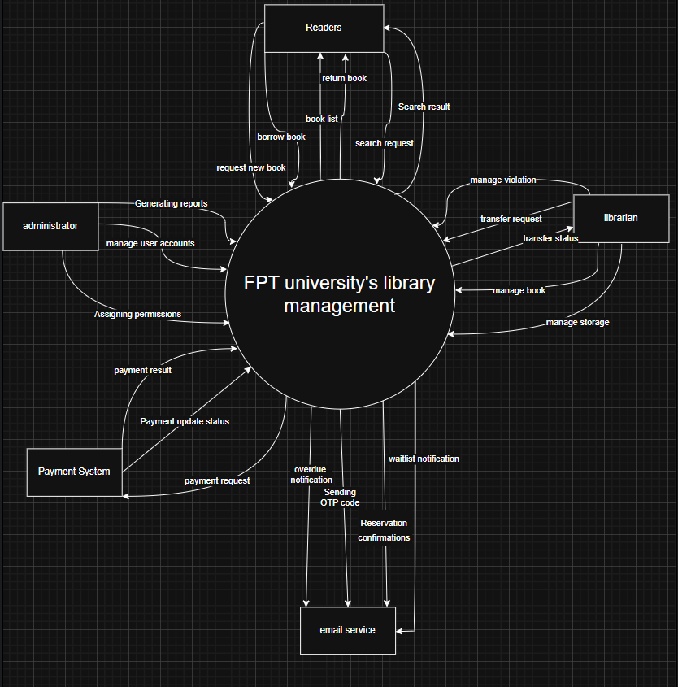

1.2 Main Business Processes
[Provide main workflows (business processes) using the swim-lane diagram(s) like sample below]
1.2.1. Book and category management

1.3 User Requirements

1.3.1 Actors
[An actor is someone/something that interacts with the system.
● The only external entities that interact with the system
● ﻿Actors are outside the system and not part of it
● ﻿A user is an individual, whereas an actor represents the role played by all users of the same type
● There are other types of actors in addition to or in place of human actors: external systems, I/O devices, or timers
Following are some questions you might ask to help user representatives identify actors
● Who (or what) is notified when something occurs within the system?
● Who (or what) provides information or services to the system?
● Who (or what) helps the system respond to and complete a task?
This part gives the description of system actors, you can follow the table form as below]
# | Actor | Description
1 | Librarian | who manage and process request from reader and manage status, situation of book in library
2 | Reader | primary actor who will make request borrow,return or require new book to the system
3 | administrator | who manage authenticate role of user login into system, create report
4 | payment system | which receive and process payment request, announce payment’s status to the system
5 | email service | which receive notification from the system when events happen such as: authenticate change password,

1.3.2 Use Cases (UC)
[A use case (UC) describes a sequence of interactions between a system and an external actor that results in the actor being able to achieve some outcome of value. The names of use cases are always written in the form of a verb followed by an object. Select strong, descriptive names to make it evident from the name that the use case will deliver something valuable for some user.
Following are some questions you might ask to help user representatives identify use cases
● What will the actor use the system for?
● Will the actor create, store, change, remove, or read data in the system?
● Will the actor need to inform the system about external events or changes?
● Will the actor need to be informed about certain occurrences in the system?
This part describes the use cases you could define, you can follow the table form as below]

BẢNG TỔNG HỢP USE CASE
ID | Use Case | Feature | Description
Dịch vụ Khách & Dùng chung (Guest / System Services)
UCG01 | Search Books | Public Access | Khách và Bạn đọc tìm kiếm đầu sách, xem kho tổng.
UCG02 | View Book Details | Public Access | Xem thông tin chi tiết ấn phẩm, số lượng bản copy sẵn sàng.
UCG03 | Login | Authentication | Đăng nhập hệ thống qua tài khoản cấp phát hoặc SSO.
Phân hệ Bạn đọc (Reader / Patron - Sinh viên & Giảng viên)
UCR01 | View Borrowing History | Patron Management | Xem danh sách các cuốn sách đang mượn và lịch sử mượn trả.
UCR02 | View Fine History | Patron Management | Xem lịch sử vi phạm và các hóa đơn phạt liên quan.
UCR03 | Manage Profile | Patron Management | Cập nhật thông tin liên hệ và theo dõi hạng thẻ.
UCR04 | Request New Materials | Resource Management | Gửi đơn đề xuất thư viện mua sắm hoặc bổ sung đầu sách mới.
UCR05 | View Notifications | System Alerts | Nhận và xem thông báo nhắc hạn trả, sách Waitlist đã về.
UCR06 | Reserve Book Online | Circulation | Đặt giữ chỗ sách vật lý trong kho trước 24 giờ.
UCR07 | Cancel Reservation | Circulation | Chủ động hủy đơn đặt giữ chỗ trước khi đến hạn.
UCR08 | Renew Borrowed Book Online | Circulation | Tự gia hạn thêm ngày trả trực tuyến đối với sách đang mượn.
UCR09 | Pay Fines Online | Fine Management | Thanh toán nợ phạt qua cổng thanh toán điện tử (VNPay/Momo).
UCR10 | Track Transport Status | Transport Management | Theo dõi trạng thái vận chuyển của đơn sách mượn liên cơ sở.
UCR11 | Book Study Room | Facility Management | Đặt trước phòng học nhóm, phòng tự học tại thư viện.
UCR12 | Scan QR Check-in | Facility Management | Quét mã QR tại cửa phòng để xác nhận sử dụng phòng đã đặt.
Phân hệ Thủ thư (Librarian)
UCL01 | Create Loan Record | Circulation | Quét thẻ Bạn đọc và mã Barcode sách để lập phiếu mượn tại quầy (Checkout).
UCL02 | Process Book Return | Circulation | Nhận lại sách, kiểm tra tình trạng vật lý và đóng phiếu mượn (Checkin).
UCL03 | Issue Fine/Penalty | Fine Management | Lập hóa đơn phạt tiền do làm mất sách, rách sách tại quầy.
UCL04 | Renew Book at Counter | Circulation | Hỗ trợ Bạn đọc gia hạn sách trực tiếp tại quầy (Cho phép đặc cách quá hạn).
UCL05 | Process Fine Payment | Fine Management | Thu tiền mặt và tất toán hóa đơn phạt cho Bạn đọc tại quầy.
UCL06 | Manage Book Transfers | Transport Management | Lập đơn luân chuyển, xuất kho và xác nhận nhập kho sách liên cơ sở.
UCL07 | Generate Desk Reports | Analytics | Kết xuất báo cáo mượn/trả, thu tiền phạt định kỳ tại cơ sở làm việc.
UCL08 | Manage Books (CRUD) | Resource Management | Quản lý danh mục gốc (Title, Author, ISBN, Categories) và biên mục sách.
UCL09 | Approve Purchase Request | Resource Management | Đánh giá và phê duyệt/từ chối các đơn xin mua sách mới (UC04) từ Bạn đọc.
Phân hệ Quản trị viên (Admin)
UCA01 | Configure System Rules | System Administration | Quản lý cấu hình toàn cục (Bảng SystemConfig: hạn mức mượn, phí phạt).
UCA02 | Manage User Accounts | System Administration | Cấp phát, phân quyền, khóa/mở khóa tài khoản toàn hệ thống.
UCA03 | Manage Campus Layout | System Administration | Quản lý sơ đồ vị trí lưu trữ (Campus, Shelves) phục vụ định vị kho.
UCA04 | Manage Facilities | Facility Management | Quản lý danh mục phòng học nhóm, trạng thái thiết bị thư viện.

…

1.3.2 Use Case Diagrams
In this section, you need to provide the UC diagram(s) to show the actor-UCs and UC-UC relationships like the sample below. You can have multiple UC diagrams for the system, each diagram is for one actor or one workflow]

1.3.2.1 UCs for Guest
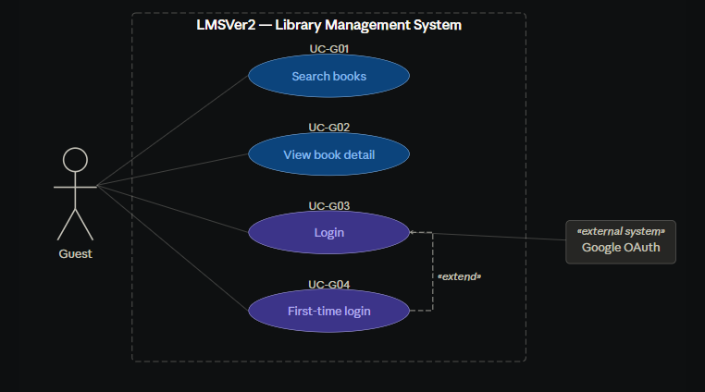

1.3.2.2 UCs for Patron/Reader
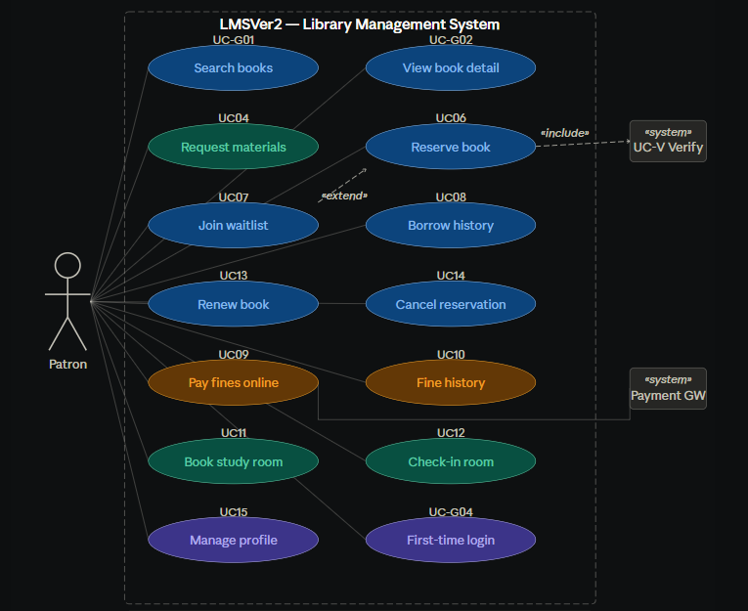

1.3.2.3 UCs for Librarian
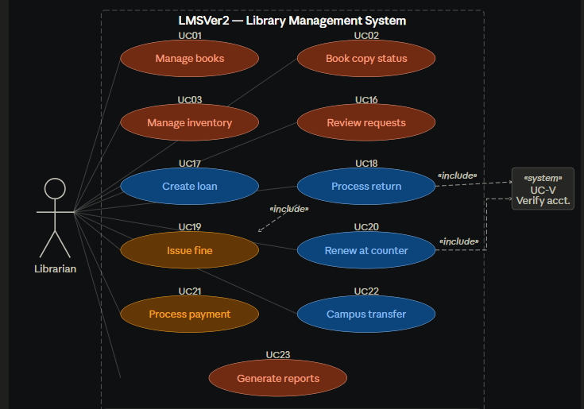

1.3.2.3 UCs for Admin
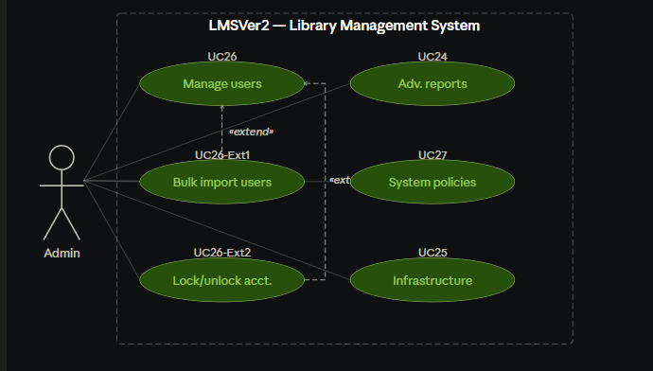

1.4 System Functionalities
[Provide functionality overview of software system: screen flow, screen descriptions, system user roles, screen authorization, non-screen functions, ERD]

1.4.1 Screens Flow
[This part shows the system screens and the relationship among screens. You can draw the Screens Flow for the system in the form of diagram as below.]

1.4.2 Screen Authorization
[Provide the system roles authorization to the system features (down to screens, and event to the screen activities if applicable) in the table form as below – replace Role-Name1, Role-Name2,… with your specific system user role names]
Screen | Role-Name1 | Role-Name2 | Role-Name3 | …
<<Screen Name1>> | X |  | X | X
<<Screen Name2>> |  | X
…

1.4.3 Non-UI Functions
[Provide the descriptions for the non-screen system functions, i.e batch/cron job, service, API, etc.]
# | Feature | System Function | Description
1 | <<Feature Name>> | <<Function Name1>> | <<Function Name1 Description>>
2 | …

1.5 Entity Relationship Diagram
[Provide the ERD using the Crow-Foot notation and the entity descriptions as below]
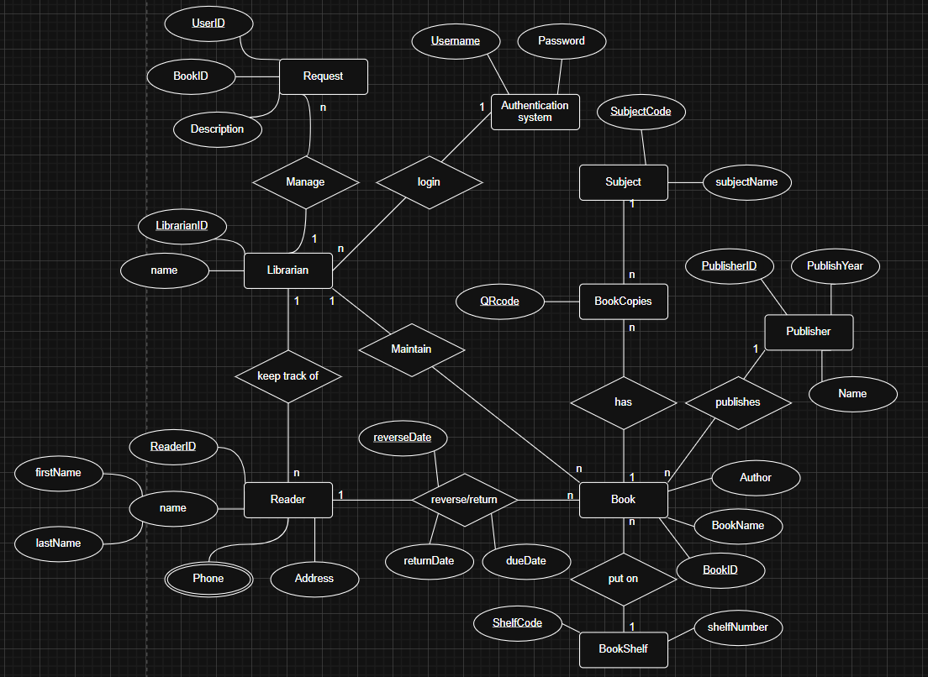

2. Use Case Specifications
[Provide specifications for the use cases (UCs) those are covered in the system. The UCs are grouped by the system features and even sub features. You just need to provide UC specifications for complex UCs involving in the main workflows (business processes). Other UCs (i.e CRUD or data-viewing UCs) are simple, and you just need to refer the descriptions in the Functional Requirement (part 3) below)]

2.1 <<Feature Name1>>

2.1.1 UC Name1
Primary Actors |  | Secondary Actors
Description
Preconditions
Postconditions
Normal Sequence/Flow
Alternative Sequences/Flows

Primary and Secondary Actors
An actor is a person or other entity external to the software system being specified who interacts with the system and performs use cases to accomplish tasks. Name the primary actor that will be initiating this UC and any other secondary actors who will participate in completing execution of the UC.
Description
Provide a brief description of the reason for and outcome of this use case, or a high-level description of the sequence of actions and the outcome of executing the use case. The description can be in the form of a user story (As a <type of user>, I want <some goal> so that <some reasons>)
Preconditions
List any activities that must take place, or any conditions that must be true, before the use case can be started.
Postconditions
Describe the state of the system at the successful conclusion of the use case execution.
Normal Flow
Provide a description of the user actions and corresponding system responses that will take place during execution of the use case under normal, expected conditions.
Alternative Flows
Describe below two information if any:
● Other successful usage scenarios that can take place within this use case. State the alternative flow, and describe any differences in the sequence of steps that take place.
● Any anticipated error conditions that could occur during execution of the use case and how the system is to respond to those conditions.

2.1.2 Login System
Primary Actors | Readers | Secondary Actors | None
Description | As a user, I want to be able to log into the system so that I can use the system’s authenticated features and access my personalized account.
Preconditions | User account has been created & authorized
Postconditions | ● User logs in the system successfully  ● The system give the role to the account
Normal Sequence/Flow | Login System  1. User clicks Login button from the page header  2. System show the User Login screen  3. User types in the login details (email, password)  4. User clicks the Login button  5. System validates the login details  6. System allows user to access  7. System tracks user’s success login and check role  8. System directs user to the Home Page or management interface
Alternative Sequences/Flows | A

2.1.3 UC Name2
…

2.2 Xyz Feature
…

3. Functional Requirements
[Provide descriptions about the system’s functions/screens. The functions/screens are grouped by the system features, and even sub-features if needed. For the screens, you need to provide the screen layouts (mock-up screens) and relevant specifications if needed]

3.1 Feature Name1

3.1.1 SubFeature Name1.1

3.1.1.1 Screen/Function Name1
[Content #1: UI layout (Mockup screen prototype)]
[Content #2: brief descriptions of the screen/function, mapped to the relevant use cases]
[Content #3: provide further descriptions for the screen’s components/fields using table format below]
Field Name | Description
Field Name1 | Field description: data type min/max length or value, initial data, etc.
Field Name2 | …
Field Group-Name1
Field Name3 | …
Field Name4 | …
Field Group-Name2
… | …

3.1.1.2 Screen/Function Name2
…

3.1.2 SubFeature Name1.2
…

3.2 User Authentication

3.2.1 User Register
…

3.2.2 User Login
…

3.2.3 Password Reset
…

3.3 System Administration

3.3.1 Master Data

3.3.1.1 Setting List
(1)

(2)

(3)
This screen allows the Administrator to:
● View Setting List: view list of current master data.
● Filter Setting List: filter master data by data types, statuses
● Search Settings: enter keyword(s) to search master data by their names or values
● Sort Setting List: sort master data list (ascending, descending) by clicking column headers
On the screen, s/he can also
● Activate/Deactivate Setting: change status of a specific inactive/active master data
● Choose to go to the Setting Details screens for adding new or updating an existing master data by clicking the New Setting or Edit link.
Field Description
Field Name | Description
(1) | Initial values: all the active setting names with null or blank type  Hover the mouse to show the field name: “Setting Type”
(2) | Initial values: All Statuses, Active, Inactive (default value “All Status”)  Hover the mouse to show the field name: “Setting Status”
(3) | The change-status action is Activate or Deactivate depending on the current status of the relevant setting (Inactive or Active, respectively).

3.3.1.2 Setting Details

This screen allows the Administrator to:
● Add New Setting: add new master data.
● Update Setting Details: update details of a specific master data
Field Description
Field Name | Description
Name | Data type: non-digit string, max length of 20 characters
Type | Initial data values: all active setting names (with null or blank type)
Value | Data type: any string, max length of 100 characters
Priority | Data type: a positive integer
Description | Data type: any string, max length of 200 characters

3.3.2 User Management

3.3.2.1 User List
…

3.3.2.2 User Details
…

4. Non-Functional Requirements

3.1 External Interfaces
[This section provides information to ensure that the system will communicate properly with users and with external hardware or software/system elements.]

3.2 Quality Attributes
[List all the required system characteristics (quality attributes) specification. Some of the possible attributes are provided with the guide/descriptions are mentioned here]

3.2.1 Usability
[This section includes all those requirements that affect usability. For example, specify the required training time for a normal user and a power user to become productive at particular operations specify measurable task times for typical tasks or base the new system’s usability requirements on other systems that the users know and like specify requirement to conform to common usability standards, such as IBM’s CUA standards Microsoft’s GUI standards]

3.2.2 Performance
[The system’s performance characteristics are outlined in this section. Include specific response times. Where applicable, reference related Use Cases by name.
Response time for a transaction (average, maximum)
Throughput, for example, transactions per second
Capacity, for example, the number of customers or transactions the system can accommodate
Resource utilization, such as memory, disk, communications, and so forth.]

3.2.3 …

5. Requirement Appendix
[Provide business rules, common requirements, or other extra requirements information here]

5.1 Business Rules
[Provide common business rules that you must follow. The information can be provided in the table format as the sample below]
ID | Rule Definition
BR-01 | Delivery time windows are 15 minutes, beginning on each quarter hour.
BR-02 | Deliveries must be completed between 10:00 A.M. and 2:00 P.M. local time, inclusive.
BR-03 | All meals in a single order must be delivered to the same location.
BR-04 | All meals in a single order must be paid for by using the same payment method.
BR-11 | If an order is to be delivered, the patron must pay by payroll deduction.
BR-12 | Order price is calculated as the sum of each food item price times the quantity of that food item ordered, plus applicable sales tax, plus a delivery charge if a meal is delivered outside the free delivery zone.
BR-24 | Only cafeteria employees who are designated as Menu Managers by the Cafeteria Manager can create, modify, or delete cafeteria menus.
BR-33 | Network transmissions that involve financial information or personally identifiable information require 256-bit encryption.
BR-86 | Only regular employees can register for payroll deduction for any company purchase.
BR-88 | An employee can register for payroll deduction payment of cafeteria meals if no more than 40 percent of his gross pay is currently being deducted for other reasons.

5.2 System Messages
# | Message code | Message Type | Context | Content
1 | MSG01 | In line | There is not any search result | No search results.
2 | MSG02 | In red, under the text box | Input-required fields are empty | The * field is required.
3 | MSG03 | Toast message | Updating asset(s) information successfully | Update asset(s) successfully.
4 | MSG04 | Toast message | Adding new asset successfully | Add asset successfully.
5 | MSG05 | Toast message | Confirming email of asset hand-over is sent successfully | A confirmation email has been sent to {email_address}.
6 | MSG06 | Toast message | Resetting asset information successfully | Return asset(s) successfully.
7 | MSG07 | Toast message | Deleting asset information successfully | Delete asset(s) successfully.
8 | MSG08 | In red, under the text box | Input value length > max length | Exceed max length of {max_length}.
9 | MSG09 | In line | Username or password is not correct when clicking sign-in | Incorrrect user name or password. Please check again.
10 | ..

5.3 Other Requirements…

