# 一、HTML

# 二、CSS

## 清除浮动

[css之clear属性，both left right详解，解决父元素高度塌陷-CSDN博客](https://blog.csdn.net/qq_42667613/article/details/123478712?ops_request_misc=%7B%22request%5Fid%22%3A%22171202347716800182743268%22%2C%22scm%22%3A%2220140713.130102334.pc%5Fall.%22%7D&request_id=171202347716800182743268&biz_id=0&utm_medium=distribute.pc_search_result.none-task-blog-2~all~first_rank_ecpm_v1~rank_v31_ecpm-7-123478712-null-null.142^v100^pc_search_result_base6&utm_term=clear both%E5%8E%9F%E7%90%86&spm=1018.2226.3001.4187)

# 三、JS

## Promise,async,await

[Promise - async await的基本用法以及使用陷阱，高效使用技巧\_await promise-CSDN博客](https://blog.csdn.net/qfc_128220/article/details/121757898?ops_request_misc=&request_id=&biz_id=102&utm_term=promise async await%E4%BD%BF%E7%94%A8&utm_medium=distribute.pc_search_result.none-task-blog-2~all~sobaiduweb~default-0-121757898.142^v100^pc_search_result_base6&spm=1018.2226.3001.4187)

## http请求的格式

[HTTP请求消息数据格式详解(请求头,请求行,请求体)\_请求头数据和请求体数据啥意思-CSDN博客](https://blog.csdn.net/qq_40121580/article/details/107349943?ops_request_misc=%7B%22request%5Fid%22%3A%22171274582516800197039641%22%2C%22scm%22%3A%2220140713.130102334.pc%5Fall.%22%7D&request_id=171274582516800197039641&biz_id=0&utm_medium=distribute.pc_search_result.none-task-blog-2~all~first_rank_ecpm_v1~rank_v31_ecpm-3-107349943-null-null.142^v100^pc_search_result_base1&utm_term=%E8%AF%B7%E6%B1%82%E8%A1%8C%E8%AF%B7%E6%B1%82%E5%A4%B4%E5%92%8C%E6%B6%88%E6%81%AF%E4%BD%93&spm=1018.2226.3001.4187)

# 四、网络

# 五、Vue

## 双向绑定，如何双向更新数据

[Vue双向绑定：原理篇（详细）\_vue实现双向绑定原理-CSDN博客](https://blog.csdn.net/weixin_51670675/article/details/124069519?ops_request_misc=%7B%22request%5Fid%22%3A%22171195693616800197053191%22%2C%22scm%22%3A%2220140713.130102334.pc%5Fblog.%22%7D&request_id=171195693616800197053191&biz_id=0&utm_medium=distribute.pc_search_result.none-task-blog-2~blog~first_rank_ecpm_v1~rank_v31_ecpm-7-124069519-null-null.nonecase&utm_term=vue%E5%8F%8C%E5%90%91%E7%BB%91%E5%AE%9A&spm=1018.2226.3001.4450)

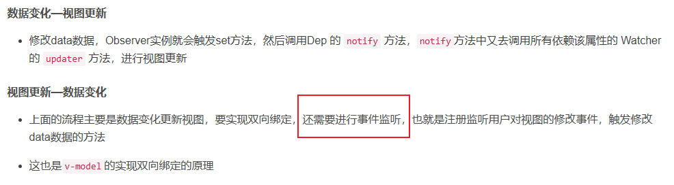

## Vue生命周期

## Vue3 defineEmits组件自定义事件实现子=>父发送信号

[【超细节】Vue3组件事件怎么声明，defineEmits与emit\_vue3 defineemits-CSDN博客](https://blog.csdn.net/weixin_42373175/article/details/132088531?ops_request_misc=&request_id=&biz_id=102&utm_term=vue3 defineEmits(["submit"])&utm_medium=distribute.pc_search_result.none-task-blog-2~all~sobaiduweb~default-0-132088531.142^v100^pc_search_result_base1&spm=1018.2226.3001.4187)

## Vue3 defineExpose暴露子组件的属性和方法供父组件调用

[Vue3中的defineExpose\_vue3 defineexpose-CSDN博客](https://blog.csdn.net/weixin_59233142/article/details/135530798?ops_request_misc=&request_id=&biz_id=102&utm_term=vue3 defineExpose&utm_medium=distribute.pc_search_result.none-task-blog-2~all~sobaiduweb~default-4-135530798.nonecase&spm=1018.2226.3001.4187)

## Vue3 defineProps定义子组件的参数，父组件可以向子组件传参

# 六、其他

## Session、cookie和JWT

[全网最细总结-Seesion,Cookie以及JWT的区别\_cookie,session,jwt-CSDN博客](https://blog.csdn.net/qq_42898642/article/details/131206223?spm=1001.2014.3001.5506)

# 项目

## Element-plus用到的组件记录

1. 修改密码时的侧边栏 el-drawer
2. 消息对话框 ElMessageBox
3. 消息提示框 ElNotification
4. 下拉菜单 el-dropdown
5. 各种图标 el-icon
6. 菜单栏 el-menu
7. 标签栏el-tabs