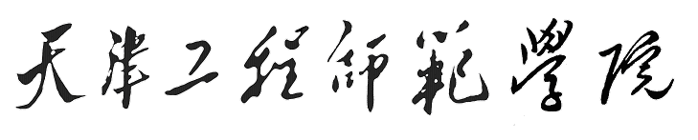

Tianjin University of Technology and Education

毕 业 设 计

专 业： 应用电子技术教育
班级学号： 0402 – 18
学生姓名： 江 智 莹
指导教师： 张 根 柱 副教授

二〇〇九 年 六 月

天津工程师范学院本科生毕业设计

汽车实验台电路控制系统
The automobile experiment set electric circuit control system

专业班级：应电0402
学生姓名：江 智 莹
指导教师：张 根 柱 副教授
系 别：电子工程系

2009年6月

摘 要
自汽车诞生以来，汽车维修业便一直伴随着汽车工业的发展而成长，汽车维修业已成为交通运输业必不可少的服务性支柱与保障。尤其是近几十年来，随着国家经济水平的发展，高速公路建设发展迅猛，通车里程快速增长。道路状况的改善，使汽车的车速越来越快，与之关系密切的汽车维修业也随着汽车高科技化的发展，出现了一些新的面貌。汽车维修制度的改革和发展及汽车维修技术的变革，促使汽车维修人员培训的教学内容、教学手段、教学设备都应作出相应的改革。因为在现代汽车维修中，有故障的车辆先用检测诊断仪器或设备进行相应的检查，而后由维修技术人员基于自己的知识能力和经验，对检查结果进行综合分析后作出相应的诊断，接下来再由主修人员独立或指导辅修人员完成故障排除或修理任务，查找故障所占的时间达总维修时间的70％以上，因此为了提高汽车维修人员素质和专业技能，以达到提高维修质量和效率的目的，所以开发设计了能进行故障模拟和故障分析诊断的实验台，用于汽车维修从业人员的培训。该实验台带有各种传感器工作时的Flash动画演示，常见故障的维修视频，故障测试等功能教师在利用实验台进行授课时，各种故障现象充分的暴漏使学生更容易理解，记忆也更深刻，学习效率将大幅高。
关键词：VB6.0；Atmega16L；TLC5618 D/A转换芯片；Access数据库

ABSTRACT
From the automobile birth, the car maintenance industry has been accompany with the development but growth of the automobile industry, the car maintenance industry has become the service of the transportation industry essential to have to pay the pillar and guarantee. Particularly，in the last several decades, along with the development of national economic level, the construction and development of expressway is swift and violent, the traffic mileage increases fast. The improvement of the road condition, The improvement of road state make speed of automobile more and more fast, the close relation of car maintenance industry also turns along with the automobile high technology of development, appear some new features.The reform and development of the car maintenance system technical change, the content of course,teaching means,the teaching equipmentseses that urge car maintenance a personnel to train all should make a reform for correspond.Because in the modern car maintenance, the vehicle that has breakdown is using the examination diagnosis instrument or equipments carry on correspond first of check, and then from maintain a technical personnel according to own knowledge ability and experience, makes a diagnosis for correspond towards checking a result after carry on the comprehensive analysis, connect down again from major personnel's independence or guide a minor a personnel completion to break down expel or fix mission, check to seek break down have of time reach 70% of total maintenance time above, so development the design can carry on to break down imitate and break down to analyze diagnosis of experiment set, used for the training of the car maintenance employee, raise the car maintenance personnel's character, thus attain exaltation maintain the purpose of the quality and efficiency.In addition teacher while making use of the experiment set to carry on a teaching, various break down phenomenon well of leak to make suddenly and violently the student comprehend more easily, remember also deeper, study an efficiency will significantly high.
Key Words: VB6.0；Atmega16L；TLC5618；Access- Database

