Standalone Phono Pre-amp

A HIGH-PRECISION PHONO PREAMPLIFIER
by Fred Nachbaur, Dogstar 1997,
1: INTRODUCTION
There has been much press lately about the merits (and drawbacks) of the venerable vacuum tube. How much of this retro movement is based in demonstrable principles, and how much is rooted in nostalgia or subjectivity is a debate that could fill volumes.
What is clear is that there is considerable renewed interest in vacuum tubes, a technology that even two decades ago was considered as obsolete as spats and top hats. Now the trend is reversing, and a number of manufacturers are again supplying tube gear for audiophiles, musicians and hobbyists. In many cases, these are simply vintage circuits in new packaging. Other products offer new approaches to vacuum tube technology, adding what we've learned in the meantime to come up with some truly noteworthy designs. The project described here fits into the latter category.
Why use tubes anyway?
The central argument for the pro-tube movement is that specs can be almost meaningless, and that what counts is how it sounds to the individual listener. Highly subjective descriptions are therefore used, instead of the techno-babble we've more-or-less gotten used to in recent times. The opposite camp claims that numbers don't lie, and that you can't improve something by adding distortion of any kind.
Both camps have valid points. Most of us have heard expensive gear with spectacular specifications, but were left cold by the "too good to be true," almost clinical sound of such equipment. Similarly, most people will agree that just because something has tubes in it doesn't make it worth listening to. Turn on one of those old "All-American Five" table-top AM radios if you want a striking demonstration of just how bad vacuum tube equipment can sound.
Perhaps a way of reconciling the two viewpoints is to consider the distinction between musical equipment, and reproduction equipment. For musical gear, the individual frequency, waveform and phase distortions are part of what defines the sound of, say, a Fender tube amp. Just as no- one would try to define a fine
Stradivarius violin with specs and distortion figures, so also it would be specious to argue that a certain tube guitar amp has over 12% THD (total harmonic distortion) at 35 watts.
Reproduction equipment, on the other hand, has always been expected to give a perfect rendition of the signal applied to it. Sounds good in principle; if such a thing existed, we should be able to exactly and perfectly reproduce everything from a grundge band to the New York Philharmonic, making the reproductions indistinguishable from the original performances.

But therein lies the rub. The overall sound of a stereo system depends so heavily on the room it's in, the speakers, volume level, personal preference, and a host of other fuzzy variables that a perfect reproduction system cannot be said to exist even in this day and age, and probably never will. Add the fact that most if not all recordings are electronically sweetened to some degree to make them "sound good" (as opposed to being an exact copy of the performance), and arguments for the clinical reproduction approach lose credibility.
Carried to extremes, an "ideal" reproduction system wouldn't even have any controls, except perhaps for selecting inputs. If you think about it, personal preference is the only reason why stereos have volume controls, equalizers, and other adjustments to let us customize the sound to suit our very individual ears and brains.
It might be best to view the reproduction gear as a continuation of the same process that started with the construction of the instruments used in the performance. What we ultimately hear is the sum total effect of everything from that original instrument design, to the way it is played by the artist, through the entire recording, mixing and distribution process, to the gear we use to play it, and how we've set its controls.
There is, therefore, a considerable difference in design approach between the
"instrument" and "reproduction" categories. An earlier design ("The Real McTube") documented a vacuum tube pre-amplifier for use as an adjunct to electric instruments. The design approach was largely empirical, and the emphasis was on highlighting the unique distortion characteristics of the vacuum tube. This article explores the reproduction aspect; the design approach was quite mathematical and precise, and the emphasis is on controlling the characteristics of the vacuum tube.
Vinyl vs. CD
Similar arguments are ongoing regarding vinyl records vs. compact discs. The CD camp points at the CD's accuracy, definition, and clarity, while vinyl lovers bemoan the CD's lack of warmth and claim that conventional records sound more
"natural."
This project gives you the opportunity to explore these subjective and controversial debates, letting your own ears be the judge. You may find that there are some recordings that sounds better through the tube pre-amp, and others that benefit from the improved definition (whatever that is, technically speaking) that good solid-state gear can offer.

2: DESIGN PHILOSOPHY
The design philosophy was to improve on "vintage" tube designs by incorporating refinements normally only associated with solid-state gear. Prime among these is the use of differential input stages, in which the inverting input is used
strictly for feedback. Another is the use of direct coupling between stages, a technique once quite common in oscilloscopes, but rare in audio gear. The resulting circuits are thus closely related to the operational amplifier, and used in a similar fashion.
In addition to the quasi-opamp idea, some other design concepts used in the
project are:
Use of readily available parts wherever possible. For this reason, tube types 12AX7A and 12AT7A were employed.
Direct coupling was used in crucial parts of the circuitry. More about this later.
Flexibility in use was a prime consideration. While this articles details the use of this circuit design as a magnetic (RIAA) and ceramic phono pre-amplifier, there is virtually no limit to the number of possible applications with suitable modification of the feedback networks.

A Word About Negative Feedback
It is perhaps an unfortunate accident of history that the term "negative feedback" was used to describe the linearization technique of applying a portion of the output signal back to the input, in opposite phase to the applied signal. It gives the impression to audiophiles with enough knowledge to be dangerous that "negative" feedback must somehow be a "bad" thing. I've seen diatribes against the evils of negative feedback, yet in the same breath such critics extol the virtues of "ultra-linear output transformers." The joke is that such transformers achieve this linearization by applying local negative feedback to the screen grids!
Perhaps a better moniker for "negative feedback" would be "dynamic compensation" or something on that order. Consider the following characteristics of
well-designed negative feedback systems:
A: Precise control over closed-loop gain and minimization of gain drift with
component aging.
B: Considerable reduction in distortion and noise introduced within a given
gain block.
C: Reduction of effective series output resistance.
D: Precise control and stabilization of frequency characteristics. Extension
of high-frequency response where needed.
E: Reduces or eliminates the need for careful component matching

3: HOW IT WORKS
The sections that follow step through the principles of operation of this design. Since it is quite different from traditional designs, I suggest that you follow through this at least once. If the "fine points" are over your head, don't worry about it; hopefully enough of the information will stick to give you at least a working understanding of the circuit.
There are in-line illustrations of the schematic, repeated as necessary. (If you have caching turned on in your browser, you'll only have to actually download the images once.) These "Figures" (schematics) are shown here in reduced size. Click on the image to enlarge it, preferably by right-clicking and opening the image in a new window. Full-size, printable versions are also available in the Resources section. It is highly recommended that you print out these files and have the diagrams at hand as you study this document, especially if you plan on actually building yourself one of these units.
Note that in the schematic diagrams, only one channel is shown; the other channel is of course identical. Please note that part numbers refer to the various sections as follows: (We'll be assuming the left channel in this discussion.)
1-99Common parts (power supply, etc.) Also tube designations.
100-199Left phono preamp
200-299Right phono preamp
3-A) HIGH-PRECISION PHONO PREAMPLIFIER: OVERVIEW

Considerable effort was taken to design a preamp that is as clean as possible to
satisfy discerning audiophiles, while maintaining a relatively low parts count to satisfy limited budgets. It should be noted at this point that, while the discussion is in the specific context of an RIAA phono pre-amplifier, this design lends itself well to a wide range of other uses.
This "universal preamp module" sports a high gain (about 60 dB) and differentialinput stages that allow for differential input (as for balanced mic preamps) as well as either inverting or non-inverting single-ended applications. Frequency
response shaping and gain setting are accomplished using the appropriate feedback networks.
The schematic diagram of the phono/mic preamp is shown in Figure 2. If built on a PCB, the phono preamp equalisation is accomplished using a small "daughter"
card directly on the main board; if you use the point-to-point wiring approach,
these networks can be wired on separate terminal strips for easy modification if
necessary.
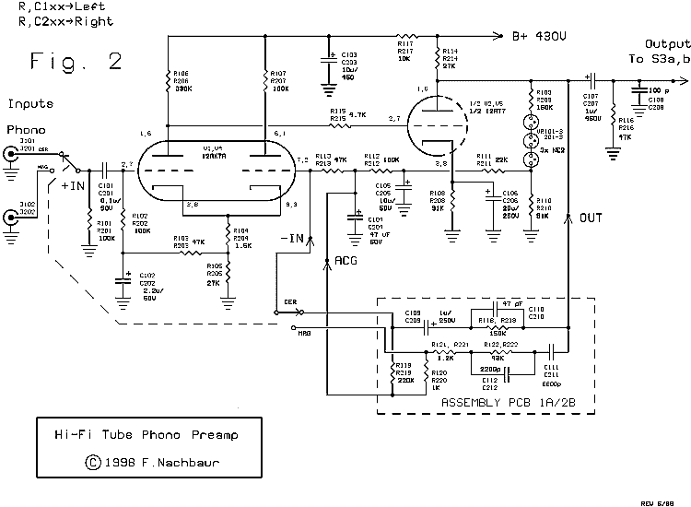
Figure 2 Phono (Magnetic and Ceramic) Preamplifie
The main circuit board was designed to be virtually universal in applicability. Small outrigger "feedback cards" are used to customize the response to almost anything you might need. Figure 6 plots gain vs. feedback ratio for the non-inverting configuration as used in the phono/mic preamp. There is an obvious linear relationship, except at high gain. (The "porch" at the low end is due to the "+1" when using the non-inverting mode; see below for further details. In the inverting mode, as used in the tone preamp section, the relationship remains linear at low gain settings.)
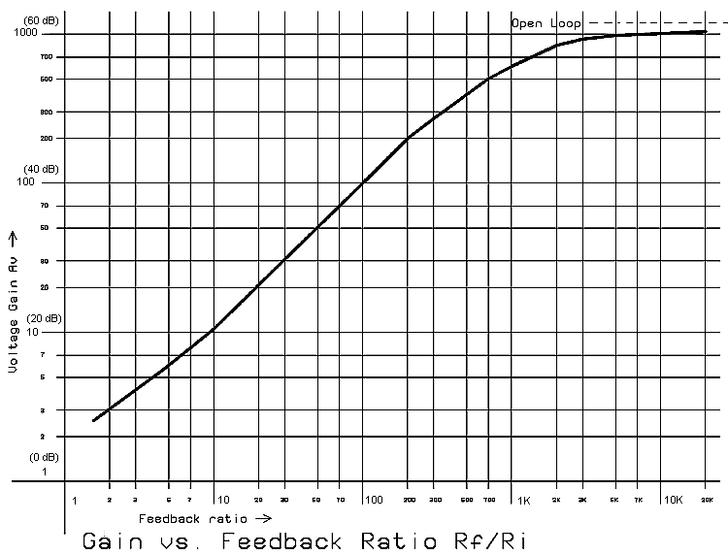

Figure 6 Preamplifier Gain vs. Feedback Ratio
As detailed here, the phono preamp is selectable (using a switch) between magnetic (RIAA equalization, high gain), and ceramic (flat response, low gain).
See Figure 7, which graphs open-loop response and the two closed-loop phono
curves. If you only need one or the other mode options, the switch and the
appropriate associated components can be omitted.

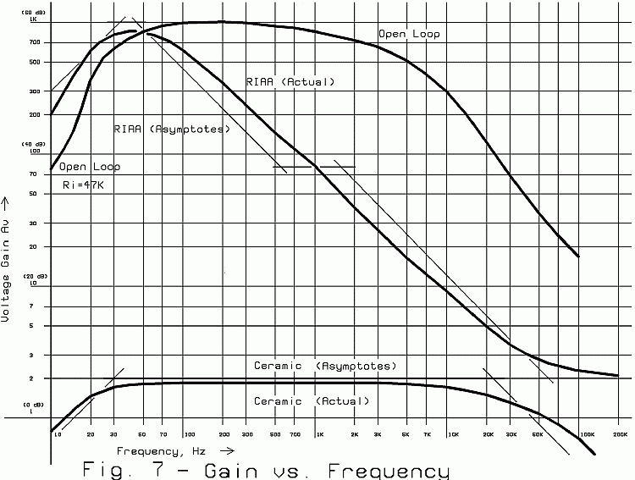
Figure 7 Open-loop, Magnetic Phono and Ceramic Phono Response Curves
There is no reason why you couldn't adapt this universal preamplifier module for
any other gain/equalization combinations, simply by modifying the feedback
networks. (Figure 8 gives a few ideas, covered in more detail in Other Preamp
Applications.)
Other Possible Preamplifier Applications
Phono equalisation
In magnetic phono mode, the RIAA curve is achieved by using negative feedback to decrease the gain at higher frequencies, according to the RIAA specification.The result is that the amplifier runs almost open-loop (about 60 dB gain) at 40Hz, and rolls off smoothly to a gain of less than 20 dB at 20 kHz. This means that the "tube sound" caused by even-order distortion will be most pronounced in the bass region, giving it that warmth that is so highly prized by vacuum tube aficionados. At higher frequencies, this distortion is increasingly cancelled out by the negative feedback that sets the gain, keeping the mids from sounding "brassy," and the highs from sounding "splashy" (two common complaints about open-loop tube amplifiers).
In CD (or ceramic cartridge) mode, response is flat within 0.5 dB over the audio range, and voltage gain is set at 5 (about 14 dB). At this relatively low gain, the circuit is very clean and distortion-free. However, discerning ears will hear a subtle quality of warmth not present in solid-state gear.
A 3:1 voltage divider at the input results in an overall system gain of 5 dB. The
output level of CD players varies widely among various models, so you can trim this input gain to suit your machine by changing a single input resistor per channel. Similarly, total circuit gain can be changed with a single resistor on the feedback cards.
The tube types and their operating points were carefully chosen to minimize power supply requirements, and to maximize tube life. Both channels together draw only about 7 mA from a 400 volt supply. This voltage can be derived from a stand-alone unit as documented in this article, or from a larger supply used to drive a vacuum tube power amp.
3-B) PRE-AMP DIFFERENTIAL INPUT STAGES
The preamplifier features a differential input stage, giving us both an
inverting and a non-inverting input and affording additional useful and
beneficial features. The following discussion relates directly to the
Phono preamps (refer to Figure 2), but applies by extension to other
applications also.
Phono Preamplifier
The appropriate input signal is coupled from the magnetic or ceramic
phono input jacks, through switch SW2, to the grid of the first section of V1 (a 12AX7A vacuum tube) via coupling capacitor C101. Since this grid is at a substantial DC voltage above ground, resistor R101 is used to insure that the input is always at DC ground potential. Note that, as far as the input AC signal is concerned, this 100K resistor is effectively in parallel with R102 (also 100K), giving us the 50K input impedance required for most magnetic phono cartridges. The two triode sections of V1 are used as a differential amplifier.
Note that the cathodes are tied together, and go to ground via a relatively large shared cathode resistance consisting of R104 and R105. This acts as a rudimentary constant-current source. If the current in either triode increases, a comparable amount of current will be robbed from the other triode. Therefore, if the voltage on the signal input increases (goes more positive), plate current increases and the plate voltage of that triode will drop, while the plate voltage of the other triode increases by about the same amount. However, if the voltage on the feedback input increases, causing an increase in current in that triode, the voltage on the plate of the first triode section will
increase and that of the other triode will decrease.
A portion of the cathode resistor voltage drop is sampled by R104, low-pass filtered by R103 and C102, and provides the grid bias for the first section of V1 via R102. An interesting feature of this circuit is that this also sets the bias and operating points for the entire amplifier, as we'll see as we progress through the analysis.
Experienced electronicists will be quick to point out that a simple cathode resistor is not an ideal current source. As a result, the "common-mode rejection ratio" (that is, the gain matching of the two inputs) of this circuit is quite low. (A great improvement results by using a pentode as a current source in the differential amplifier cathode circuit, a trick that's used in the driver stage where common-mode reduction is more critical because we also require balanced outputs.)
What we do instead, in the preamp modules, is "cheat the system" and carefully choose the operating points of the two triodes to be different, to help offset the error. Note that, even though there is approximately the same current flowing in the plate circuit of each triode section (about 500 microamperes), the plate voltage on the second section is considerably higher (by about 90 volts) than the plate voltage of the first section. This is because of the lower value of plate resistor R107, as compared to R106. This "trick" assumes that the two sections of the tube are reasonably well-matched, and will furthermore track as the tube ages. Tests with different tubes of varying manufacture and condition have verified that this assumption is indeed valid.
3A-2: PREAMPLIFIER OUTPUT STAGE
Figure 2 is a schematic diagram of the Hi-Fi Tube Stereo Preamp. Since both channels are identical, only one is shown. Please note that part numbers 100-199 refer to the left channel, and 200-299 refer to the right channel. We'll be assuming the left channel in this discussion.
Both channels share a single power supply, shown at the bottom of Figure 2. Transformer T1 steps the 120 volts AC from the power line down to 12.6 volts, to supply the heaters of the three tubes. The center-tapped configuration is used to help reduce hum induced by the heater circuits.
Transformer T2 steps the 12.6 volts AC back up to about 110 volts AC for our high-voltage plate supply. Diodes D1-D3 and capacitors C4-C6 are a voltage tripler circuit, providing about 450 volts DC open circuit, or around 380 volts under load. Note that D1, D2, C4 and C5 form the classic positive voltage doubler circuit. On negative half-cycles, C4 is charged through D1.
On positive half-cycles, C4 is effectively placed in series with the transformer, and diode D2 transfers this doubled voltage to C5. D3 and C6 are a negative half-wave rectifier/ filter, so the total voltage across C5 and C6 is about three times what would be obtained from a half-wave rectifier. This configuration is used instead of the more common "cascade" tripler circuit because of its slightly better regulation.
The tripled voltage is filtered by the low-pass network formed by R1 and C7. It is further filtered and decoupled by R2/C9 and R3/C8 to form the main supply for each channel. This eliminates any cross-talk between channels due to power supply coupling.
Additional decoupling is provided for the critical first stage of each amplifier by onboard filters R117/C103 (left channel) and R217/C203 (right channel), reducing power supply hum injected into these high gain circuits.
The output of our differential amplifier is direct-coupled to the grid of the second stage, V2, a 12AT7 dual triode. This tube was chosen over the more common (and cheaper) 12AU7 because it sports about three times the gain (transconductance), yet is capable of almost the same output drive.
The difficulty with direct-coupled vacuum tubes is that the grid of the second stage sits at a substantial voltage above ground (about 200 volts in our circuit). This is why we need a relatively high B+ voltage, since we have to insure that the plate circuit of the second stage has enough headroom. So why bother at all? After all, tube amps have been made for over half a century with good old RC interstage coupling. The answer has to do with dynamic stability as the tubes age. Unlike conventional multi-stage tube amplifiers, our circuit is self-levelling because its DC biasing is in a closed feedback loop.
R115 in series with the grid of V2 introduces a high-frequency pole with V2's grid-to-plate capacitance, effectively limiting high-frequency response. This allows us to run the preamp with relatively eavy negative feedback (low gain) without worrying about oscillations caused by phase shifts. You can think of it in op-amp terms as "internal compensation".
Another reason for using direct coupling is because of the relatively large voltage swings at this point in the circuit. Capacitors (even good ones) can exhibit some non-linearity in capacitance vs. voltage -- a fact that is often overlooked in amplifier design. Direct coupling eliminates this capacitor, and as a bonus gets rid of one more pole in our transfer function that could complicate our application of negative feedback for gain and frequency response control.
In order to bias V2's grid at the proper voltage (about -1 volts with respect to cathode), we need a humungous cathode resistor R108. To avoid losing all our AC gain, this resistor is bypassed for AC by capacitor C106.
3A-3: PREAMPLIFIER DC FEEDBACK
The rest of our circuitry completes the DC feedback loop. In case you're wondering about the presence of the three NE-2 neon bulbs in series, let's analyze the circuit without them. The plate of V2 will be sitting at about 315 volts, whereas the grids of V1 are at about 27 volts, or a factor of about 12:1. We could use a 12-to-1 voltage divider, which would give us a DC closed-loop gain of about 13. That is, it would require a 13 volt change at the output to compensate for a 1 volt change at the input.
We can easily improve on this considerably. The lowly neon bulb can be viewed as the tube- technology equivalent of the zener diode. That is, the voltage drop across the bulb (typically about 65 volts) is reasonably independent of the current passing through it. The three NE -2's can therefore be viewed as a 200 volt "level shifter," allowing us to use a much lower voltage division ratio (about 4:1) in our DC feedback loop. The result is an almost 3 times improvement in DC operating point stability.
The level-shifted and divided output voltage goes through a two-stage low-pass filter consisting of R111, C105, R112 and C104. This strips AC signals from our DC feedback loop, to insure that the amplifier will still have full open-loop AC gain. The resulting DC feedback voltage is applied to the inverting input of our differential amplifier via R113.
The junction of R113 and C104 also forms a convenient "AC Ground" point for our signal feedback networks. Let's step through what happens if some change occurs in DC operating point. This change could be caused by tubes and other components aging, power supply voltage fluctuations, or input overdrive conditions. Let's assume that the change causes the output voltage to rise, as would be the case as V2's emission decreases. This would cause an increase of bias voltage (more positive) on the grid of V1B (the feedback input), causing that stage to draw more current and increase the voltage on the common cathode. V1A (our input stage) would therefore draw less current, causing the voltage on its plate (and therefore the grid of V2) to increase. This would cause an increased V2 plate current, resulting in a decrease in plate voltage, tending to buck the original change. See how the overall circuit is self-regulating?Resistor R114 forms the plate load for V2, and C107 couples the output to the tone/line preamp module via the input and tape monitor switches.
Capacitor C108 provides another pole of high- frequency attenuation (compensation) to prevent oscillation at low gain. (Before I added this additional compensation, the first prototype became a dandy 11 megahertz transmitter at gains lower than about 3!) The original value for this capacitor was 1000 pF, but I've found since then that this can be considerably lower, depending on layout. In the schematic it's shown as 100 pF, if you get oscillation or other instability increase this as necessary.
3A-4: PREAMPLIFIER AC FEEDBACK
So far we have a pre-amplifier with an open-loop passband gain of about 60 dB, with 3-dB corners at about 40 Hz and 2 kHz. (See Fig. 7.) While the low-frequency end isn't bad, the high-frequency end is pretty awful. This is partly because of the compensation intentionally introduced by R115 and C108 and partly because of tube electrode and circuit wiring capacitances. Not to worry, our bandwidth automatically increases again when we apply negative feedback, just as it does with solid-state compensated op-amps.

Fig. 7: Preamplifier Open-Loop and Phono Gain Curves
As hinted already, this circuit behaves very much like an operational amplifier (op-amp). But before we get on with designing feedback networks, we'll point out the ways in which it is not like an op-amp:
a) Open loop gain, although quite high, cannot be considered infinite as in many solid state op- amp devices.
b) The circuit exhibits a large output-to-input voltage offset (on the order of 290 volts). Any AC feedback elements between output and input therefore have to include DC blocking capacitors. The alternative would be level-shifters, which would in my opinion be an additional complication (and expense) without commensurate rewards in terms of performance.
c) The DC voltage at the feedback input is non-zero (about 27 volts in practise), so again there is a need for DC blocking. The point marked "ACG" (AC Ground) is provided for convenience, acting as a virtual ground for AC, at the same DC voltage as the inverting input.
The not-quite-ideal Tube Opamp
Keeping these restrictions in mind, we can use the formula for the classic non-inverting op-amp to approximate our gain with feedback. Note that the inverting input (-IN) has a 47K resistor (R113) to "AC Ground". This is our "default" value for input resistance to the feedback input. Let's call that resistance Ri, though it can be considerably higher, as needed. The bare-minimum feedback network would consist of just a single resistance (we'll call it Rf ) in series with a DC blocking capacitor between output and -IN. The theoretical gain with feedback would then be:
Av = ( Rf / Ri ) + 1
For instance, let's compute our gain if we connect a "bare bones"feedback network consisting of a 430K resistor in series with a DC blocking capacitor between "OUT" and "-IN". That is, Rf / Ri = 9.15, so our gain would be 10.15, or about 20 dB.
The feedback elements do not have to be pure resistances; the above formula could be generalized to include complex impedances.
Av = ( Zf / Zi ) + 1
The circuit's actual performance follows this predicted formula very closely, verifying that our gain-matching shortcut described earlier works just fine. See Figure 6 for an actual plot of the prototype. The slight curve at the low end is caused by that "+1" factor in the equation; as Rf / Ri increases, that factor becomes less significant, and the graph approaches a straight-line relationship. However, at gain settings above about 200 (46 dB), the relationship begins to fall apart as we approach the amplifier's open-loop gain. Incidentally, this gain setting is also the practical maximum as regards frequency response; the 3 dB corner at this gain will be on the order of 16 kHz.

Figure 6 Preamplifier Gain Vs Feedback Ratio
3A-5: PREAMPLIFIER PHONO FEEDBACK NETWORKS
Ceramic phono
The feedback network for the Ceramic phono input is little more than our "bare bones" network described above. R118 in series with C109 forms our Zf . R119 is added as a refinement to insure that the negative end of C109 is always held at the DC potential of our feedback input, eliminating the massive pop that would otherwise result when switching modes. Note, however, that it is effectively in parallel with
R113, lowering our Ri value to 38.7K. You can verify that our closed-loop gain would therefore be (150/38.7)+1, or about 5 (14 dB).
Input resistor R123 attenuates our input signal by a factor of about 3:1, so the overall system gain is a little less than 2 (5 dB).
The final element is C110, which introduces a 3 dB corner at about 20 kHz, rolling off ultrasonics that we aren't interested in. (Without this capacitor, the gain is actually flat to well beyond 100 kilohertz! See how feedback got rid of that open-loop corner at 2 kHz?)
The magnetic phono feedback is only a little more involved. The straight thin lines in Figure 7 show the theoretical RIAA specification (asymptotes), and the curve shows the actual response of our preamp in this mode.
Note that, in the bass region, our preamp has to run open-loop in order to get the required 60 dB gain. Our feedback network therefore doesn't even have to bother with the poles in this region. Instead, R120 was chosen to present an appropriately low value for Ri . The effect is to further "swamp" any low frequencies that manage to make it through the DC feedback filter consisting of R111, C105, R112 and C104. This pushes our low-frequency "hump" to exactly where we want it.As frequency increases, at about 50 Hz., C111 comes into play and acts as an integrator to roll off our response. At about 530 Hz., the pole consisting of C111 and R122 tries to level the response, and at about 1600 Hz. C112 and R122 introduce the second roll-off section. The net result is a gradual rolloff over the audio range at a somewhat gentler
average slope (about 4.5 dB per octave) than would be achieved with a single-pole integrator (6 dB per octave). Finally, R121 limits minimum gain to about 6 dB at ultrasonic frequencies, helping to insure stability.
3D: POWER SUPPLY
3D-2: A Simple Power Supply for Standalone Preamps
The power requirements for the standalone phono preamp are very modest; 12 volts at less than 0.5 amperes, and 430 volts at about 10 milliamperes. Figure 5A shows a simple supply using readily-available12 volt, 1/2 ampere transformers (units capable of 1 ampere preferred for continuous operation). The 12 volt output from the first transformer is used to power the filaments, and is also fed to the second transformer connected as a step-up device to provide about 110 VAC. This supplies a voltage tripler circuit that provides the 400+ volts required for the preamplifier plate circuitry.
Note that, thanks to the self-levelling properties of our DC feedback circuitry, the actual value of the B+ voltage is non-critical; this is what allows us to use a voltage tripler, with notoriously poor voltage regulation, while maintaining a high degree of precision and independence from power supply fluctuations, tube characteristics, and component aging.

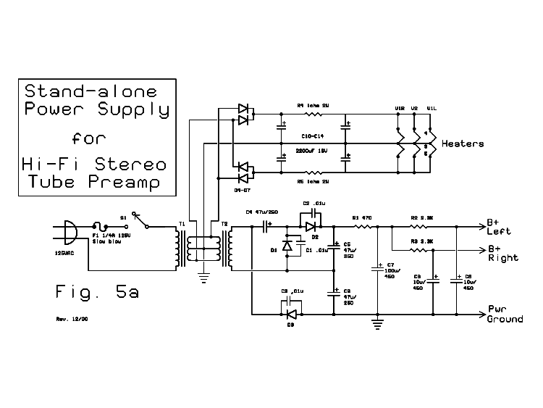
Fig. 5a: Power Supply for Standalone Preamp
Filaments are powered from a DC supply to minimise (i.e. virtually eliminate) AC hum induced from the filaments. The four diodes D4-D7 form a full-wave bridge rectifier, and CRC filters provide a sufficiently clean DC voltage to the filaments to satisfy even "sticklers".Power supply section of the standalone phono preamp
4: CONSTRUCTION HINTS
The first prototype of the phono preamp was built into a small metal box chassis, using PCB construction. I subsequently re-used the PCB module for use as one of the preamps in my RA-100 integrated amplifier. If you wish to duplicate the layout of the PCB-based prototype, download the file sapart.zip, (be sure to read "artwork.txt" included in the zip file) which contains the images necessary to create your PC board. Write me if you want the original Gerber files, should you have access to a "one of" PCB manufacturer. Note that the preamplifier module is designed for double-sided boards. This can be tricky, and is recommended only for experienced PC prototypers.
Note also: There is a polarized component shown on either side of the centre tube (12AT7) which is not used in normal applications; this was left as an option should someone wish to use the preamp in a "cathodyne" configuration. This, and its associated output connection pads are ignored in this design.
The second prototype (pictured below) used the same type and size (210 mm x 155 mm x 50 mm) steel box chassis. However, for the purpose of this article (and to assure myself that the design does indeed give good results using conventional wiring) this version was built using point-to-point wiring techniques, employing the tube socket pins and rows of terminal strips to provide the required connection points. Testing showed no measurable (or audible) difference in the two design approaches, so use whichever technique you're more comfortable with. This second prototype was constructed with the bulk of the preamp circuitry on the top case-half, and the power supply, mode switching, input/output jacks, and feedback networks in the bottom case-half. If I had it all to do over, I'd leave myself more room in the top section for the many resistors and capacitors, and also more room in the bottom for the feedback networks. However, since it's unlikely that I'll build yet another of these in the foreseeable future, I leave it to you to come up with a superior mechanical layout. ;-)
The Inner Workings of the second prototype.
Note the shielded cables on all audio lines, and twisted pairs on power wires.The top case-half, showing most of the preamp wiring.You'll probably want to leave yourself more room by increasing the spacing between tube sockets, and mounting more terminal strips.
The power supply section (lower case-half). High-voltage supply on the left, DC filament supply on the right. Feedback network components wired near the mode switch on the left side of the front panel.
Wiring tips
Be extremely careful. This cannot be overemphasised. The voltages and currents in this project can hurt you. Be constantly aware of this fact, and the worst you can do is make a bunch of bad smoke. Burned out components are replaceable; you're not.
Start by doing all the mechanical work. Lay out, drill and cut your enclosure for the power transformers, input and output jacks, power cord, switches, and standoffs for the PC board (if used) or tube sockets and terminal strips (if using the point-to-point approach).
In other words, do as I say, don't do as I do. When prototyping, the design and construction aspects often go hand in hand, leaving plenty of opportunity for a slip of the drill to send you crashing through some delicate part of the circuit. You, as the builder, have the luxury of being able to methodically start with the heavy stuff, and progress to the more delicate circuitry once all the grunt-work has been done.
Your enclosure should be metal (steel or aluminum). Plastic or other non-conductive enclosures are simply not appropriate for this design, mainly because they are a lot more prone to hum. The prototype shown in the photographs was built in an 8" x 6" x 2" steel chassis box
However, this particular box is a rather tight fit; you should go for the compact look only if you're relatively experienced. A somewhat larger box will give you more elbow room, and allow you to place the transformers further away from the
more sensitive circuitry. Make provision to connect the ground wire from your turntable to the chassis of the preamp. A bolt, lockwasher, and a couple nuts is all it
takes for this. Or, make arrangements for a wing-nut, thumb-screw or wire clip arrangement if you prefer.
Next wire up the power supply. This is best done using the point-to-point approach. Carefully follow the schematic diagram, being very very careful to observe polarity on diodes and capacitors. This is not just an idle warning; reverse polarity at these voltages can cause electrolytic capacitors to explode enthusiastically, making a heck of a mess at best and possibly injuring someone (e.g. you) at worst. Run all power wiring as twisted pairs. This includes AC input, filament supplies, and B+ lines.
An important part of building the power supply is making an insulated "bleeder resistor." This consists of a 10K, 1 watt resistor soldered to insulated wire, with shrink-wrap or tape completely covering the connections. At the ends of the wires install insulated clips.
This is to discharge the capacitors after testing or otherwise working on the power supply. Connect the clips between the positive end of C7, and "Pwr Ground" for at least ten seconds before touching anything in the power supply area. Getting sloppy with this can result in nasty (and potentially dangerous) surprises. However, don't forget to unclip the bleeder resistor before powering up; the resistor will heat up in a hurry if you do, letting you know in a startling (and smelly) way.
Ground returns should be grounded at a central grounding point only. (This is also called the "star-grounding" method.) Resist the temptation to use the chassis as a ground return. The only components that may be safely chassis-grounded are the Ceramic inputs and the output jacks on the rear apron. Failing to pay careful attention to proper grounding can result in hard-to-remove AC hum and other artifacts
Check, double-check, and re-check your wiring before proceeding. Then do a preliminary test by turning the supply on very briefly (2 seconds or so). There should be no smoke. Use your VOM in 500 to 2000 volt range, and check the voltage at your B+ outputs; they should read several hundred volts. If ok so far, turn the unit on while monitoring the B+ voltage. After a few seconds it should stabilize at 450-470 volts. Power down, and don't forget to bleed the capacitors!
Similarly check the filament supply. The filament supplies should ride around +/- 8 volts DC (16 volts end-to-end) with no load.
Optionally, you can check the supply under load by temporarily soldering 100K, 2 watt resistors between each B+ line and "power ground," and a 27 ohm, 5 watt resistor across the filament lines. Your B+ voltage should be around 390 volts DC, (no less than about 360), and filament voltage should be right about 12 volts AC (6 volts either side of "heater ground".) Don't leave the supply on for too long; the resistors will get quite hot after a while. Run all audio lines using good-quality shielded cable. The shield should be grounded at one end only (I suggest using the "source" end for the ground, making it easier to trace signal direction later should
it become necessary.) Cut away the shield at the other end, and shrink-wrap or tape the cut to prevent the little "fuzzies" from shorting against anything. The exception is the magnetic phono inputs (see next item).
The phono and mic inputs require special handling. The input jacks should be isolated from ground using insulated mounting hardware. This is the only case where the shield of the cable is connected at both ends. Connect to the jack's ground return at the jack end, and to a common tie point with the grounds going to the mode switch (if implementing the Ceramic phono option).
The output of your switching
The line from the common switch terminal should be connected to the input of the preamp using shielded cable, again with the switch end grounded to the common tie point, and the preamp end grounded to the ground pad nearest the input terminal (PCB construction) or to the terminal strip connection to which R101, C102 and R105 are connected (or the corresponding right-channel parts).
Keep all lines as short as is practical. Try to keep input lines away from AC and filament supply lines, and from the output lines.
The lines to the input and output jacks on the rear apron may optionally be two-conductor shielded cable, one for each channel. This is what I used on the prototype. However, if you want to maintain the highest possible channel separation, run separate single-core cables instead. Don't be careless with any lines that carry supply voltages. Make sure that all connections are well-insulated. Don't let any uninsulated high-voltage point come any closer to any other point (including, of
course, the chassis) by less than about 5 mm worst-case.
Other tips
Don't skimp on capacitor voltage ratings. If you can find capacitors rated at 500 volts continuous, these would be preferable; however, most sources only supply up to 450 volt units, which have held up fine in my prototypes; the slight over-voltage that can occur before the tubes heat up and start drawing current doesn't seem to cause adverse effects.
Because of the unit's low power consumption, no special heat-sinking techniques need be observed. However, if you enclose the entire unit (including the tubes) inside a closed case, allow at least a few ventilation holes.
Keep this project well out of reach of small children and pets at all times. I keep coming back to the safety aspect, not because I'm paranoid, but because there is real danger in carelessness.
Adjustment and testing
Assuming that everything goes well, there is not much to adjust. Turn the unit on and let it warm up for at least a minute. Measure the voltages at the following points (relative to chassis ground). A deviation of about 10% is nothing to worry about, but larger differences should be investigated. Compare the readings for both channels; they should agree quite well:

Plate V1A (bottom of R106/R206) 190-210 V
Plate V1B (bottom of R107/R207) 270-290 V
Cathodes V1 (top of R104/R204) 26-32 V
Grid supply V1A (top of C102/C202) 1.5 V less than cathodes
Grid supply V1B (ACG) 2V less than cathodes
Grid V2 (R115/R215) same as Plate V1A
Cathode V2 (top of R108/R208) 1.5V higher than Grid V2
Plate V2 (OUT) 290-310 V
+IN (top of R101/R201), Outputs 0V
Filaments +6.3 V (pins 4), =6.3V (pins 5)
OK so far? Congratulations! Your DC servo loops are working just great. If not, don't fret. Remember that any problem in the DC loop will probably cause all voltages to be wonky, so it may not be easy to troubleshoot. Take your time, go over all your connections, verify parts, etc. Still having trouble with one channel? Swap 12AX7A's. If the problem follows the tube, you've got a bad one. If the problem stays with the same channel, there's a problem on the board circuitry.
There, you got it? Well done! Ideally, final testing should be done using a sine-wave signal generator and oscilloscope, to verify that your performance is similar to the curves shown in the "How It Works" section. If this kind of test gear is not available to you, you'll have to use the "plug it in and see if it works" approach. Do be careful, when connecting to your amplifier, to bring the amp's volume control up from zero very gradually, in case you have a problem such as excessive hum or oscillation.
Using the preamp is pretty straightforward; connect your phono (Ceramic or Magnetic cartridge) to the appropriate input jacks, and connect the output jacks to your amplifier. And away you go!

5: PARTS LIST, STEREO PHONO PREAMPLIFIER

rev. 05/01
© 1998, 2000 Fred Nachbaur
PART DESCRIPTION NOTES
C ------ CAPACITORS
C1-3 .01uF 600V (optional) cer/mylar unl. noted
C4, C6 47 uF 250V electr.
C5 47 uF 350V electr.
C7 100 uF 450V electr.
C8, 9 10 uF 450V electr.
C10-14 2200 uF 16V electr.
C101,201 0.1 uF 50V
C102,202 2.2 uF 50V elect.
C103,203 10 uF 450V elect.
C104,204 47 uF 50V electr.
C105,205 10 uF 50V electr.
C106,206 20uF 250V electr.
C107,207 1 uF 450V electr.
C108,208 100-1000 pF (as needed)
C109,209 1 uF 250V electr.
C110,210 47 pF 250V
C111,211 6800 pF 250V
C112,212 2200 pF 250V

D ------ SEMICONDUCTOR DIODES
D1-3 1N4007 ECG/NTE 125
D4-7 1N4002 or better ECG/NTE 116

F ------ FUSE
F 1 0.25A Slo-blo (MDL) fuse/ holder Holder: Mode 55-800-0, etc.

J ------ JACKS AND CONNECTORS
J P1 2-wire AC plug and cord 5A Mode 30-021-0
J101-103 RCA jack Mode 24-181-0
J201-203 RCA jack Mode 24-181-0

PCB ---- PRINTED CIRCUITS
PCB 1 Preamp PCB (optional) (artwork available from website)

R ----- RESISTORS
R1 470R 1/2W 1/4 5% unless noted
R2, R3 3.3K
R4, R5 1R 2W
R101, 201 100K
R102, 202 100K
R103, 203 47K
R104, 204 1.5K
R105, 205 27K
R106, 206 330K 1/2W
R107, 207 180K 1/2W
R108, 208 91K 1/2W
R109 ,209 160K
R110, 210 51K
R111, 211 22K
R112, 212 100K
R113, 213 47K
R114, 214 27K
R115, 215 4.7K
R116, 216 47K
R117, 217 10K
R118, 218 160K
R119, 219 220K
R120, 220 1K
R121, 221 1.2K
R122, 222 43K

S ------ SWITCHES
S 1 SPST 6A mini-toggle (power) Mode 41-230A-0
S 2 DPDT 6A mini-toggle (power) Mode 42-342A-0

T ------ TRANSFORMERS
T 1 Power Transformer, 12V .5A or better Mode 60-912-0
T 2 Power Transformer, 12V .3A or better Mode 60-912-0

V ------ VACUUM TUBES (VALVES)
V1, 3 12AX7A dual triode
V2 12AT7A dual triode

VR ----- NEON REGULATORS
(Mode 55-120-0)
VR101-3 3x NE-2 matched with VR201-3
VR201-3 3x NE-2 matched with VR101-3

Chassis, as desired
Bottom plate for chassis, if needed
Hookup wire (600V)
Shielded cable, single and double conductor
Perf-board as required for power supply sections
Mounting hardware (bolts, nuts, washers, L brackets for mounting perfboard)
Strain relief for power cord
Terminal strips, phenolic solder type
Tube sockets (3 ea. 9-pin PCB- or chassis-mount)

Note:
Many parts such as connectors, pots, etc. can be obtained from any Mode
Electronics distributor (visit www.mode-elec.com for the distributor
nearest you). The Mode part number for many such components is given
above. Tubes and sockets can be ordered online from many suppliers; a
search for tubes and sockets will return many such suppliers.

3B: OTHER APPLICATIONS FOR THE UNIVERSAL PREAMP MODULE
Figure 8 shows a few other options for the basic preamp circuit. This was originally intended as an Appendix, but it's sufficiently important to be included in this discussion of the "Quasi-opamp Tube Preamp." You could design any number of stand-alone applications for this device, the ones provided here are just a few examples of the possibilities.

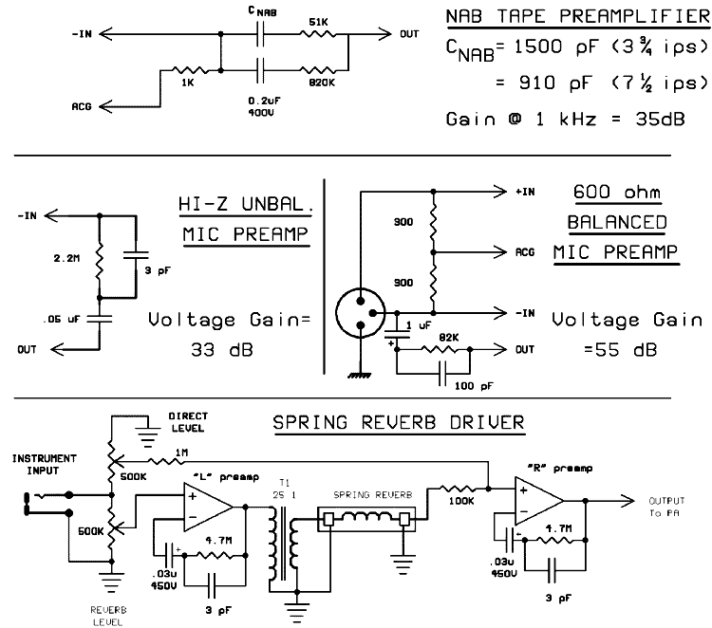

Fig. 8: Other Applications for the Preamp Module
You might have an old reel-to-reel in a closet somewhere. If not, keep an eye out at the second- hand stores; these can often be picked up for a song. The biggest drawback with many of these is the early transistor playback preamps, especially the ones that use germanium transistors.
Replace the playback amp with the variation shown in Fig. 8a. Note that for proper equalization at both speeds (3-3/4 and 7-1/2 ips) you'll need to switch between two different values for CNAB.
The NAB tape standard is even simpler than the RIAA phono spec, consisting essentially of a 6 dB per octave de-emphasis. Again, we use the preamp in open-loop mode at low bass frequencies, and again we usea low value of Ri to maximize our bass response.
Fig. 8b shows a preamp for high-impedance, single-ended dynamic microphones. It is similar to our Mic/Line mode, except that the fixed gain simplifies construction for standalone projects. Add an impedance-matching transformer, and the circuit is usable with low-impedance microphones.
Fig. 8c shows a application of the differential input capability of our preamp. This is for balanced, low impedance microphones. Note that this is a transformer-less circuit, and therefore offers a significant improvement over Fig. 8b. However, the circuit's shortcomings should be pointed out: First, as mentioned earlier, the common-mode rejection ratio of this circuit is nothing to write home about, and so it will not be suitable if your microphone is connected via a long cable run near stage lighting cables, etc. Secondly, the microphone element will be sitting at about 25 volts DC relative to system ground. A dedicated balanced mic tube preamp that avoids these shortcomings would not be difficult to design, I'd consider taking on such a project if the interest is there. Finally, Fig. 8d shows a "spring reverb" driver. The transformer can be a small output transformer, such as might be salvaged from an old tube radio. A turns ratio of about 25:1 (corresponding to an impedance ratio of 5000 ohms to 8 ohms or thereabouts) would be fine. The first preamplifier (e.g. "left") amplifies your instrument's output with enough drive to run the reverb input transducer via the matching transformer. The second preamplifier (e.g. "right") amplifies the much lower voltage appearing at the reverb's output transducer. Separate gain controls allow you to mix "dry" and "reverb" signals to your heart's content. The resistor values are given as a starting point; depending on the instrument and your particular spring reverb assembly, you might have to trim values to suit. As shown, there should be enough gain to allow you to distort either signal by overdriving the preamp sections.
Incidentally, because of the unique DC feedback system, the clipping characteristics of this circuit are quite a bit different than what you might be used to, even compared to other tube circuits. The author has not experimented with the fine points of this, so the field is ripe for experimentation in this area.

