

|  |  |  |
| --- | --- | --- |
| **Sprint Documentation** | | |
| **Sprint 1** | **Start Date: 23/09/2024** | **Final Date: 30/09/2024** | |
| **Team Members** | | | |
| Edson Pereira De Carvalho | | | |
| Lemuel Prates Sobrinho Ferreira | | | |
| Maria Clara Borges Cardoso | | | |
| Rodrigo Yoshida Lombezzi | | | |
| Vinicius Lúcio Marcolino Da Silva | | | |

|  |  |  |  |
| --- | --- | --- | --- |
| **Sprint Backlog** | | | |
| Task# | Description | Start Date | Final date |
| 11 | Sprint 01 - Desenvolver Enum EducationLevel | 23/09/2024 | 30/09/2024 |

|  |  |  |  |  |  |
| --- | --- | --- | --- | --- | --- |
| **Task Description** | | | | | |
| Task # | Description | Assigned To | Status | Estimated Hours | Logged Hours |
| 11 | Enum Education Level desenvolvido | Vinicius | Concluído | 2 | 2 |
| 11 | Documentação | Vinicius | Concluído | 2 | 2 |

|  |
| --- |
| **Sprint Results** |

Foi Desenvolvido o Enum EducationLevel a partir da seguinte representação no diagrama de classes:

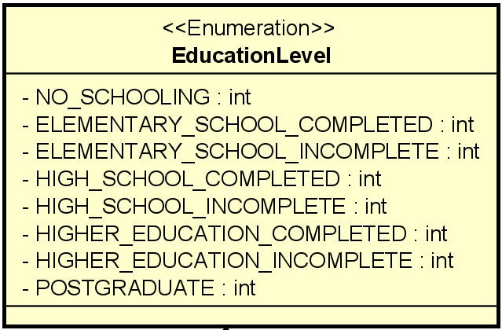

Os valores definidos foram:

* NO_SCHOOLING = 1
* ELEMENTARY_SCHOOL_COMPLETED = 2
* ELEMENTARY_SCHOOL_INCOMPLETE = 3
* HIGH_SCHOOL_COMPLETED = 4
* HIGH_SCHOOL_INCOMPLETE = 5
* HIGHER_EDUCATION_COMPLETED = 6
* HIGHER_EDUCATION_INCOMPLETE = 7
* POSTGRADUATE = 8