

|  |  |  |
| --- | --- | --- |
| **Sprint Documentation** | | |
| **Sprint #01** | **Start Date: 16/09/2024** | **Final Date: 30/09/2024** | |
| **Team Members** | | | |
| Edson Pereira De Carvalho | | | |
| Lemuel Prates Sobrinho Ferreira | | | |
| Maria Clara Borges Cardoso | | | |
| Rodrigo Yoshida Lombezzi | | | |
| Vinicius Lúcio Marcolino Da Silva | | | |

|  |  |  |  |
| --- | --- | --- | --- |
| **Sprint Backlog** | | | |
| Task# | Description | Start Date | Final date |
| 13 | Sprint 01 - Desenvolver Enum Ethnicity | 23/09/2024 | 30/09/2024 |

|  |  |  |  |  |  |
| --- | --- | --- | --- | --- | --- |
| **Task Description** | | | | | |
| Task # | Description | Assigned To | Status | Estimated Hours | Logged Hours |
| 13 | Desenvolver Enum Ethnicity | Lemuel | Concluído | 2 | 1 |

|  |
| --- |
| **Sprint Results** |

Foi desenvolvido o Enum Ethnicity a partir da seguinte representação no diagrama de classes:

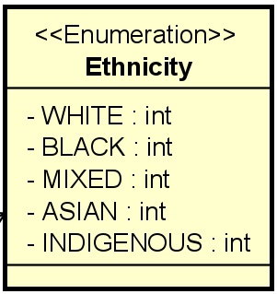

Os valores definidos foram:

* WHITE = 1
* BLACK = 2
* MIXED = 3
* ASIAN = 4
* INDIGENOUS = 5