
Sprint Documentation
Sprint 1 | Start Date: 23/09/2024 | Final Date: 30/09/2024
Team Members
Edson Pereira De Carvalho
Lemuel Prates Sobrinho Ferreira
Maria Clara Borges Cardoso
Rodrigo Yoshida Lombezzi
Vinicius Lúcio Marcolino Da Silva

Sprint Backlog
Task# | Description | Start Date | Final date
11 | Sprint 01 - Desenvolver Enum EducationLevel | 23/09/2024 | 30/09/2024

Task Description
Task # | Description | Assigned To | Status | Estimated Hours | Logged Hours
11 | Enum Education Level desenvolvido | Vinicius | Concluído | 2 | 2
11 | Documentação | Vinicius | Concluído | 2 | 2

Sprint Results

Foi Desenvolvido o Enum EducationLevel a partir da seguinte representação no diagrama de classes:
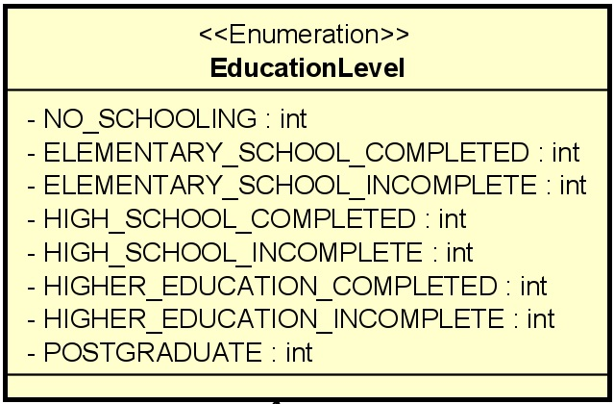
Os valores definidos foram:
- NO_SCHOOLING = 1
- ELEMENTARY_SCHOOL_COMPLETED = 2
- ELEMENTARY_SCHOOL_INCOMPLETE = 3
- HIGH_SCHOOL_COMPLETED = 4
- HIGH_SCHOOL_INCOMPLETE = 5
- HIGHER_EDUCATION_COMPLETED = 6
- HIGHER_EDUCATION_INCOMPLETE = 7
- POSTGRADUATE = 8

