1. ***Overview of the AdventureWorks2022 database:***

The AdventureWorks2022 database serves as a comprehensive simulation of real-world business operations, organized into multiple interlinked schemas that cover different aspects of a company's activities.

|  |  |
| --- | --- |
| Schema | Description |
| dbo Schema | Contains system-related tables |
| Human Resources Schema | Manages employee-related data |
| Person Schema | Individual entities associated with the business |
| Production Schema | Central to the manufacturing aspect of the business |
| Purchasing Schema | Related to procurement |
| Sales Schema | Sales operations details |

The following tables offer a concise overview of various aspects of a company's operations:

Customers by Demographics

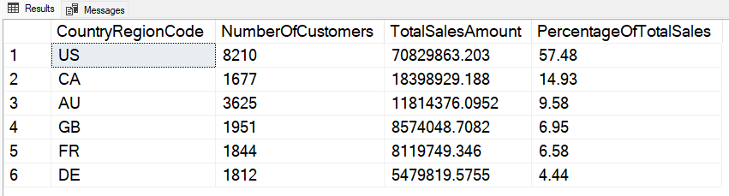

Yearly Revenue

Employees Performances:

Total Inventory Value by Category

1. ***perform statistical analysis:***

Examining the inventory segment through a detailed statistical analysis allows us to gain a better understanding of the inventory dynamics by category.

* Mean Inventory Value: $53,964,146.23
* Confidence Interval (95.0%): [$40,000,919.84, $67,927,372.62]
* Standard Deviation of Inventory: $83,262,121.14
* Median Inventory Value: $7,808,060.26
  1. ***Interpretation****:*

The mean inventory value is approximately $53.96 million, with a 95% confidence interval between $40.00 million and $67.93 million. The substantial standard deviation of $83.26 million indicates considerable variability. Furthermore, the right-skewed distribution, as evidenced by a median inventory value of $7.81 million, suggests (outliers: product/category) with exceptionally high values. Identifying and managing these outliers becomes crucial for efficient inventory management.

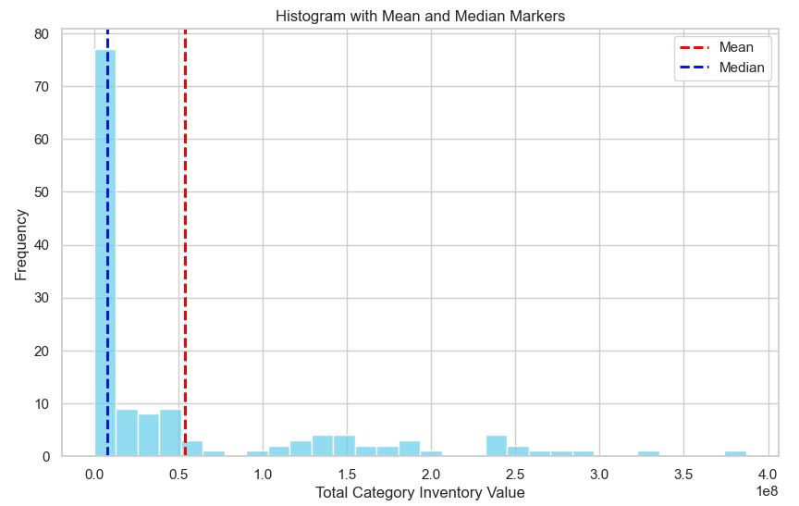

1. ***Analysis of data and results:***

The dataset encompasses detailed information on four distinct product categories: Bikes, Components, Clothing, and Accessories. It provides insights into the inventory dynamics and order statistics from 2011 to 2014.

* The Bikes category consistently holds a dominant position in both inventory and inventory value. Notably, a peak is observed in March 2014, where the inventory reaches 445,433 units, and the inventory value totals $ 386,830,991.8.
* The inventory value for the Bikes category is significantly higher than other categories, influencing the overall mean.
* A graph of a number of different colored lines

  Description automatically generatedExcluding the Bikes category results in a substantial reduction in the overall mean inventory value, reflecting the impact of Bikes' disproportionately large values as we can see in the charts below:

* 1. ***Recommendations:***
* Strategic Pricing and Marketing:

Review and adjust pricing and marketing strategies for products with low stock value to stimulate demand and increase visibility.

* Supply Chain Alignment:

Align supply chain practices for high-turnover products to ensure optimal stock levels and minimize holding costs.

* Data-driven decision-making:

Implement data-driven decision-making processes for adaptive strategies and explore potential adjustments in inventory levels within each category based on demand patterns and product performance to enhance overall business efficiency.

1. ***Executive summary***

After Analyzing the AdventureWorks2022 Database, Here Are the Key Findings:

*1. Sales Performance Insights:*

Unveiling the top-performing products, we identified that "Mountain Bike”, and "Road Helmet" significantly fueled the company's robust sales performance, steering yearly revenue trends.

*2. Employee Contribution Metrics:*

Identifying key contributors, employees like Linda Mitchell and Jillian Carson emerged as top performers, each securing sales amounts exceeding $11 million.

*3. Market Distribution Impact:*

Analyzing customer demographics showcased the dominance of the U.S., contributing 57.48% of total sales, followed by Canada, Australia, and the United Kingdom.

1. *Inventory Dynamics Breakdown:*

Exploring total inventory value by category, the Bikes category stood out with 14,536 units and a value exceeding $14.6 million.

1. *Statistical Analysis:*

The mean inventory stands at $53,964,146.23, with a $7.81 million median signaling a right-skewed distribution, highlighting specific high-value products/categories.

1. *Bikes Category Dominance:*

The consistent dominance of the Bikes category significantly influenced the overall mean inventory value and shaped inventory dynamics.

1. *Outlier Identification:*

Excluding the Bikes category led to a noteworthy reduction in the mean inventory value, emphasizing the impact of outliers and prompting targeted inventory management.

1. *Strategic Pricing Impact:*

Recommendations for strategic pricing adjustments extend to high-performing products like "Mountain Bike" and "Road Helmet," aiming to stimulate demand and enhance market visibility.

1. *Supply Chain Optimization Strategies*:

Aligning supply chain practices, especially for high-turnover products like Bikes, becomes critical for maintaining optimal stock levels and minimizing holding costs.

1. *Data-Driven Decision-making Emphasis:*

Emphasizing data-driven decision-making processes is crucial for adaptive strategies, considering product performance and demand patterns to enhance overall business efficiency.

***Recommendations:***

In conclusion, leveraging insights from top-performing products, employee contributions, and market distribution, we propose strategic adjustments in pricing, supply chain practices, and data-driven decision-making.