**Splash Screen (Form1.frm)**

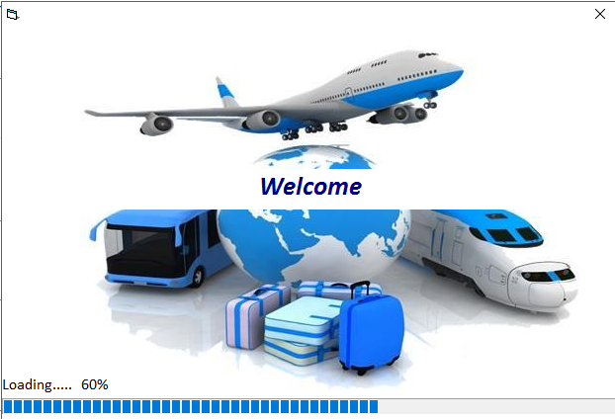

**Login in (Form2.frm)**

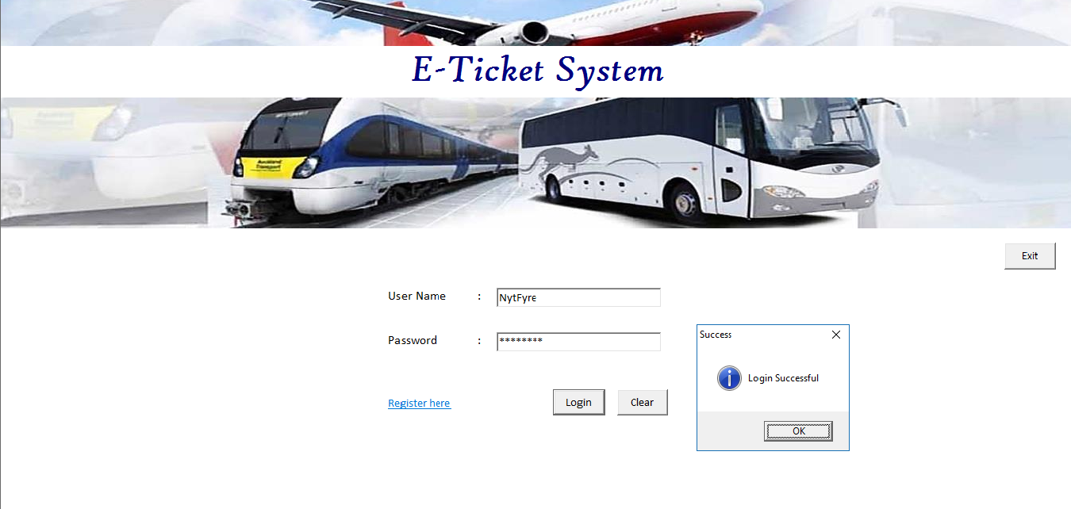

**Registration (Form3.frm)**

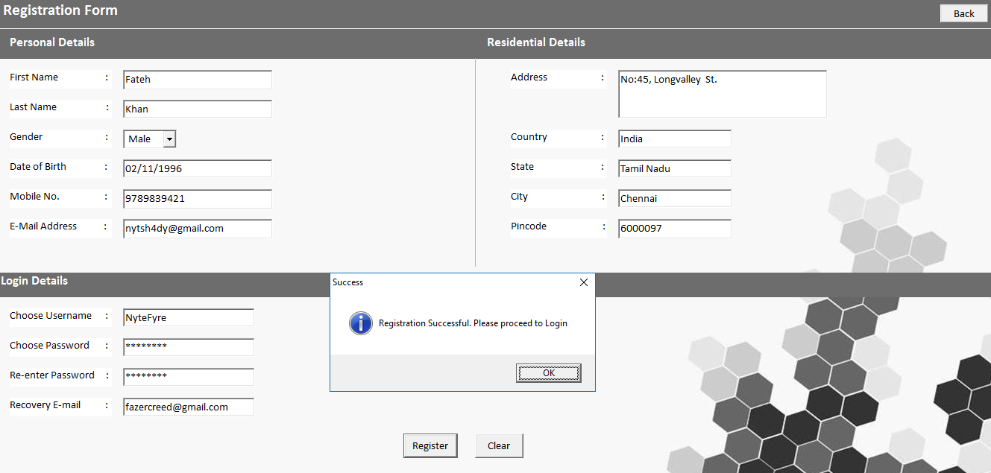

**Choose Option (Form4.frm)**

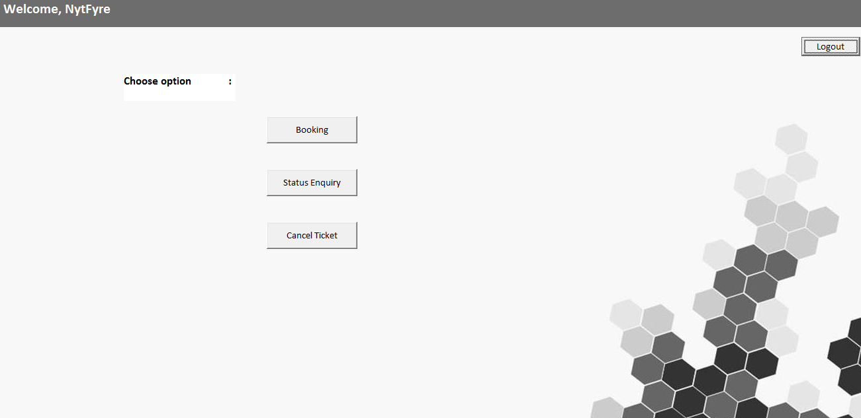

**Search (Form5.frm)**

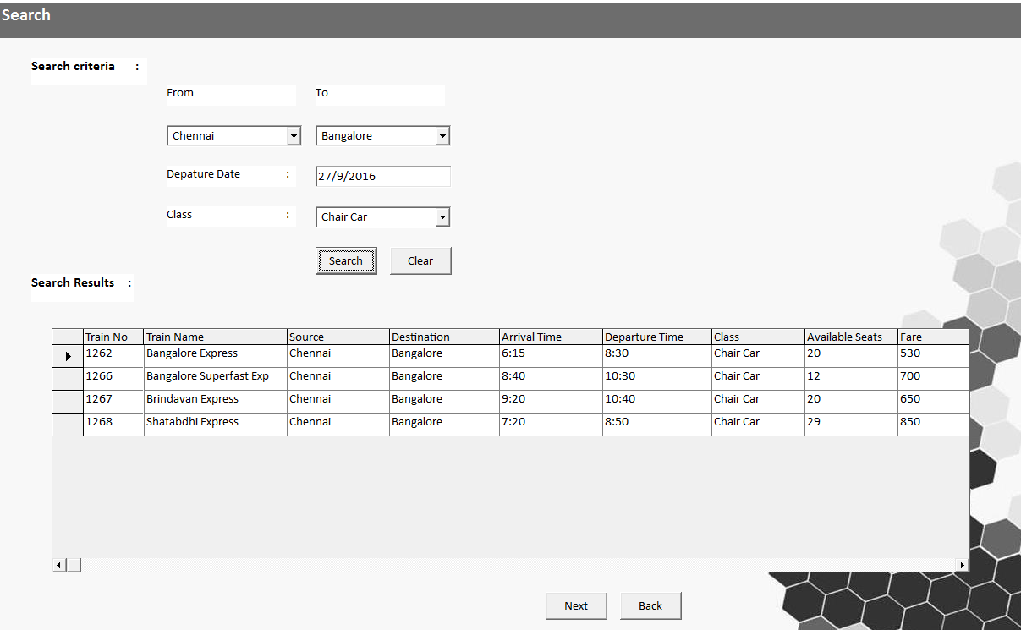

**Booking (Form6.frm)**

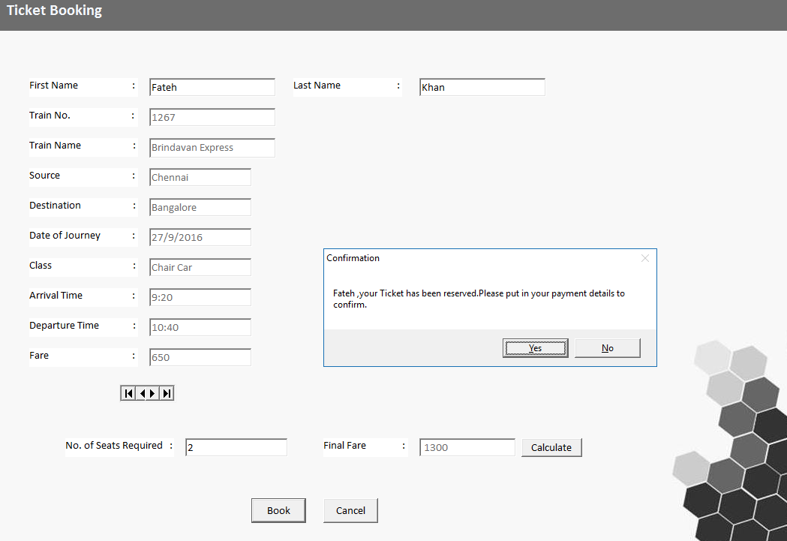

**Payment (Form7.frm)**

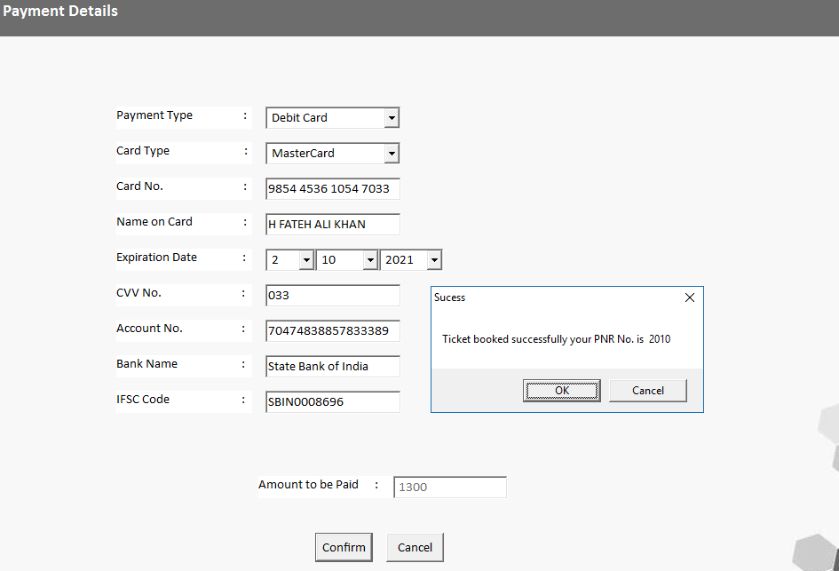

**Check Status (Form8.frm)**

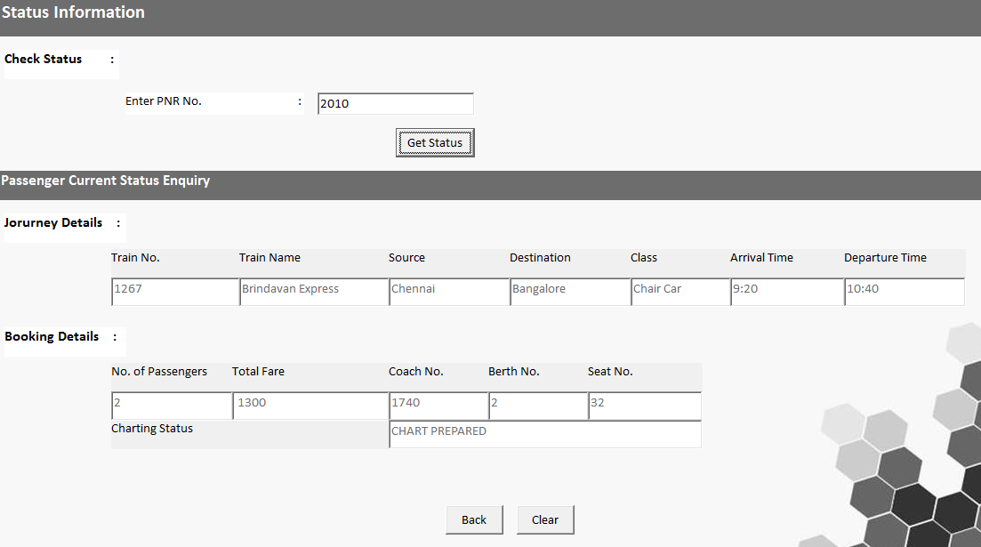

**Cancellation (Form9.frm)**

