Lab #02
Name: Fateh Ali
Reg. No: FA24-BCS-032

Screenshots:
Mobile View:
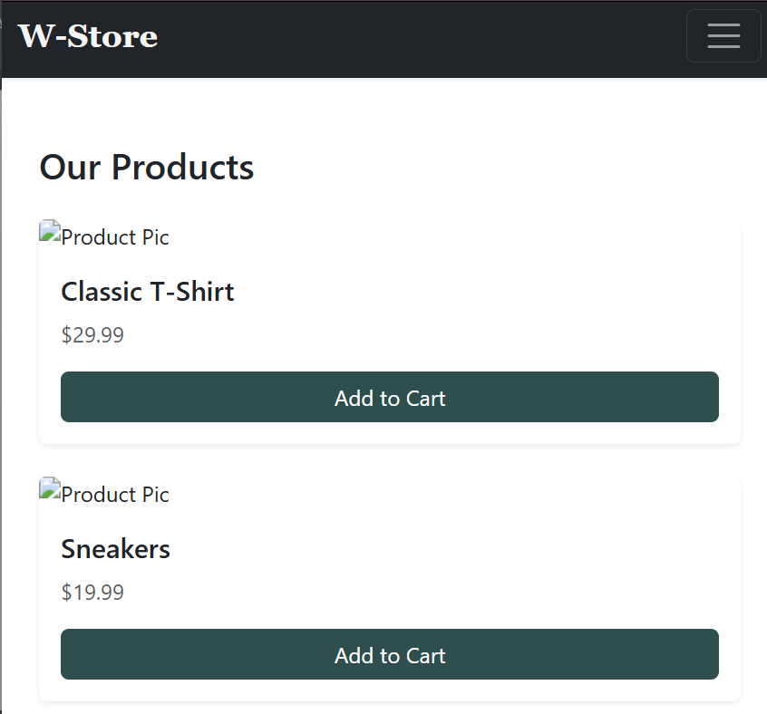

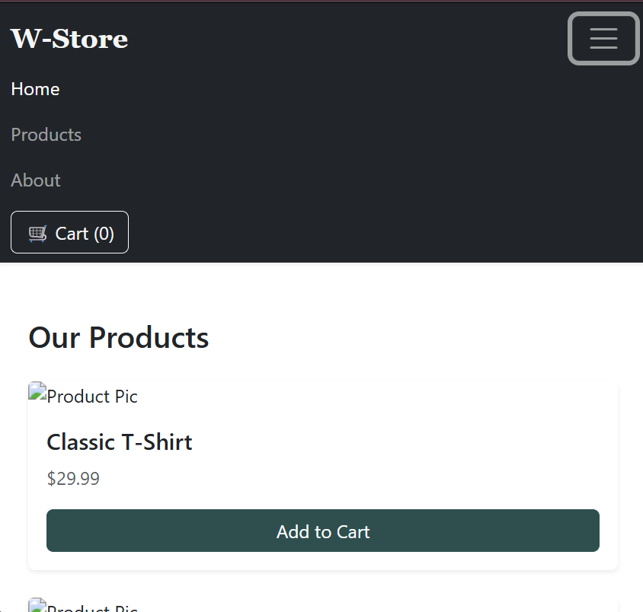
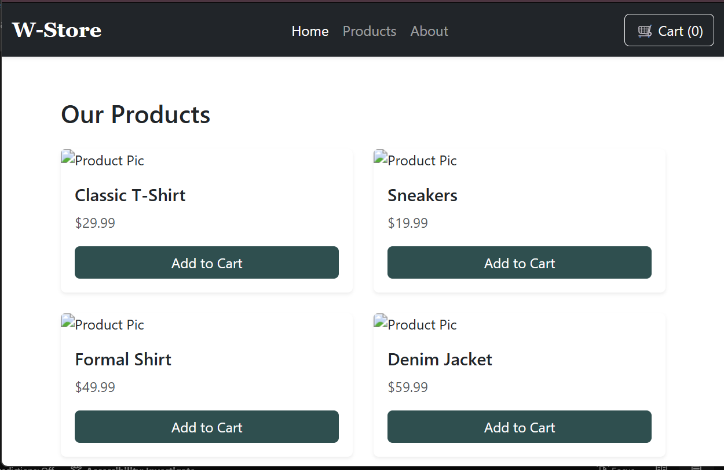
Tablet View:

Desktop View:
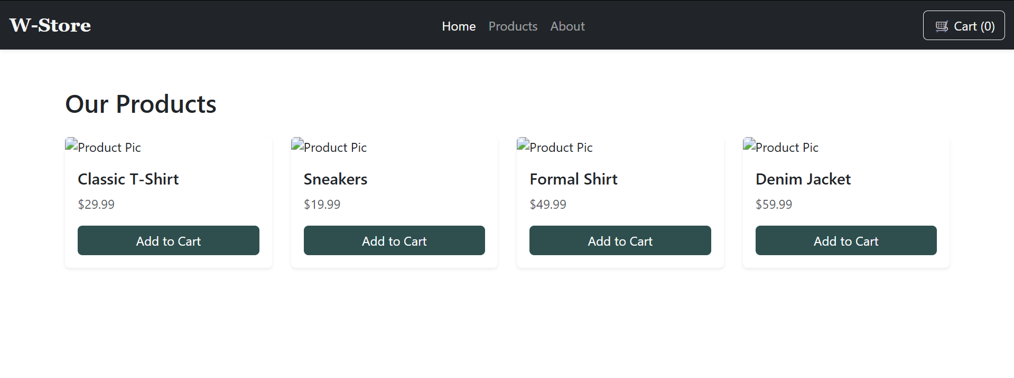

Index.html:
<!doctype html>
<html lang="en">
<head>
<meta charset="UTF-8" />
<meta name="viewport" content="width=device-width, initial-scale=1.0" />
<link
href="https://cdn.jsdelivr.net/npm/bootstrap@5.3.8/dist/css/bootstrap.min.css"
rel="stylesheet"
integrity="sha384-sRIl4kxILFvY47J16cr9ZwB07vP4J8+LH7qKQnuqkuIAvNWLzeN8tE5YBujZqJLB"
crossorigin="anonymous"
/>
<script
src="https://cdn.jsdelivr.net/npm/bootstrap@5.3.8/dist/js/bootstrap.bundle.min.js"
integrity="sha384-FKyoEForCGlyvwx9Hj09JcYn3nv7wiPVlz7YYwJrWVcXK/BmnVDxM+D2scQbITxI"
crossorigin="anonymous"
></script>
<link rel="stylesheet" href="styles.css" />
<title>LAB 02</title>
</head>
<body>
<nav class="navbar navbar-expand-md navbar-dark bg-dark shadow-sm">
<div class="container-fluid">
<a class="navbar-brand custom-brand fw-bold" href="#">W-Store</a>

<button
class="navbar-toggler"
type="button"
data-bs-toggle="collapse"
data-bs-target="#mobileMenu"
>
<span class="navbar-toggler-icon"></span>
</button>

<div class="collapse navbar-collapse" id="mobileMenu">
<ul class="navbar-nav mx-auto mb-2 mb-md-0">
<li class="nav-item">
<a class="nav-link active" href="#">Home</a>
</li>
<li class="nav-item"><a class="nav-link" href="#">Products</a></li>
<li class="nav-item"><a class="nav-link" href="#">About</a></li>
</ul>

<div class="d-flex">
<button class="btn btn-outline-light">🛒 Cart (0)</button>
</div>
</div>
</div>
</nav>

<div class="container mt-5 mb-5">
<h2 class="mb-4">Our Products</h2>
<div class="row g-4">
<div class="col-12 col-md-6 col-lg-3">
<div class="card h-100 border-0 shadow-sm">
<img
src="https://via.placeholder.com/300x200"
class="card-img-top"
alt="Product Pic"
/>
<div class="card-body d-flex flex-column">
<h5 class="card-title">Classic T-Shirt</h5>
<p class="card-text text-muted">$29.99</p>
<button class="btn btn-primary mt-auto">Add to Cart</button>
</div>
</div>
</div>

<div class="col-12 col-md-6 col-lg-3">
<div class="card h-100 border-0 shadow-sm">
<img
src="https://via.placeholder.com/300x200"
class="card-img-top"
alt="Product Pic"
/>
<div class="card-body d-flex flex-column">
<h5 class="card-title">Sneakers</h5>
<p class="card-text text-muted">$19.99</p>
<button class="btn btn-primary mt-auto">Add to Cart</button>
</div>
</div>
</div>

<div class="col-12 col-md-6 col-lg-3">
<div class="card h-100 border-0 shadow-sm">
<img
src="https://via.placeholder.com/300x200"
class="card-img-top"
alt="Product Pic"
/>
<div class="card-body d-flex flex-column">
<h5 class="card-title">Formal Shirt</h5>
<p class="card-text text-muted">$49.99</p>
<button class="btn btn-primary mt-auto">Add to Cart</button>
</div>
</div>
</div>

<div class="col-12 col-md-6 col-lg-3">
<div class="card h-100 border-0 shadow-sm">
<img
src="https://via.placeholder.com/300x200"
class="card-img-top"
alt="Product Pic"
/>
<div class="card-body d-flex flex-column">
<h5 class="card-title">Denim Jacket</h5>
<p class="card-text text-muted">$59.99</p>
<button class="btn btn-primary mt-auto">Add to Cart</button>
</div>
</div>
</div>
</div>
</div>
</body>
</html>

Styles.css:
.custom-brand {
font-family: "Georgia", serif;
color: whitesmoke;
font-size: 1.5rem;
}

@media (min-width: 768px) {
.navbar-expand-md {
display: flex;
flex-wrap: nowrap;
}
}
.btn-primary {
background-color: darkslategrey;
border-color: darkslategray;
}
.btn-primary:hover {
background-color: darkgrey;
border-color: darkslategray;
}

