Complete eCommerce Business
Management System



Overview
A scalable full-stack eCommerce Business Management System built to help businesses manage products, inventory, customer orders, payments, courier operations, and business analytics from a centralized admin dashboard.

The platform provides customers with a seamless shopping experience while giving administrators complete control over daily business operations through a secure and responsive management system.

Tech Stack
Frontend

- Next.js 15
- React
- TypeScript
- Tailwind CSS

Backend

- NestJS
- PostgreSQL
- JWT Authentication
- Cloudinary

Project Links
Live Demo: https://www.sumashop.xyz/

Key Features

Customer Website
- Responsive Shopping Experience
- Product Search
- Product Variants
- Shopping Cart
- Secure Checkout
- Fetches real-time shipping rates via Shippo API
- Customers can compare available shipping options
- Customers can select their preferred shipping rate/service during checkout.
- Cash on Delivery
- Stripe Mock Payment
- Order Tracking
- Dark / Light Mode

Admin Panel
- Product Management
- Category Management
- Variant Management
- Inventory Management
- Order Management
- Customer Management
- Payment Verification
- Courier Dispatch
- Sales Dashboard

Advanced Features

Fraud Detection System
- Risk Score Calculation
- Fake COD Detection
- Suspicious Address Detection
- Repeated Phone Detection
- Same IP Detection
- High Value COD Detection

Smart Inventory
- Automatic Stock Reservation
- Automatic Stock Restore
- Variant Stock Management

Courier Integration
- Shippo API
- Shipment Tracking
- Tracking Link


Figure 1: Alurea — Full-Stack E-commerce Storefront Homepage
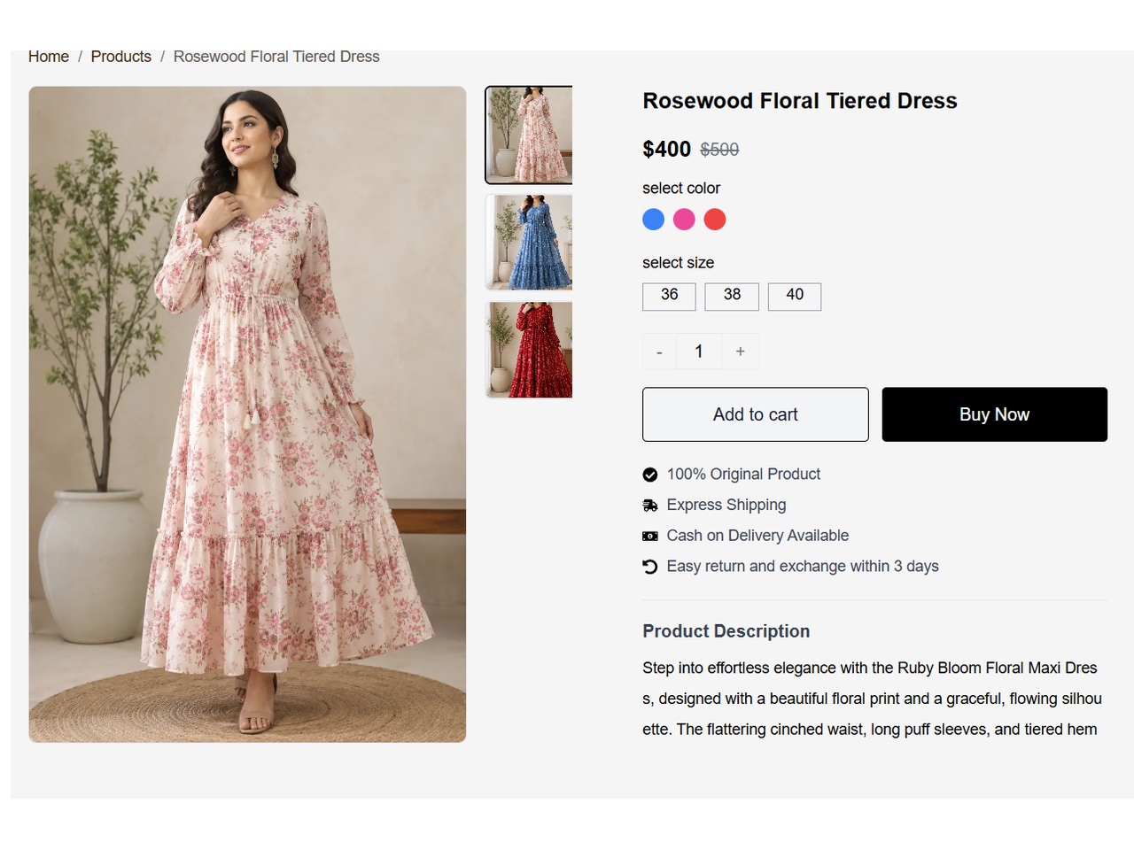
Figure 2: Alurea Product Detail Interface Featuring Product Gallery, Variants, and Add-to-Cart Workflow

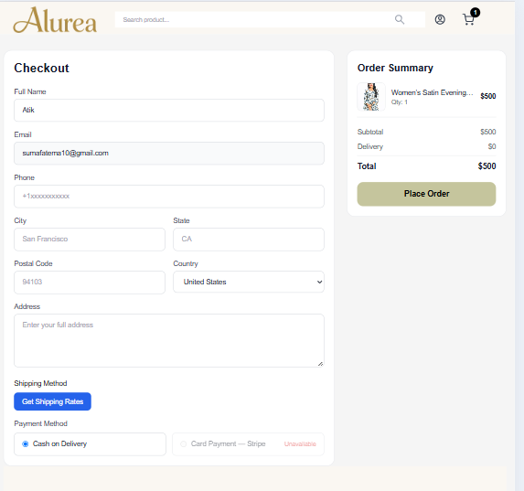
Figure 3:Alurea Checkout Page with Shipping, Payment, and Order Summary Workflow

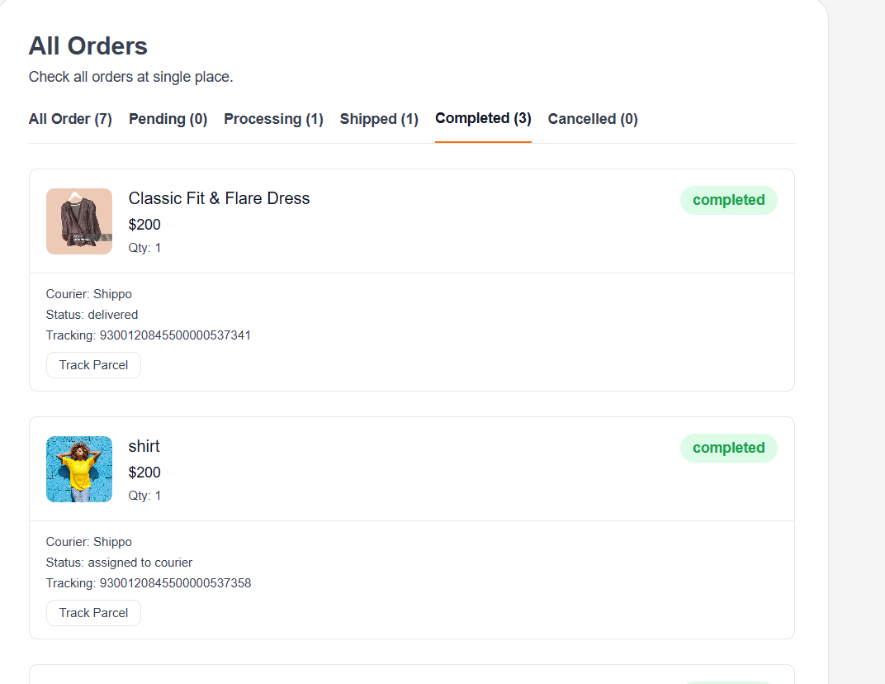
Figure 4: Alurea Order Dashboard Featuring Order Status, Courier Tracking, and Delivery Updates

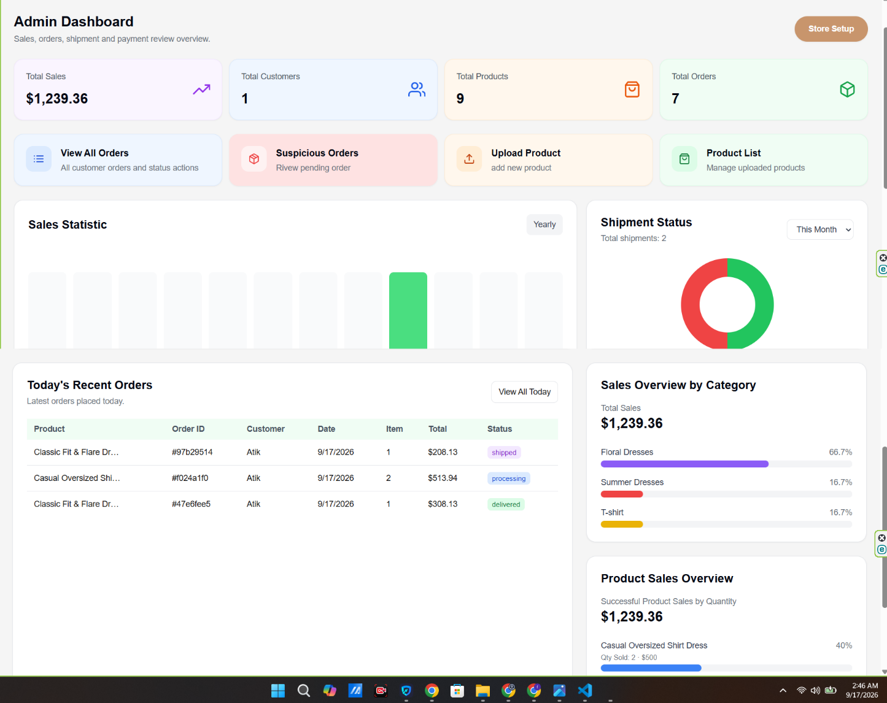
Figure 5: Alurea Admin Management Dashboard Featuring Sales Analytics, Order Monitoring, Product Management, and Shipment Overview

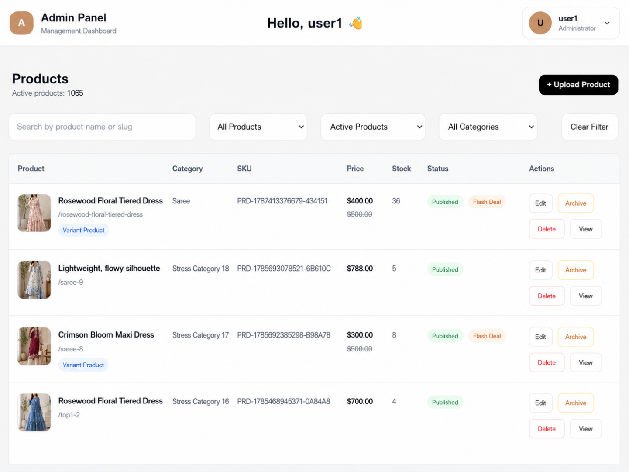
Figure 6: Alurea Admin Product Management Dashboard
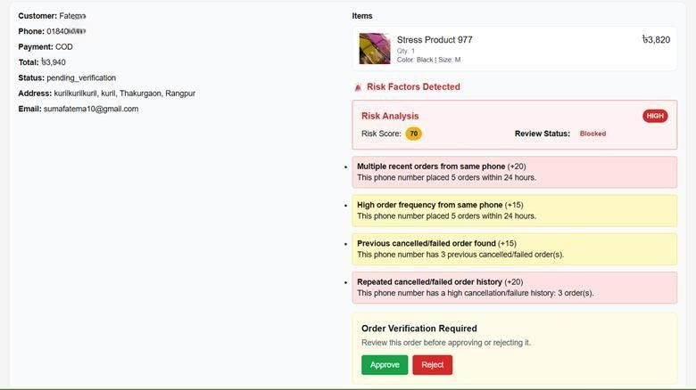

Figure 7: Automated order risk analysis dashboard identifying suspicious orders through customer behaviour patterns and verification checks.

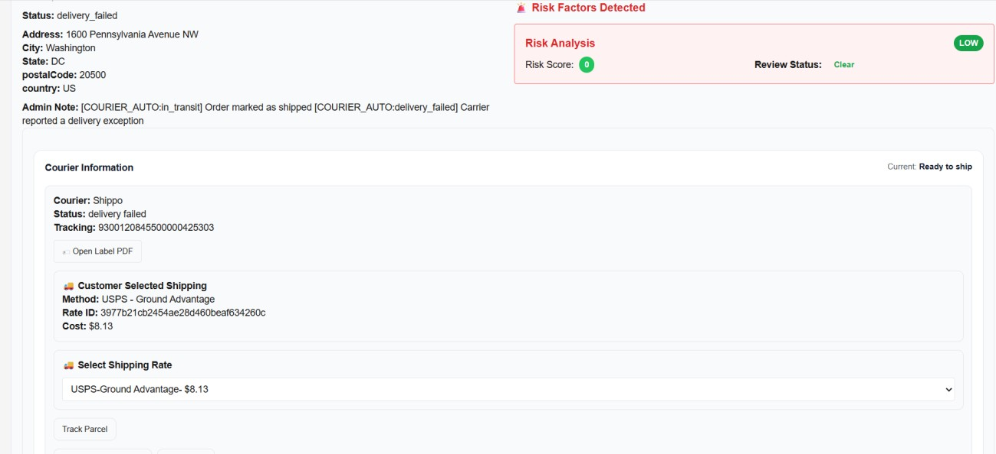
Figure 8: Shipment management interface displaying courier details, tracking information, shipping rates, and delivery status updates.

Technical Architecture
Frontend

- Next.js 15
- TypeScript
- Tailwind CSS
Backend
- NestJS
- PostgreSQL
Authentication
- JWT
- RBAC

Storage

- Cloudinary
Deployment
- Vercel
- Render

Business Value
Why this project?

- Complete business management
- Reduce fake orders
- Save courier costs
- Improve inventory accuracy
- Increase operational efficiency
- Better customer experience

Project Statistics

- ✓ 50+ Business Features
- ✓ 27+ Admin Features
- ✓ 21+ Customer Features
- ✓ 11 Order Statuses
- ✓ 7 Fraud Detection Rules
- ✓ 2 Payment Methods
- ✓ Shippo API Integration
- ✓ JWT Authentication & RBAC
- ✓ Responsive Design
- ✓ Light & Dark Mode

Contact
ʌ□V□• Email
sumafatema10@gmail.com

-¡uA LinkedIn linkedin.com/in/fatemaakhterdev

Live Demo https://sumashop.xyz/
Github:
https://github.com/Fatema-Akther/ecommerce-platform-backend https://github.com/Fatema-Akther/ecommerce-platform-Frontend

.

