Chapter 1
INTRODUCTION
  - Overview of Database Management System
A Database is a collection of related data organized in a way that data can be easily accessed, managed and updated and various operations can be performed on it. By Data, we mean known facts that can be recorded and that have implicit meaning. A DBMS is a collection of programs that enables users to create and maintain a database. The DBMS is a general-purpose software system that facilitates the processes of defining, constructing, manipulating, and sharing databases among various users and applications. DBMS also provides protection and security to database. It maintains data consistency in case of multiple users. Here are some examples of popular DBMS, MySQL, Oracle, Sybase, Microsoft Access and IBM DB2 etc.
The database system can be divided into four components:
- The database system can be divided into System developer and End users.
- Database application: Database application may be Personal, Departmental, Enterprise and Internal
- DBMS: Software that allow users to define, create and manages database access, Ex: MySQL, Oracle etc.
- Database: Collection of logical data.
Functions of database management system:
- Provides Recovery services
- Provides utility
- Provides data Independence
- Provides a clear and logical view of the process that manipulates data
Advantages of DBMS:
- Segregation of application program
- Minimal data duplicity and Easy retrieval of data
1.2 Problem Statement
The aim of this project is to design an online bookstore system where customer can purchase books. The database system contains various books in stock along with their title, author, cost and other information.

The system provides the user with a choice of different books available for purchase in the store. The customer may even search for specific books in the database. Once a book is selected, it is added to the cart and based on the customer’s choice a bill can be generated or further shopping is done.

1.3 Objectives
- Online Bookstore is an online system where the customer can purchase books online. The customers can search for a book by its title or author, later can add to the shopping cart and finally purchase the books.
- The online bookstore system enables us to setup online bookstore where customers can browse through the books and a system administrator to approve and reject requests for new books and maintain lists of book categories.
- A customer can shop online by browsing through books, selecting books of his choice and then placing the books into a shopping cart and paying the bill for the same.
- The system provides the user with a choice of different books available for purchase in the store. A user can view a large range of books arranged in respective categories.
- A user may select the desired book and view its price and other details.
- Once the user selects a book to be bought, it is added to the cart and based on the user’s choice a bill can be generated or further shopping is done. This system helps users to know about different kinds of books just by searching in the system using category id.
- The Administrator will have additional functionality when compared to the common user. He can add, delete and update the author, publisher, book categories, book details, member information and also confirm a placed order.
1.4 Dataset Description
Given below are the entities along with its attributes and relations present in the database of this application that are used to retrieve information from the database as per requirement of user.
- An entity type ‘CUSTOMER’ with attributes cust_id, cust_name, address, email, login, password and phone where cust_id is the primary key attribute.
- An entity type ‘CATEGORY’ with attributes cid and cname where cid is the primary key attribute.
- An entity type ‘BOOK’ with attributes id, title, author, cate_id, image, quantity, price and rating where id is the primary key attribute and cate_id is the foreign key attribute referencing from ‘CATEGORY’ table. This entity has a strong relationship with ‘CATEGORY’ entity.
- An entity type ‘CART’ with attribute book_id and cost which has book_id as the primary key attribute.
- An entity type ‘BILL’ with attribute order_id, cust_id, purchase_amt and orderdate where order_id acts as the primary key attribute.

Chapter 2
SYSTEM REQUIREMENTS
To be used efficiently, all computer software needs certain hardware components or other software resources to be present on a computer. These prerequisites are known as (computer) system requirements and are often used as a guideline as opposed to an absolute rule. Most software defines two sets of system requirements: minimum and recommended. With increasing demand for higher processing power and resources in newer versions of software, system requirements tend to increase over time.
2.1 Software Requirements
- Operating System : Windows 7 or higher
- Front End : HTML5/CSS/JavaScript
- Back end : MySQL/PHP
- Server : XAMPP
- Browser : Mozilla Firefox
2.2 Hardware Requirements
- Processor : Pentium III or higher
- RAM : 2GB or above
- Hard Disk : 20 GB or More

Chapter 3
SYSTEM DESIGN
3.1 Entity Relationship Diagram
An Entity Relationship Diagram describes interrelated things of interest in a specific domain of knowledge. A basic ER model is composed of entity types and specifies relationships that can exist between instances of those entity types. In software engineering, an ER model is commonly formed to represent things that a business needs to remember in order to perform business processes. Consequently, the ER model becomes an abstract data model that defines a data or information structure which can be implemented in a database, typically a relational database.

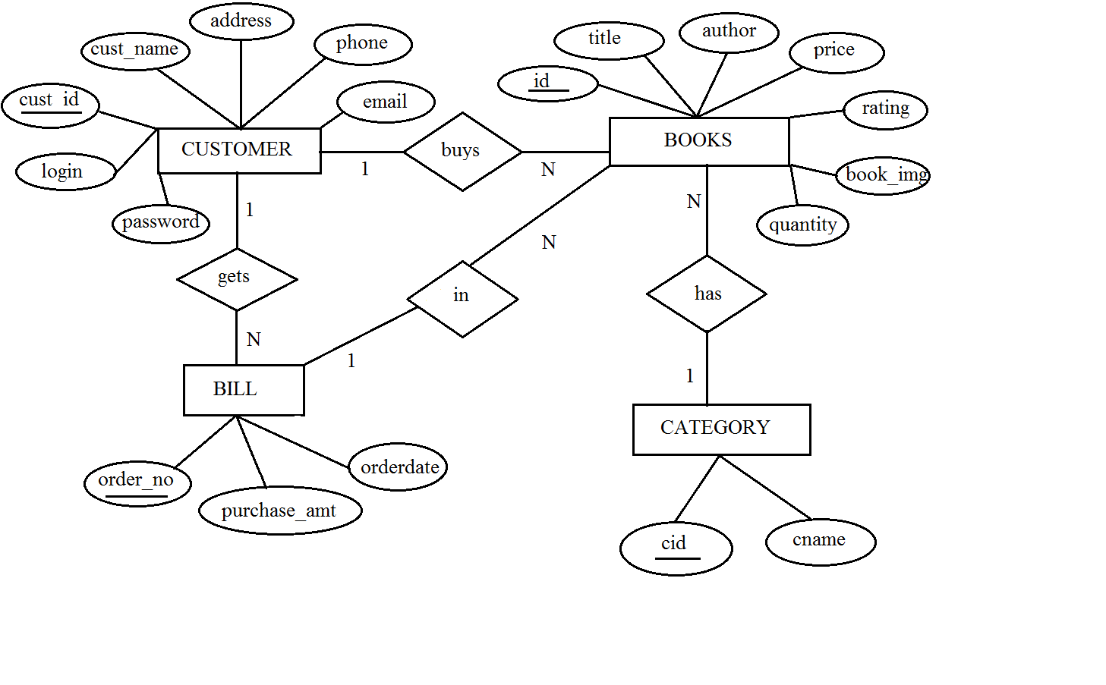

Figure 3.1: E R diagram of Online Bookstore System.
3.2 Schema Diagram
A database schema is the skeleton structure that represents the logical view of the entire database. It formulates all the constraints that are to be applied on the data. A database schema defines its entities and the relationship among them. It contains a descriptive detail of the database, which can be depicted by means of schema diagrams.

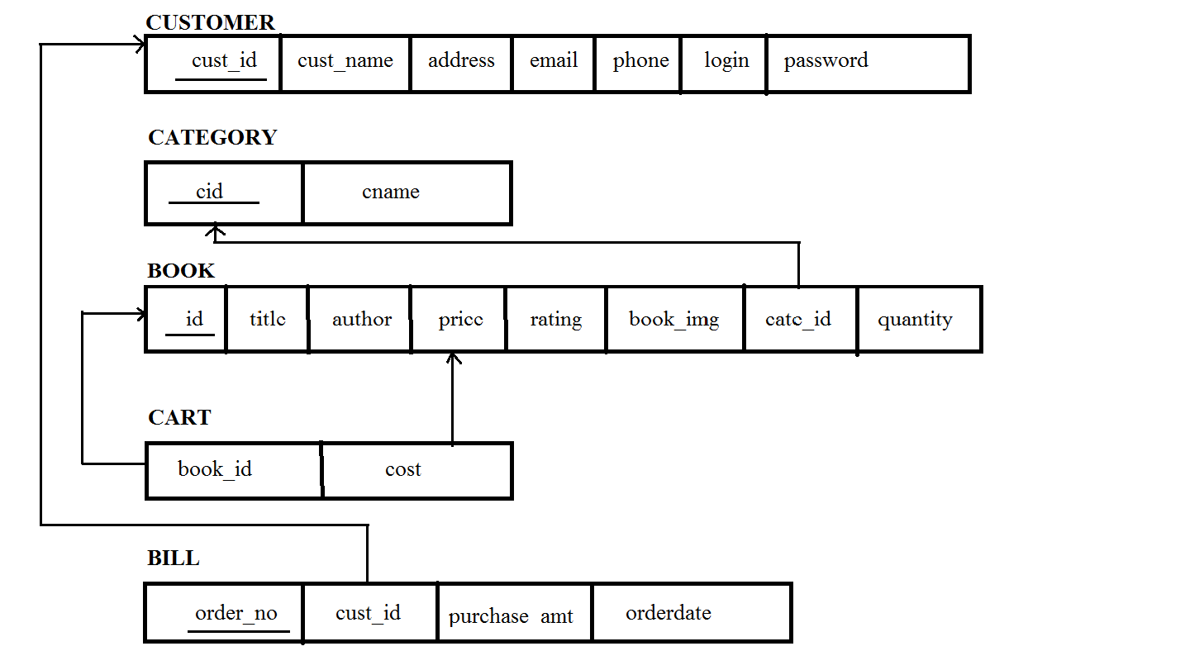

Figure 3.2: Schema diagram of online bookstore system
3.3 Overview of Graphical User Interface

GUI is program interface that takes advantages of the computer’s graphics capabilities to make the program easier to user. Well-designed graphical user interfaces can free the user from learning complex command language. On the other hand, many users find that they work more efficiently with a command-driven interface, especially if they already know the command language.
Hypertext Markup Language (HTML) is the standard markup language for creating web pages and web applications. With Cascading Style Sheets (CSS) and JavaScript it forms a triad of cornerstone technologies for the World Wide Web. Web browsers receive HTML documents from a web server or from local storage and render them into multimedia web pages. HTML describes the structure of a web page semantically and originally included cues for the appearance of the document.
Cascading Style Sheets (CSS) is a style sheet language used for describing the presentation of a document written in a markup language. Although most often used to set the visual style of web pages and user interfaces written in HTML and XHTML, the language can be applied to any XML document and is applicable to rendering in speech, or on other media. CSS is a cornerstone technology used by most websites to create visually engaging webpages, user interfaces for web applications, and user interfaces for many mobile applications.
Hypertext Preprocessor ( PHP) is a general-purpose programming language originally designed for web development. PHP code may be executed with a command line interface (CLI), embedded into HTML code, or used in combination with various web template systems, web content management systems, and web frameworks. PHP code is usually processed by a PHP interpreter implemented as a module in a web server or as a Common Gateway Interface (CGI) executable. The web server outputs the results of the interpreted and executed PHP code, which may be any type of data, such as generated HTML code or binary image data. PHP can be used for many programming tasks outside of the web context, such as standalone graphical applications and robotic drone control.

3.4 Normalization
Normalization rule are divided into following normal form.
- First Normal Form
- Second Normal Form
- Third Normal Form

CUSTOMER table

It is in 1NF as it does not have any composite or multivalued attributes.
Customer’s cart is multivalued; hence it is decomposed to a separate relation.
It is in 2NF as it is fully functionally dependent.
(cust_id) → (cust_name, address, email, phone, login, password)
As the relation does not contain a non-key attribute functionally determining other non-key attributes, it is in 3NF (there is no transitivity in attributes).

BOOK table

It is in 1NF as it does not have any composite or multivalued attributes.
It is in 2NF as it is fully functionally dependent.
(id) → (cate_id)
(id) → (title, author, price, rating, book_img, quantity)
Book’s category is decomposed in a separate relation so as to decompose it into 2NF.
As the relation does not contain a non-key attribute functionally determining other non-key attributes, it is in 3NF(there is no transitivity in attributes).

CATEGORY table
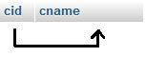
It is in 1NF as it does not have any composite or multivalued attributes.
It is in 2NF as it is fully functionally dependent.
(cid) → (cname)
As the relation does not contain a non-key attribute functionally determining other non-key attributes, it is in 3NF(there is no transitivity in attributes).

CART table
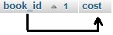

It is in 1NF as it does not have any composite or multivalued attributes.
It is in 2NF as it is fully functionally dependent.
(book_id) → (cost)
As the relation does not contain a non-key attribute functionally determining other non-key attributes, it is in 3NF(there is no transitivity in attributes).

BILL table
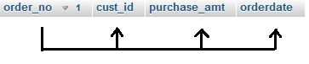
It is in 1NF as it does not have any composite or multivalued attributes.
It is in 2NF as it is fully functionally dependent.
(order_no) → (cust_id, purchase_amt, orderdate)
As the relation does not contain a non-key attribute functionally determining other non-key attributes, it is in 3NF (there is no transitivity in attributes).
Chapter 4
IMPLEMENTATION
4.1 Table Creation

ADMIN
create table admin
(
admin varchar(10) primary key,
password varchar(10) not null
);

CUSTOMER
create table customer
(
cust_id int(3) auto_increment primary key,
cust_name varchar(15) not null,
address varchar(40) not null,
email varchar(20) not null,
phone varchar(10) not null,
login varchar(10) not null,
password varchar(8) not null
);

CATEGORY
create table category
(
cid int primary key,
cname varchar(20) not null
);

BOOK
create table book
(
id int auto_increment primary key,
title varchar(40) not null,
author varchar(20) not null,
price int not null,
rating int not null,
book_img varchar(30) not null,
cate_id references category(cid) on delete cascade,
quantity int(5) not null,
);

BILL
create table bill
(
order_no int(4) auto_increment primary key,
cust_id references customer(cust_id) on delete cascade,
purchase_amt int(5) not null,
orderdate date not null
);
CART
create table cart
(
book_id references book(id) on delete cascade,
cost int(5) not null
);

4.2 Description of Tables

Table 4.2.1 – Admin Description
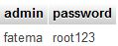
Table 4.2.2 – Customer Description
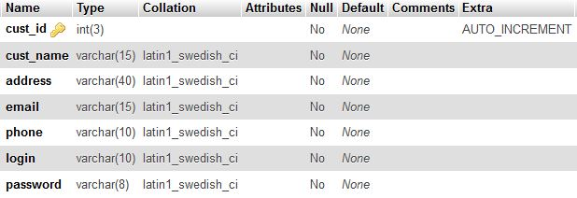
Tab le 4.2.3 – Category Description
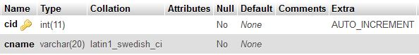
Table 4.2.4 – Book Description
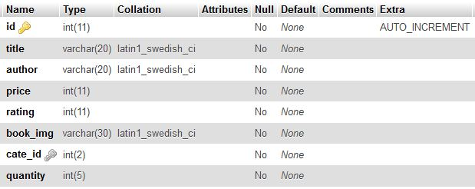
Table 4.2.5 – Cart Description
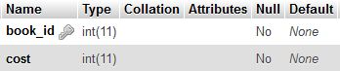
Table 4.2.6 – Bill Description
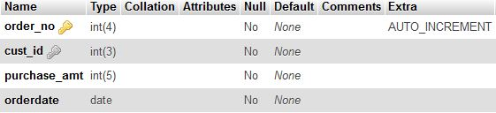

4.3 Populated Tables

Table 4.3.1 – Admin Table Values
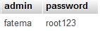
Table 4.3.2 – Customer Table Values
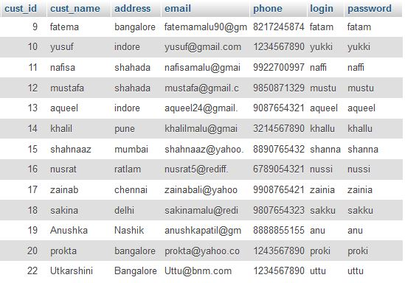
Table 4.3.3 – Category Table Values
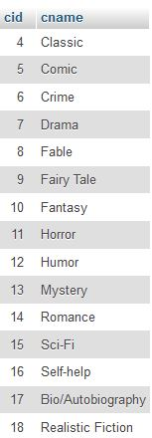
Table 4.3.4 – Book Table Values
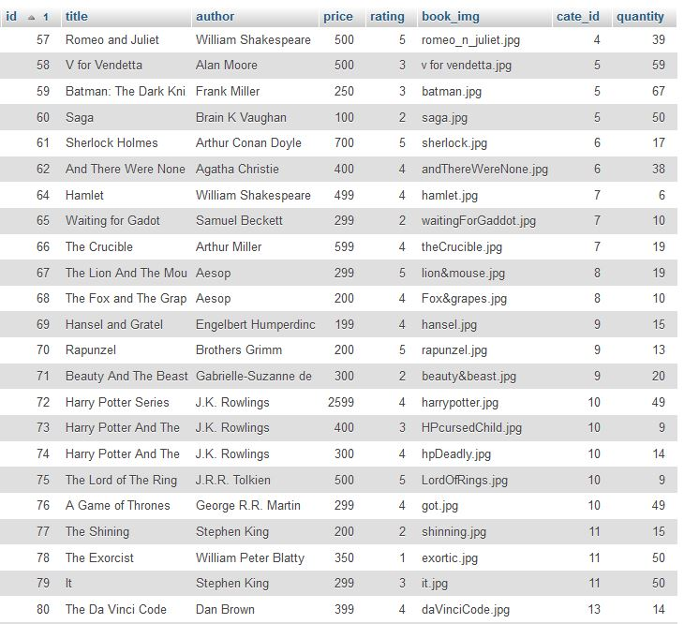
Table 4.3.5 – Cart Table Values
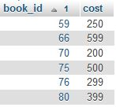
Table 4.3.6 – Bill Table Values
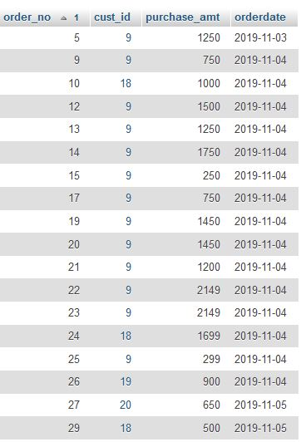

4.4 SQL Triggers & Stored Procedures
Triggers
A database trigger is procedural code that is automatically executed in response to certain events on a table or view in a database. The trigger is mostly used for maintaining the integrity of the information on the database.
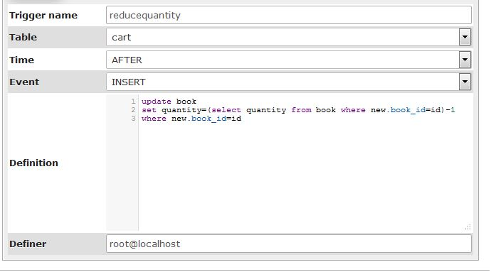
Stored Procedure
A stored procedure is a set of Structured Query Language (SQL) statements with an assigned name, which are stored in a relational database management system as a group, so it can be reused and shared by multiple programs.
Code for Stored Procedure is as follows:
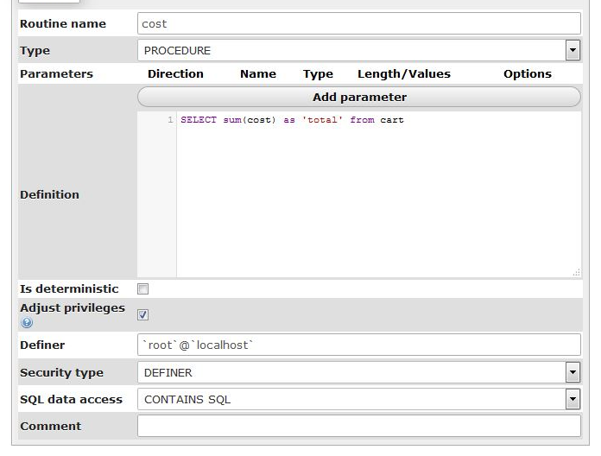
4.5 Database Connectivity
In computer science, a database connection is the means by which a database server and its client software communicate with each other. The term is used whether the client and the server are on different machines. The client uses a database connection to send commands to and receive replies from the server. A database is stored as a file or a set of files on magnetic disk or tape, optical disk, or some other secondary storage device. The information in these files may be broken down into records, each of which consists of one or more fields. The connection to XAMPP database is obtained by the following code snippet:
<?php
$conn = mysqli_connect(“localhost”, “root”, “”, “dbms”);
//Check connection
if(mysqli_connect_errno()){
echo “Failed to connect to MySQL:”. mysqli_connect_error();
}
?>
4.6 Modules
The data flow diagram to transit through the various modules in this project are as shown below:
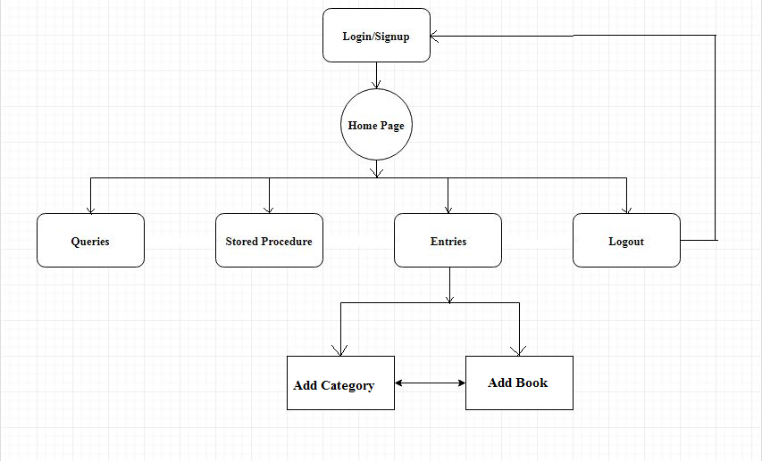

Chapter 5
RESULTS
Home page for the online bookstore: PICK-A-BOOK

Figure 5.1: Home page.

Signup page for new customers
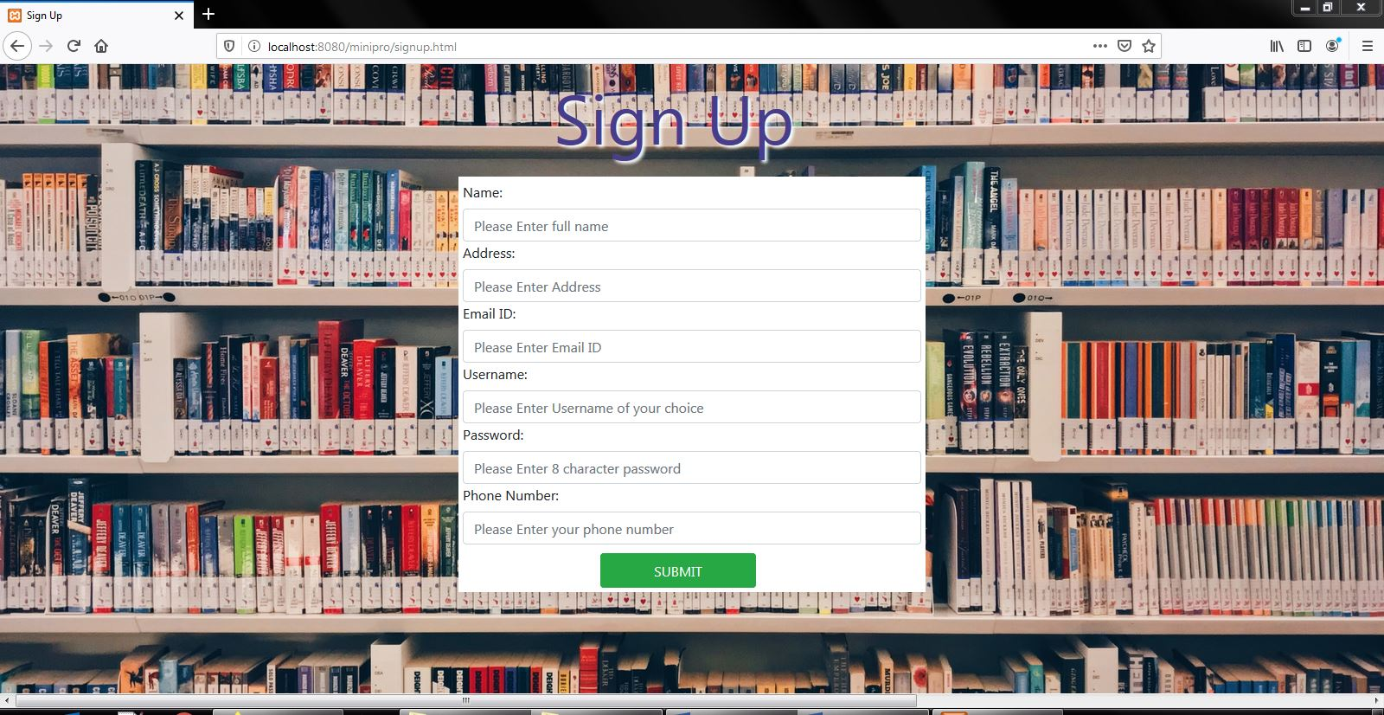

Figure 5.2: Customer Registration Page.

User login page

Figure 5.3: Customer Login Page.
User dashboard page to select books
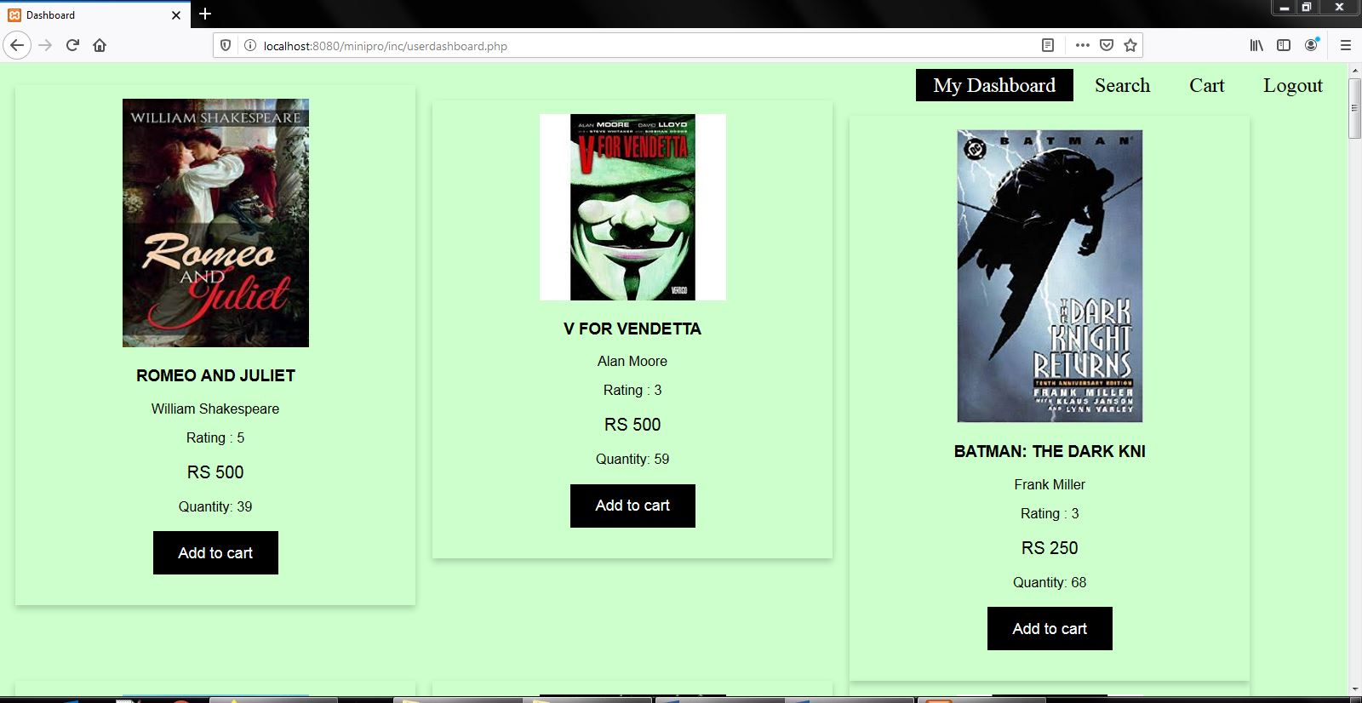
Figure 5.4: User Dashboard Page.
Searching for a book
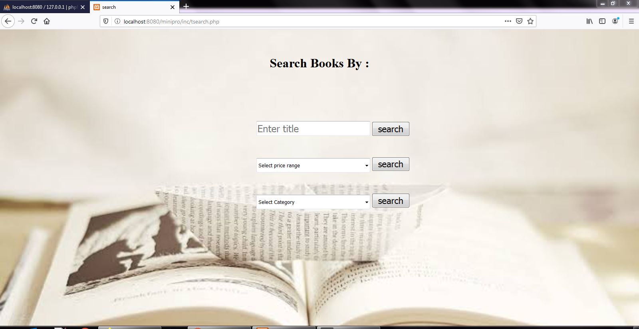
Figure 5.5: Search Query Page
Searching a book by its Title

Figure 5.6: Resulting Page of Search by Title.
Searching a book by price range
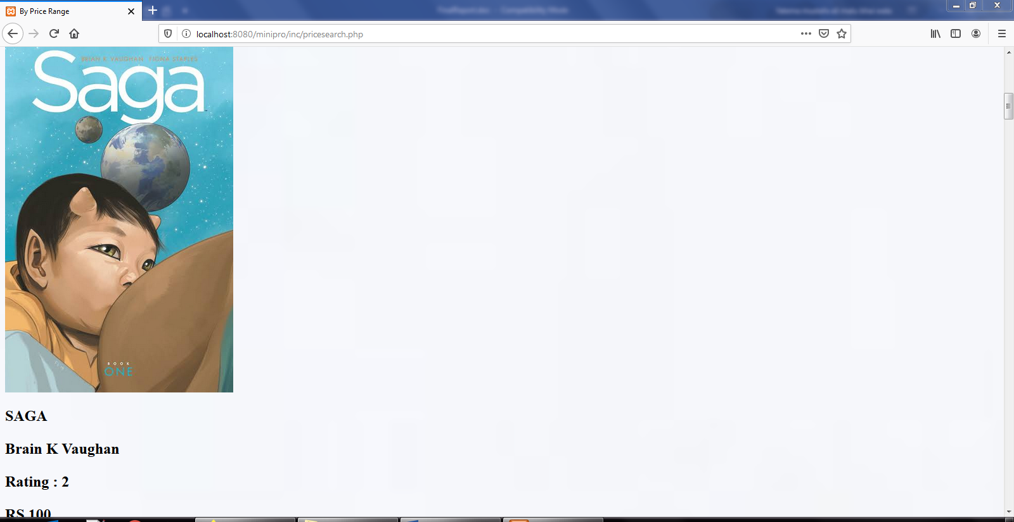
Figure 5.7: Resulting Page of Search by Price Range.
Searching a book by category

Figure 5.8: Resulting Page of Search by Category.

User’s cart with added books for buying
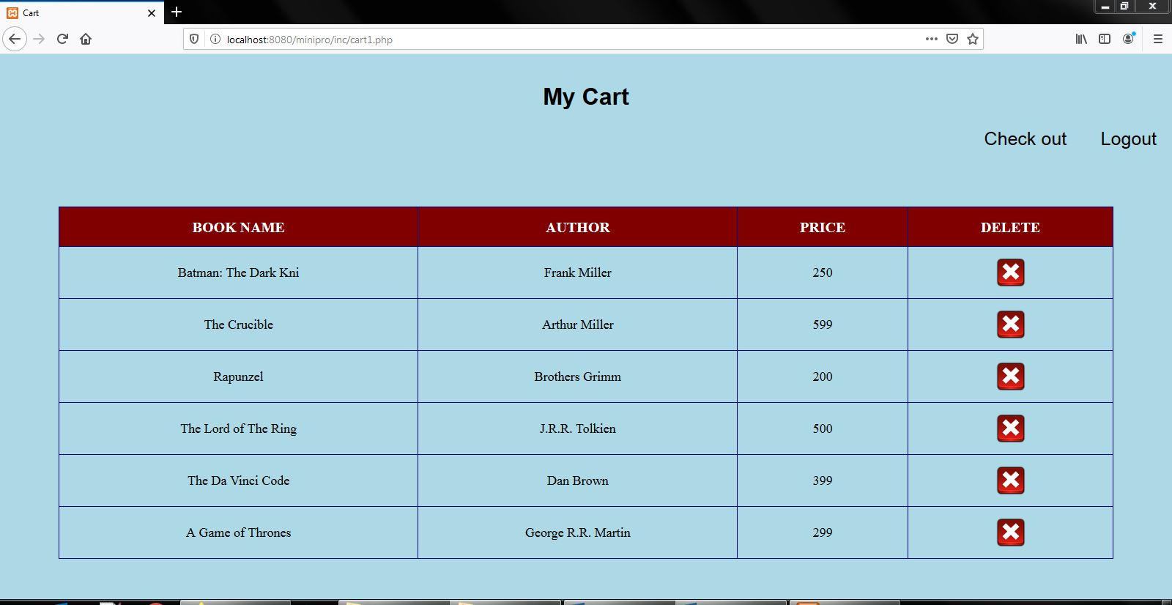
Figure 5.9: Customer Cart Page.

Bill generated for the user on checkout
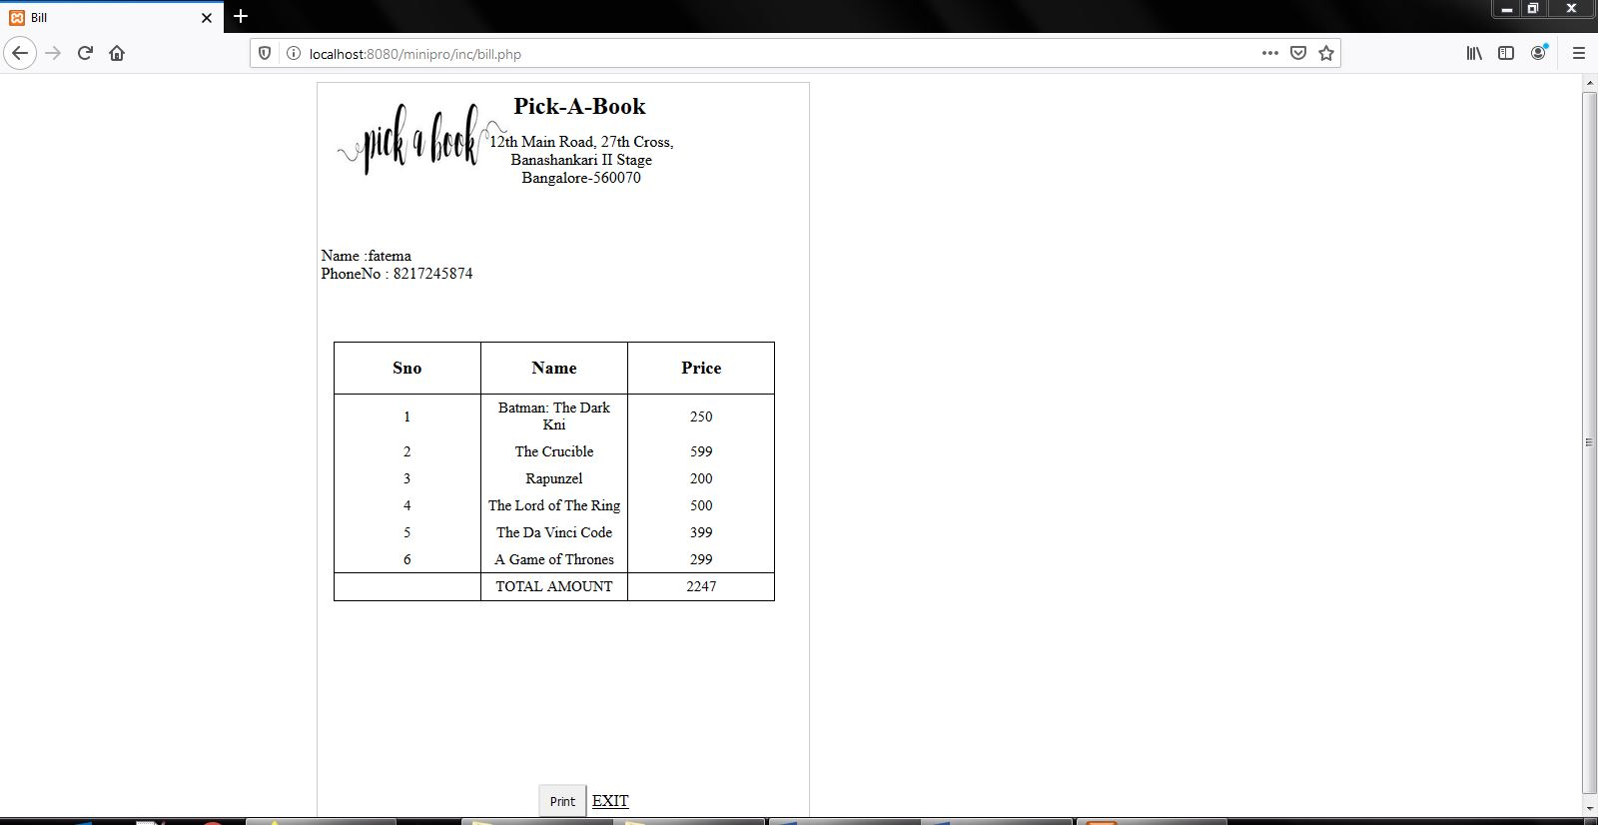
Figure 5.10: Customer Bill Generation Page.

Administrative login page

Figure 5.11: Admin Login Page.
Admin dashboard with all the privileges that admin can have.
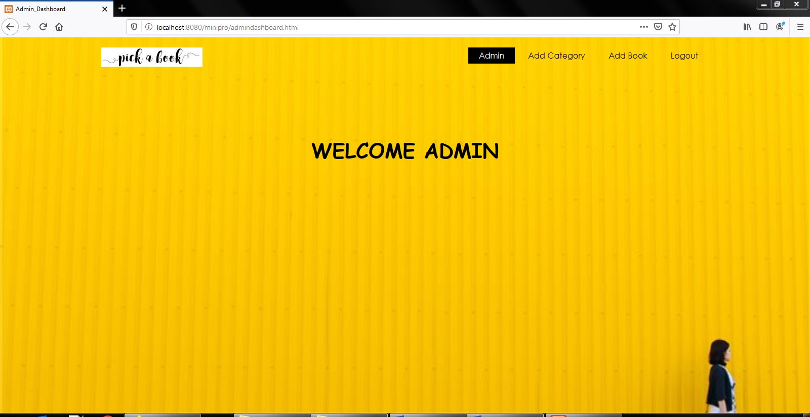
Figure 5.12: Admin Dashboard Page.
Adding of category by admin
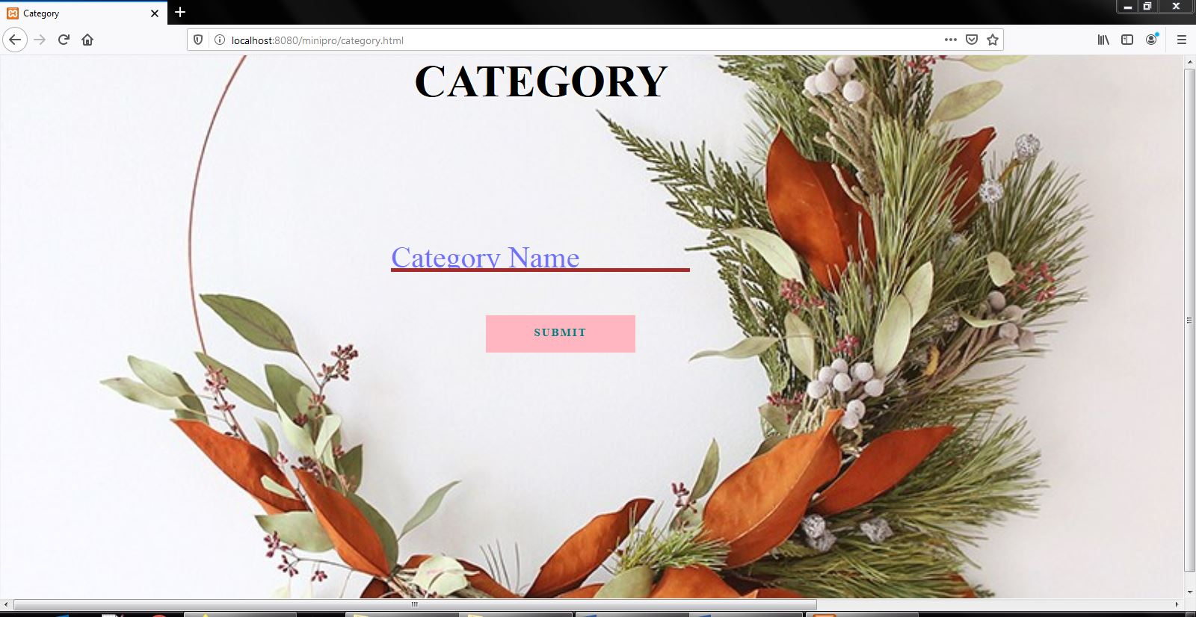
Figure 5.13: Add Category Page.

Adding of book along with its details by admin
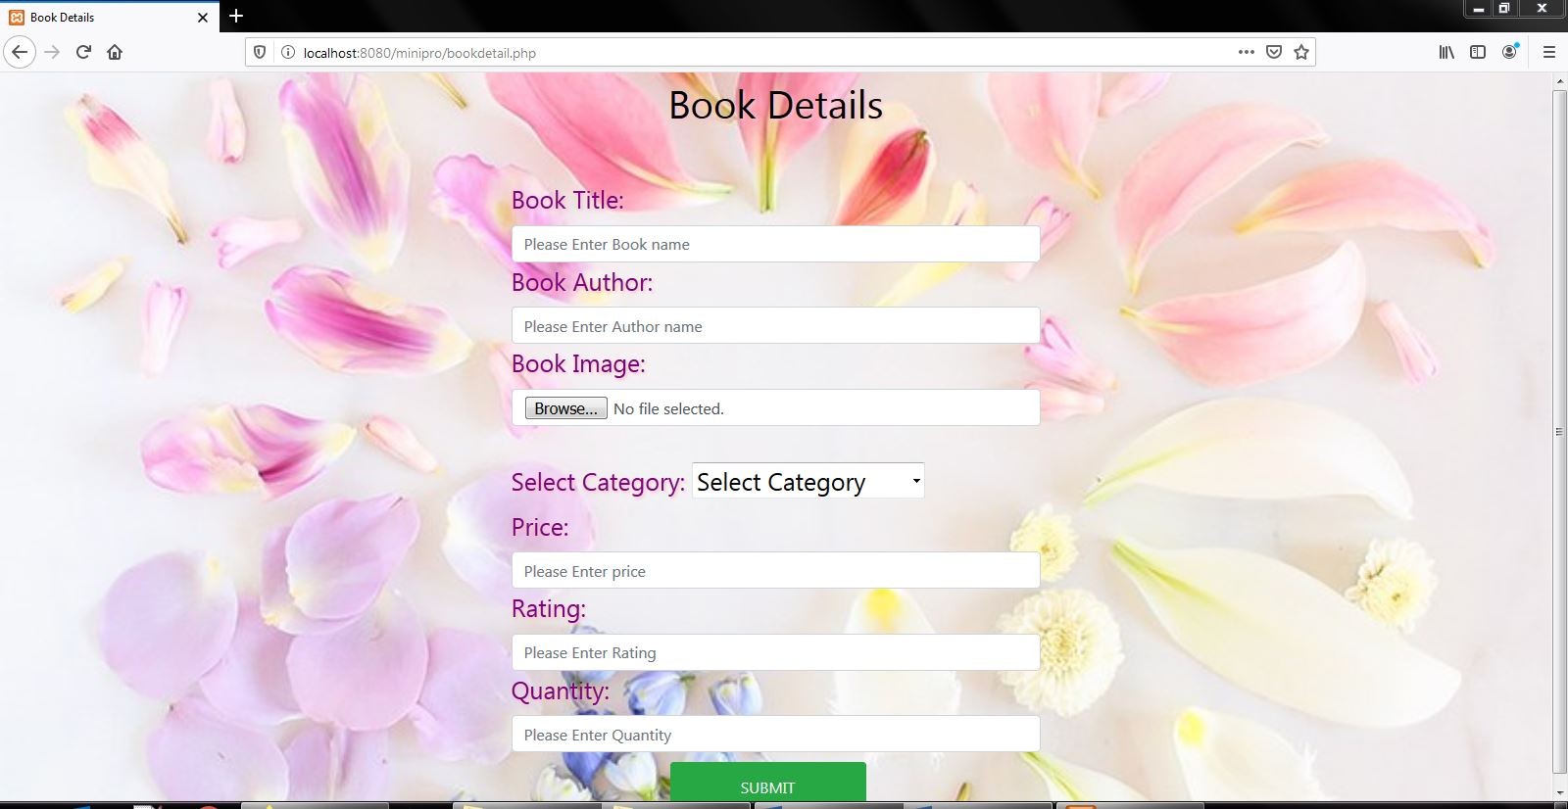
Figure 5.14: Add Book Details Page.

Contact Us page for customers to send their queries and contact us when they require

Figure 5.15: Contact Us Page.

Chapter 6
CONCLUSION AND FUTURE ENHANCEMENT

Conclusion:
The Online Bookstore management project is designed to meet the requirements of a bookstore. The main aim of maintaining the bookstore data has been achieved in this system. It has been developed in PHP, HTML, CSS keeping in mind the specification of the system.
For designing the system, PHP is being used as the front end in phpMyAdmin
Environment. Overall the project teaches us the essential skills like:
• Understanding the database handling and query processing
• Implement, analyze and evaluate the project developed for an application
• Demonstrate the working of different concepts of DBMS

Scope of Future Enhancement
This project can be used in the real-world bookstore after adding some more useful modules in the project for which the respected bookstore is providing services
Nowadays bookstore is providing many other facilities, this project can also be improved with the improvement in those stores.
Additional features that can be added to this project in future are:
- Different online payment gateways can be added to felicitate online transaction.
- Delivery services based on the address of the customer can be included.
- SMS based alert system can be added after purchasing the book.
- Seller wise books can be maintained in the future.
Utmost care and back-up procedures must be established to ensure 100% successful implementation of the computerized Bookstore system. In case of system failure, the organization should be able to process the transaction with another organization and in case of failure; it should be able to complete the process manually.

