**East West University**

**CSE412: Software Engineering**

**Project Report (SRS)**

**PET : Personal Expense Tracker**

**Section: 2**

**Group: 08**

**Group Name: Team Noob**

**Name & ID of Students:**

| Abu Kahhar Mohammad Sakib | 2021-1-60-040 |
| --- | --- |
| Prioti Kar Tithy | 2022-1-60-082 |
| Budrun Nahar Bristy | 2022-1-60-144 |
| Fatema Tuz Zannat | 2022-1-60-153 |

**Course Instructor Information:**

Yasin Sazid

Lecturer

Department of Computer Science and Engineering

East West University

| **Table of Contents** | |
| --- | --- |
| **Contents** | **Page No.** |
| 1. Introduction   * Project overview * Purpose and scope * Stakeholders | 02 - 03 |
| 2. Requirements Engineering Process | 04 - 11 |
| 2.1 Stakeholder Needs & Analysis   * Primary and Secondary Stakeholders * Methods Used for Requirement Elicitation | 04 |
| 2.2 List of Requirements   * User Requirements * Functional requirements (FRs) * Non-functional requirements (NFRs) * Extra-ordinary requirements | 05 - 06 |
| 2.3 House of Quality (QFD Integration)   * Customer Requirements (CRs) List * Engineering Requirements (TRs) List * QFD Matrix (House of Quality) | 06 - 07 |
| 3. Requirements Modeling   * Use case diagrams * Activity diagrams * Prototyping using wireframes or UI sketches | 08 - 12 |
| Appendix | 13 - 22 |

## **1. Introduction**

## The **Personal Expense Tracker** is a software application that enables users to manage their daily financial transactions efficiently. It provides a structured platform where users can log income and expenses, categorize transactions, and generate insightful reports for better financial decision-making.

### **Project Overview**

A user wants to track the budget via a web-based application. For starters, he sets up an account via his email and password. Upon sign-up, he securely logs in to access his saved financial data on the website. With the dashboard, he can create new spending and income transactions by inputting fields like description, date, category, and amount. If they make a mistake, they can revise or remove transactions to maintain their records accurately.

To better control expenses, the user allocates transactions to predefined categories like Food, Rent, and Entertainment. They can define monthly budget limits for certain categories or all together to limit spending and get notified when they are near or have crossed their budget. The system also offers AI-driven forecasts for next month's spending based on historical spending patterns, enabling them to plan their finances.

The user can also invite family members to the platform, making it a family-shared expense tracker. Every member can monitor their income and expenses, which will create a combined financial summary. The system will update all transactions in real-time, so everyone will be made aware of the economic condition of the family. To check their spending, users visit the reports feature, where they get interactive graphs and charts displaying money trends. Users can filter reports based on date, category, or transaction type to receive precise information. The system should further provide a breakdown of total income, spending, and savings over a specified time and give a general financial overview for the user or the entire family.

### **Purpose**

The purpose of this project is to provide an efficient and user-friendly solution for tracking personal finances. By offering a streamlined approach to logging income and expenses, users can maintain financial discipline, identify spending patterns, and improve budgeting skills.

### 

### **Scope**

This project include:

* Manage expenses and income entries
* Expense and income tracking with categorization
* Monthly budget planning and alerts
* Data visualization through charts and graphs
* Secure authentication and data storage
* Report generation for better financial analysis
* AI-based predictive analytics
* Collaborative expense management

### **Stakeholders**

* Users (Individuals Managing Personal Finances)
* Product Owner/Project Manager
* Development Team
* Financial Advisors
* Regulatory Authorities
* Technical Support & Maintenance Team

## 

## **2. Requirements Engineering Process**

### **2.1 Stakeholder Needs & Analysis**

### **Primary Stakeholders:**

* **Users (Individuals Managing Personal Finances):** 
  + People who will use the application to track income and expenses.
  + Their feedback is crucial in designing a user-friendly experience.

### **Product Owner/Project Manager**

* + Responsible for ensuring the project meets its objectives and aligns with user needs.

### **Project Development Team**

* + Includes developers, UI/UX designers, and testers responsible for building and maintaining the application.

### **Secondary Stakeholders:**

### **Financial Advisors:**

* + May provide insights on financial management best practices to improve the application’s features.

### **Regulatory Authorities:**

* + Entities ensure that the application complies with financial and data protection regulations.

### **Technical Support & Maintenance Team:**

* + Responsible for maintaining and updating the application after deployment.

### **Methods Used for Requirement Elicitation:**

For requirement elicitation we did a Survey and Physical Interview both. Surveys were a useful method for gathering requirements because by doing so we collect information from a broad audience efficiently. Also did 6 physical interviews by asking their requirements for better interaction. For our project, both methods helped us understand the needs and preferences of potential users regarding personal finance management.

### **2.2 List of Requirements**

### **User Requirements:**

* Add, edit and delete expenses
* Add, edit and delete sources of income
* Budgeting of expenditures (e.g., Food, Transport, Rent, Shopping)
* Monthly budget generation and tracking
* Graphical portrayal of financial figures (Graphs, Charts)
* Automatic generation of daily, weekly, and monthly reports
* The data must be secured
* Provide smart recommendations based on expenditure trends.
* Allow shared budgets for groups and families.
* Receipt scanning and integration with other apps and bank accounts. (Not Scalable)
* AI chatbot/ AI assistance (Not Scalable)

### **Functional Requirements (FRs):**

* A user should register/ sign up with proper authentication to enter the website
* Users should be able to add, edit, and delete expenses
* Users should be able to add, edit, and delete income sources
* Categorization of expenses (Food, Transport, Rent, Shopping) should be maintained by the website
* Users can set monthly budget and track expenses
* Uses can get visual representation of financial data (Graphs, Charts)
* Report generation (Daily, Weekly, Monthly summaries) should be viewed by the website
* The users should get alert messages for nearing the set budget or exceeding it.

### **Non-Functional Requirements (NFRs):**

* User data should be protected and to login the user should need proper authentications.
* Application should load within 5 seconds.
* The interface should be simple and mobile-responsive.
* The system should support multiple users simultaneously.

### 

### **Extra-Ordinary Requirements (Wow Factors):**

* Provide smart recommendations based on spending habits using AI.
* Enable seamless synchronization of data across multiple devices.
* The website should support shared budgeting for families and groups.
* The website might reward users with badges for achieving savings goals.

### **2.3 House of Quality (QFD Integration)**

### **Customer Requirements (CRs) List:**

1. Secure Registration & Authentication
2. Expense & Income Management
3. Expense Categorization
4. Budget Setting & Tracking
5. Data Visualization
6. Reports & Summaries
7. Budget Alerts
8. Data Protection & Security
9. Fast & Responsive Interface
10. Multi-User Support
11. Smart AI-based Recommendations
12. Cross-Device Synchronization
13. Shared Budgeting

### **Engineering Requirements (TRs) List:**

1. Authentication & Authorization
2. Database Management and Expense & Income CRUD Operations
3. Expense Categorization Logic
4. Budget Tracking Algorithm
5. Data Visualization
6. Report Generation
7. Real-time Alerts
8. Mobile Responsiveness
9. Performance Optimization
10. Scalability & Multi-User Support
11. AI-based Spending Insights
12. Cloud Data Sync
13. Shared Budgeting Feature

### **QFD Matrix (House of Quality)**

## **3. Requirements Modeling**

### **Use Case Diagram:**

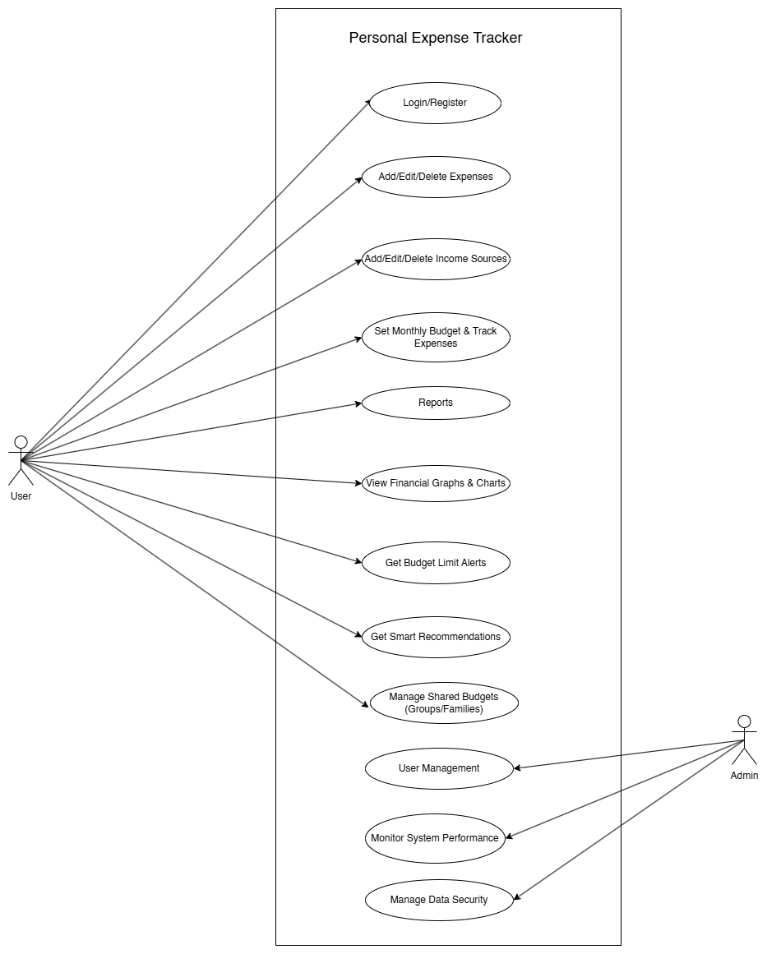

### **Activity Diagram**

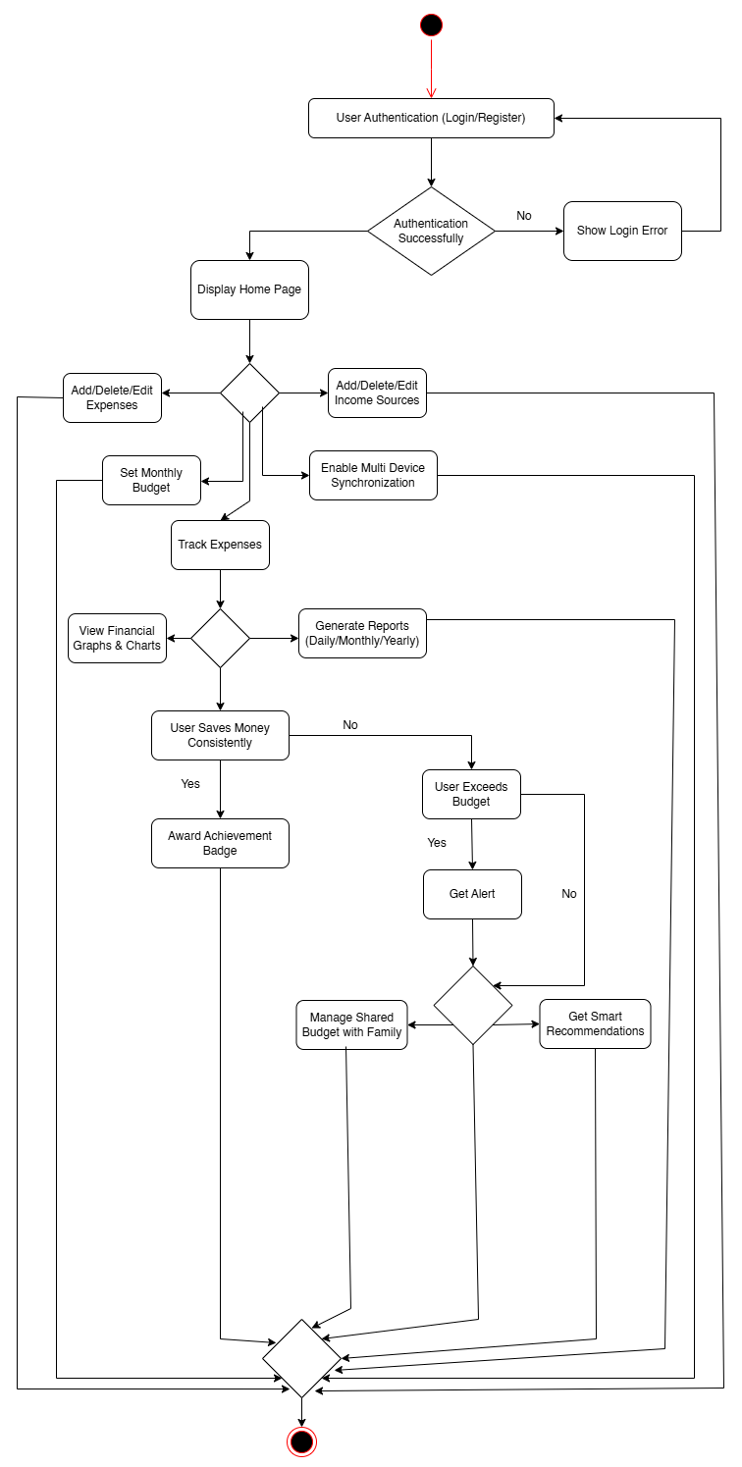

### **Prototype:**

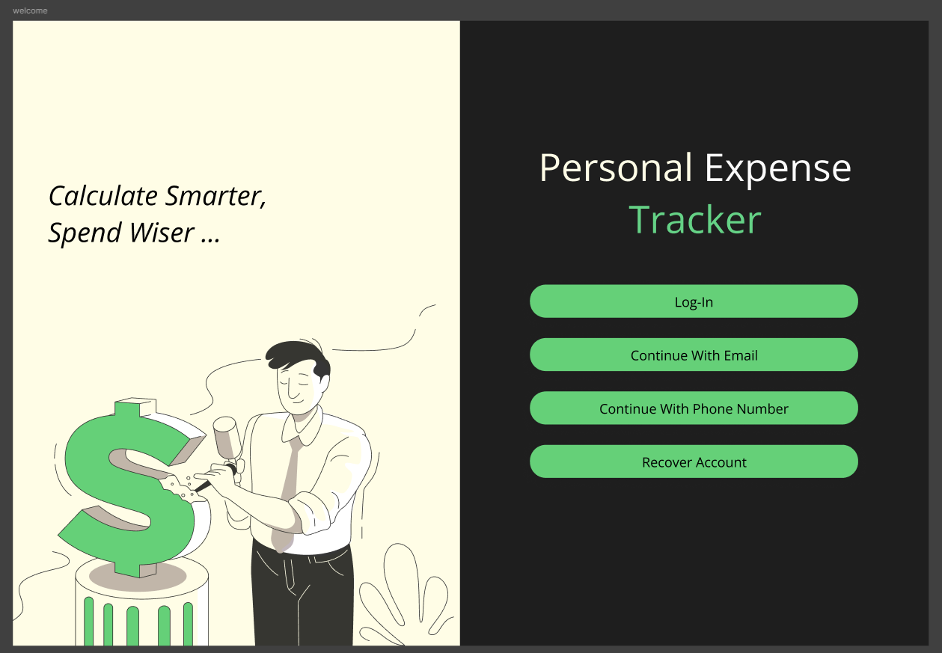

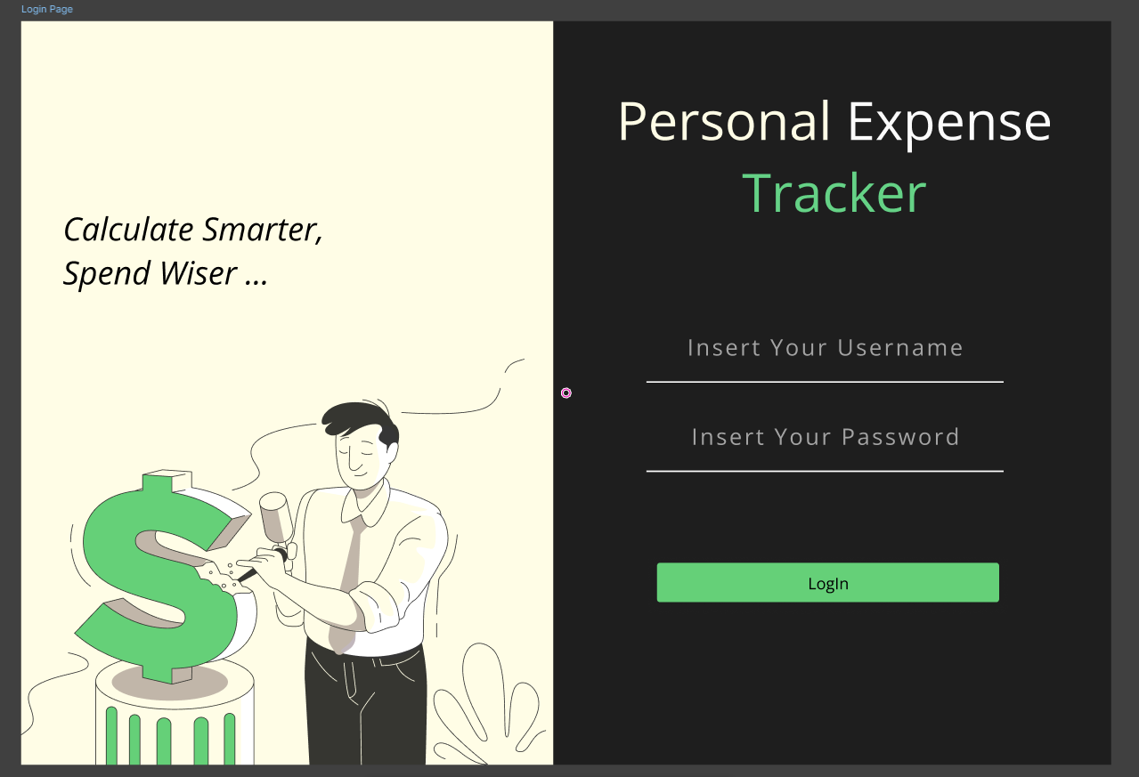

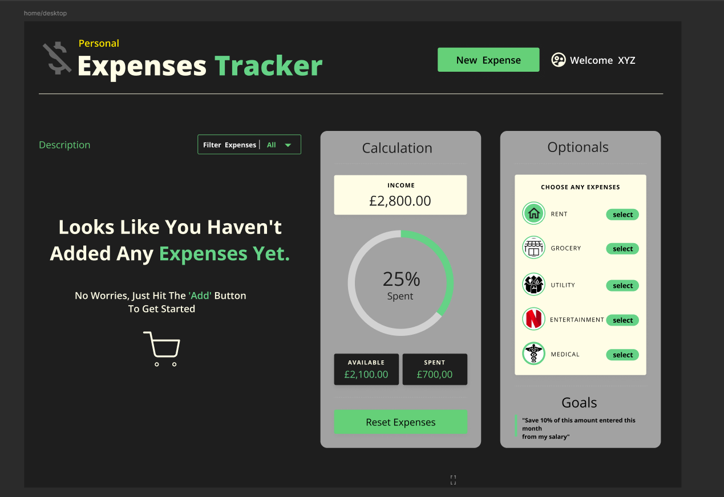

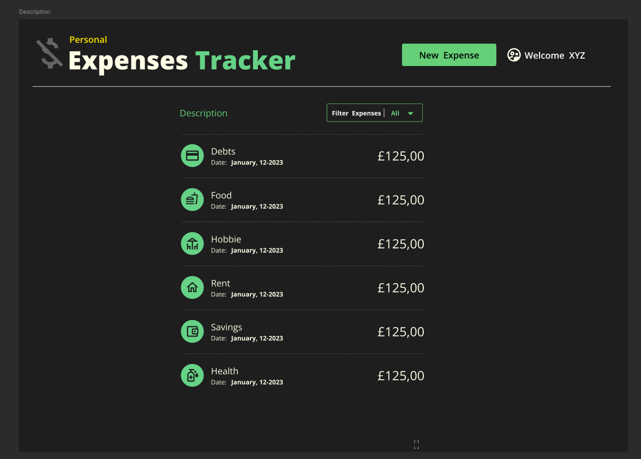

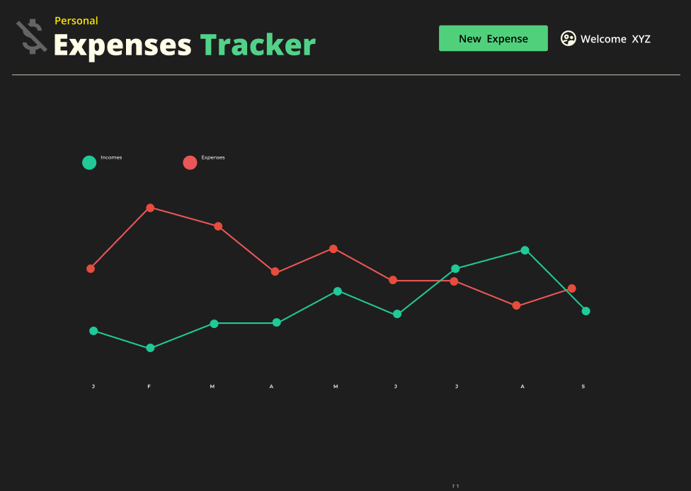

## **Appendix**

### **Google Form Responses**

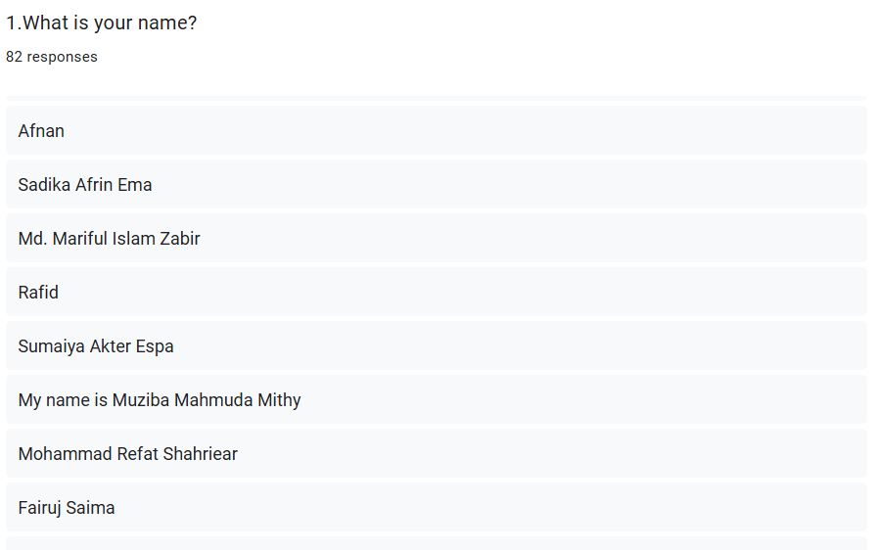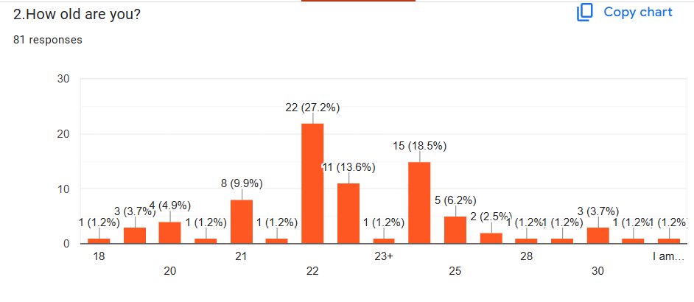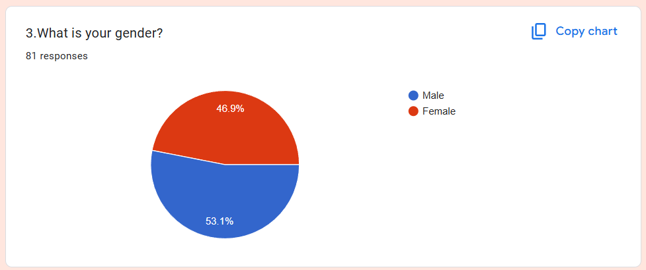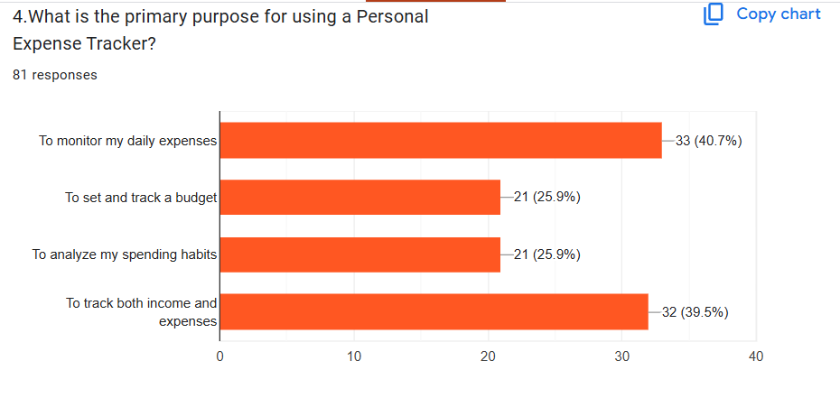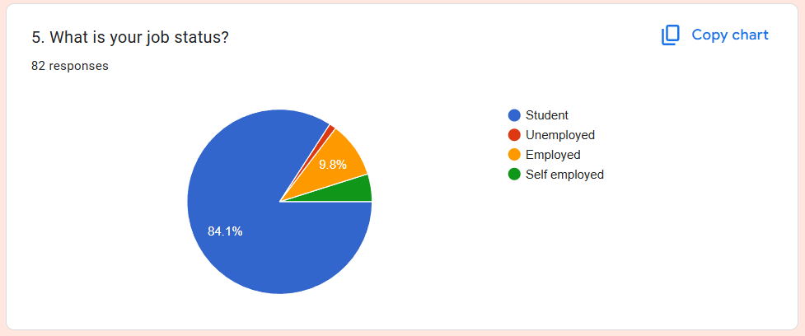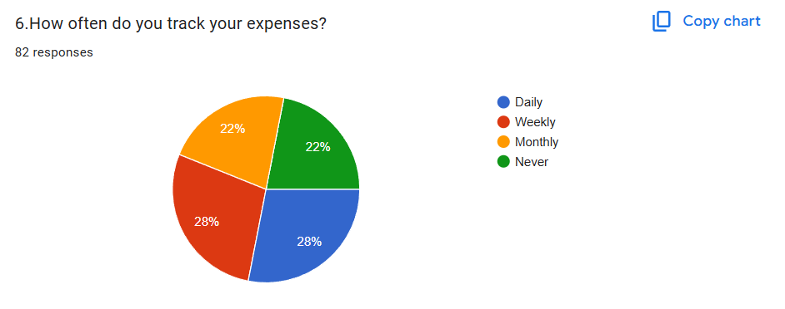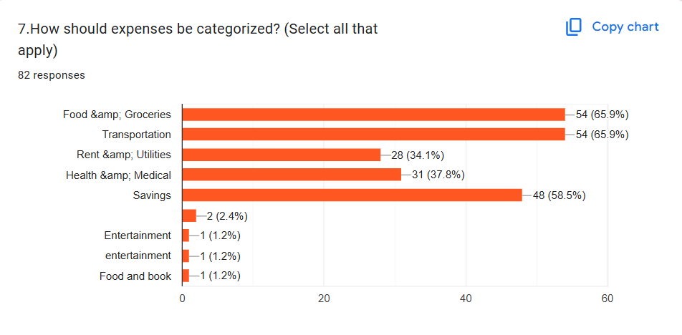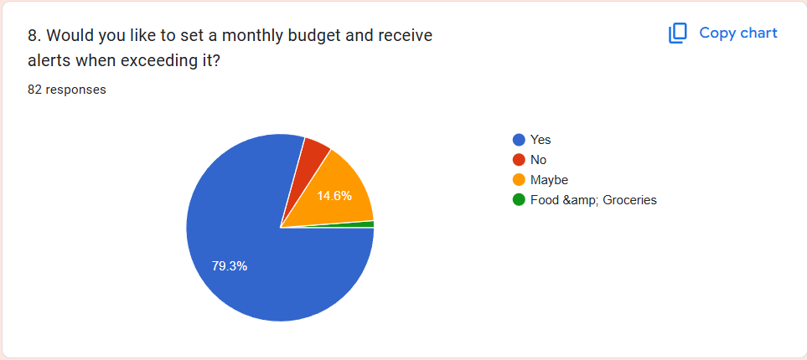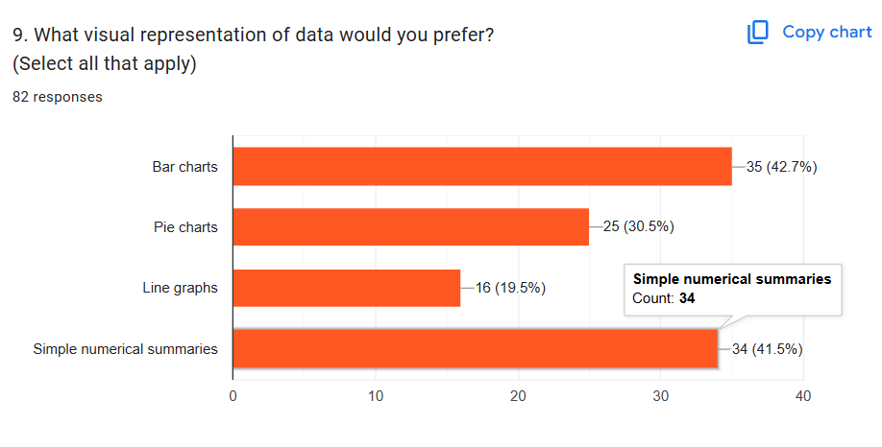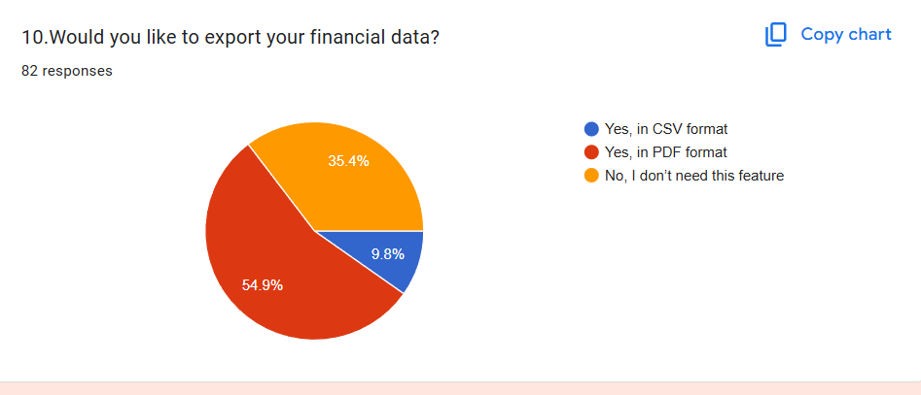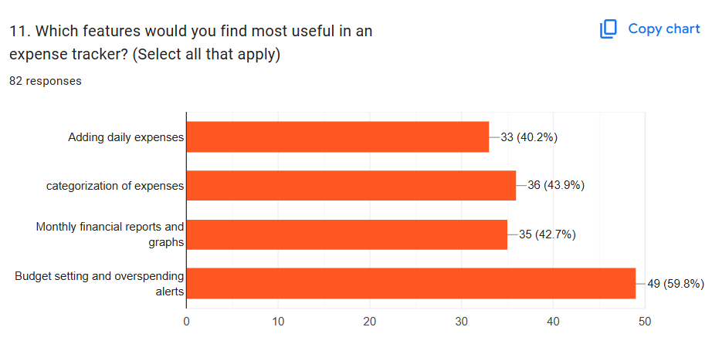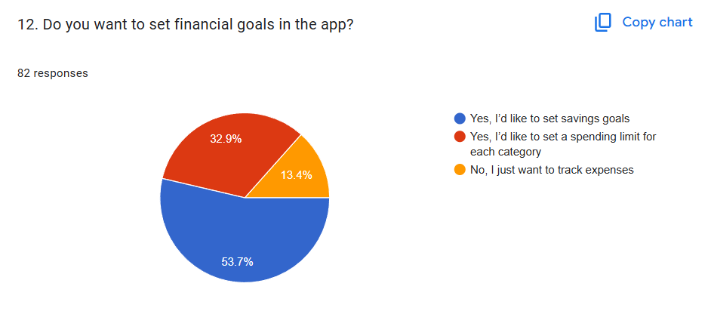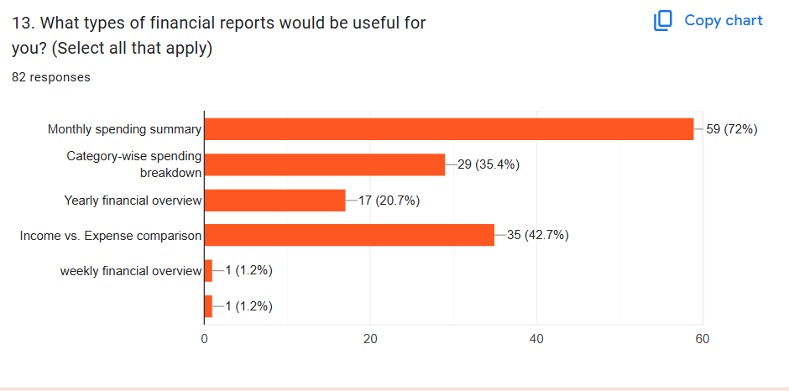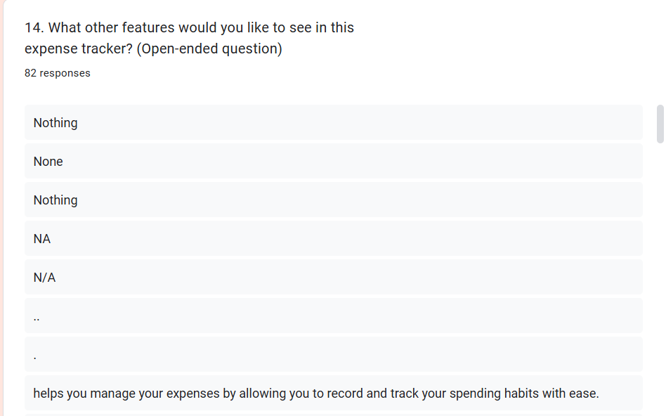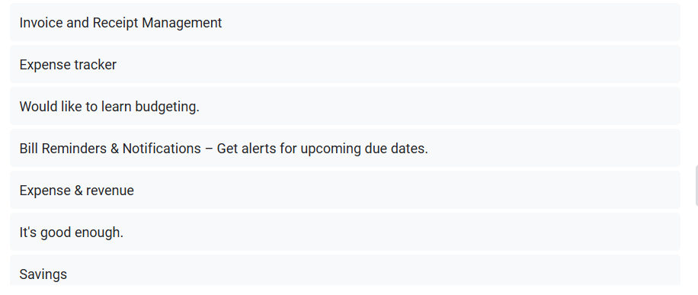

### **Interview Drafts:**

