

American International University-Bangladesh (AIUB)  
**Department of Computer Science and Engineering   
Faculty of Science &Technology (FST)  
Fall 20-21  
CSC 00191- Object Oriented Analysis And Design (OOAD)**

**Section:**

**Project Title: SGSF Hospital Management System**

**Submitted by:**

|  |  |
| --- | --- |
| **Name** | **ID** |
| 1. **Sazia Rahman** | **19-39976-1** |
| 1. **Shaikh Allahma Galib** | **20-42325-1** |
| 1. **Shafiul Islam Mazumder** | **19-41370-3** |
| 1. **Fatema Tuz Zuhura** | **19-41784-3** |

**Submitted to:**

**MD. ANWARUL KABIR**

**Sr. Assistant Professor**

**Department of Computer Science**

# 

# OOAD Project (Group Project)

## Project Proposal

**1. Project Name: SGSF Hospital Management System**

# 2. Project overview

The name of the hospital is “***SGSF***” where patients are come for booking appointment with doctor. Here, one patient will be able to appoint one or more doctor. Before anything at first, patient will register themself. Receptionists have to log in and book an appointment for a patient. On the contrary there one doctor handles the Prescription, Admit, Operations, Tests, of one or many patients. Nurses will update treatment history of all patients. All these doctoral handles will be recorded under the treatment history. Patients can call for ambulance by receptionist. When a doctor refers a patient to be admitted, then receptionist check for cabin availability and allot for the patient. After that discharge of a patient, receptionist make the cabin unallocated from the patient. There an automated bill calculator system will generate the bill based on a patient’s treatment history and verify patient’s payments. Patient can pay bill by cash or card. Technologists also can do many tests of many patients at a day and after the confirmation of technologist, receptionist provide the test reports to the patient. Doctors will be performing doctor while they can reach 50 patient a month. After that, Patient will Regular patient while the takes



treatment by every two months. Patient’s Id will be locked for a due of over 1 year after alarm.

**COMPONENTS**

Patients : To login, Register themselves at first , Booking appointment with

doctor , Call for ambulance by receptionist , Verify, Pay bill .

Technologist : Can do test, Provide the test report to receptionist.

Doctor : To handle prescription, admit, operations, tests which all in one in

Treatment History and pass it to nurse

Nurse : Update the system history, Then generate the bill to near Bill Calculator.

**-------------------------------------------------------------**



# 3. Justification :

**Hospital Management System is a large system including several subsystems or modules providing variety of functions. UML use case diagram example above shows actor and use cases for a hospital management system. In this Pandemic situation we don’t need to go out from home so that we can easily booking seat in hospital, admit, consult with doctor and so on. Hospital Management System is powerful, flexible, and easy to use and is designed and developed to deliver real conceivable benefits to hospitals. Hospital Management System is designed for multispeciality hospitals, to cover a wide range of hospital administration and management processes. It is an integrated end-to- end Hospital Management System that provides relevant information across the hospital to support effective decision making for patient care, hospital administration and critical financial accounting, in a seamless flow. It also**

**reduce the unemployment problem. In this Covid-19 pandemic situation it is a great opportunity by this system. Hospital Management System is a software product suite designed to improve the quality and management of hospital management in the areas of clinical process analysis and activity-based costing. It enables you to develop your organization and improve its effectiveness and quality of work. Managing the key processes efficiently is critical to the success of the hospital helps you manage your processes. The Unified Modeling Language (UML) is a standard language for specifying, visualizing, constructing, and documenting the software system and its components. It is a graphical language , which provides a vocabulary**

**and set of semantics and rules. The UML focuses on the conceptual and physical representation of the system. It captures the decisions and understandings about systems that must be constructed. It is used to understand, design, configure, maintain, and control information**



**about the systems. A usecase diagram in the Unified Modeling Language(UML) is a type of behavioral diagram defined by and created from a use-case analysis. its purpose is to present a graphical overview of the functionality provided by a system in terms of actors, their goals(represented as use cases),and any dependencies between those use cases.**

**Hospital Management System is essential and mandatory for healthcare establishments**

**like nursing homes, rehabilitation centers, clinics, hospitals, health clinics, dispensaries, and more. Some of the top benefits of implementing an HMS are role-based access control, data accuracy, revenue management, appointment booking, and data security. The implementation of hospital management system project provides the institution with different advantages that improve the service quality and efficiency.**

**As mentioned above it is created for groups of users: Patients, Nurse, Doctor and third-parties like Receptionist, Technologist, Automated Bill Calculator. The interaction between them conveys the general performance.**

**The benefits received by a certain group of users also positively influence the work of the others. Cooperation and communication are the fundamental requirements here.**

**---------------------------------------------------------**



# 4. Overall Use Case of the Proposed Project

***System*** - SGSF Hospital

***Patients*** : _ booking appointment

_ register

_ call for ambulance

_ pay bill (cash or card)

***Doctor*** : _ handle (prescription, admit, operations, tests)

_treatment history



***Receptionist*** : _ login (book an appointment)

_ provide test report

_ check for cabin availability ( allot for the patient )

_ make the cabin unallocated

***Nurses*** : _update the treatment history

_assist

***Technologists*** : _ can do many tests

***Automated Bill Calculator*** : _ bill based on treatment history



_ verify patients payment



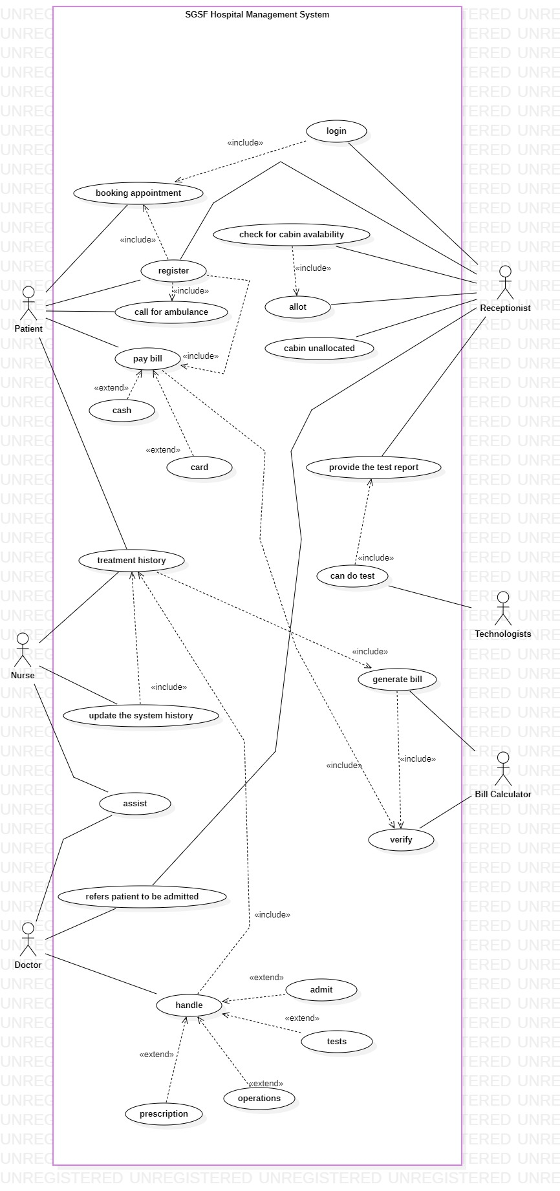

**Class Diagram**

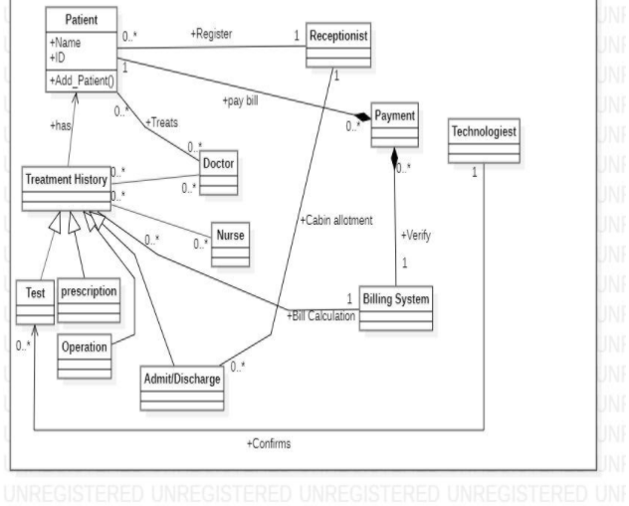

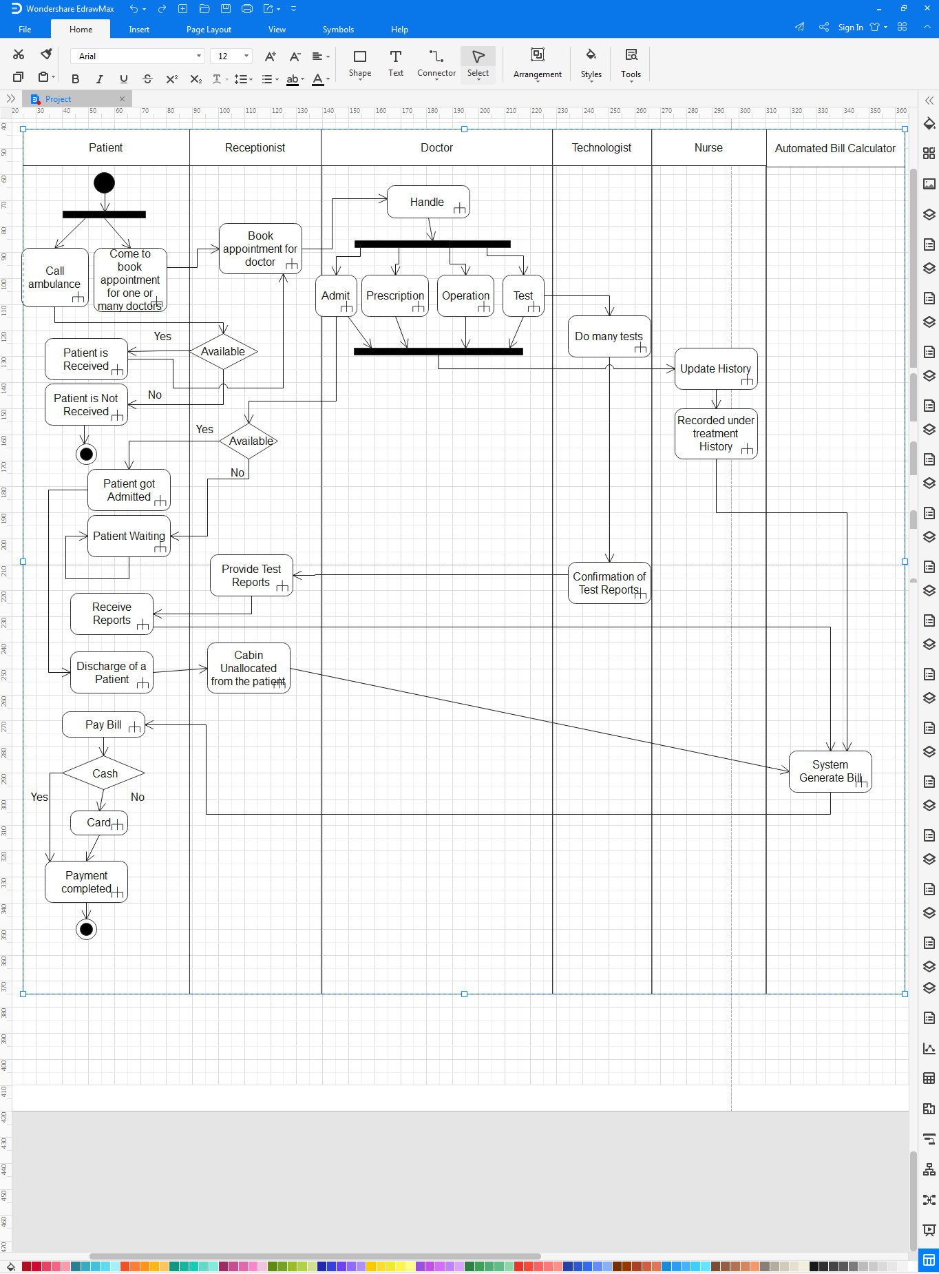**Activity Diagram**

**Sequence Diagram**

Here sequence diagram has 2 parts which one is Book Appointment and the other one is Pay Bill.

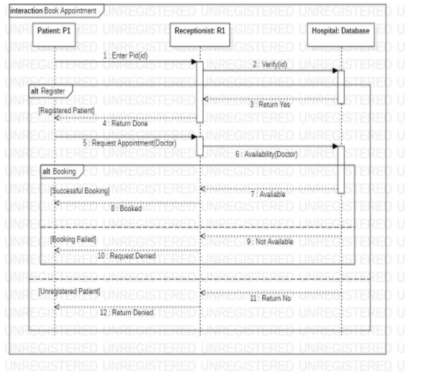



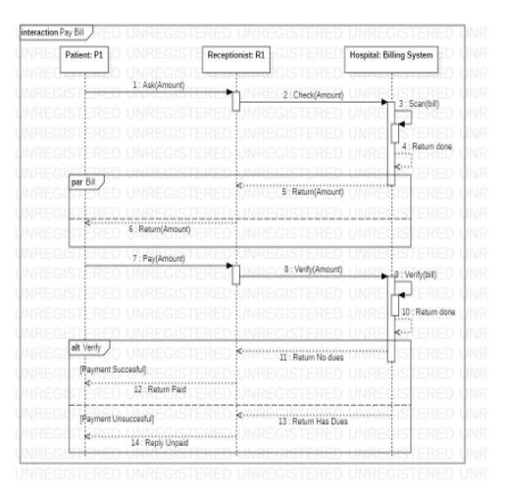

**State Chart Diagram**

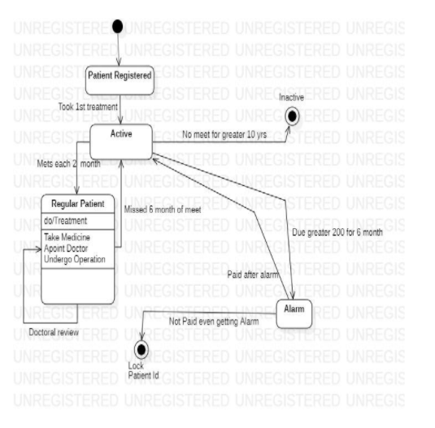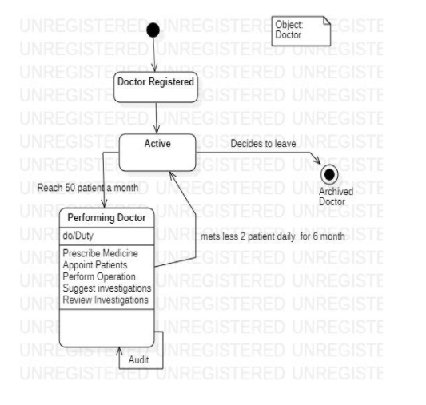



*The End………*



**MD. ANWARUL KABIR**

**Sr. Assistant Professor**

**Department of Computer Science**