|  |
| --- |
| Ans to Q no:1.1 |
| Test case id: QAAE2002 |
| Created by: Fatema Akter (Lead QA) |

|  |
| --- |
| Date: 7/19/2020 |
| Required: Browser installed on computer and internet connection. |

|  |
| --- |
| Test case Description: Contact Us Form shall be available in the footer and in the contact us page. Should be able to contact with valid information and get a success message while submit. Izaan should get an email. |

|  |  |  |  |
| --- | --- | --- | --- |
| Test steps | Detals | Expected | result |
| Step 1 | <http://izaan.s3-website-us-east-1.amazonaws.com/> copy and past this URL to google search and click enter | Izaan website should be appear. | passed |
| Step 2 | Contact Us Form shall be available in the footer | Contact Us Form shall be available in the footer | passed |
| Step 3 | In the header, mouse over About Us, A drop down should appear with Contact us clickable link. | Contact us clickable link appeared under About us menu. | passed |
| Step 4 | Should be able to click on “contact us” and “send US A MESSEGE” page should appear. | “contact us” page appears | passed |
| Step 5 | In the footer and contact us navigation section, for “send us a message” form, User should input the invalid name, valid email, valid confirmation email, valid phone number, input message, click on send message button, and should get an confirmation message “ message sent successfully”. | Should be able to send message with an invalid name and other valid information. And got a confirmation message. | passed |
| Step 6 | In the footer and contact us navigation section, for “send us a message” form, User should input the valid name, valid email, valid confirmation email, valid phone number, input message, click on send message button, and should get an confirmation message “ message sent successfully”. | Should be able to send message with an invalid name and other valid information. And got a confirmation message “ message sent successfully”, Izaan got an email. | passed |
| Step 7 | In the footer and contact us navigation section, for “send us a message” form, User keep empty name field, valid email, valid confirmation email, valid phone number, input message, click on send message button, and should get an confirmation message “ Name cannot less than 2 char””. | Should not be able to send message with an empty name and other valid information. And got a confirmation message ” Name cannot less than 2 char” | passed |
| Step 8 | In the footer and contact us navigation section, for “send us a message” form, User input some space on name field, valid email, valid confirmation email, valid phone number, input message, click on send message button, and should get an confirmation message “ Name cannot less than 2 char””. | Should not be able to send message with some space name and other valid information. And got a confirmation message ” Name cannot less than 2 char” | passed |
| Step 9 | In the footer and contact us navigation section, for “send us a message” form, User input name on name field, invalid email, invalid confirmation email, valid phone number, input message, click on send message button, and should get an confirmation message “please enter valid email address” | Should not be able to send message with invalid email and other valid information. And got a confirmation message ” please enter valid email address” | passed |
| Step 10 | In the footer and contact us navigation section, for “send us a message” form, User input name on name field, valid email, valid confirmation email, valid phone number, input message, click on send message button, and should get an confirmation message “please enter valid email address” | Should not be able to send message with invalid confirmation email and other valid information. And got a confirmation message ” please enter valid email address” | passed |
| Step 11 | In the footer and contact us navigation section, for “send us a message” form, User input name on name field, empty email, valid confirmation email, valid phone number, input message, click on send message button, and should get an confirmation message “please enter valid email address” | Should not be able to send message with empty email and other valid information. And got a confirmation message ” please enter valid email address” | passed |
| Step 12 | In the footer and contact us navigation section, for “send us a message” form, User input name on name field, valid email, empty confirmation email, valid phone number, input message, click on send message button, and should get an confirmation message “please enter valid email address” | Should not be able to send message with empty confirmation email and other valid information. And got a confirmation message ” please enter valid email address” | passed |
| Step 13 | In the footer and contact us navigation section, for “send us a message” form, User input name on name field, valid email, valid confirmation email, invalid phone number, input message, click on send message button, and should get an confirmation message “please enter valid phone number” | Should not be able to send message with invalid phone number and other valid information. And got a confirmation message “please enter valid phone number” | passed |
| Step 14 | In the footer and contact us navigation section, for “send us a message” form, User input name on name field, valid email, valid confirmation email, empty phone number, input message, click on send message button, and should get an confirmation message “please enter valid phone number” | Should not be able to send message with empty phone number field and other valid information. And got a confirmation message “please enter valid phone number” | passed |
| Step 15 | In the footer and contact us navigation section, for “send us a message” form, User input name on name field, valid email, valid confirmation email, valid phone number, empty message field, click on send message button, and should get an confirmation message “please enter message” | Should not be able to send message with empty message field and other valid information. And got a confirmation message “please enter message” | Passed |

Ans to Q no:1.2

regression test plan:

|  |  |  |
| --- | --- | --- |
| Terminology | plan | example |
| Test objective | Need to check all button and links are working properly on <http://izaan-test.s3-website-us-east-1.amazonaws.com/> | Trying to check functionality f a feature. |
| Test object | Component to be tested | Links and buttons |
| Test item | To check all the links and buttons are working. | Check all the link navigation bar working properly, user can sign in, sign up, send message, can extend content by read more button. |
| Test condition | Browser installed on computer and internet is connected. |  |

regression test cases:

|  |  |  |  |
| --- | --- | --- | --- |
| test steps | Details | expected | Result |
| 1 | <http://izaan.s3-website-us-east-1.amazonaws.com/> copy and past this URL to google search and click enter | Izaan website should be appear. | passed |
| 2 | When bring the cursor on the top of the page, the mouse over navigation bar should appear. | Navigation bar appears | Passed |
| 3 | When bring cursor on software development , it should color change, and should be able to click on it and software development page should appear | Able to click and the expected page appears | passed |
| 4 | The navigation bar should be top f the page and should be able to navigate to other pages. | navigation bar is working good and able to go back to home page by clicking Izaan | passed |
| 5 | When mouse over staffing, it should provide dropdown click able list. | The dropdown click able list is there | passed |
| 6 | Click on staffing from staffing dropdown and it should go to staffing page. | Able to visit staffing page from staffing dropdown. | passed |
| 7 | The navigation bar should be top f the page and should be able to navigate to other pages from staffing page | navigation bar is working good and able to go back to home page by clicking Izaan | passed |
| 8 | Click on resume upload from staffing dropdown and it should go to resume upload page. | Able to visit resume upload page from staffing dropdown. | passed |
| 9 | Should be able to click on upload button on resume upload, and a resume upload confirmation form should appear. | a resume upload confirmation form appeared . | passed |
| 10 | Should be able to fill all the field can able to click on confirm resume upload button and get a confirmation message | Able to upload resume and got confirmation message. | passed |
| 11 | The navigation bar should be top of the page and should be able to navigate to other pages from resume upload page | navigation bar is working good and able to go back to home page by clicking Izaan | passed |
| 12 | Should be able to click on training on navigation bar, and training page should appear | Able to click and the expected page appears | passed |
| 13 | The navigation bar should be top f the page and should be able to navigate to other pages | navigation bar is working good and able to go back to home page by clicking Izaan | passed |
| 14 | Should be able to click on about Izaan on navigation bar, and About us page should appear | Able to click and the expected page appears | passed |
| 15 | The navigation bar should be top of the page and should be able to navigate to other pages | Able to click and the expected page appears | passed |
| 16 | Contact us from about us dropdown would be clickable and display a page with send us a message form on footer | Able to click and the expected page appears | passed |
| 17 | Should be able to send message with valid data by clicking send message button and got a confirmation message. | Able to click | passed |
| 18 | Able to click on sign in button  And signing page appear | Able to click | passed |
| 19 | Able to click on sign as client | Able to click on sign as client | passed |
| 20 | Able to click on sign as trainee | Able to click on sign as trainee | passed |

Ans to Q no:1.3

Ans to Q no:2

Website link on ec2 insane: <http://18.222.215.230/>

2.7. Describe what is Client/Server Architecture?

Client /server Architecture is a computing model where server or host provide services to the client. Within the connection of internet, we can connect to anywhere in the world by following some Architecture for communication.

Client computer send request to server for any kind of service, then server accept the request, process it and provide the service as requested to client. One server can provide service to many clients in same time, and a client can connect to many servers at same time.

Google server can provide same direction to million client same time. to maintain the architecture, we use specific language rules. The 2 popular protocol use are http and https.

2.8. Describe what is API?

API stands for application program interface. It is a set of rules to build the software application. Api is mainly responsible for GUI components. Windows and mac have its own different API. which allow programmers to make different user interface. Web applications follows different API to make the graphical presentation. YouTube, Facebook, amazon, eBay , twitter use different API.

Ans: to q no 3:

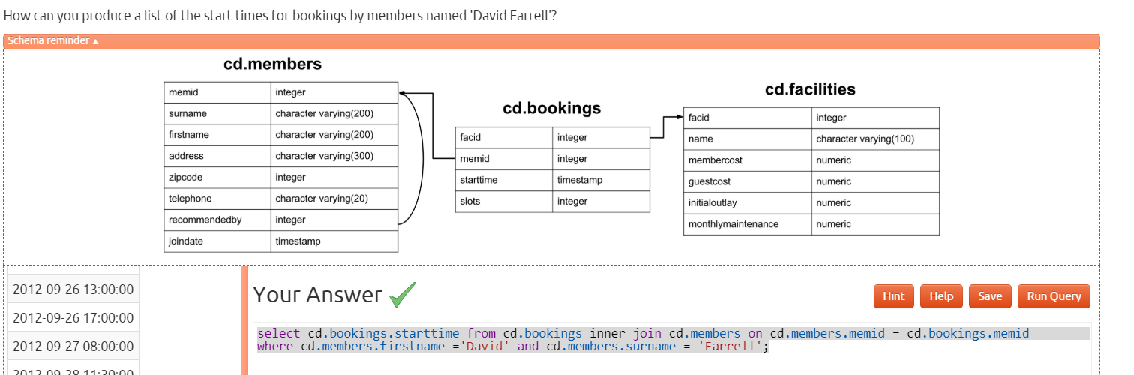

select cd.bookings.starttime from cd.bookings inner join cd.members on cd.members.memid = cd.bookings.memid

where cd.members.firstname ='David' and cd.members.surname = 'Farrell';

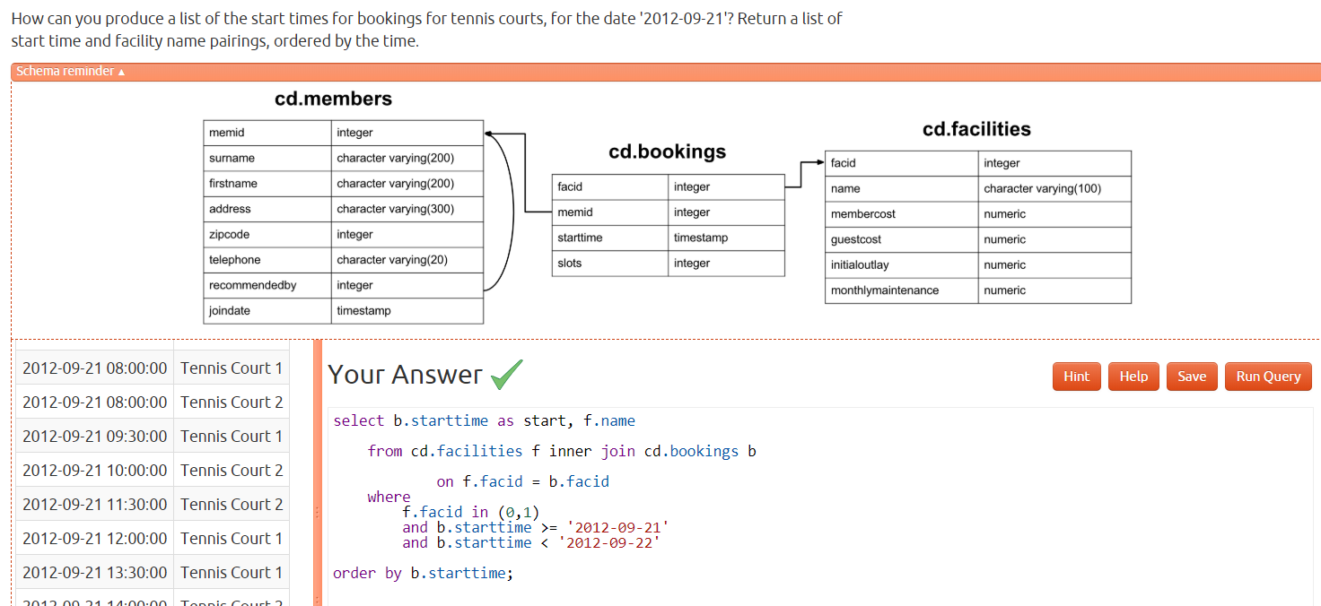

select b.starttime as start, f.name

from cd.facilities f inner join cd.bookings b

on f.facid = b.facid

where

f.facid in (0,1)

and b.starttime >= '2012-09-21'

and b.starttime < '2012-09-22'

order by b.starttime;

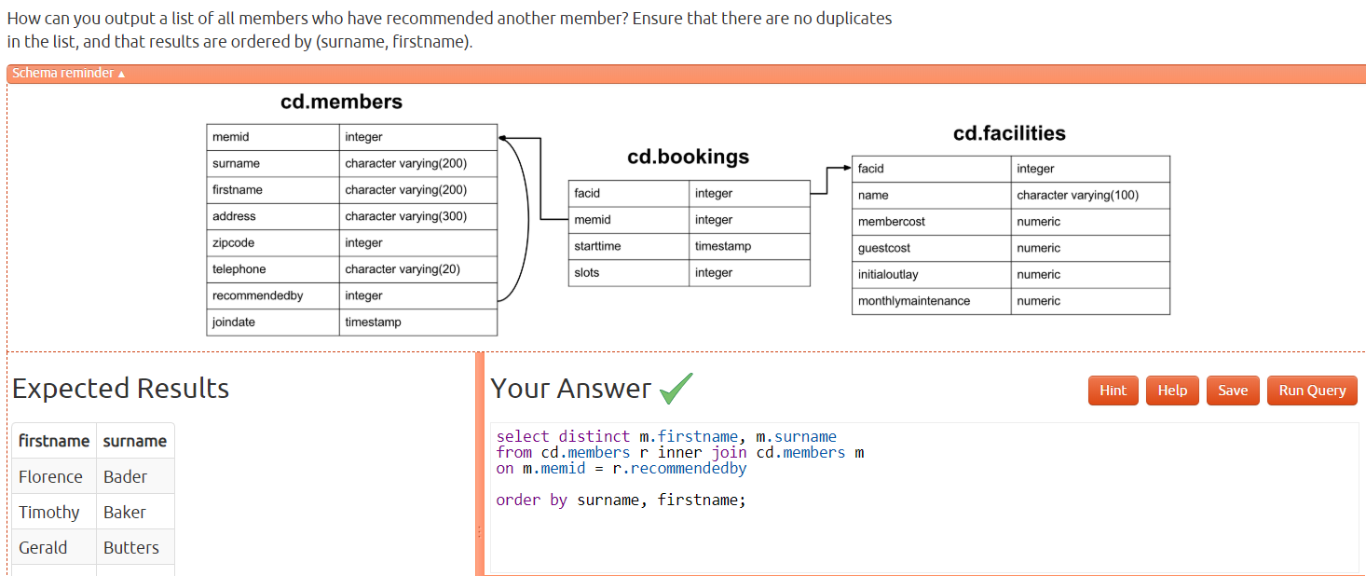

select distinct m.firstname, m.surname

from cd.members r inner join cd.members m

on m.memid = r.recommendedby

order by surname, firstname;

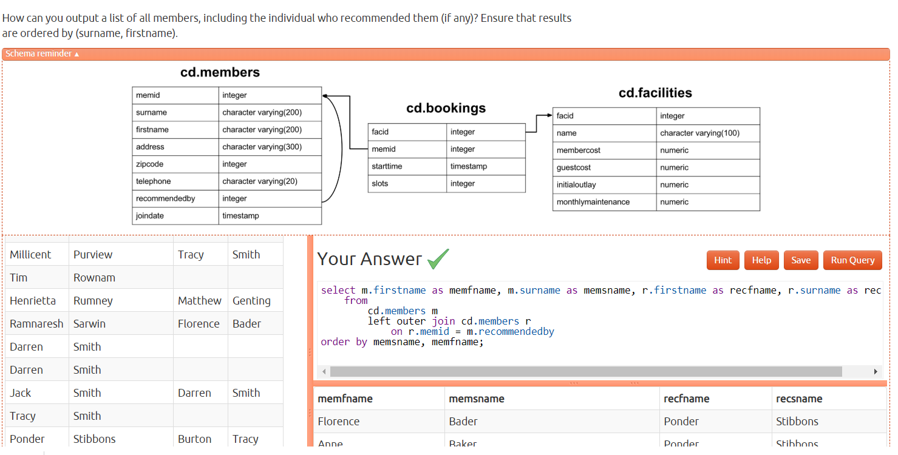

select m.firstname as memfname, m.surname as memsname, r.firstname as recfname, r.surname as recsname

from

cd.members m

left outer join cd.members r

on r.memid = m.recommendedby

order by memsname, memfname;

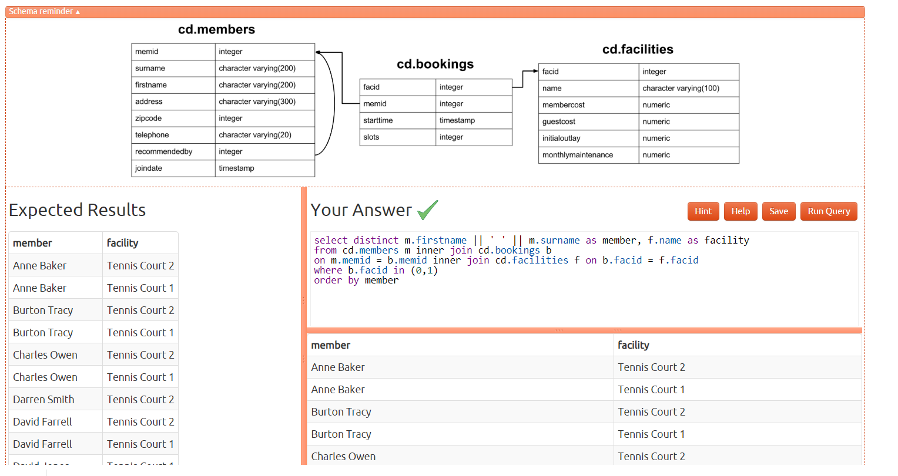

select distinct m.firstname || ' ' || m.surname as member, f.name as facility

from cd.members m inner join cd.bookings b

on m.memid = b.memid inner join cd.facilities f on b.facid = f.facid

where b.facid in (0,1)

order by member

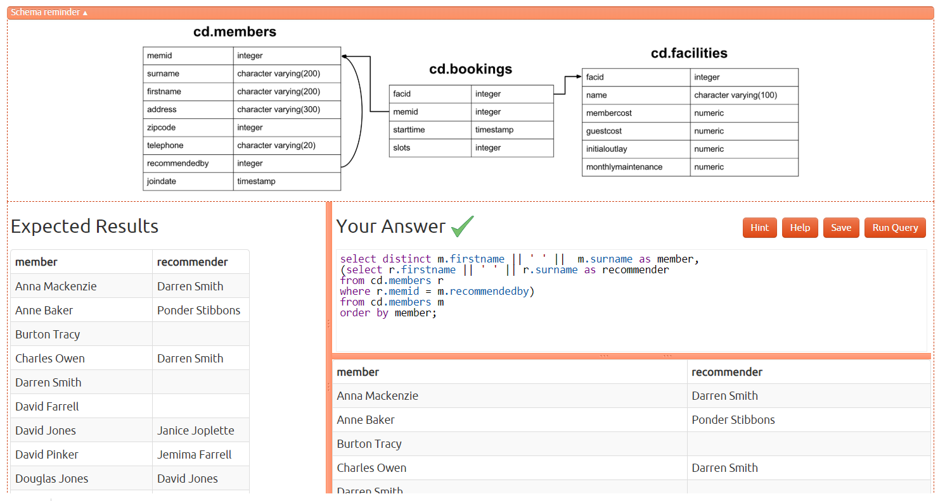

select distinct m.firstname || ' ' || m.surname as member,

(select r.firstname || ' ' || r.surname as recommender

from cd.members r

where r.memid = m.recommendedby)

from cd.members m

order by member;

Ans to q no: 4

