|  |  |  |
| --- | --- | --- |
|  | **CMPS 312 Project Phase 1 – UI Design and Implementation**  **(20% of the course grade)** | |
| **Group Id:** | | **05** |
| **Group Members:** | | **FatemaElzahraa Elrotel:** [**fe2104034@qu.edu.qa**](mailto:fe2104034@qu.edu.qa)  **Sara Said:** [**ss2004034@qu.edu.qa**](mailto:ss2004034@qu.edu.qa)  **Aisha Al-Kaabi:** [**aa2102900@qu.edu.qa**](mailto:aa2102900@qu.edu.qa) |

**Grading Rubric - In the Functionality column please specify either: *Working (completed x%)*, *Not Working (completed x%)* or *Not done*.**

|  |  |  |  |  |
| --- | --- | --- | --- | --- |
| Criteria | | % | Functionality* | Quality of the implementation |
| 1. **Application Design:** Repositories or Providers Class Diagram | | 5% | **4** | Good but with duplication and unnecessary complexity. See comments added to the diagrams below. |
| **2) Design and implement (90%)** | |  |  |  |
|  | **Quran Navigator**  - Navigate by Juz (7 pts)  - Navigate by Surah (7 pts)  - Navigate by page number (3 pts) | 17 | **17** | All done ok |
| **Quran Viewer**  - Display the Quran Page and a summary text for each section (قسم) (25 pts)  - View resources associated with the section (10 pts) | 35 | **28** | * Loading Quran Viewer is very slow due to inefficient implementation and not leveraging cashing of the Providers (-2) * View resources (even dummy examples) not done due mostly to misunderstanding of the requirements (-5) |
| **Topics Map**  - Topics Map (12 pts)  - View Quran page associated with the section (4 pts) | 16 | **15** | Good work.  UI modularity could be improved, e.g., TopicsScreen could be broken into multiple widgets such TopicCard, TopicList. Also, it is important to use consistent terminology in the whole project. Topic should be Mihwar. |
| Aya and Theme Search | 8 | **8** | All ok except Aya search needs Tashkeel. You could have another list of verses without Tashkeel to implement Aya search. |
| Verse Recitation | 7 | **7** | Good work |
| Verse Tafsir | 7 | **6** | Ok but slow |
| **3) Testing documentation** using screen shots illustrating the app testing.  - Discussion of the project contribution of each team member [-10pts if not done] | | 5% | **5** | Excellent work |
| **Total** | | 100 | **90** | Good submission but slow and inefficient implementation of the Quran Viewer. It takes a long time to load! |
| Copying and/or plagiarism or not being able to explain or answer questions about the implementation | | -  100 |  |  |

**\* Possible grading for functionality** - ***Working*** (get 70% of the assigned grade), ***Not*** ***working*** (lose 40% of assigned grade and ***Not done*** (get 0). The remaining grade is assigned to the quality of the implementation.

In case your implementation is not working then 40% of the grade will be lost and the remaining 60% will be determined based on of the code quality and how close your solution to the working implementation.

Solution quality also includes meaningful naming of identifiers (according to Flutter/Dart naming conventions), no redundant code, simple and efficient design, clean implementation without unnecessary files/code, use of comments where necessary, proper code formatting and indentation.

**Marks will be reduced** forcode duplication, poor/inefficient coding practices, poor naming of identifiers, unclean/untidy submission, and unnecessary complex/poor user interface design.

# App Design

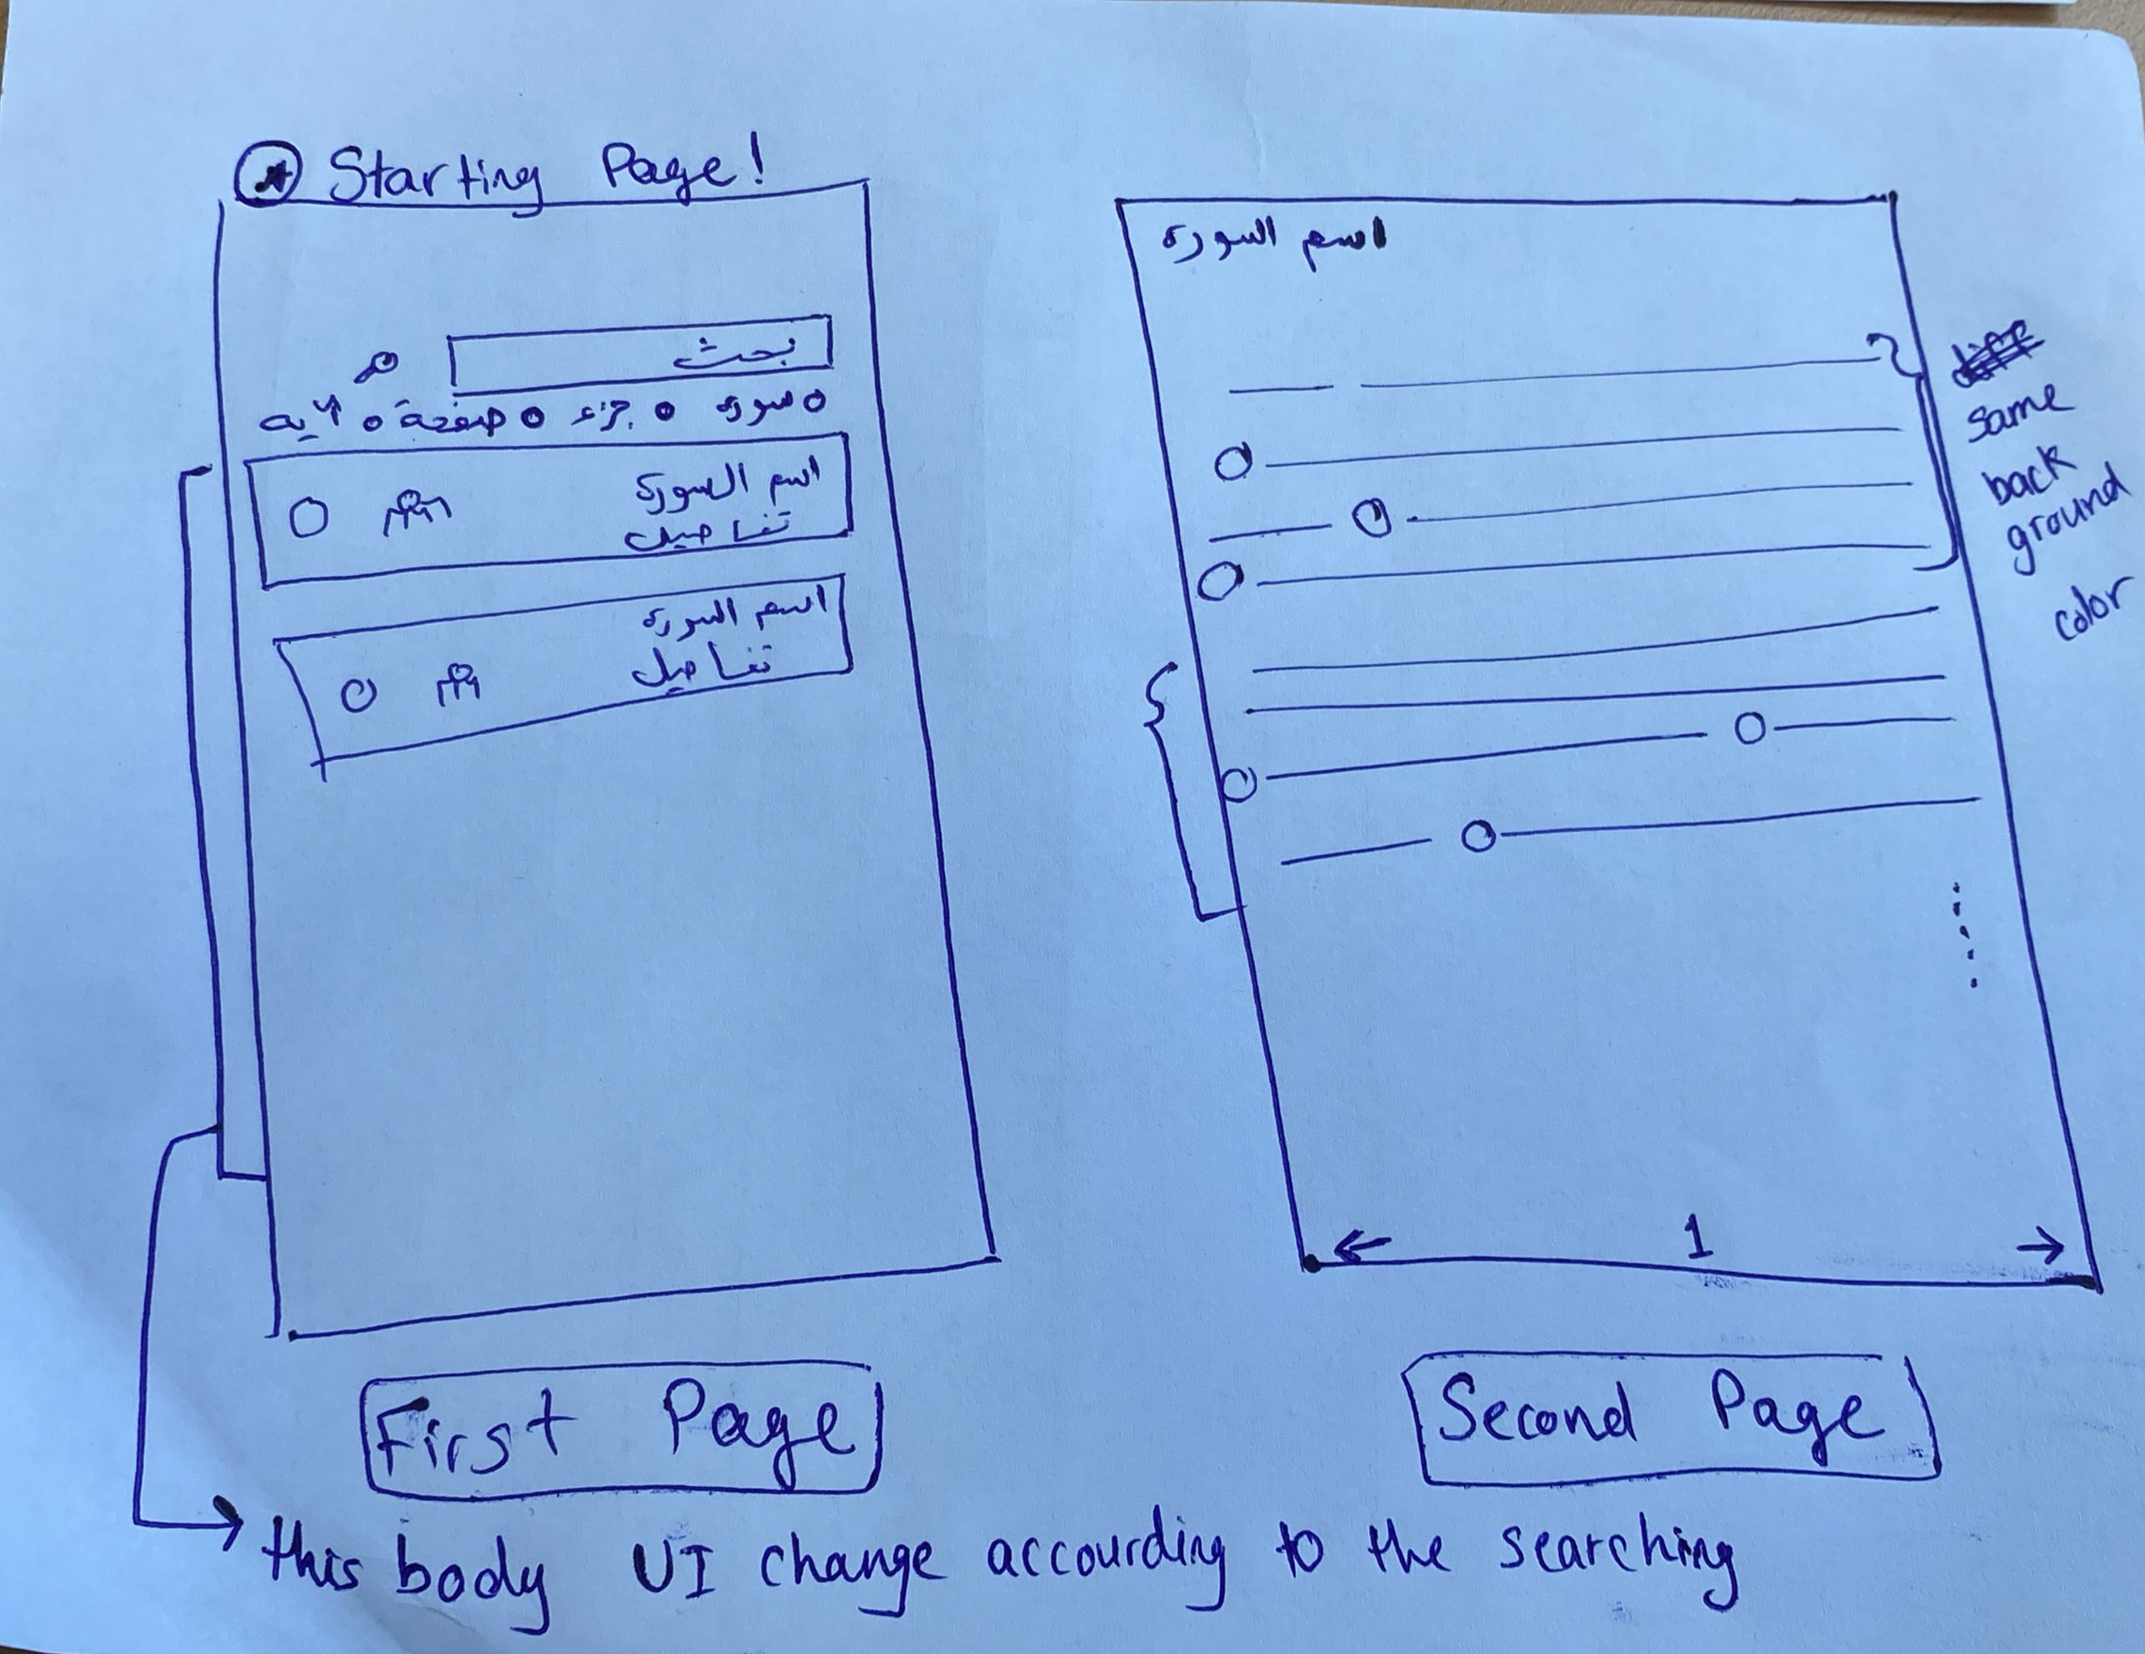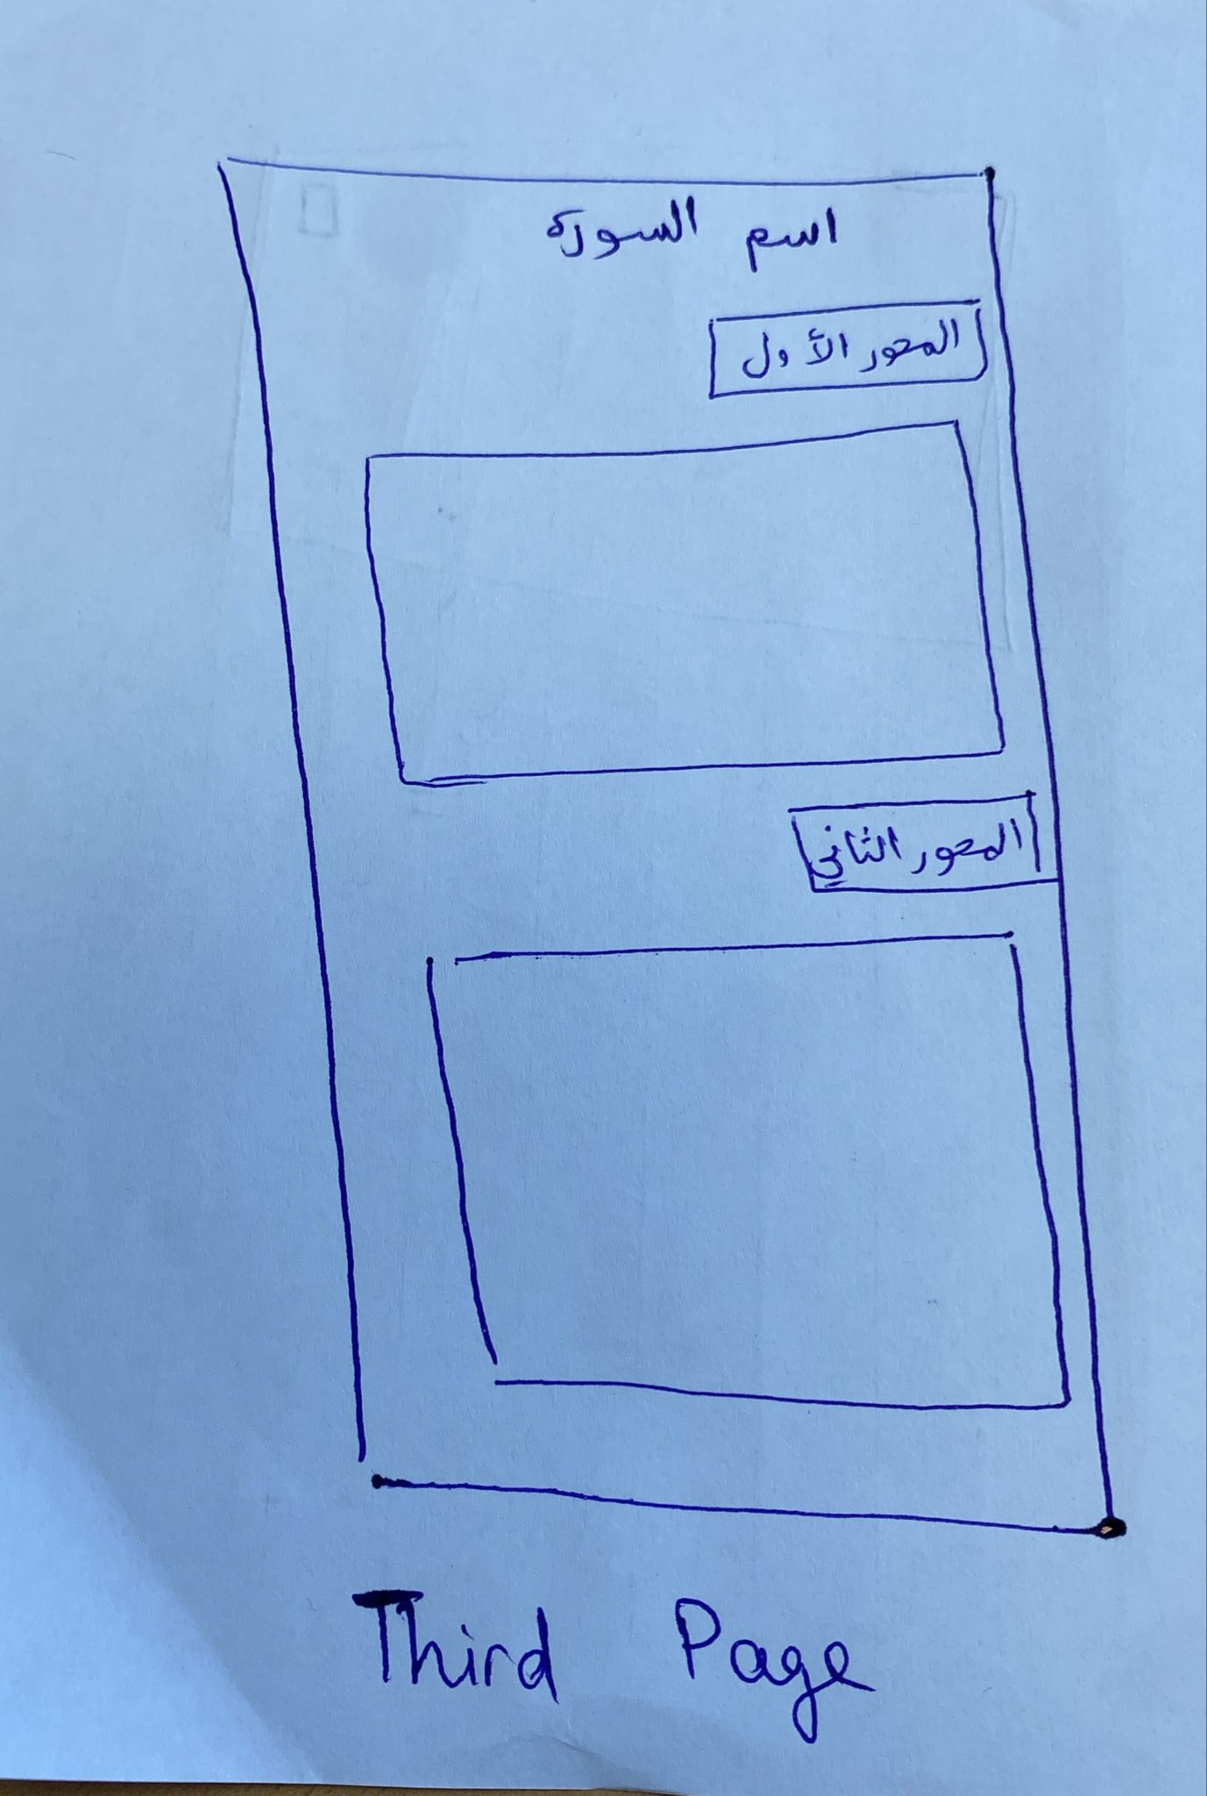

# Application Design – Repositories or Providers Class Diagram

* **Models**

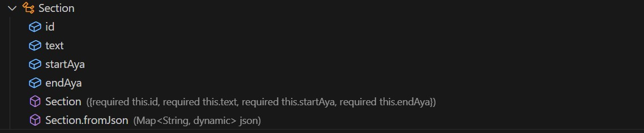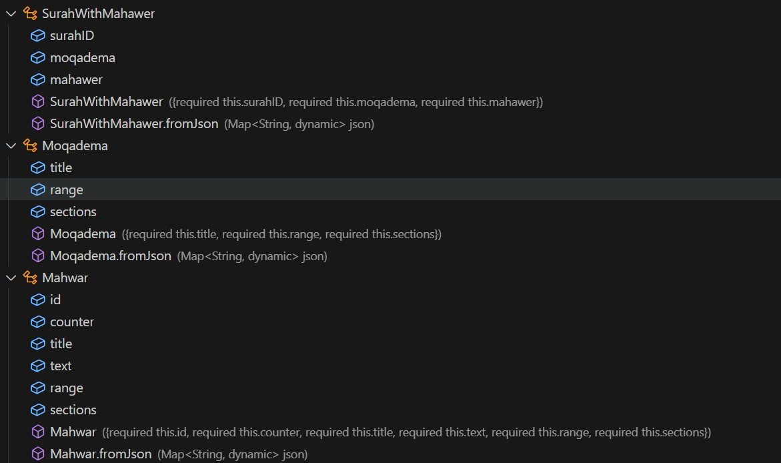

* **Providers:**

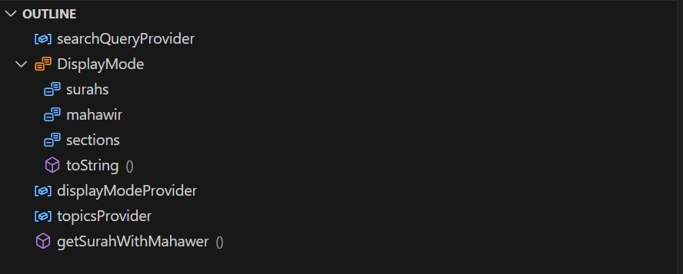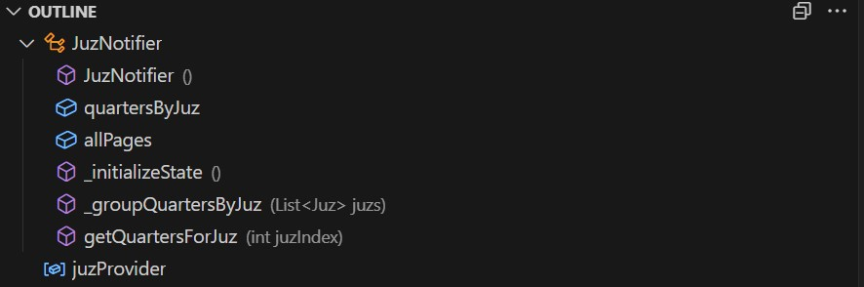

* **Repositories:**

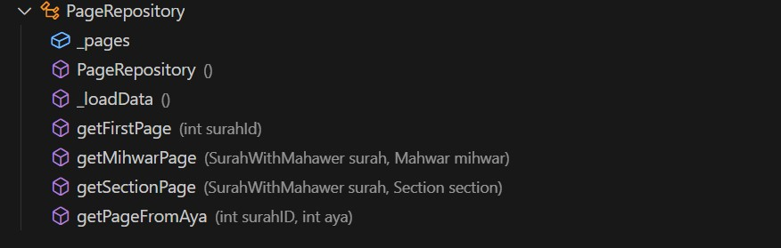

* **Screens:**

* **App Router:**

* **Widgets:**

* **Main:**

# Testing

# Quran Navigator

# Navigate by Juz

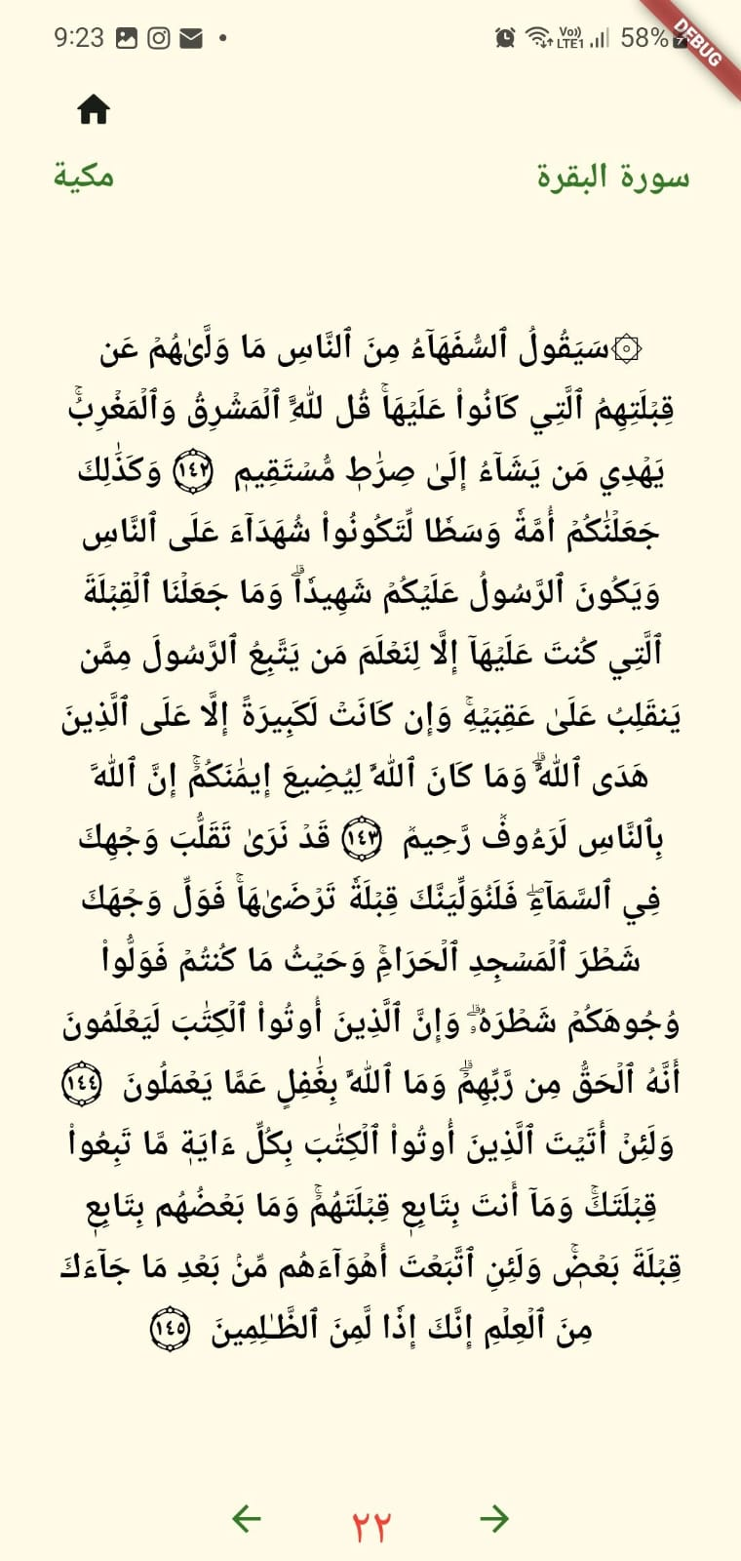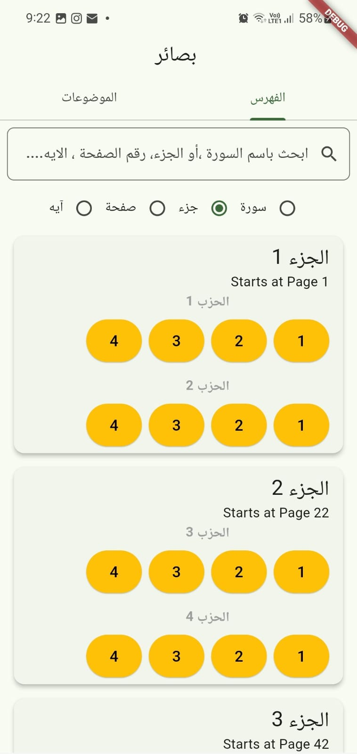



# Navigate by Surah

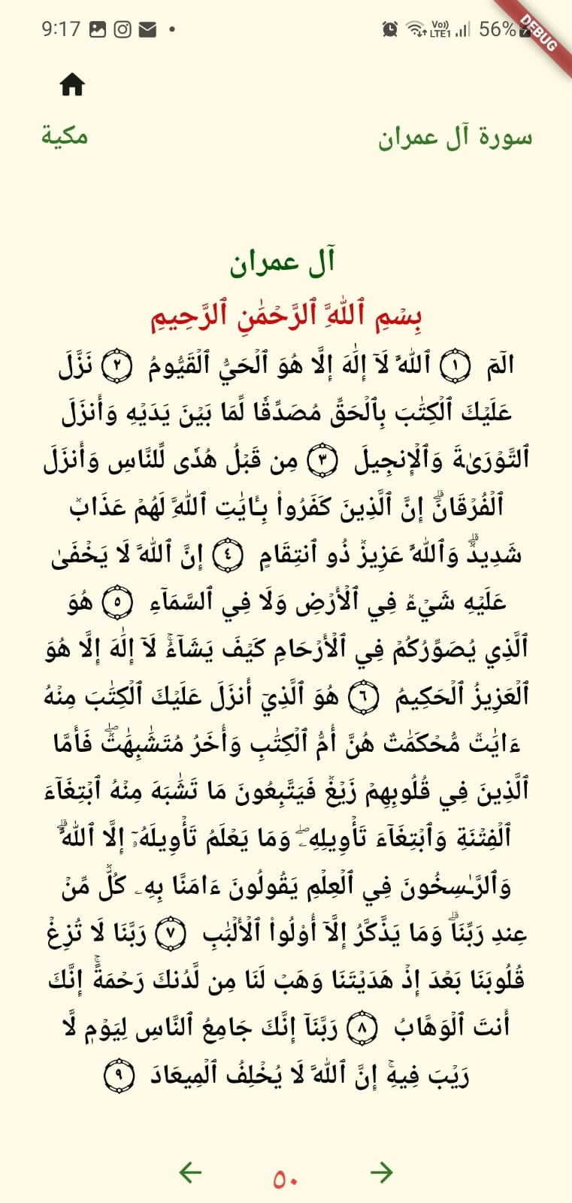



* + 1. **Search By surah**

# Navigate by page number

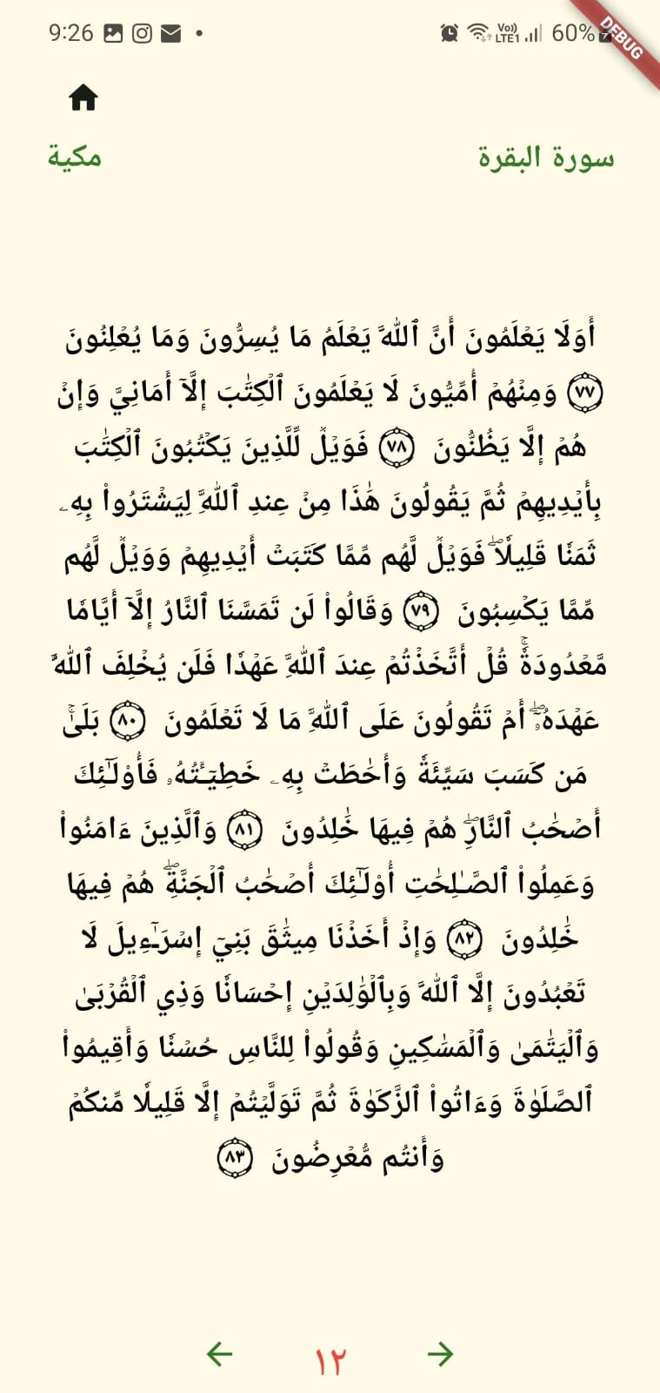

# Quran Viewer

# Display the Quran Page and the summary text for each section

**Small Screen :**

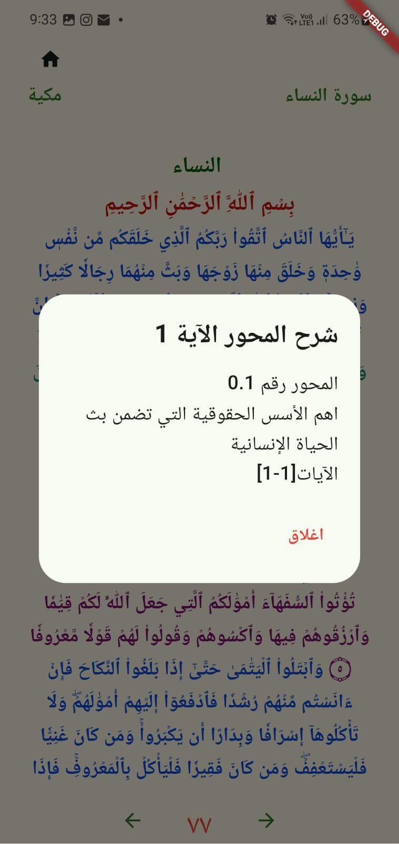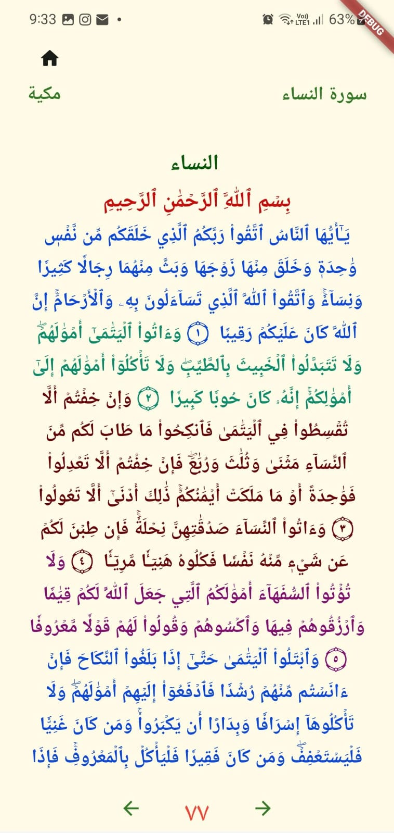

**Large Screen:**

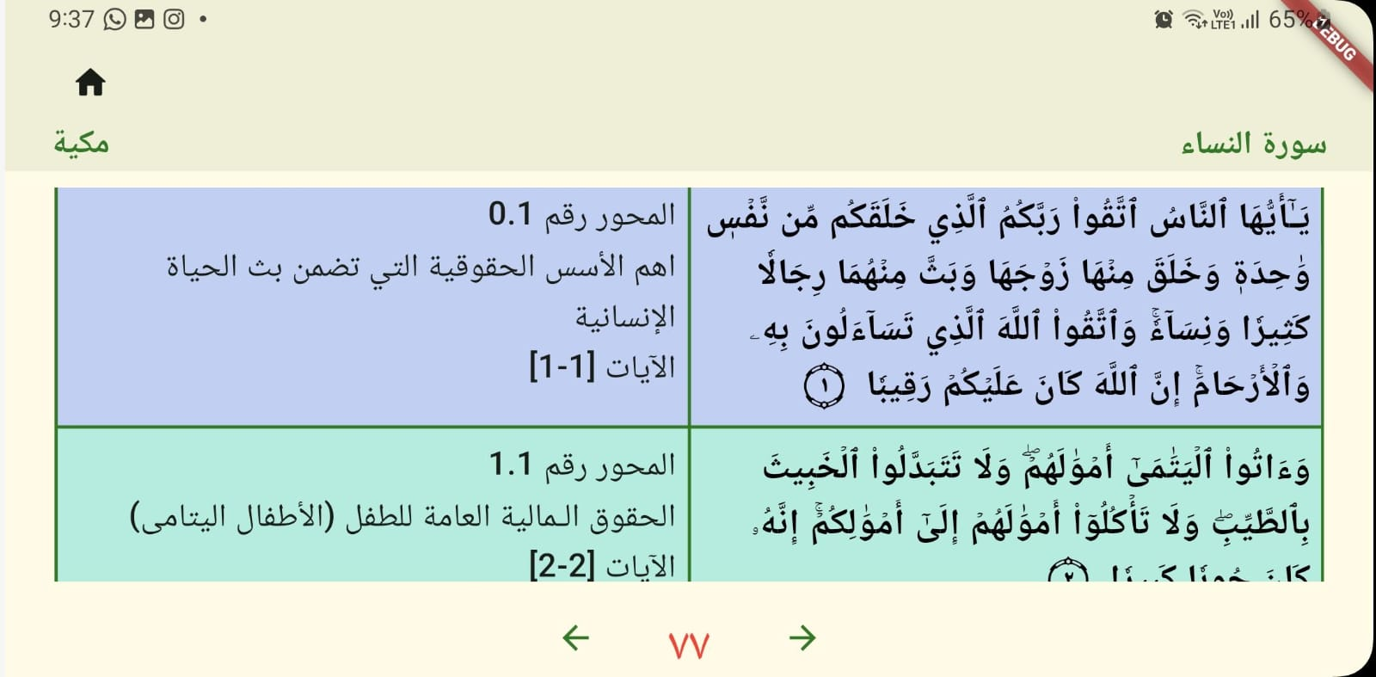

# View resources associated with the section

**Small screen:**

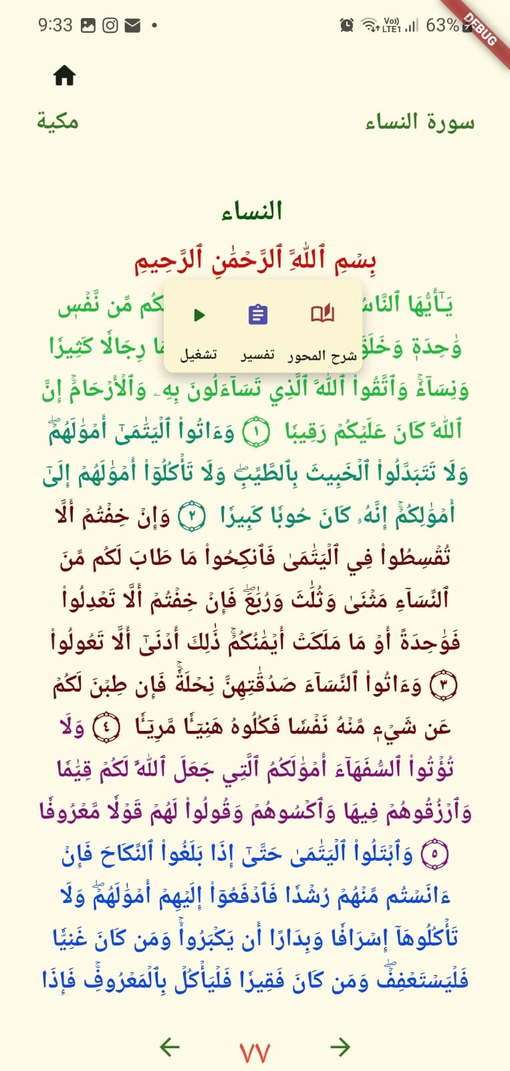



# Topics Map

# Topics Map

# View Quran page associated with the section



# Aya and Theme Search

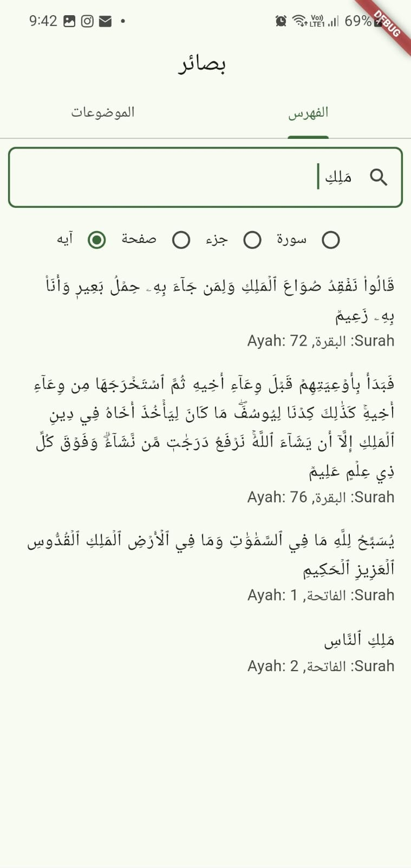



# Verse Recitation

**Small screen:**



**Large screen:**

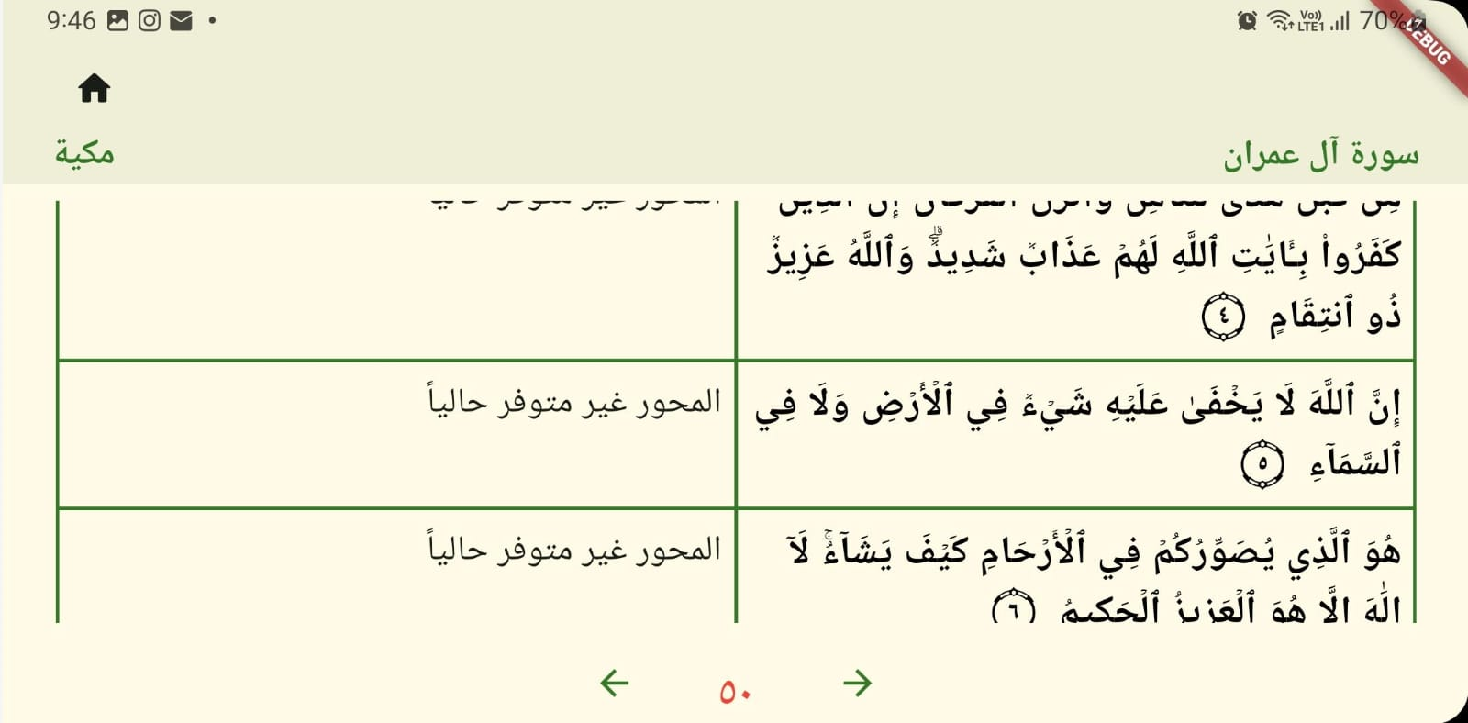



# Verse Tafsir

**Small screen:**

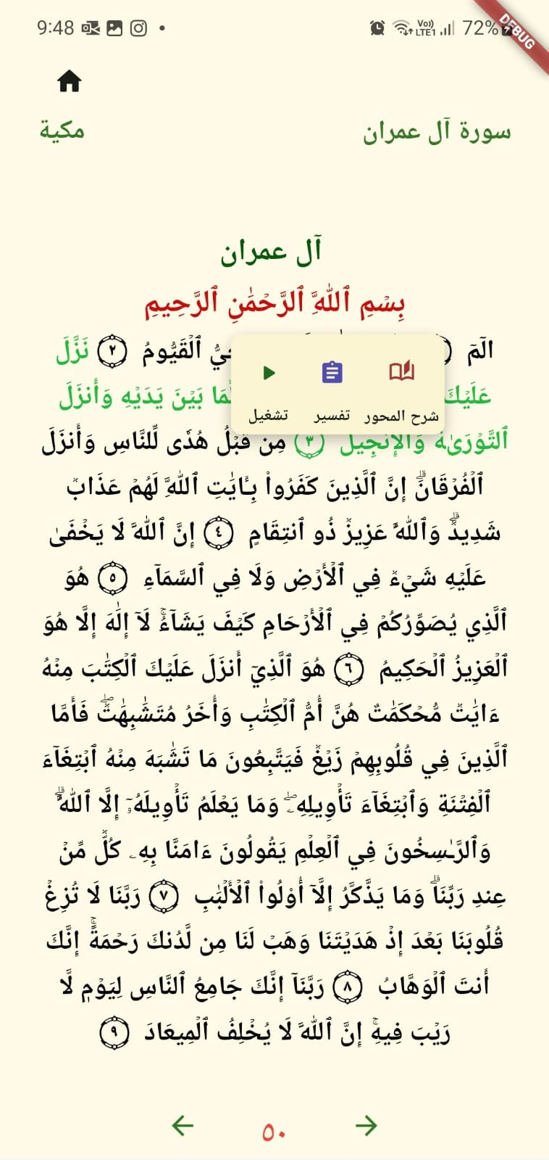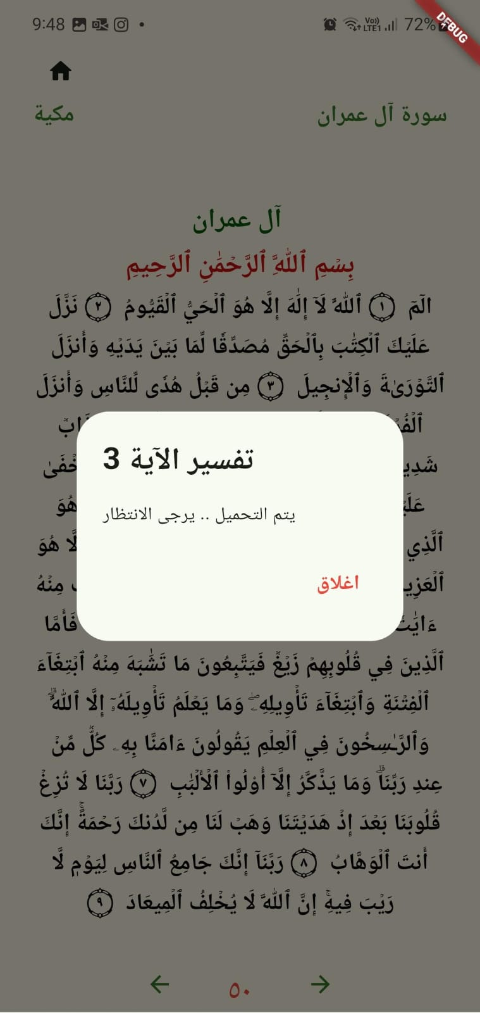



**Large screen:**

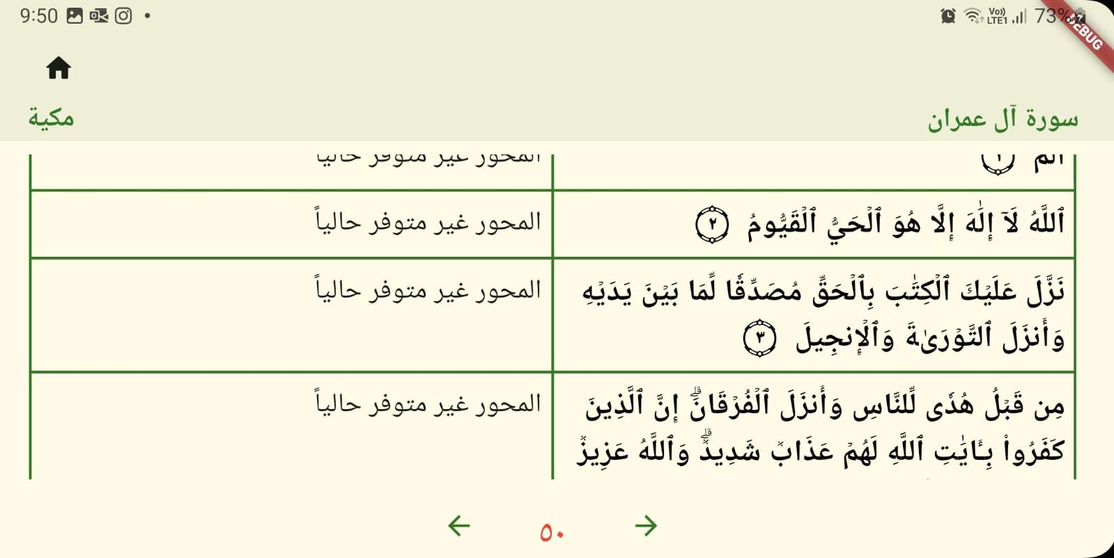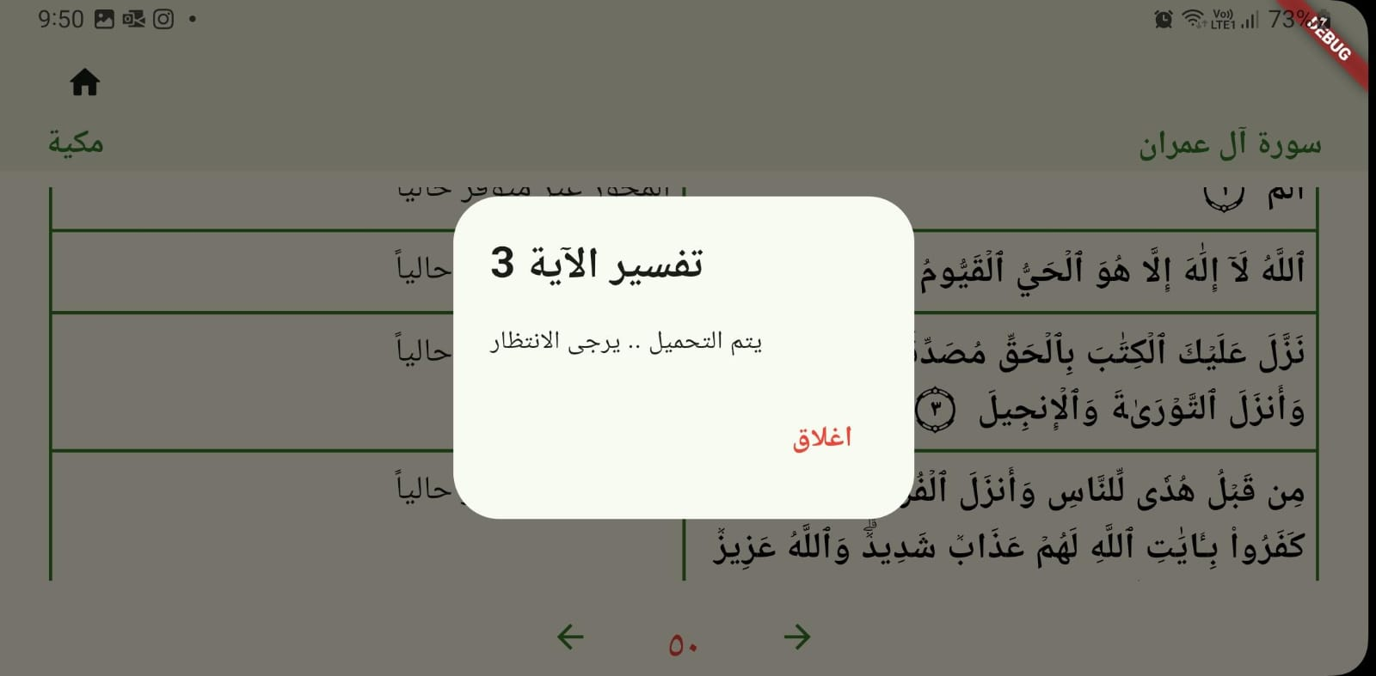



1. **Search**
   1. **Search by juz:**

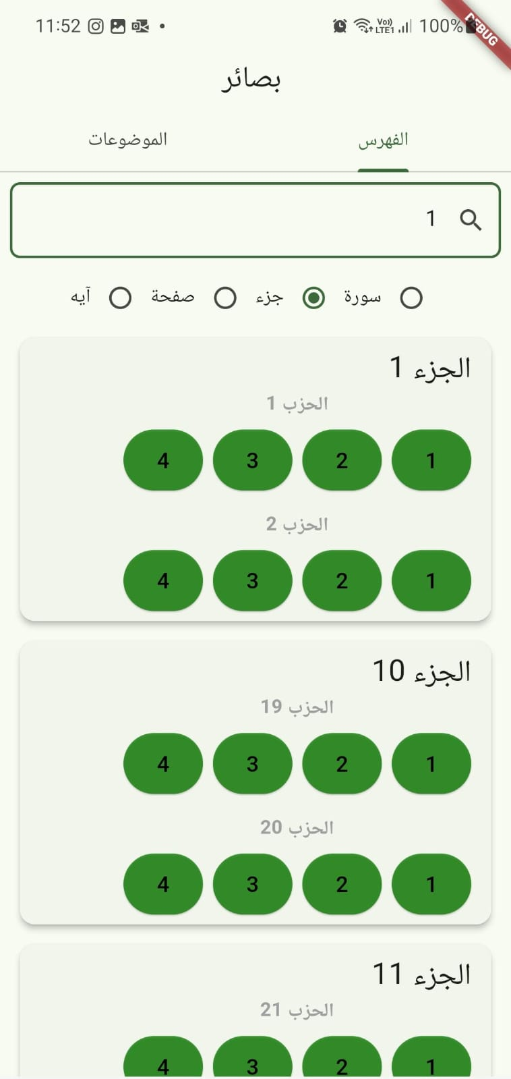

# Summary of team member contributions

|  |  |
| --- | --- |
| **Member** | **Completed use cases / tasks** |
| **FatemaElzahraa Elrotel** | * **Models (mahwar, page, tafsir, verses)** * **Quran Viewer, Display qaran page and summary of each text** * **Verse Recitation** * **Verse Tafsir** * **SuarhWithMahawer_provider** * **Tafsir_provider** * **Verse_provider** |
| **Sara Said** | * **Modesl ( Juz, Surah, Quarter)** * **Quran Navigator : by juz + by surah + by page number** * **App Router** * **Search by Aya + Surah + Page Number** * **Juz_provider** * **Surah_provider** |
| **Aisha Al-Kaabi** | * **Topics Screen** * **Navigation from mihwar/ section to quran viewer** * **Navigation from quarter to quran viewer** * **Page repository** * **Quarter Repository** |
|  |  |

**Note: The json files have been updated as some surahs were missing.**