**CMPS451 Project Phase 2**

**Done by:**

* **FatemaElzahraa Elrotel – 202104034 –** [**fe2104034@qu.edu.qa**](mailto:Fe2104034@qu.edu.qa)
* **Dina Ayad – 202003969 –** [**da2003969@qu.edu.qa**](mailto:da2003969@qu.edu.qa)

**Relational Database Schema**

**Tables we used**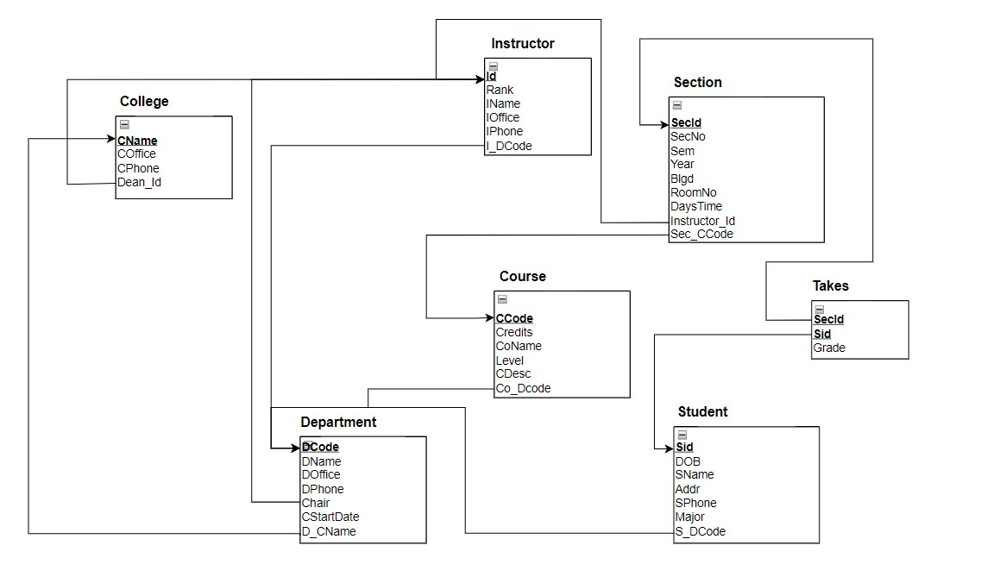

**Description**

* For the frontend, we used java swing to make the GUI of our program. We created 6 scenes. In the main scene, we have three buttons, the select button that takes us to the select window, the join button that takes us to the join window, and the metadata button that takes us to the metadata window. In the select window, the user can choose the query he prefers, to calculate its cost. In the Join window, the user chooses to calculate the cost of the join query. In the metadata window, we present the metadata table from Oracle.
* For the backend, we created a Dbase class which contains the connection between Java and Oracle. We wrote all the methods for the execution plans in the Dbase like (BinarySearch, LinearSearch, …etc).

**Summary of the metadata**

In our metadata, we stored for every table Table_name, column_name, column_type, key_type, index_type, blevel, distinct_ values, max_val, and min_val. For Table_name we stored the table name. For column_name we stored every column name. For column_type we stored the type of the data in a column whether it's number or varchar. For key_type we stored the type of key in every column, whether it's primary, Candidate, or none. For index_type we stored the type of index whether it's primary or Secondary. For blevel, we stored the number of levels of the BTree, which depends on the number of distinct values. For distinct_ values we stored the number of distinct values for every column. For max_val and min_val we stored the maximum and minimum values for the columns that contain numbers.

**Queries in our program**

* Select equality on a key.
* Select range on a key.
* Select equality on non-key.
* Select range on non-key.
* Conjunctive Selection.
* Disjunctive Selection.
* equi-join.

**Google Drive link to the code**

<https://drive.google.com/drive/folders/1bYa_k-v9c7Uh1Cs5N7cmppaYbFs9zi5D?usp=drive_link>

**Screenshots of runs for every type of query**

* **Select equality on a key:**

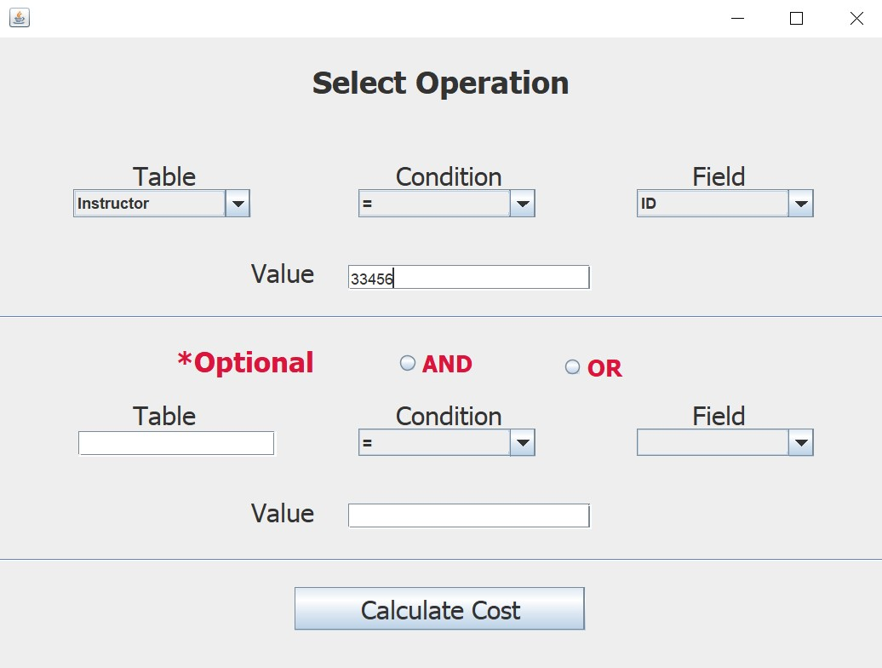

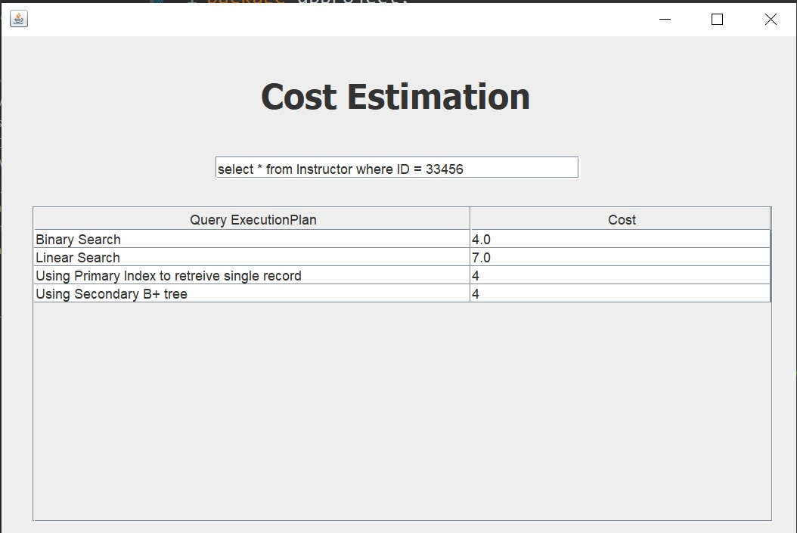

* 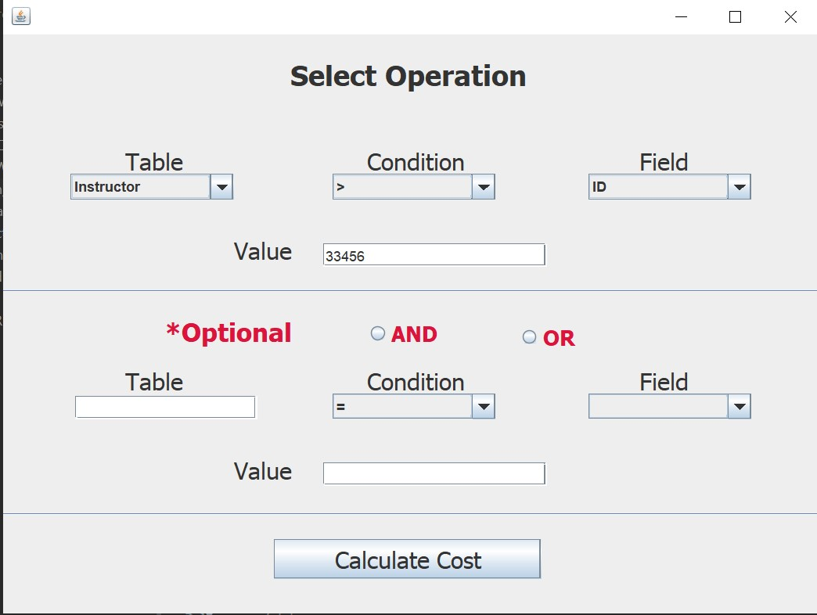**Select range on a key:**

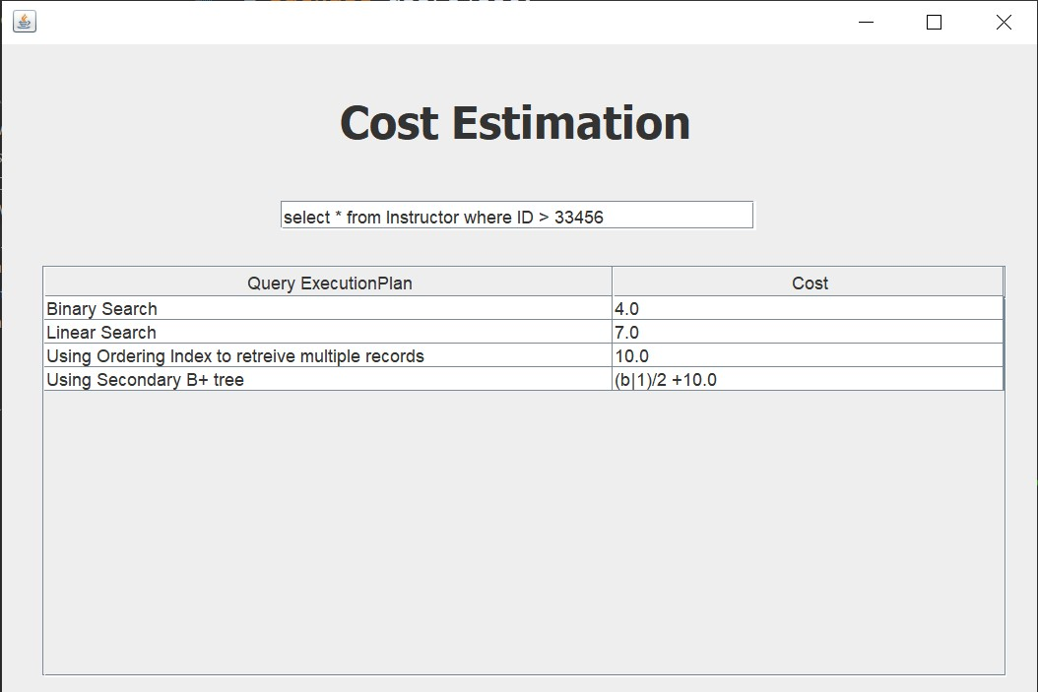

* **Select equality on non-key:**

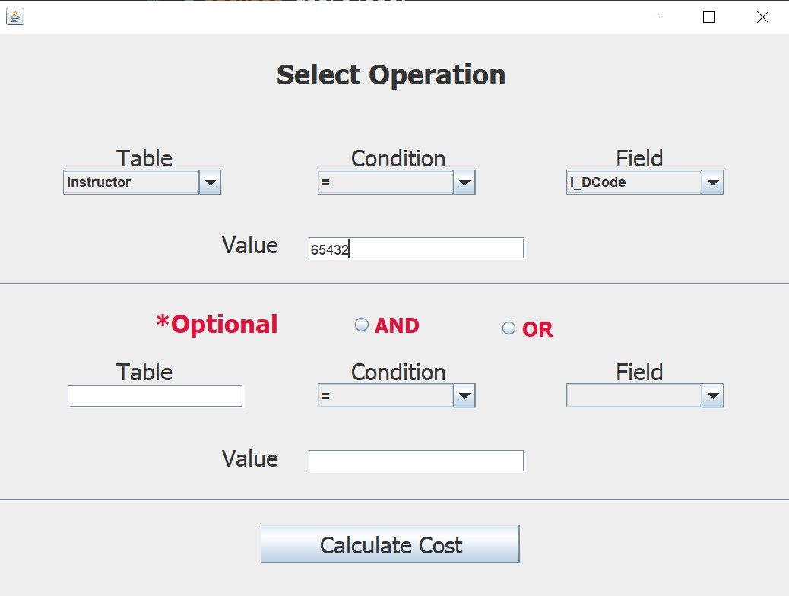

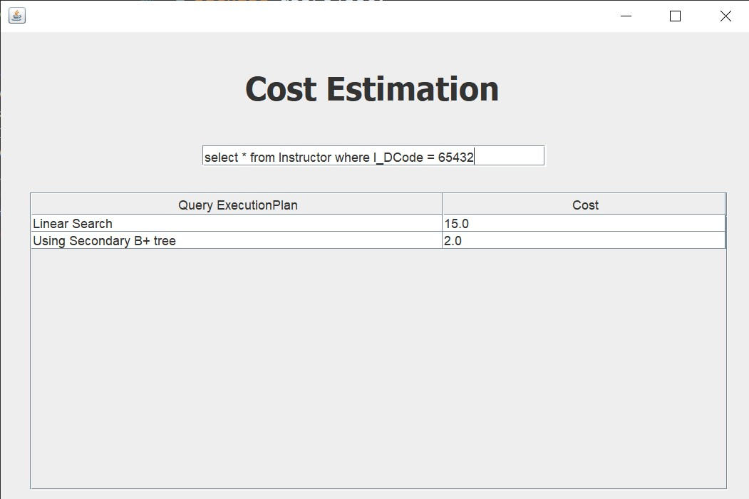

* **Select range on non-key:**

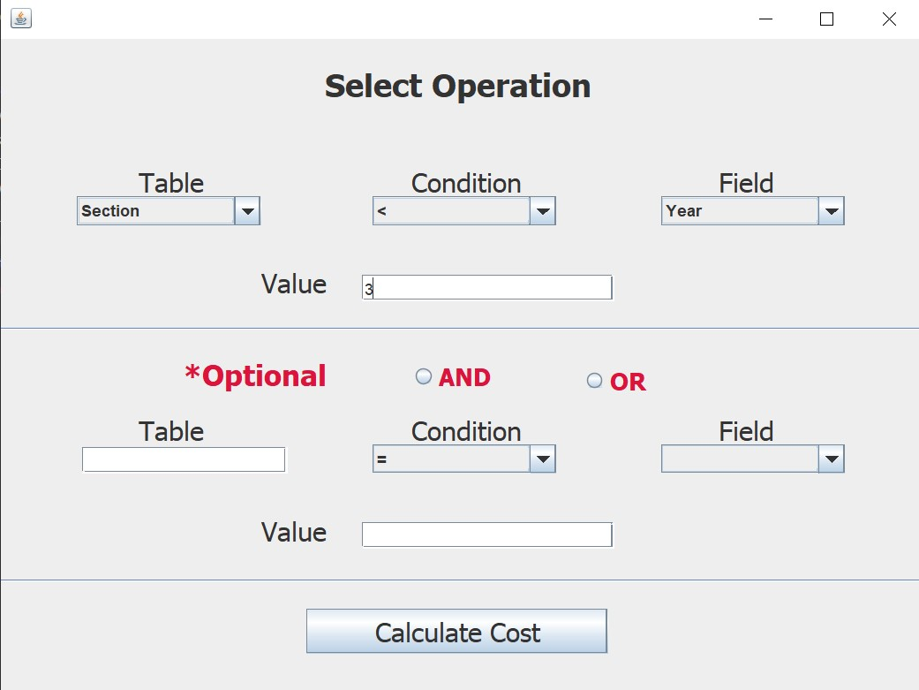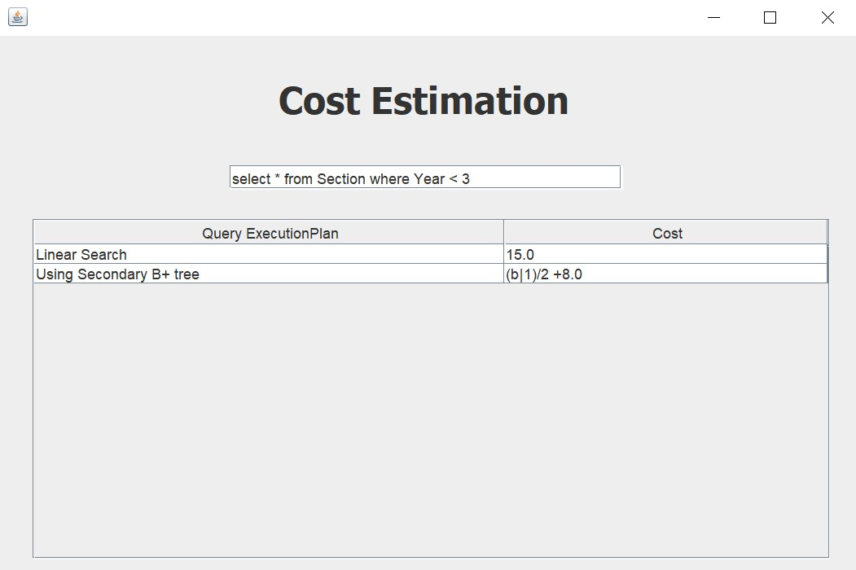

* **Conjunctive** **Selection:**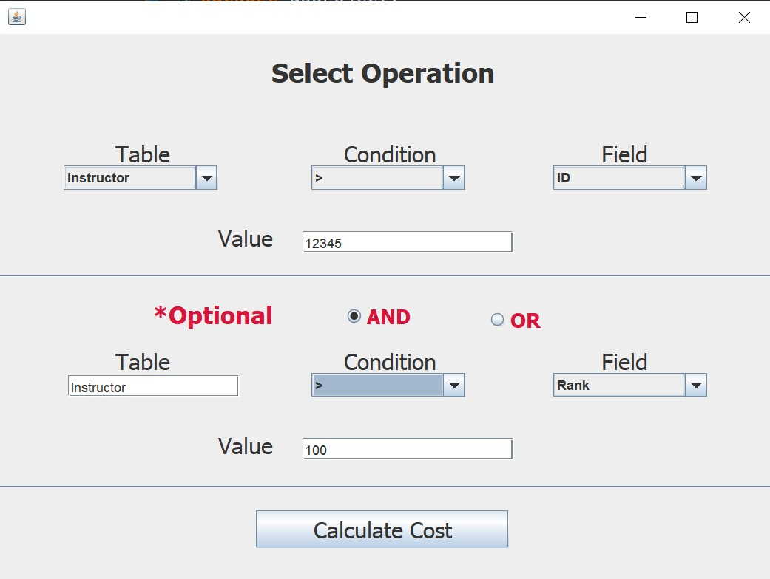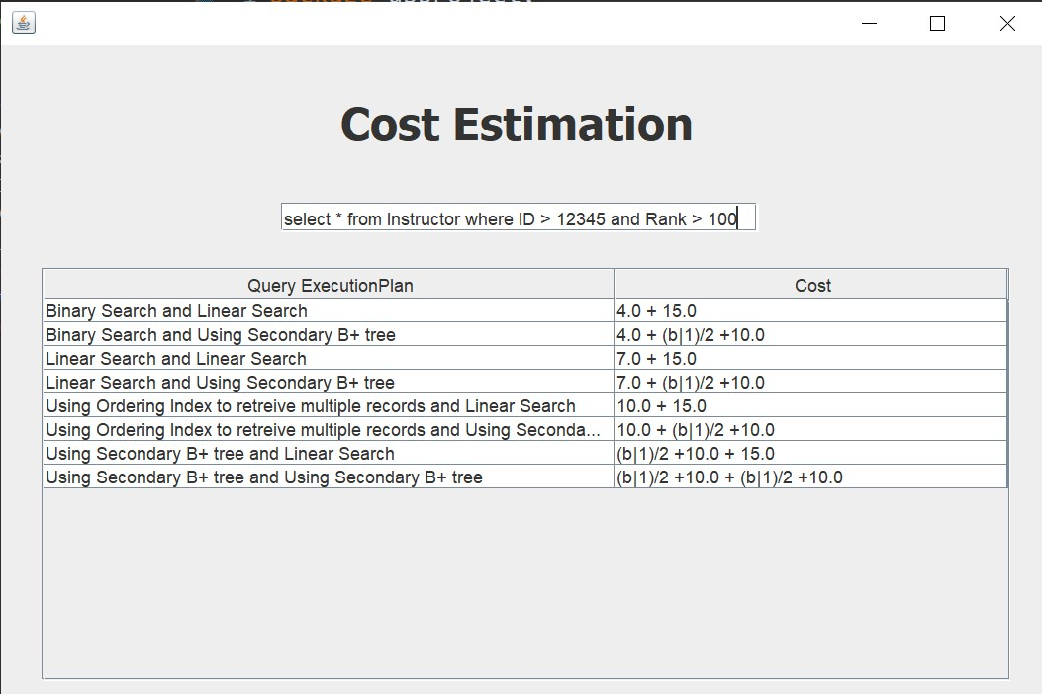
* **Disjunctive Selection:**

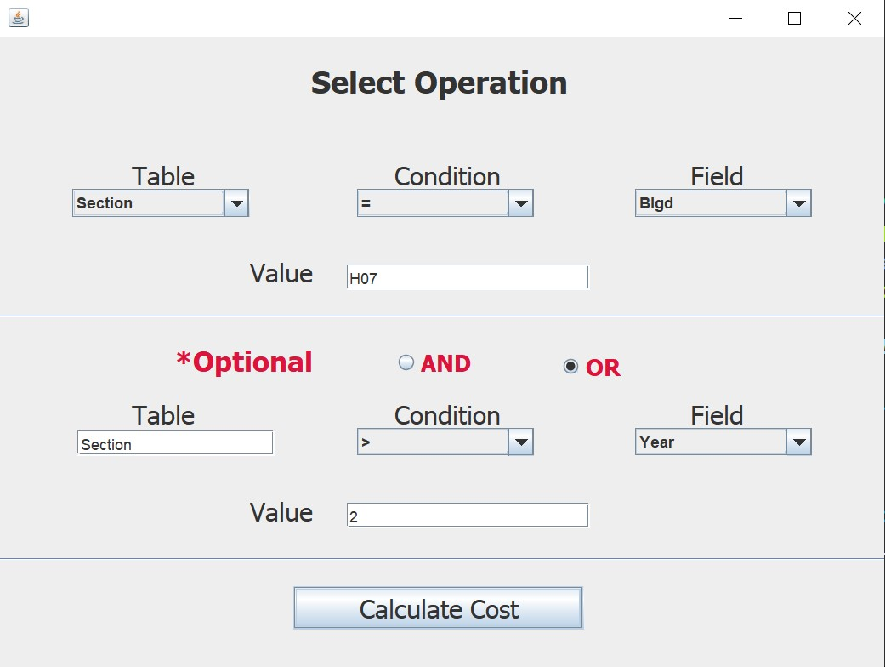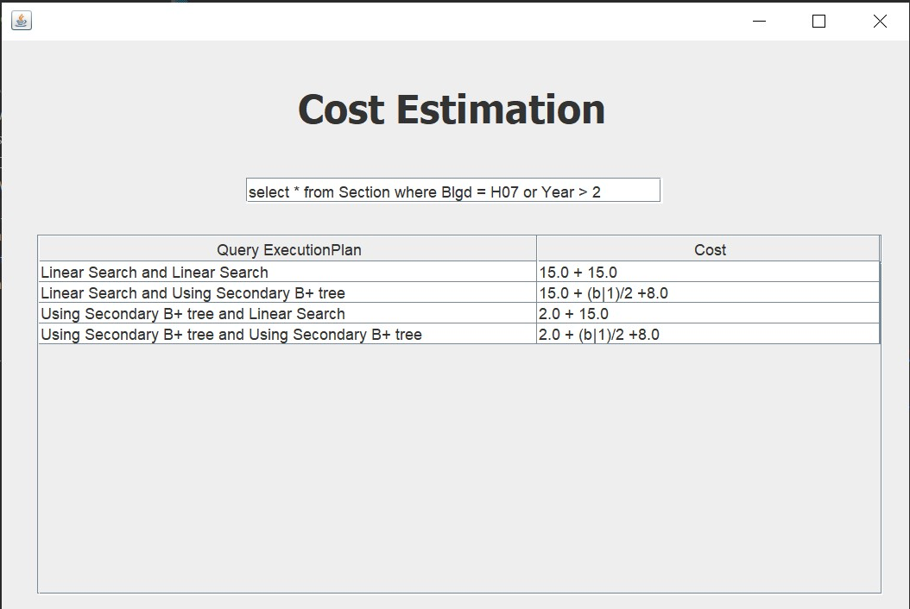

* **equi-join:**

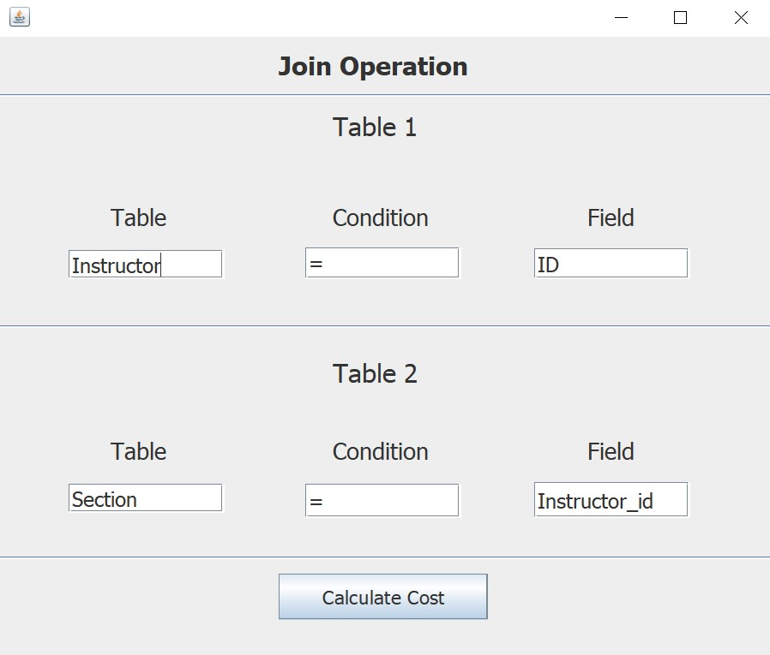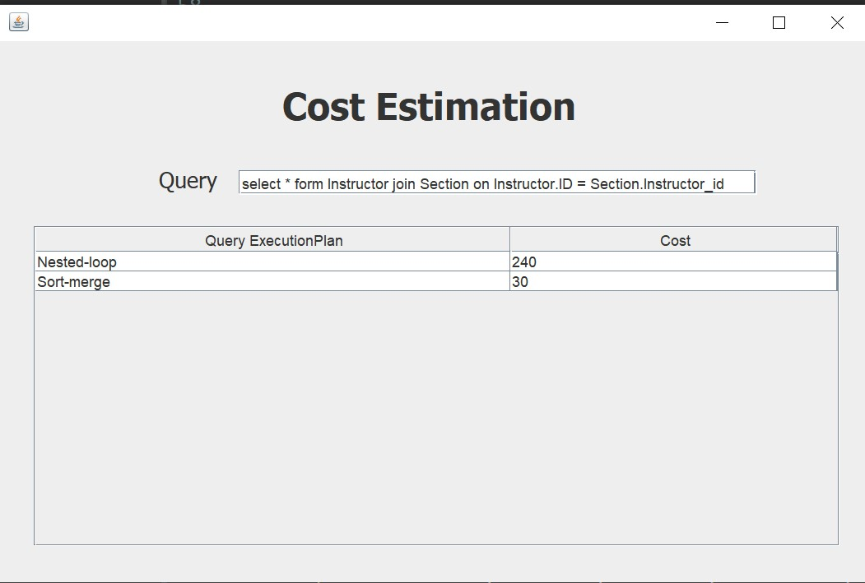

**Metadata**

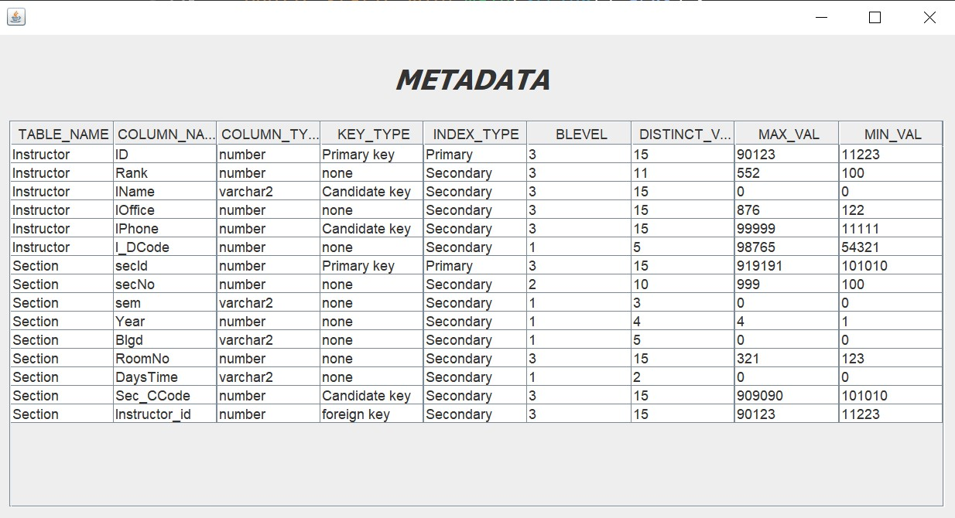

**Screenshot of metadata in SQL**

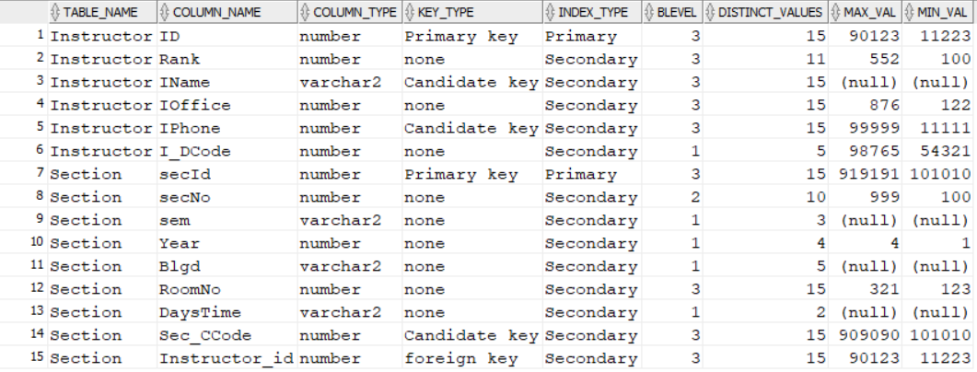

**Statistics table**

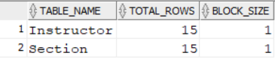

**Oracle SQL Developer Code**

create table Instructor (

ID number(10) primary key,

Rank number(10),

IName varchar2(15),

IOffice number(10),

IPhone number(10),

I_DCode number(10));

insert into Instructor (ID, Rank, IName, IOffice, IPhone, I_DCode) values (12345, 100, 'Ali', 531, 11111, 54321);

insert into Instructor (ID, Rank, IName, IOffice, IPhone, I_DCode) values (23456, 300, 'Mohamed', 138, 22222, 65432);

insert into Instructor (ID, Rank, IName, IOffice, IPhone, I_DCode) values (34567, 250, 'Ahmed', 244, 33333, 76543);

insert into Instructor (ID, Rank, IName, IOffice, IPhone, I_DCode) values (45678, 174, 'Amr', 463, 44444, 87654);

insert into Instructor (ID, Rank, IName, IOffice, IPhone, I_DCode) values (56789, 552, 'Omar', 123, 55555, 98765);

insert into Instructor (ID, Rank, IName, IOffice, IPhone, I_DCode) values (67890, 210, 'Hassan', 876, 66666, 65432);

insert into Instructor (ID, Rank, IName, IOffice, IPhone, I_DCode) values (78901, 440, 'Sara', 321, 77777, 76543);

insert into Instructor (ID, Rank, IName, IOffice, IPhone, I_DCode) values (89012, 150, 'Lina', 224, 88888, 87654);

insert into Instructor (ID, Rank, IName, IOffice, IPhone, I_DCode) values (90123, 310, 'Karim', 587, 99999, 98765);

insert into Instructor (ID, Rank, IName, IOffice, IPhone, I_DCode) values (11223, 400, 'Mona', 122, 33322, 54321);

insert into Instructor (ID, Rank, IName, IOffice, IPhone, I_DCode) values (22334, 200, 'Tarek', 277, 44422, 65432);

insert into Instructor (ID, Rank, IName, IOffice, IPhone, I_DCode) values (33445, 150, 'Rania', 524, 55522, 76543);

insert into Instructor (ID, Rank, IName, IOffice, IPhone, I_DCode) values (44556, 100, 'Samir', 667, 66622, 87654);

insert into Instructor (ID, Rank, IName, IOffice, IPhone, I_DCode) values (55667, 310, 'Dina', 189, 77722, 98765);

insert into Instructor (ID, Rank, IName, IOffice, IPhone, I_DCode) values (66778, 200, 'Youssef', 276, 88822, 54321);

select * from Instructor;

drop table Section;

create table Section (

secId number(10) primary key,

secNo number(10),

sem varchar2(20),

Year number(4),

Blgd varchar2(10),

RoomNo number (10),

DaysTime varchar2 (20),

Sec_CCode number(10),

Instructor_id number(10),

foreign key (Instructor_id) references Instructor(Id) on delete cascade);

insert into Section (secId,secNo,sem,Year,Blgd,RoomNo,DaysTime,Sec_CCode,Instructor_id) values (212121, 111, 'Fall', 2, 'C01', 123, 'UTR', 101010, 12345);

insert into Section (secId,secNo,sem,Year,Blgd,RoomNo,DaysTime,Sec_CCode,Instructor_id) values (313131, 222, 'Spring', 4, 'H07', 321, 'MW', 202020, 23456);

insert into Section (secId,secNo,sem,Year,Blgd,RoomNo,DaysTime,Sec_CCode,Instructor_id) values (414141, 333, 'Spring', 1, 'GCR', 234, 'MW', 303030, 34567);

insert into Section (secId,secNo,sem,Year,Blgd,RoomNo,DaysTime,Sec_CCode,Instructor_id) values (515151, 444, 'Fall', 2, 'C01', 231, 'UTR', 404040, 45678);

insert into Section (secId,secNo,sem,Year,Blgd,RoomNo,DaysTime,Sec_CCode,Instructor_id) values (616161, 555, 'Spring', 3, 'H07', 213, 'UTR', 505050, 56789);

insert into Section (secId,secNo,sem,Year,Blgd,RoomNo,DaysTime,Sec_CCode,Instructor_id) values (717171, 666, 'Samar', 3, 'H07', 134, 'UTR', 606060, 66778);

insert into Section (secId,secNo,sem,Year,Blgd,RoomNo,DaysTime,Sec_CCode,Instructor_id) values (818181, 777, 'Fall', 4, 'H07', 145, 'MW', 707070, 78901);

insert into Section (secId,secNo,sem,Year,Blgd,RoomNo,DaysTime,Sec_CCode,Instructor_id) values (919191, 888, 'Fall', 2, 'C01', 167, 'UTR', 808080, 89012);

insert into Section (secId,secNo,sem,Year,Blgd,RoomNo,DaysTime,Sec_CCode,Instructor_id) values (101010, 999, 'Spring', 2, 'C01', 189, 'MW', 909090, 90123);

insert into Section (secId,secNo,sem,Year,Blgd,RoomNo,DaysTime,Sec_CCode,Instructor_id) values (121212, 100, 'Fall', 3, 'H07', 190, 'MW', 111213, 11223);

insert into Section (secId,secNo,sem,Year,Blgd,RoomNo,DaysTime,Sec_CCode,Instructor_id) values (131313, 111, 'Samar', 1, 'B13', 214, 'UTR', 121314, 67890);

insert into Section (secId,secNo,sem,Year,Blgd,RoomNo,DaysTime,Sec_CCode,Instructor_id) values (141414, 222, 'Spring', 3, 'C01', 215, 'UTR', 131415, 22334);

insert into Section (secId,secNo,sem,Year,Blgd,RoomNo,DaysTime,Sec_CCode,Instructor_id) values (151515, 333, 'Spring', 3, 'H07', 216, 'MW', 141516, 33445);

insert into Section (secId,secNo,sem,Year,Blgd,RoomNo,DaysTime,Sec_CCode,Instructor_id) values (161616, 444, 'Samar', 1, 'GCR', 217, 'UTR', 151617, 44556);

insert into Section (secId,secNo,sem,Year,Blgd,RoomNo,DaysTime,Sec_CCode,Instructor_id) values (171717, 555, 'Spring', 1, 'BCR', 220, 'MW', 161718, 55667);

select * from Section;

drop table metadata;

create table metadata(

Table_name varchar2(20),

column_name varchar2(20),

column_type varchar2(20),

key_type varchar2(20),

index_type varchar2(20),

blevel number(10),

distinct_values number(10),

max_val number(10),

min_val number(10));

select max(I_DCode) from instructor;

select min(I_DCode) from instructor;

insert into metadata(Table_name, column_name, column_type, key_type, index_type, blevel, distinct_values, max_val, min_val)

values ('Instructor', 'ID', 'number', 'Primary key', 'Primary',3, 15, 90123,11223);

insert into metadata(Table_name, column_name, column_type, key_type, index_type, blevel, distinct_values, max_val, min_val)

values ('Instructor', 'Rank', 'number', 'none', 'Secondary',3, 11, 552,100);

insert into metadata(Table_name, column_name, column_type, key_type, index_type, blevel, distinct_values)

values ('Instructor', 'IName', 'varchar2', 'Candidate key', 'Secondary',3, 15);

insert into metadata(Table_name, column_name, column_type, key_type, index_type, blevel, distinct_values, max_val,min_val)

values ('Instructor', 'IOffice', 'number', 'none', 'Secondary',3, 15, 876,122 );

insert into metadata(Table_name, column_name, column_type, key_type, index_type, blevel, distinct_values,max_val, min_val)

values ('Instructor', 'IPhone', 'number', 'Candidate key', 'Secondary',3, 15,99999, 11111);

insert into metadata(Table_name, column_name, column_type, key_type, index_type, blevel, distinct_values, max_val, min_val)

values ('Instructor', 'I_DCode', 'number', 'none', 'Secondary',1, 5, 98765,54321 );

select count(distinct IPhone) from Instructor;

select max(Instructor_id) from Section;

select min(Instructor_id) from Section;

insert into metadata(Table_name, column_name, column_type, key_type, index_type, blevel, distinct_values, max_val, min_val)

values ('Section', 'secId', 'number', 'Primary key', 'Primary', 3, 15, 919191, 101010);

insert into metadata(Table_name, column_name, column_type, key_type, index_type, blevel, distinct_values, max_val, min_val)

values ('Section', 'secNo', 'number', 'none', 'Secondary', 2, 10, 999, 100);

insert into metadata(Table_name, column_name, column_type, key_type, index_type, blevel, distinct_values)

values ('Section', 'sem', 'varchar2', 'none', 'Secondary', 1, 3);

insert into metadata(Table_name, column_name, column_type, key_type, index_type, blevel, distinct_values, max_val, min_val)

values ('Section', 'Year', 'number', 'none', 'Secondary', 1, 4, 4, 1);

insert into metadata(Table_name, column_name, column_type, key_type, index_type, blevel, distinct_values)

values ('Section', 'Blgd', 'varchar2', 'none', 'Secondary', 1, 5);

insert into metadata(Table_name, column_name, column_type, key_type, index_type, blevel, distinct_values, max_val, min_val)

values ('Section', 'RoomNo', 'number', 'none', 'Secondary', 3, 15, 321, 123);

insert into metadata(Table_name, column_name, column_type, key_type, index_type, blevel, distinct_values)

values ('Section', 'DaysTime', 'varchar2', 'none', 'Secondary', 1, 2);

insert into metadata(Table_name, column_name, column_type, key_type, index_type, blevel, distinct_values, max_val, min_val)

values ('Section', 'Sec_CCode', 'number', 'Candidate key', 'Secondary', 3, 15, 909090, 101010);

insert into metadata(Table_name, column_name, column_type, key_type, index_type, blevel, distinct_values, max_val, min_val)

values ('Section', 'Instructor_id', 'number', 'foreign key', 'Secondary', 3, 15, 90123, 11223);

select* from metadata;

create table statistics(

Table_name varchar2(20),

total_rows number(10),

block_size number(10));

insert into statistics(Table_name, total_rows, block_size)

values ('Instructor', 15, 1);

insert into statistics(Table_name, total_rows, block_size)

values ('Section', 15, 1);

select * from statistics;

-- Create a non-unique index on the 'IName' column

create index instructor_IName ON Instructor(IName);

create index instructor_rank ON Instructor(Rank);

create index instructor_IOffice ON Instructor(IOffice);

create index instructor_IPhone ON Instructor(IPhone);

create index instructor_I_DCode ON Instructor(I_DCode);

select * from ALL_INDEXES;

select INDEX_NAME, TABLE_NAME, BLEVEL FROM ALL_INDEXES where TABLE_NAME = 'INSTRUCTOR' ;