**CMPS451 Project Phase I**

**Done by:**

* **FatemaElzahraa Elrotel – 202104034 –** [**Fe2104034@qu.edu.qa**](mailto:Fe2104034@qu.edu.qa)
* **Dina Ayad – 202003969 –** [**Da2003969@qu.edu.qa**](mailto:Da2003969@qu.edu.qa)

**ER Diagram Chosen : University Database**

**Relational Database Schema**

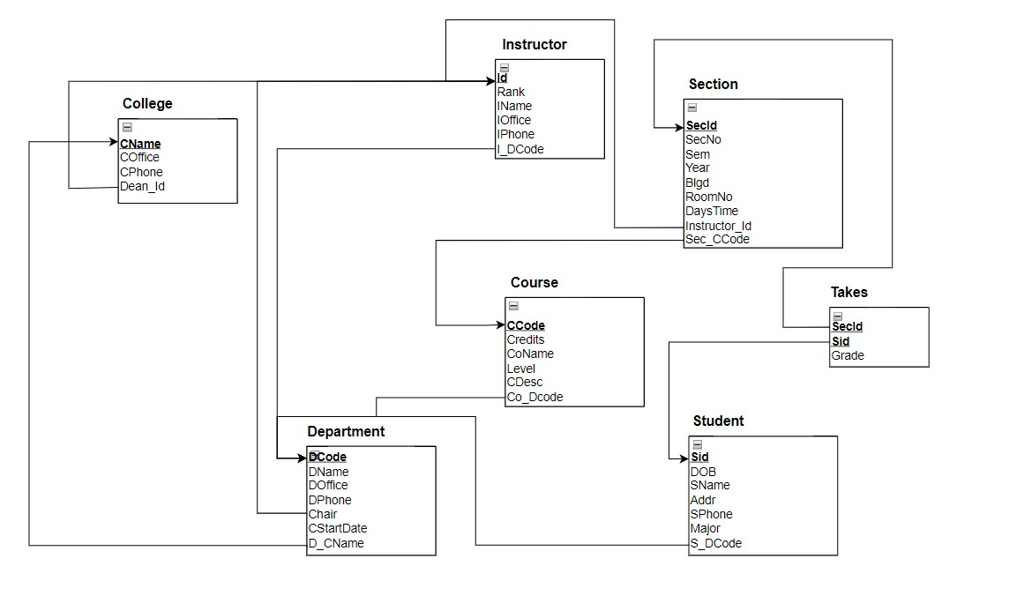

|  |  |
| --- | --- |
| **Entity** | **Details** |
| **Instructor** | The Instructor entity have many-to-one relationship with Department entity, thus we added the primary key of Department (**DCode**) to the many entity which is Instructor as a foreign key (**I_DCode**). |
| **College** | The College entity have a one-to-one relationship with Instructor entity; thus, we added a foreign key (**Dean_Id**) to the full participation entity which is the College from the Instructor primary key (**Id**). |
| **Department** | * The Department entity have a many-to-one relationship with the College entity; thus we added the primary key of College (**CName**) to many entity which is Department as a foreign key (**D_CName**). * The Department entity have one-to-one relation with Instructor, thus we added the instructor primary key (**ID**) to the full participation entity which is department as a foreign key (Chair), we also added the attribute (**CStartDate**) to the department entity. |
| **Course** | The Course entity have a many-to-one relationship with Department, so we added the primary key of Department (**DCode**) to the one entity which is Course as a foreign key (**Co_DCode**). |
| **Student** | The entity Student have a many-to-one relation with Department, so we added the primary key of Department (**DCode**) to Student as a foreign key (**S_DCode**). |
| **Section** | * The entity Section has a many-to-one relationship with Instructor, so we added the primary key of Instructor (**ID**) to Section as a foreign key (**Instructor_Id**). * The entity Section have a many-to-one relationship with Course; thus, we added the primary key of Course (**CCode**) to Section as a foreign key (**Sec_CCode**). |
| **Takes** | As Student and Section have a many-to-many relationship then we created a third relation called **Takes** which contains a composite primary key from both Student and Section primary simple primary keys. In addition, we added the attribute **Grade** to the new created relation **Takes**. |