**SOFTWARE REQUIREMENT SPECIFICATION**

1. **INTRODUCTION**

This section gives a scope description and overview of everything included in this SRS document. Also, the purpose for this document is described and a list of abbreviations and definitions is provided.

This is a dynamic college website which is designed to facilitate easy updating of information .

**1.1 PURPOSE**

The purpose of this document is to give a detailed description of the requirements for the “College Dynamic Website” software.

The main objective of this project is to develop a college website, which is dynamic in nature.

This website also provides information about college and its functions which include the programs it offers, the academic curriculum, the admission structure, current affairs occurring in college and also gives information about the University and the Institute.

The existing systems are time consuming and there are many difficulties faced by administrator to get information about any activity or work done in the college. Presently , the administrator faces problems regarding updation of the existing website which needs to be done in the original source file. This project provides an administrator panel through which administrator can easily update the current website. It provides interactive user interface and helps users in an organization to get information immediately at that instant of time.

**1.2 SCOPE**

The “College Dynamic Website” is a web application which helps students, staff, visitors and administrator to manage all the things online. The web application is OS independent and can be accessed from any modern browsers. The whole system consists of following categories of stakeholders:

Visitors: The visitors (students, staff, faculty and others) to this application can only see the basic information provided about college.

Administrator: The administrator ( college incharge) can monitor performance and  add/remove any data accordingly.

The scope of College Dynamic Website is not only about product-development but also up to the implementation and deployment; this includes the training of the various end-users and maintenance of the products.

Objectives-

* Helps the administrator, students, staff and faculty to keep track of the detailed  information of the college.
* Assists in the smooth interaction between coordinators of different departments.
* Proper maintenance  of  available resources.
* Provides information about events and activities in college.
* Provide information regarding academics and courses.
* Provide information of faculty and staff.

**1.3** **DEFINITIONS,ACRONYMS AND ABBREVIATIONS:**

**1.4 REFERENCES:**

* IEEE Software Engineering Standards Committee, “IEEE Std 830-1998, IEEE Recommended Practice for Software Requirements Specifications” October 20, 1998.
* Django Documentation online

# Overall Description

## Product Perspective

It is a replacement of the current college website.As it provides dynamicity as one of its improved functionality. It is intended to be a stand alone product and should not depend on the availability of other software. It should run on any platform.

## Product Functions

* College Dynamic Website is used to maintain and manage the information of the College.
* This web application helps the user to easily access the information
* There will unique id and password provided for the authorized users so they can modify the content as per their interests
* The visitors will be provided with limited access to the application (i.e. they can only view the specific contents.)
* The newly created site has an extra feature of ‘Administrator site’ which is visible to all the users who have valid and registered username and password.

## User Classes and Characteristics

The users of the system are visitors, staff , students ,faculty and the administrators who maintain the system. The visitors are expected to be Internet literate, once he/she can login the system and navigate between web pages, he/she can use the basic functionality of the system. The administrators of the system to have more knowledge of the internals of the system and is able to rectify the small problems that may arise due to disk crashes, power failures and other catastrophes to maintain the system. Also, the user must be aware of Basic English to interact with the system.

## Operating Environment

This web application is platform independent and can be accessed via any browser which has internet connectivity.

## Design and Implementation Constraints

* The Internet connection is also a constraint for this web application. Since the application fetches data from the database over the Internet,it is crucial that there is an Internet connection for the application to function.
* Since the system is using bootstrap and other technologies,the user needs to use the advanced browsers(Mozilla Firebox 1.5, Internet Explorer 6,Google Chrome) to access the web application.
* The web application will also be constrained by capacity of database. Since the database is shared between different categories of users, it may be forced to queue incoming requests and therefore increase the time it takes to fetch data.
* The users must have their correct usernames and passwords to enter into the Online College Dynamic System.

## Assumptions and Dependencies

.

# External Interface Requirements

## User Interfaces

**3.1.2 HARDWARE INTERFACE:**

The system is a web based application; clients are requiring using a modern web browser such as Mozilla Firefox 1.5, Internet Explorer 6 and Enable Cookies. The computer must have an Internet connection in order to be able to access the system.

Since the web application doesn’t have any designated hardware, it does not have any direct hardware interfaces and therefore the hardware connection to the database server is managed by the underlying operating system on the web server.

**3.1.3 SOFTWARE INTERFACE:**

This system is designed using bootstrap and can therefore be run on all modern browsers(Safari, latest Google chrome, Firefox 4+, Internet explorer 7+).

**3.1.4  COMMUNICATION INTERFACE:**

The HTTP protocol will be used to facilitate communications between the client and server.

# System Features

**FUNCTIONAL REQUIREMENTS:**

The Functional requirements depends upon different stakeholders of the system:

**3.2.1 VISITORS**

3.2.1.1 INTRODUCTION

The visitors have limited access to the web application and they can’t alter any content.The visitors can only visit and are not provided with login facilities.They have access to following categories:

(1) About us: He can know about the aim, mission, core areas and information of university and college .

(2) Programs : He can browse through all programs and courses it contains.

(3) Admissions : He can look for full details for admission procedure.

(4) News and Notifications: He can get all latest news and notifications.

(5) Staff and Faculty information: He can view profiles of all the staff and faculty of the institution.

(6) Placements: He can track the previous year's placements and companies.

3.2.1.2 INPUT

The visitors are not laced with any input facility. They can only visit the website.

3.2.1.3 PROCESSING

Depending upon the user choice or the response to any link the data gets automatically fetched from the database and associated information will be displayed.

3.2.1.4 OUTPUT

On user’s click the information requested will be retrieved from the database and displayed. Output will be generated in case of no errors.

3.2.1.5 ERROR HANDLING

There are rare possibilities of occurrences of errors except in case if there is not a proper web server capabilities or internet connection.. And this error can be rectified by the user itself by checking the Internet connection or other criteria related to network problem.

**3.2.3 ADMINISTRATOR (ADMIN)**

3.2.3.1 INTRODUCTION

ADMIN is considered as the head incharge of DC, who have all rights to directly access the accounts of each DC member.He has access to following categories:-

1. Authorization: He can provide access and authentication to groups and users.
2. Update Staff and Faculty: He can add a new person and has also given right to remove any existing staff or faculty.
3. Monitoring : Admin monitor the daily, weekly or monthly status of  any activity occuring in the institution.
4. Add or remove programs: He can update courses and programs present in the institution.
5. Provide Communication: He can avail connectivity provided to him.
6. Maintain Admissions: He can modify the contents of admissions section if required.

 3.2.3.2 INPUT

Admin would be having his unique id and password in order to make changes and he has to provide name of the section whose contents he needs to edit.

3.2.3.3 PROCESSING

When administrator selects the name of any section the corresponding data is fetched from the database and displayed.

3.2.3.4 OUTPUT

The output will contain specific information which was requested by the administrator about any section of the website.

3.2.3.5 ERROR HANDLING

The only error that can occur is when the information provided to the administrator are incomplete and this error can be resolved by admin itself by performing strict actions on the specific member.

**USE CASE DIAGRAMS**

VISITORS:

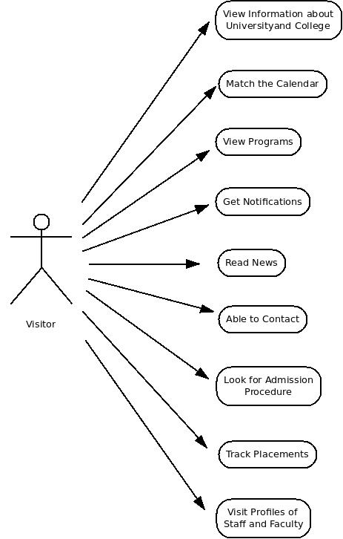

**USE CASE DIAGRAMS**

ADMINISTRATOR

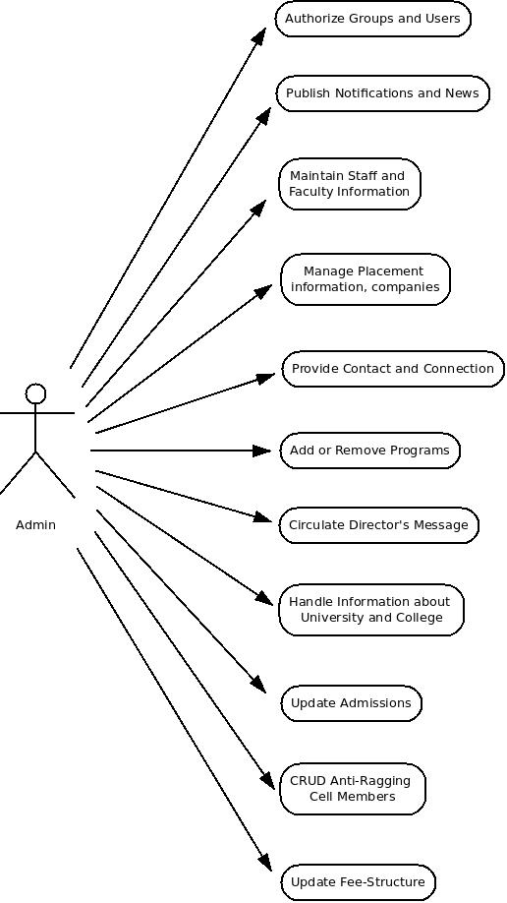

**3.4 NON FUNCTIONAL REQUIREMENTS:**

**3.4.1 Performance**

* Response Time:

The web page or Information page should be able to be downloaded within a minute . The information is refreshed every two minutes. The access time for a mobile device should be less than a minute. The system shall respond to the member in not less than two seconds from the time of the request submittal except in case of no errors. It has short data transmission time.

* Capacity:The system is capable of handling multiple users at a time.

**3.4.2 Reliability**

The system has to be very reliable due to the importance of data and the damages incorrect or incomplete data can do.

**3.4.3 Availability**

The system is available 100% for the user and the system shall be operational 24*7. The website is available on the user’s click. Also the availability depends on the Internet speed of the user's system.

**3.4.4 Security**

The MIS is a secure system as there is a login ID and password required for a particular user to access the database of the system. Only the administrator has permission to modify the contents of the database

**3.4.5 Portability**

Due to its portability feature a client does not need to access it from a specific machine and can be accessed from any device which has a web browser.

**4. ANALYSIS MODEL**

**4.1 SEQUENCE DIAGRAMS**

**4.1.1 ADMIN**



**Use Case Visitor:**

