|  |  |  |  |  |
| --- | --- | --- | --- | --- |
| AMERICAN INTERNATIONAL UNIVERSITY–BANGLADESH (AIUB)  FACULTY OF SCIENCE & TECHNOLOGY  DEPARTMENT OF COMPUTER SCIENCE AND ENGINEERING  Computer Network  Spring 2024-2025  Section: D  FINALTERM LAB TASKS  Supervised By Dr. Rajarshi Roy Chowdhury Submitted By   |  |  | | --- | --- | | Name | ID | | Fatema Akter Tripty | 22-46989-1 |   Date of Submission: May 26, 2025 |

Task -1

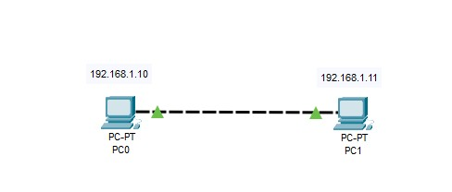

Task-2

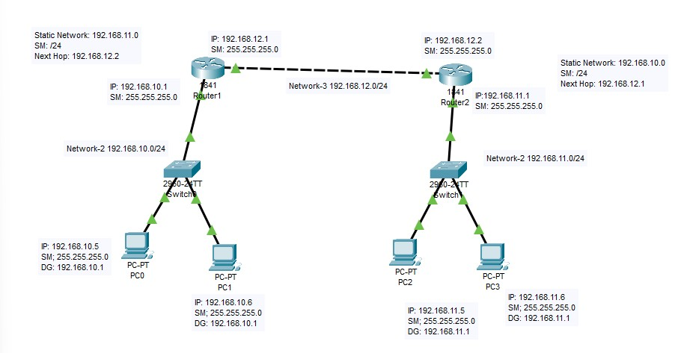

Task-3

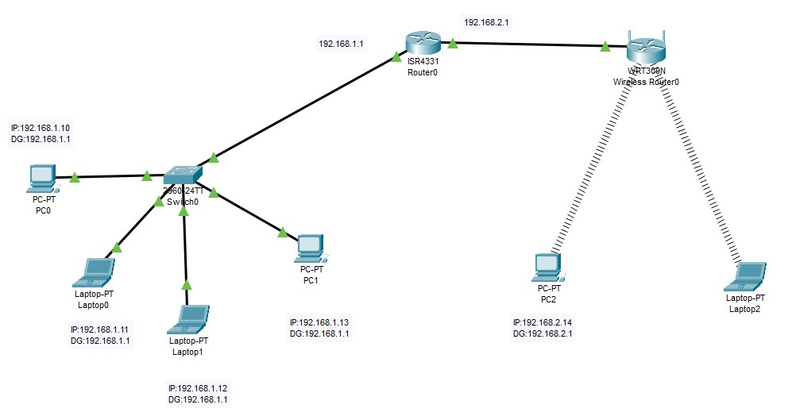

Task-4

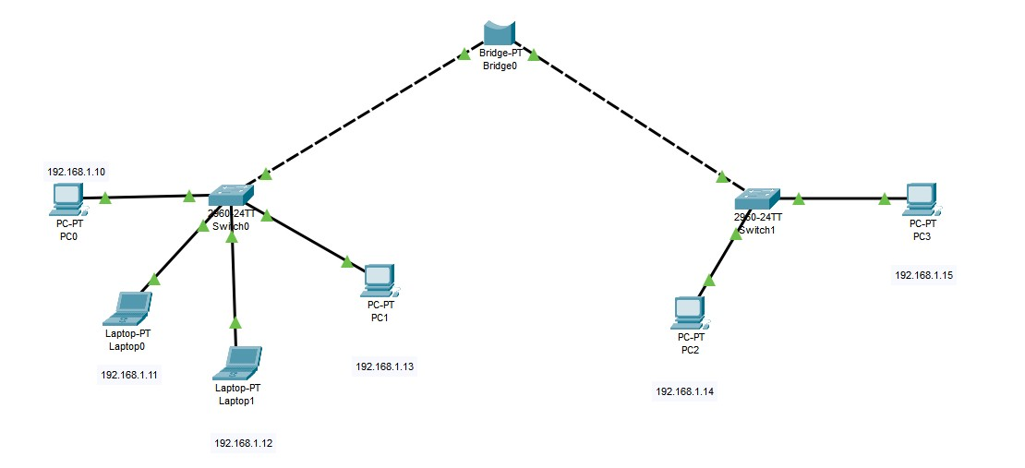

Task-5

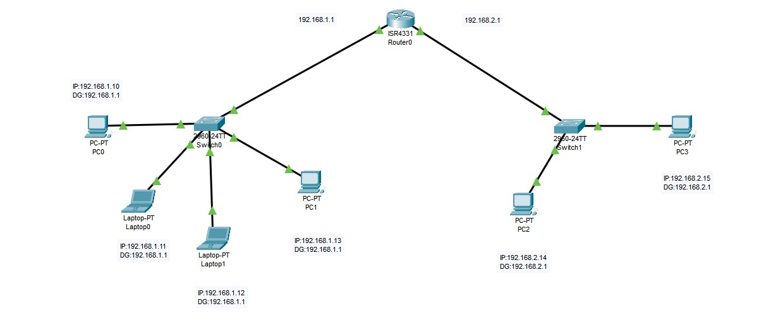

Task-6

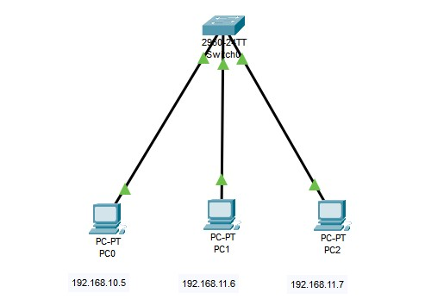

Task-7

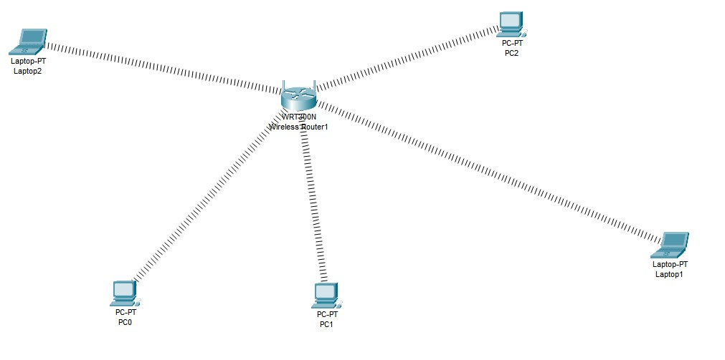

Task- 8

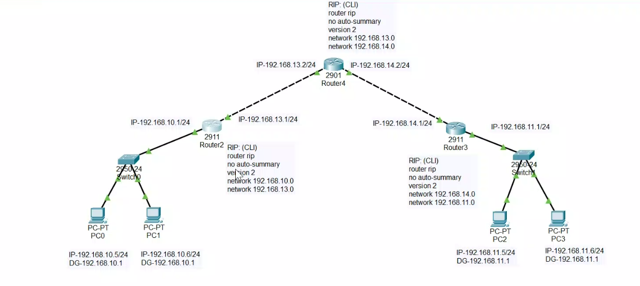

Task – 9

