- RUET Computing Society

RUET Computing Society is a student-led technology community at Rajshahi University of Engineering & Technology, focused on learning, innovation, and practical computing. It brings together students interested in technology through workshops, events, projects, and collaborative activities, creating a space to learn new skills, build ideas, and grow together.
Advisor: Dr. Md. Shahid Uz Zaman
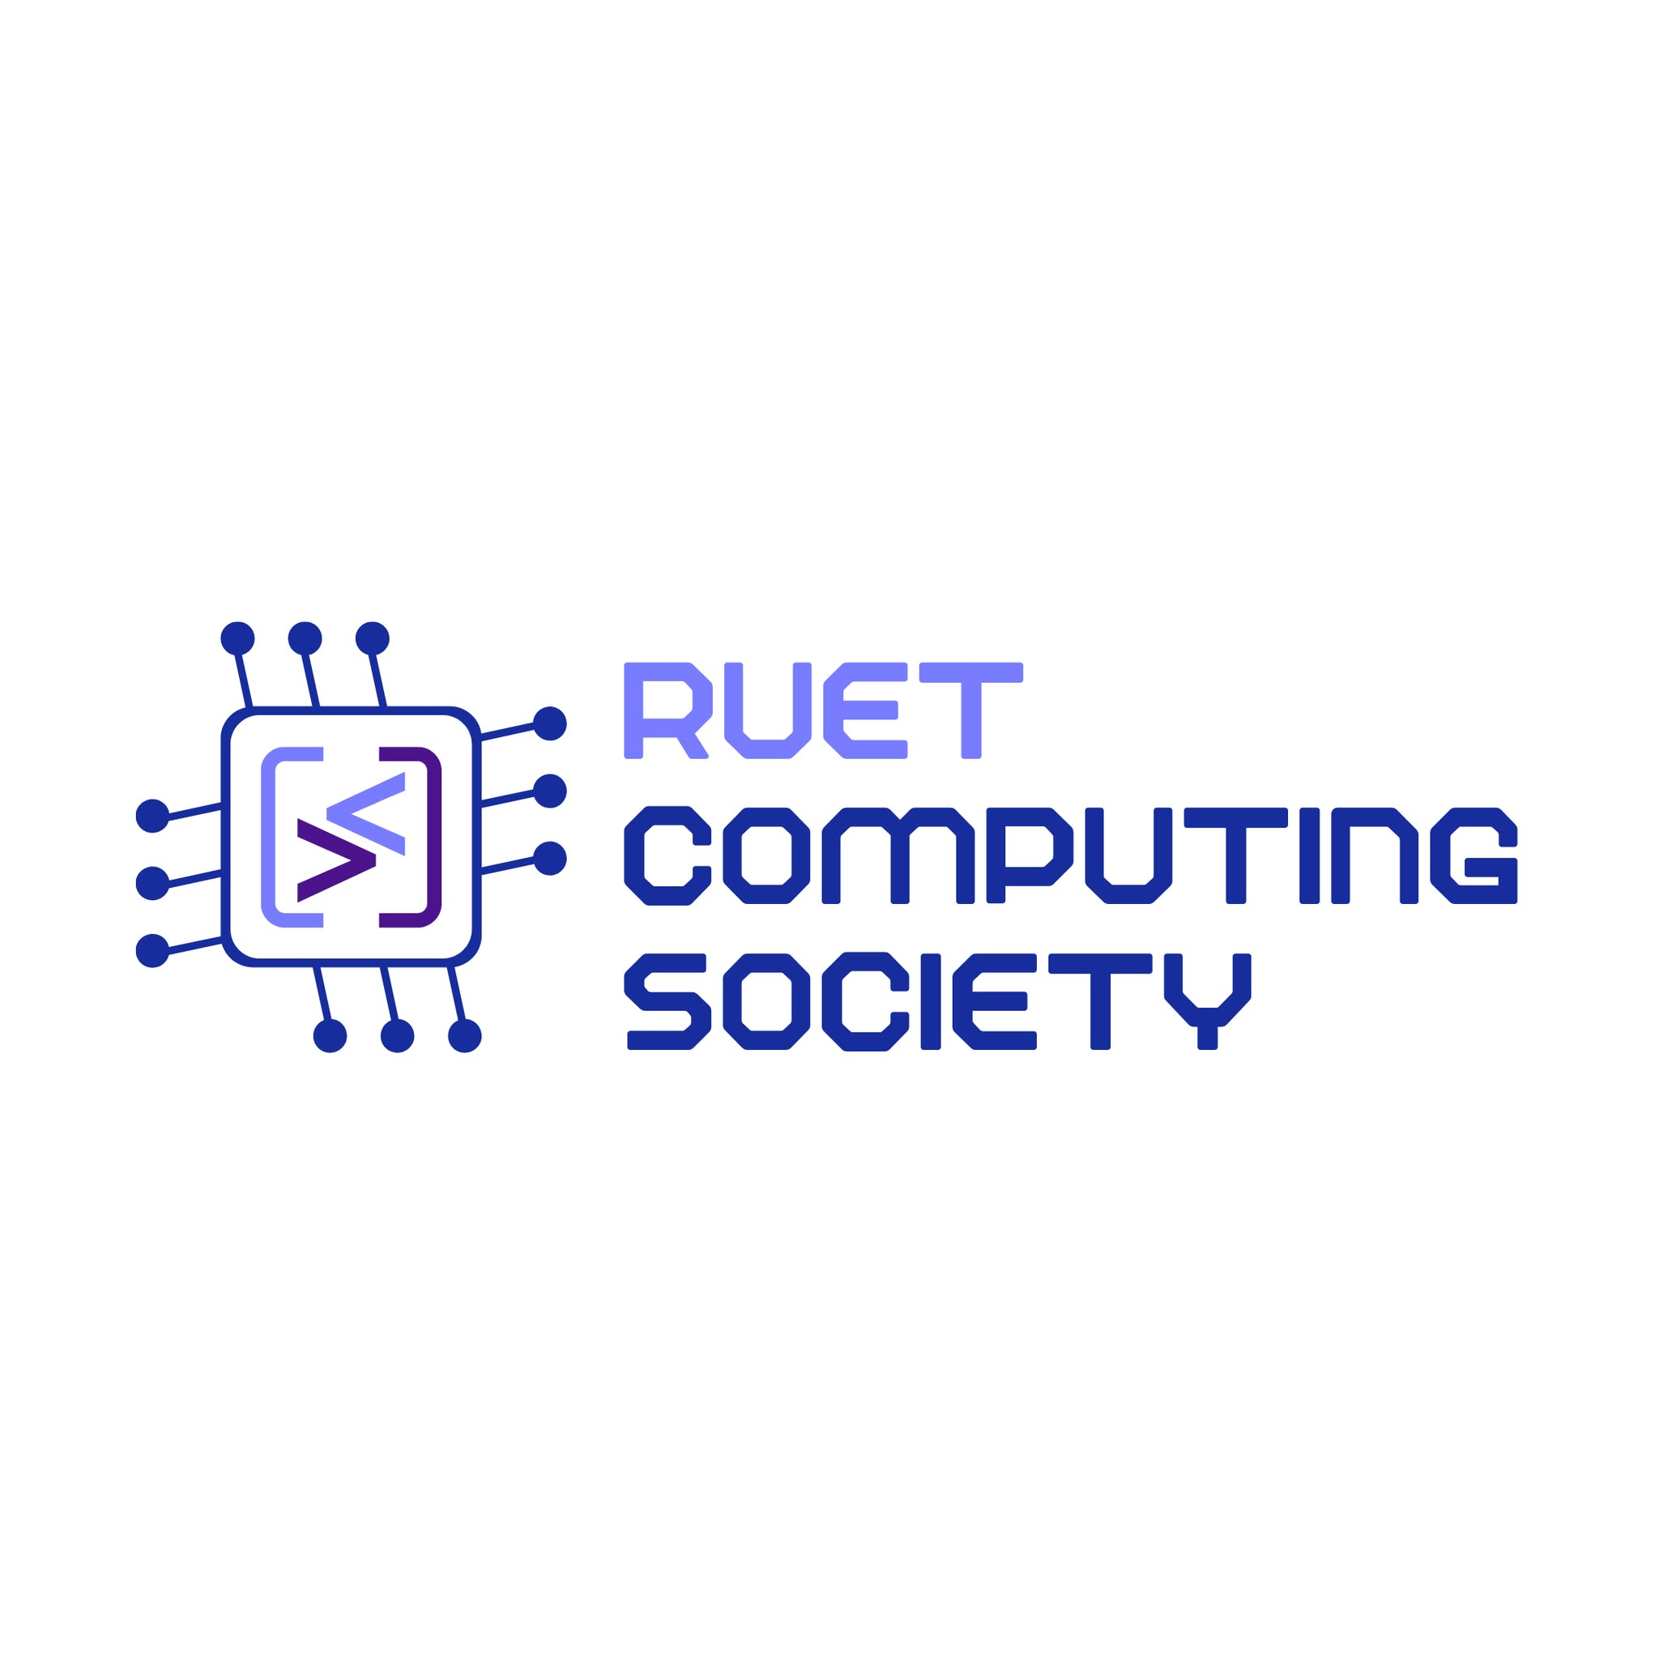

- RUET Cybersecurity Club

The Cybersecurity Club is a student-led community dedicated to exploring cybersecurity, ethical hacking, digital safety, and emerging security technologies. It provides students with opportunities to learn, practice, collaborate, and develop practical skills for tackling real-world cybersecurity challenges.
Advisor: Dr. Md. Nazrul Islam Mondal
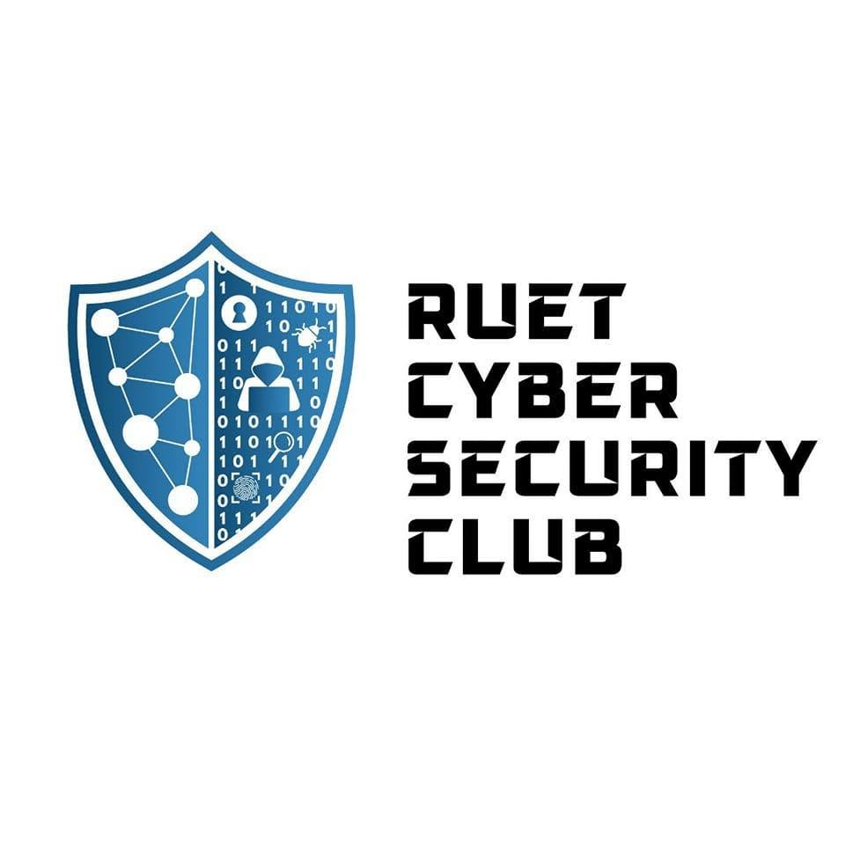

- Robotic Society of RUET
Curious about robots, automation, electronics, or building things that actually move? Robotic Society of RUET is a place to learn, experiment, build, and turn ideas into working projects while collaborating with fellow tech enthusiasts.
Advisor: ----
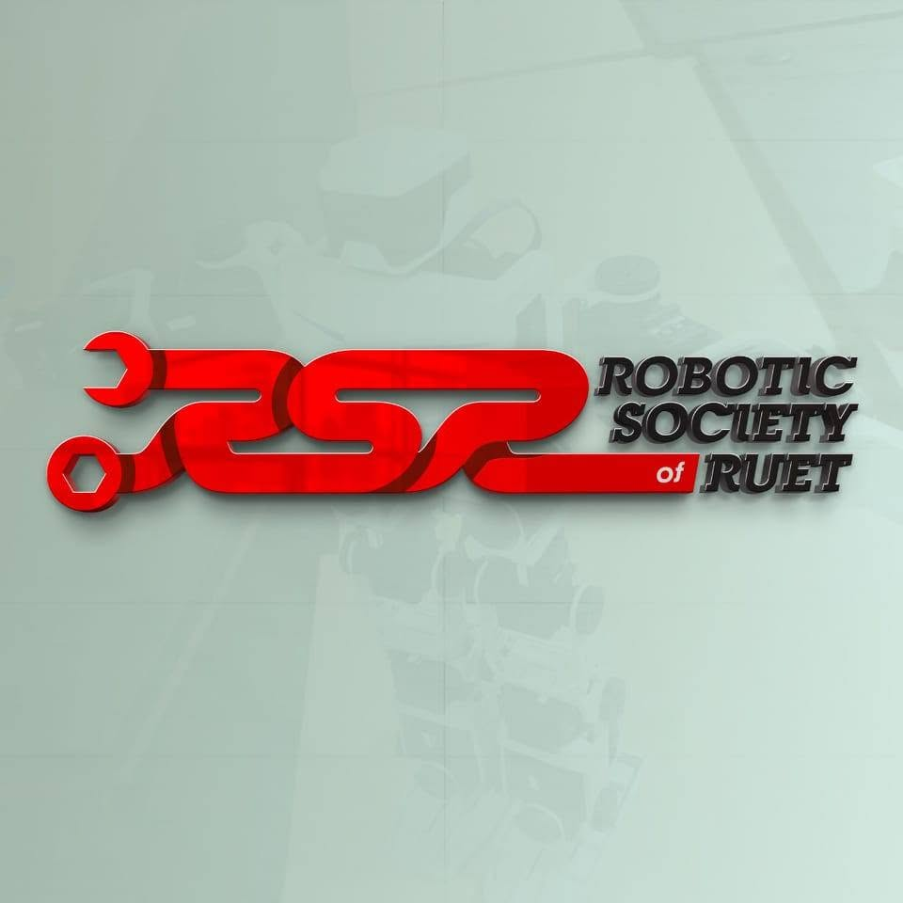

- Astronomy and Science Society of RUET
Ever looked at the night sky and wondered what’s out there? Astronomy and Science Society of RUET brings together curious minds through stargazing, science activities, competitions, and exploration—making science something to experience, not just study.
Advisor: Dr. Md. Johirul Islam
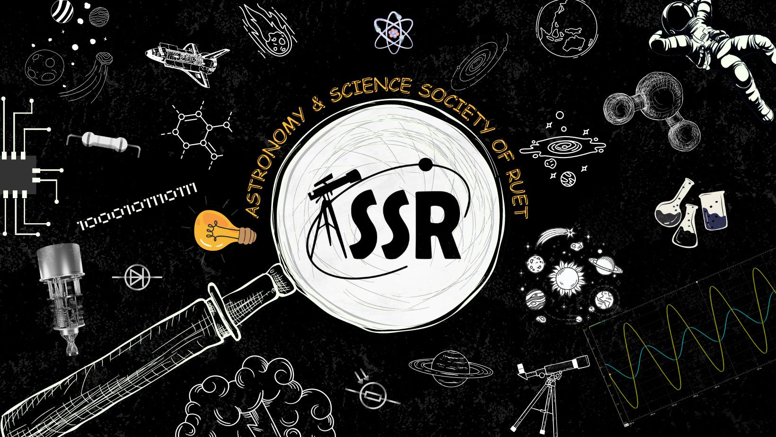

- Onuronon - RUET Cultural Club
Love music, dance, drama, literature, or simply expressing yourself creatively? Onuronon is a vibrant space to discover your talents, share your creativity, and celebrate culture with the RUET community.
Advisor: Md Abu Ismail Siddique
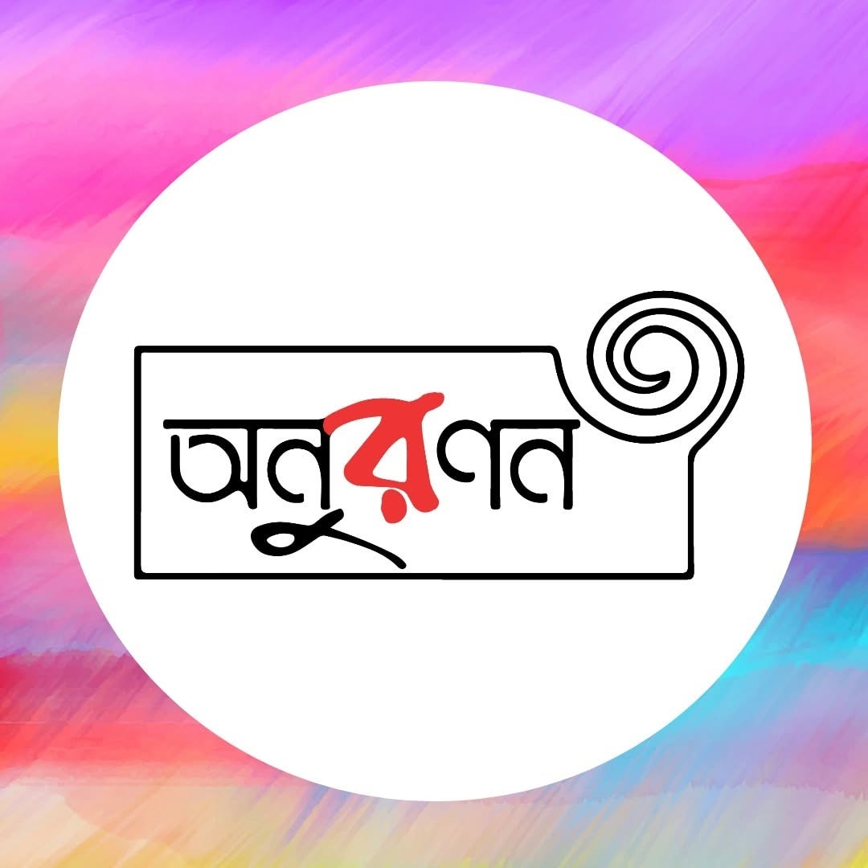

- RUET Debating Club - RUET DC
Love a good argument—or want to become better at expressing your ideas? RUET DC helps you sharpen your thinking, speaking, and debating skills through engaging debates, discussions, and competitions.
Advisor: Md Abu Ismail Siddique


- Team Crack Platoon
Bangladesh’s first Formula SAE team, Team Crack Platoon was formed by a group of automotive enthusiasts from RUET. Bringing together passion, engineering, and innovation, the team designs and builds race cars while taking on the challenges of Formula SAE competitions.
Advisor : --
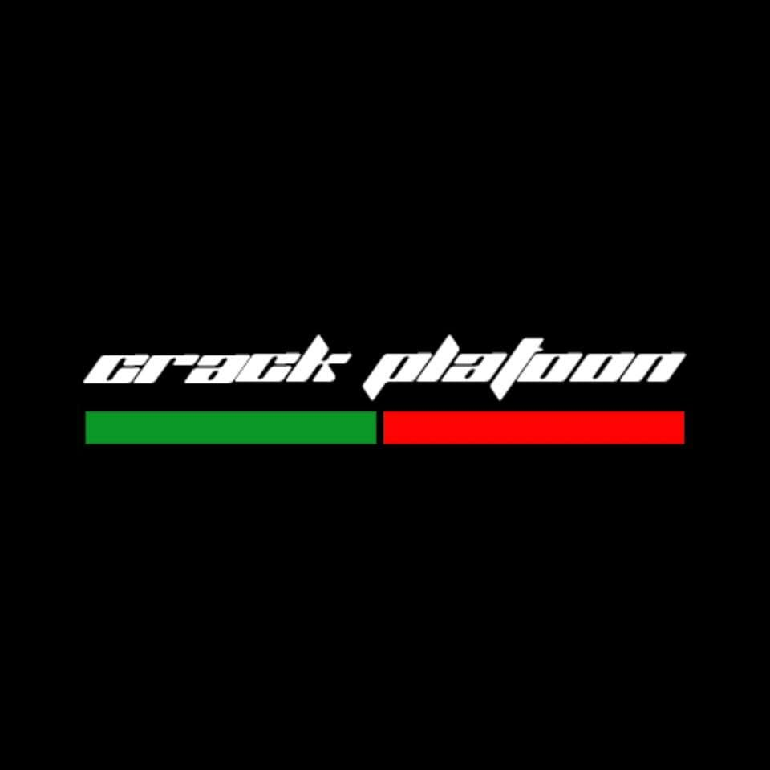

- Team Ogrodoot - RUET Rover Team
Fascinated by Mars and space exploration? Team Ogrodoot is a community of space enthusiasts working together to design and build Mars rovers, turning curiosity about the Red Planet into hands-on engineering, innovation, and adventure.
Advisor: ---
