EVENTS:

- RUET Cybersecurity Club
Event: Cyber Treasure Hunt 2.0
Venue: Online
Date: 18. 09.2026
Time: 10 am to 4 pm
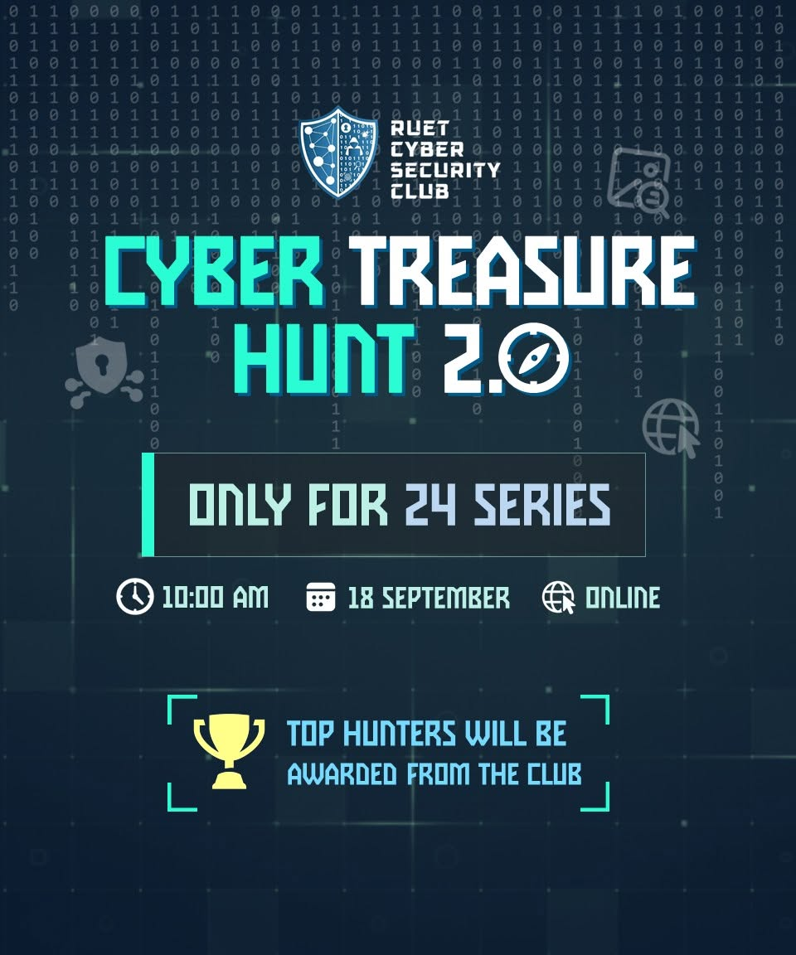

- Astronomy and Science Society of RUET
Event: Sky Observation Event
Date: 24. 09. 2026
Venue: Talaimari Shahid Minar, Rajshahi
Time: 8 pm
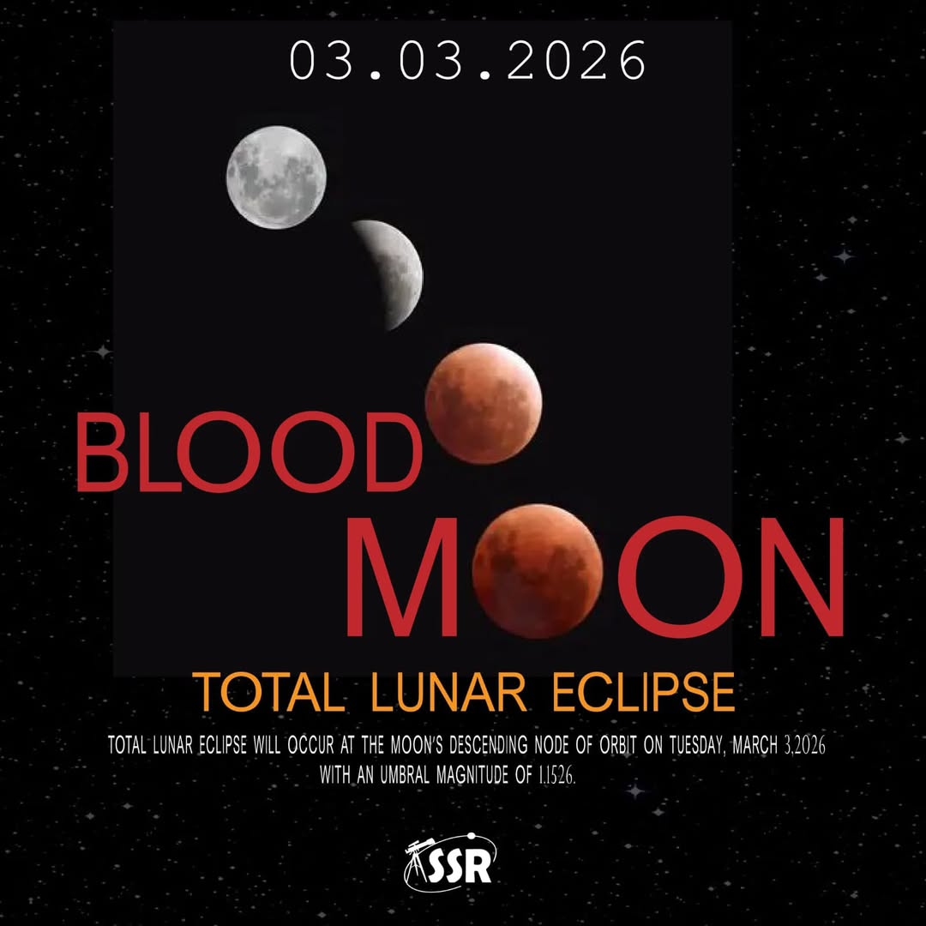

ACHIEVEMENTS:

- 6th Break Team and Quarter-Finalist at the TCDC 1st National Debate Festival 2026
Club: RUET Debating Club



- Winner at উচ্ছ্বাসে স্পন্দন 2026, Season 2
Club: Onuronon - RUET Cultural Club
