1. Project Introduction
2. Dataset Loading
3. Dataset Understanding
4. Data Cleaning
5. Exploratory Data Analysis
- Genre distribution
- Top artists
- Danceability distribution
- Energy distribution
- Tempo distribution
- Loudness distribution
- Duration distribution
- Average audio features
- Correlation heatmap
- Genre-based averages
6. Outlier Detection
7. Key Insights and Conclusion

Project Introduction
This project analyzes the Spotify Top 50 tracks from 2020. The goal is to understand which audio features are common among popular songs, identify patterns across genres, detect unusual tracks, and summarize music trends based on the dataset. The dataset contains 17 columns. Most column names are clear, lowercase, and descriptive. There are no duplicate column names and no unusual symbols in the column names. The only exception is the column `Unnamed: 0`, which appears to be an exported index column rather than a meaningful variable. This column will be reviewed during the data cleaning phase. The dataset includes identification information such as artist, album, track name, and track ID. It also contains several numerical Spotify audio features, including energy, danceability, loudness, acousticness, speechiness, instrumentalness, liveness, valence, tempo, and duration. The genre column can be used for categorical analysis and comparison between music styles.
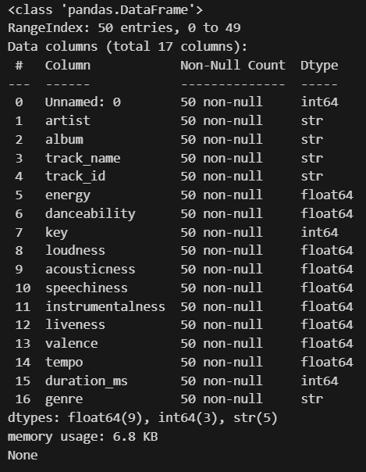

Genre Distribution
The genre distribution shows that Pop is the most frequent genre in the Top 50 tracks, with 14 songs. It is followed closely by Hip-Hop/Rap, with 13 songs. Together, these two genres account for 27 out of 50 songs, meaning they represent more than half of the dataset. Other genres appear less frequently. Dance/Electronic appears 5 times, while Alternative/Indie appears 4 times. Several genres, such as Chamber pop, Pop rap, Hip-Hop/Trap, and Nu-disco, appear only once. This suggests that the Top 50 tracks in this dataset are mainly concentrated around Pop and Hip-Hop/Rap, while the remaining genres form a more diverse but less frequent group. Since the dataset contains only 50 tracks, these results should be interpreted as trends within this Top 50 list, not as a complete representation of all Spotify music.
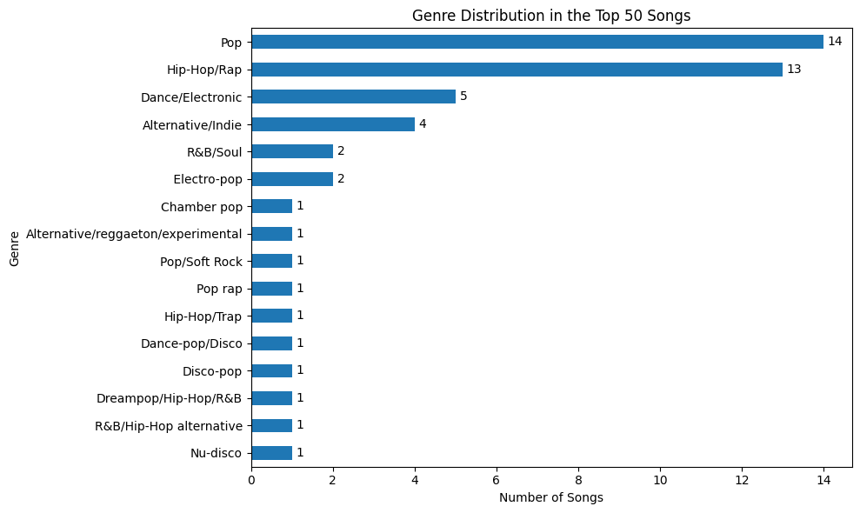

Artist Distribution
The artist distribution was analyzed by counting how many times each artist appears in the Top 50 tracks. The results show that seven artists have more than one popular track in the dataset. Dua Lipa, Billie Eilish, and Travis Scott appear most frequently, with three tracks each. Lewis Capaldi, Post Malone, Justin Bieber, and Harry Styles each appear with two tracks. This suggests that although some artists had multiple popular songs, the Top 50 is not completely dominated by only a few artists. Most artists in the dataset are likely represented by only one track, while a smaller group of artists appears more than once.
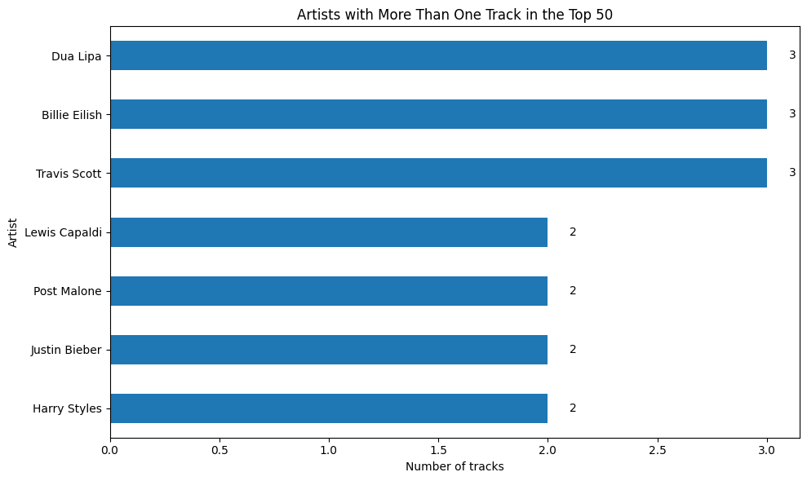

Danceability Distribution
The danceability distribution was analyzed using a histogram. Danceability values range from 0 to 1, where higher values indicate that a track is more suitable for dancing. The results show that the Top 50 tracks are generally danceable. The mean danceability value is 0.717, and the median value is 0.746, which means that the central tendency of the dataset is above 0.7. In addition, 33 out of 50 tracks have high danceability values between 0.7 and 1.0, while only 3 tracks have low danceability values below 0.5. Most songs are concentrated between approximately 0.65 and 0.85, suggesting that danceability is relatively high across the dataset. However, the values range from 0.351 to 0.935, showing that there is still some variation among the tracks. Overall, the Top 50 songs in this dataset can be considered mostly danceable.
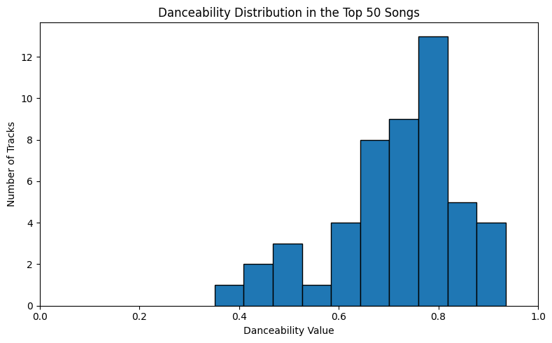

Energy Distribution
The energy distribution shows that the Top 50 tracks are generally moderate to high in energy. The mean energy value is 0.609 and the median is 0.597, meaning the central tendency is around the medium-energy range. Out of 50 tracks, 13 songs have low energy values below 0.5, 16 songs have medium energy values between 0.5 and 0.7, and 21 songs have high energy values above 0.7. This means that most tracks, 37 out of 50, have energy values above 0.5. The values range from 0.225 to 0.855, showing that the dataset includes both calmer and more energetic songs. Overall, popular tracks in this dataset tend to be moderately energetic, with a noticeable number of highly energetic songs.
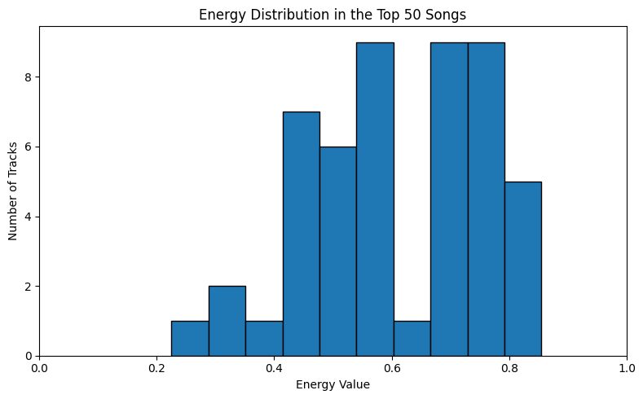

Tempo Distribution
The tempo distribution was analyzed using a histogram. Tempo is measured in beats per minute, BPM, and the values in this dataset range from 75.80 BPM to 180.07 BPM. The mean tempo is 119.69 BPM, while the median is 116.97 BPM, showing that the central tempo of the Top 50 tracks is around 117–120 BPM. Based on the middle 50% of the songs, the common tempo range is approximately 99.56 BPM to 132.32 BPM. The histogram also shows that many tracks are concentrated around the 100–130 BPM range, suggesting that most popular songs in this dataset have a moderate tempo. No unusual tempo values were detected using the IQR method. However, the dataset still includes some slower songs below 90 BPM and some faster songs above 160 BPM, showing that there is variation in tempo among the Top 50 tracks.
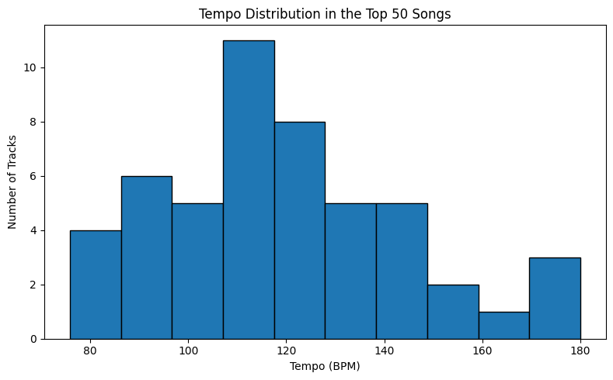

Loudness Distribution
The loudness distribution was analyzed to understand how loud the Top 50 tracks are. Loudness is measured in decibels, dB, and the values are usually negative. Values closer to 0 indicate louder tracks. In this dataset, loudness values range from -14.454 dB to -3.280 dB. The mean loudness is -6.226 dB, and the median is -5.992 dB. This shows that most tracks are relatively loud, which is expected for popular commercial music. The middle 50% of songs are between approximately -7.553 dB and -4.286 dB, suggesting that many tracks are concentrated in a loud, radio-friendly range. Overall, the Top 50 songs are generally loud and commercially mastered, although a few tracks are noticeably quieter than the rest.
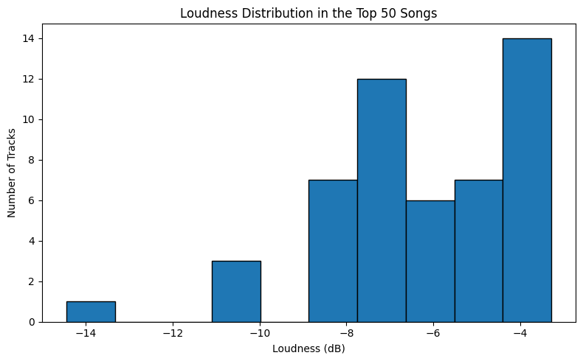

Duration Distribution
The duration distribution was analyzed to understand how long popular songs are. Since the original duration column was measured in milliseconds, it was converted into minutes for easier interpretation. The average song duration is approximately 3.33 minutes, while the median duration is 3.30 minutes. The shortest song is about 2.34 minutes, and the longest song is about 5.21 minutes. The middle 50% of songs are between approximately 2.93 and 3.58 minutes. This suggests that most popular songs in the Top 50 follow a common commercial duration, usually around 3 to 3.5 minutes. This length is typical for streaming and radio-friendly songs. However, the dataset also includes some shorter and longer tracks, showing that popular songs do not all follow exactly the same structure.
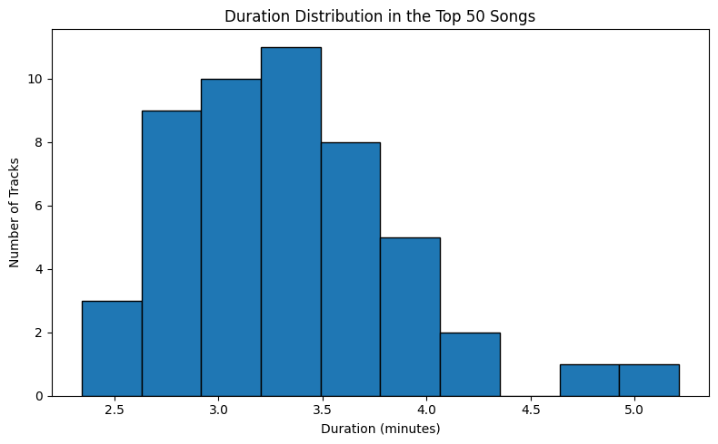

Average Audio Features
The average audio features were analyzed to understand the general sound profile of the Top 50 tracks. The selected features were danceability, energy, acousticness, speechiness, instrumentalness, liveness, and valence. These features mostly range from 0 to 1. The highest average feature is danceability, with a mean value of 0.717. This suggests that the Top 50 tracks are generally suitable for dancing or rhythmic listening. Energy is also relatively high, with an average value of 0.609, showing that popular tracks tend to have a moderate to high level of intensity. Valence has an average value of 0.556, which suggests that the emotional tone of the songs is mixed but slightly positive. Acousticness has a lower average value of 0.256, indicating that most tracks are not strongly acoustic. Speechiness is also low, with an average value of 0.124, meaning that most tracks are not heavily speech-based. Instrumentalness is very low, with an average value of 0.016, which strongly suggests that the Top 50 songs are mostly vocal-based rather than instrumental. Overall, the general audio profile of the Top 50 songs is danceable, moderately energetic, mostly vocal-based, and more studio-produced than acoustic.
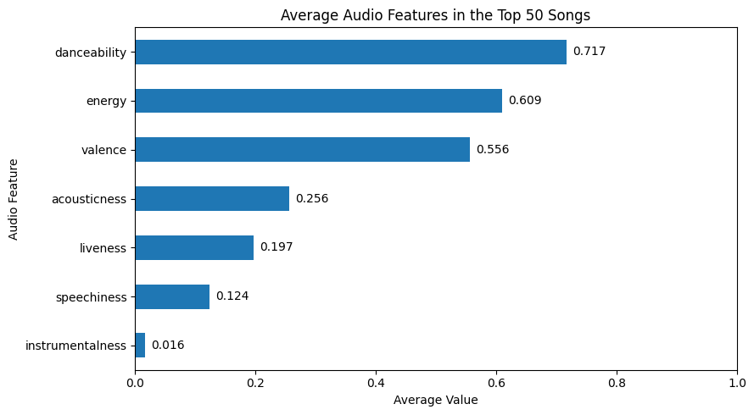

Correlation Heatmap
The correlation heatmap was used to examine relationships between numerical audio features. Correlation values range from -1 to +1. A positive value means that two features tend to increase together, while a negative value means that one feature tends to decrease as the other increases. The strongest positive relationship is between energy and loudness, with a correlation of 0.79. This means that more energetic tracks also tend to be louder. This is reasonable because energetic songs are often produced with stronger intensity and higher volume. There is a strong negative relationship between energy and acousticness, with a correlation of -0.68. This suggests that more acoustic tracks tend to be less energetic, while more energetic tracks are usually less acoustic. Loudness also has a negative correlation with acousticness, around -0.50, meaning that more acoustic songs are generally quieter. Danceability has a moderate positive relationship with valence, around 0.48. This suggests that more danceable songs may also tend to sound more positive or cheerful. Valence also shows moderate positive relationships with energy and loudness, meaning that more energetic and louder tracks may also feel more positive. Most other correlations are weak, which means that many audio features are not strongly linearly related to each other in this dataset. Since the dataset contains only 50 songs, these correlations should be interpreted carefully as trends within this Top 50 list, not as general rules for all Spotify music.
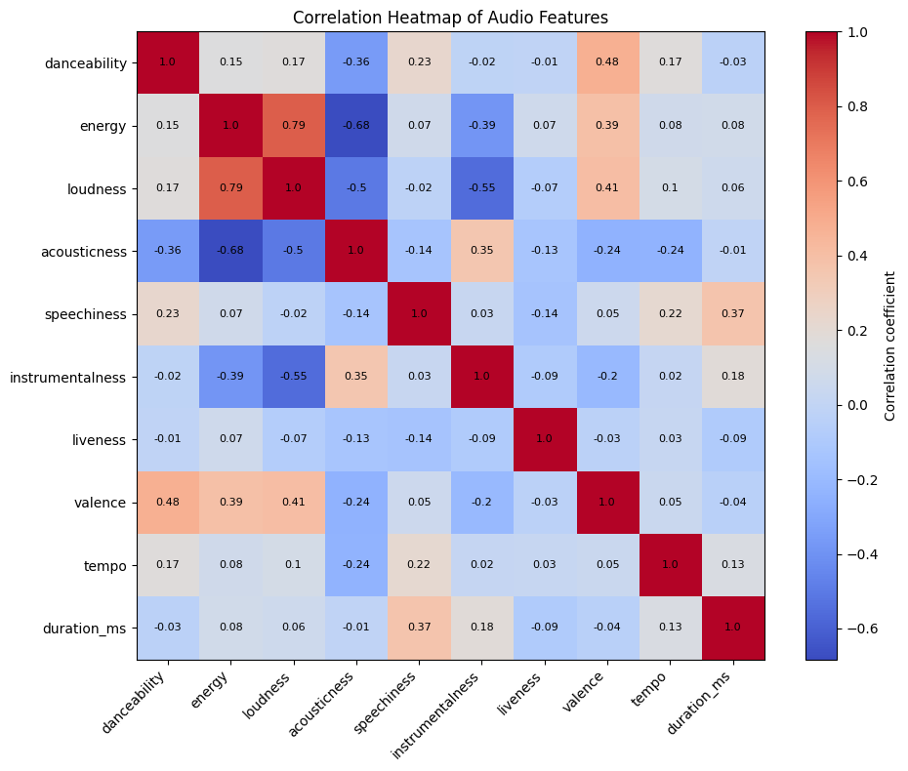

Genre-Based Averages
The genre-based averages were analyzed to understand how audio features differ across genres. Only genres with more than one track were considered, because genres represented by a single song are not reliable for comparison. Dance/Electronic has high average energy, danceability, and valence. This suggests that Dance/Electronic tracks in the dataset are generally rhythmic, energetic, and positive-sounding. Hip-Hop/Rap also has high average danceability and relatively higher speechiness compared with several other genres, which is expected because rap tracks often contain more spoken or rhythmic vocal delivery. Pop has moderate values across most features. It has relatively high danceability and moderate energy, which suggests that Pop tracks in the Top 50 are generally balanced and accessible. Alternative/Indie shows the highest acousticness among the common genres, suggesting that these tracks may rely more on acoustic or less heavily produced sounds. R&B/Soul has relatively high energy in this dataset, but because it has only two tracks, this result should be interpreted carefully. Overall, the genre-based analysis shows that different genres have different audio profiles. Dance/Electronic appears more energetic and positive, Hip-Hop/Rap appears danceable and more speech-oriented, while Alternative/Indie appears more acoustic. However, some genres have only a small number of songs, so the results should be considered as observations within this dataset rather than broad conclusions about the genres.
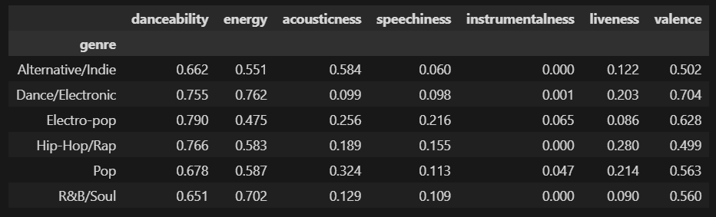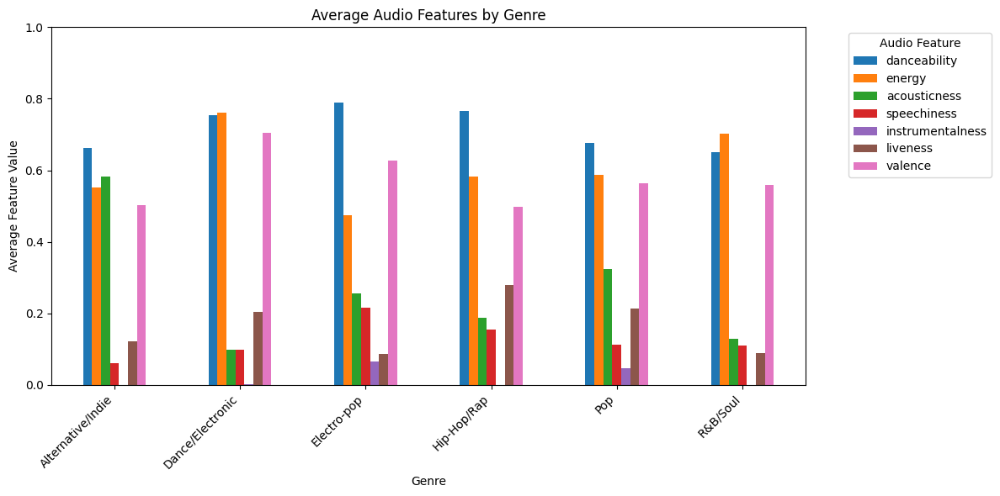

Final Key Insights and Conclusion
This exploratory data analysis examined the Spotify Top 50 tracks from 2020 to identify patterns in genre, artist frequency, and audio features. The analysis shows that Pop and Hip-Hop/Rap are the most common genres in the dataset. Together, they represent more than half of the Top 50 tracks, suggesting that popular music in this list is strongly concentrated around these two genres. However, several other genres also appear, showing that the Top 50 includes some musical diversity. The artist analysis shows that a small number of artists appear more than once. Dua Lipa, Billie Eilish, and Travis Scott each have three tracks, while Lewis Capaldi, Post Malone, Justin Bieber, and Harry Styles each have two tracks. This means that some artists had multiple popular songs, but the dataset is not completely dominated by only a few artists. The audio feature analysis shows that the Top 50 tracks are generally danceable and moderately energetic. Danceability has a high average value, and most songs have danceability values above 0.7. Energy is also generally moderate to high, although there is more variation compared with danceability. Tempo values are mostly concentrated around 100 to 132 BPM, which suggests that popular songs commonly fall within a moderate tempo range.
The loudness analysis shows that most tracks are relatively loud, with an average loudness around -6.23 dB. This supports the idea that popular tracks are usually commercially mastered. The duration analysis shows that most songs are around 3 to 3.5 minutes long, which is consistent with common commercial song lengths. The average audio feature profile suggests that the Top 50 songs are mostly vocal-based, danceable, moderately energetic, and not strongly acoustic or instrumental. The very low instrumentalness value indicates that instrumental tracks are rare in this dataset. The correlation heatmap shows that energy and loudness have the strongest positive relationship, meaning that more energetic tracks tend to be louder. Energy and acousticness have a strong negative relationship, meaning that more acoustic songs tend to be less energetic. These relationships help explain some of the general sound characteristics of popular tracks.
Overall, the Spotify Top 50 tracks in this dataset are mainly characterized by high danceability, moderate to high energy, commercial loudness, vocal-based production, and common song durations. The results suggest that popular songs in 2020 tended to be accessible, rhythmic, and professionally produced. However, because the dataset contains only 50 tracks from one year, the findings should be interpreted as trends within this specific dataset rather than general conclusions about all Spotify music.

