MCI SIM ACTIVATION ANALYTICS PROJECT
Technical Documentation: Data Warehouse, Daily ETL, and Power BI Dashboard
Prepared for MCI | 19 October 2026

1. Project Objective and Scope
This project implements an analytics workflow for daily SIM activation reports received as CSV files from multiple channels. The objective is to prepare the data for consistent analysis, store it in a relational warehouse, automate recurring ingestion, and provide a Power BI management dashboard for reviewing activation volume over time, by channel, and by region.
The solution includes SQL Server warehouse objects and a processing stored procedure, PowerShell ETL orchestration, Windows Task Scheduler configuration, and a Power BI report. It runs in a local SQL Server Express environment; it is not claimed to be a live telecom production deployment.

2. Data Preparation and Star Schema

2.1 Data preparation
The PowerShell script scans CSV files and loads a file into dbo.stg_Activations_Incoming, the per-file landing table. SQL processing then maintains source-level history in dbo.stg_Activations and dbo.ActivationDailySnapshot and refreshes the reporting fact data. SourceFile metadata is retained for lineage and file-level traceability. The incoming table was empty after the successful isolated validation run.
In ActivationDailySnapshot, NUMBER_OF_ACTIVATION is stored as text (nvarchar), so numeric summaries use safe conversion such as TRY_CONVERT. The recorded validation checks confirmed that the activation totals reconcile between the snapshot and fact tables and that FactActivation has no duplicate DateKey × ChannelKey × RegionKey combinations at its defined grain.

2.2 Star Schema and table roles
FactActivation stores the ActivationCount measure and keys to descriptive dimensions. Its documented grain is one row per unique DateKey × ChannelKey × RegionKey combination. DimDate supplies date context, while channel and region dimensions provide descriptive context for grouping and filtering. This design allows the dashboard to analyze data by date, channel, and region without reporting directly from raw CSV files.
Object | Role and observed details
dbo.FactActivation | Aggregated fact table; 1,444 rows and SUM(ActivationCount) = 531,040 in the main database.
dbo.DimDate | Date dimension; DateKey is the date key and ActiveDate display format is YYYY/MM/DD.
Channel and Region dimensions | Descriptive dimensions used for channel and regional analysis.
dbo.ActivationDailySnapshot | Source-level snapshot; 186,156 rows; safely converted activation total = 531,040.
dbo.stg_Activations / Incoming | Raw source history and per-file landing area; incoming staging was zero after the isolated test.
dbo.ETL_FileLog | File audit and duplicate protection; 12 registered records. Fields include SourceFile, ReportDate, RowsLoaded, LoadDateTime, LoadStatus, and Notes.

3. Daily ETL and Duplicate Prevention
Main script: E:\Projects\SIM_Activation_Project\Data\Run_ETL.ps1. It targets SQL Server instance DESKTOP-LDNBD3P\SQLEXPRESS and the main database SIMActivationDW. PowerShell coordinates file discovery, loading, procedure invocation, logging, and file movement; SQL Server performs relational processing and warehouse refresh.
- Scan source files: Scan Data\Source for CSV files matching the expected activation-report filename pattern.
- Check file history: Check ETL file history; files already registered as completed are skipped to prevent reloading.
- Load incoming staging: Load the new file into dbo.stg_Activations_Incoming.
- Process in SQL: Call dbo.usp_ProcessIncomingActivationFile with the source filename; process incoming data and refresh affected snapshot/fact data.
- Validate and log: Record status and row counts, apply the implemented checks, and write processing details to the logs.
- Route the file: Move successful files to Data\Processed; failures are logged and routed to Data\Failed according to the script.
- Finish the scan: Write a completion message to Data\Logs.
Windows Task Scheduler contains the daily task SIM Activation Daily ETL. It runs PowerShell with -NoProfile -ExecutionPolicy Bypass and the Run_ETL.ps1 script, using the Data folder as its working directory. On 19 October 2026 at 16:40:10, the task was invoked and returned LastTaskResult = 0. The execution log confirmed that the scan completed and the 12 previously registered files were correctly skipped by the duplicate-file control.

4. Power BI Management Dashboard
The report title is “MCI SIM Activation Dashboard” and the subtitle is “Performance Analytics”. It uses a landscape layout with an MCI-inspired palette. The Activation Date, Channel, and Region slicers allow users to explore the KPIs and visuals in the current filter context.
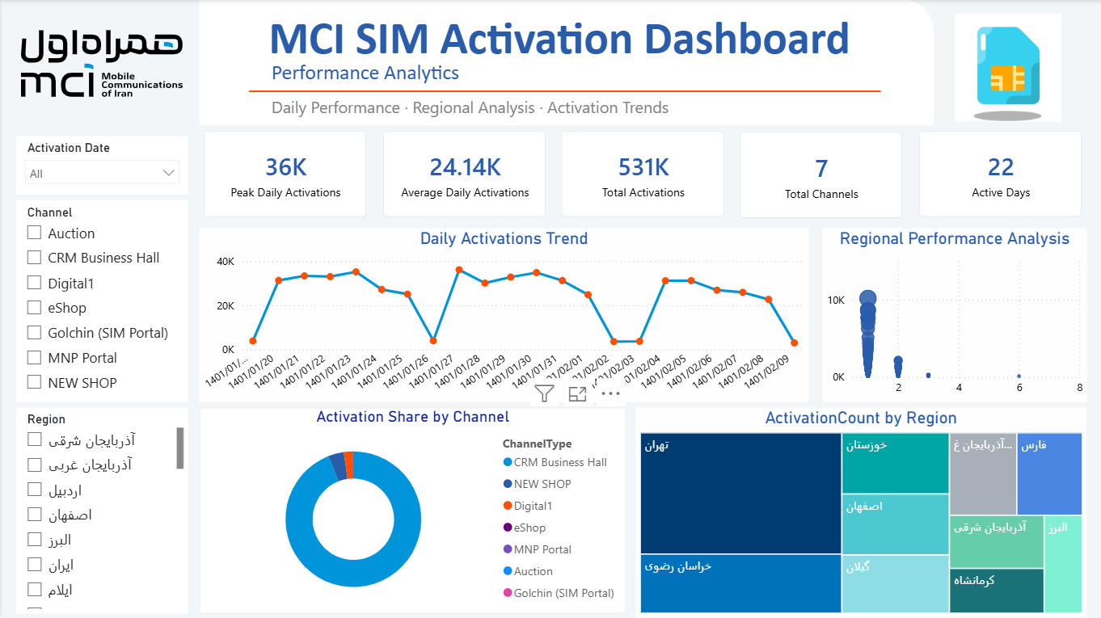
Figure 1. Actual Power BI dashboard supplied for this documentation.
Dashboard element | Purpose
Peak Daily Activations | Highest daily activation count in the current filter context.
Average Daily Activations | Average daily activation volume for the selected context.
Total Activations | Total activation volume under the current filters.
Total Channels | Number of channel categories represented by the KPI.
Active Days | Number of active/reporting days represented in the selected context.
Daily Activations Trend — line chart | Shows daily activation values over time and makes peaks and low-activity dates visible.
Regional Performance Analysis — scatter chart | Provides a comparative regional view. Interpret the numeric axes according to the fields configured in the visual.
Activation Share by Channel — donut chart | Shows how activation volume is distributed among channel categories.
ActivationCount by Region — treemap | Compares activation volume across regions; rectangle size represents the region’s relative contribution.

5. Validation Results and Operational Checks

5.1 Main database
In SIMActivationDW, FactActivation contained 1,444 rows and SUM(ActivationCount) was 531,040. ActivationDailySnapshot contained 186,156 rows, and safely converted NUMBER_OF_ACTIVATION values also totaled 531,040. ETL_FileLog contained 12 records. The recorded uniqueness check found no duplicate DateKey × ChannelKey × RegionKey combinations. Snapshot and fact row counts differ because they represent different grains; the relevant recorded reconciliation is the activation total.

5.2 Isolated new-file ETL test
A controlled end-to-end test was run against the separate database SIMActivationDW_ETLValidation, not the main database. A copied CSV with 88,884 source rows was processed successfully. The procedure returned RunID=6, RowsLoaded=88,884, DatesRefreshed=10, Status=Succeeded. Fact and snapshot totals in that validation database both equaled 528,043, incoming staging was empty after success, and the file was skipped on rerun because it was already registered.

5.3 Assumptions and limitations
- The main warehouse and the isolated validation database were checked independently. Their totals are reported separately because each reflects its own data state.
- The post-edit run against SIMActivationDW confirmed the database connection, source-file scan, duplicate-file protection, and successful scan completion. The separate end-to-end validation run additionally demonstrated successful processing of a new file, logging, warehouse reconciliation, clearing of incoming staging, and duplicate skipping on rerun.
- Power BI KPI values are filter-dependent and may change when the date, channel, or region slicers are used.
- The validation approach combines aggregate reconciliation, fact-grain uniqueness checks, ETL status and row-count logging, incoming-staging checks, and a duplicate-rerun test. These checks provide complementary coverage of warehouse consistency and the core file-processing workflow.

6. Conclusion
The project brings together CSV ingestion, SQL Server warehouse modeling, PowerShell ETL orchestration, file-level logging, duplicate protection, scheduled execution, and a Power BI dashboard for management analysis. Validation confirmed that the main warehouse fact and snapshot totals reconcile at 531,040, with no duplicate combinations found at the defined fact grain. The post-edit main-database run completed its scan and correctly skipped the 12 previously registered files. A separate end-to-end test successfully processed a new file, reconciled the validation database totals, cleared incoming staging, and skipped the file on rerun. Together, these results demonstrate the core warehouse consistency and ETL processing controls implemented in the project.

