

**Final Report Document for:**

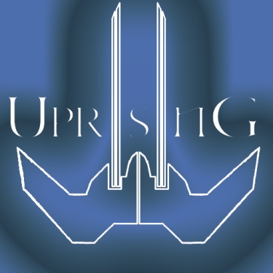

All work Copyright © 2014 by Fates United

Written by:

Tom Phillips

Ian Swift

Mike Berg

Dustin Bullard

Version #1.30

Thursday, May 08, 2014

**Running the Game from Unity**

Running shouldn’t be difficult at all. You can load up the “connect” scene to save some time, but the [FU] Splash screen will work as well. You ARE going to need 2 instances of the game seeing as it is a 1v1 game, thus requiring two people. Pretty much start a server on one end and connect to it from the other end. Simple.

**Trade-offs**

We wanted 3 maps to play, wanted to implement abilities for each ship, and get finalized game balancing done. We had to sacrifice that and settle for regular attacks as well as one map in order to get a mostly functional game. We didn’t stray too far from our original concepts, just needed a little more time to finish (we plan on trying to complete this game over the summer).

**Overall Design of the Game:**

**Data Structures**

We primarily used arrays to manage everything. This includes servers available, ships in game, separating player one from player two things. We did not feel the need for a more complicated set-up.

**State Machines**

We used state machines to manage menus. The title screen menu uses a simple state machine to determine which parts of the GUI to show, and the same applies to the in-game escape menu. The hotkeys are also selectable depending on which state the in-game menu is in.

**AI**

Our game did not require any AI components. The only thing remotely close to it was when an enemy ship gets too close to a station, the station will fire at the closest target until it leaves the range or is destroyed, then it looks for more targets.

**Visual/Audio Components**

A lot of what you will see is spawned objects, we wanted to add more specific visual particles and sound effects but ran a little short on time. The support ship at the very least as a pulse spawning from itself and heals all friendly units that it hits.

**Other Unique Aspects**

The networking for this game was a huge pain. Having to deal with making sure both ends received the correct models and updates was difficult, particularly with removed lasers after they collided with an object. This issue was persistent and caused extreme lag for the game.

**Credits**

All the music in the game was created by Ian. The [FU] logo was created by Tom. Ship models and textures were created by Dustin. Mike created the map along with the environment models and textures. The only thing not ours was the image of Kostanza, which is still in our Github directory but should not be anywhere found in the game itself.