VaR

**Introduction**

My recent article focused on using R to perform some basic exploratory data analysis[1].

The focus of this article will be to highlight some packages that focus on financial analytics (TTR, quantmod and PerformanceAnalytics) and a package that will allow us to build an interactive UI with a package called Shiny.

For this article we will focus on Value at Risk[2], a common market risk measure developed by JP Morgan and most recently criticized by Nassim Taleb[3].

**Historical Simulation - Methodology**

For the first part of this article I will walk through the methodology of calculating VaR for a single stock using the historical simulation method (as opposed to the Monte Carlo or parametric method)[4].

VaR allows a risk manager to make a statement about a maximum loss over a specified horizon at a certain confidence level.

V will be the Value at Risk for a one day horizon at a 95% confidence level.

Briefly, this method is: retrieve and sort a returns timeseries from a specified period (usually 501 days) and take a specific quantile and you will have the Value at Risk for that position.

Note however this will only apply to a single stock, I will cover multiple stocks in a later article. Normally a portfolio will not only include multiple stocks, but forwards, futures and other derivative positions.

In R, we would proceed as follows.

##pre-requisite packages  
   
 library(quantmod)  
 library(PerformanceAnalytics)

With the packages loaded we can now run through the algorithm:

X <- c(0.95)  
 stock <- c("AA") ##American Airlines  
  
  
 ## define the historical timeseries  
 begin <- Sys.Date() - 501   
 end <- Sys.Date()   
  
 ## first use of quantmod to get the ticker and populate our dataset with the timeseries of Adjusted closing price  
 tickers <- getSymbols(stock, from = begin, to = end, auto.assign = TRUE)   
 dataset <- Ad(get(tickers[1]))   
  
 ## now we need to convert the closing prices into a daily returns timeseries - we will use the Performance Analytics package  
 returns_AA <- Return.calculate(dataset, method=c("simple"))

We now have the dataset and can start to do some elementary plotting, firstly the returns timeseries to have a quick look:

chartSeries(returns_AA)

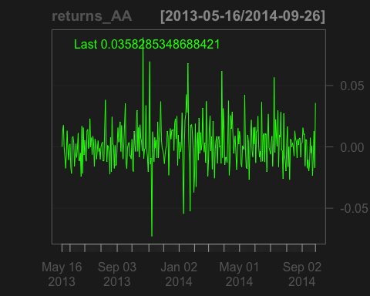

Now, we'll convert the timeseries into a sorted list and apply the quantile function

##convert to matrix datatype as zoo datatypes can't be sorted, then sort ascending  
 returns_AA.m <- as.matrix(returns_AA); sorted <- returns_AA.m[order(returns_AA.m[,1])]   
  
 ##calculate the 5th percentile, na.rm=TRUE tells the function to ignore NA values (not available values)  
 100*round(quantile(returns_AA.m[order(returns_AA.m[,1])], c(1-X), na.rm=TRUE), 4)

## 5%   
## -2.14

This shows us that the 5% one day value at risk for a position in American Airlines is -2.14%, that is, for $100 of position, once every 20 days you would lose *more than* $2.14.

**Building a UI**

A worthwhile guide to using Shiny is available on the Shiny Website. (<http://shiny.rstudio.com/tutorial/>)

In essence, we will need to define two files in one directory, *server.R* and *UI.R*.

We'll start with the UI code, not that I have used the "Telephones by Region" as a template (<http://shiny.rstudio.com/gallery/telephones-by-region.html>).

The basic requirements are:

1. A drop-down box to choose the stock.
2. A function that plots a histogram of the returns time-series and shows the VaR as a quantile on the histogram.

##get the dataset for the drop-down box, we'll use the TTR package for downloading a vector of stocks, and load this into the variable SYMs  
library(TTR)  
library(sqldf)  
library(shiny)  
  
suppressWarnings(SYMs <- TTR::stockSymbols())  
  
##use the handy sqldf package to query dataframes using SQL syntax - we'll focus on Banking stocks on the NYSE.  
SYMs <- sqldf("select Symbol from SYMs where Exchange='NYSE' and Industry like '%Banks%'")  
  
# Define the overall UI, shamelessly stolen from the shiny gallery  
  
shinyUI(  
   
 # Use a fluid Bootstrap layout  
   
 fluidPage(  
 # Give the page a title  
   
 titlePanel("NYSE Banking Stocks - VaR Calculator"),   
   
 # Generate a row with a sidebar, calling the sidebar "Instrument" and populating the choices with the vector SYMs  
   
 sidebarLayout(  
   
 selectInput("Instrument", "Instrument:", choices=SYMs),  
 hr(),  
 ),   
   
 # Create a spot for the histogram  
   
 mainPanel(plotOutput("VaRPlot"))  
   
 )  
 )

With the UI layout defined, we can now define the functions in the Server.R code:

shinyServer(function(input, output){  
   
 # Fill in the spot we created in UI.R using the code under "renderPlot"  
   
 output$VaRPlot<-renderPlot({  
   
 ##use the code shown above to get the data for the chosen instrument captured in input$Instrument  
   
 begin <- Sys.Date() - 501   
 end <- Sys.Date()   
   
 tickers <- getSymbols(input$Instrument, from = begin, to = end, auto.assign = TRUE)  
   
 dataset <- Ad(get(tickers[1]))  
 dataset <- dataset[,1]  
 returns <- Return.calculate(dataset, method=c("simple"))  
   
 ##use the quantmod package that creates the histogram and adds 95% VaR using the add.risk method  
   
 chart.Histogram(returns, methods = c("add.risk"))  
   
 })  
  
})

In RStudio, you will then see the button "Run App", which after clicking will run your new and Shiny app.

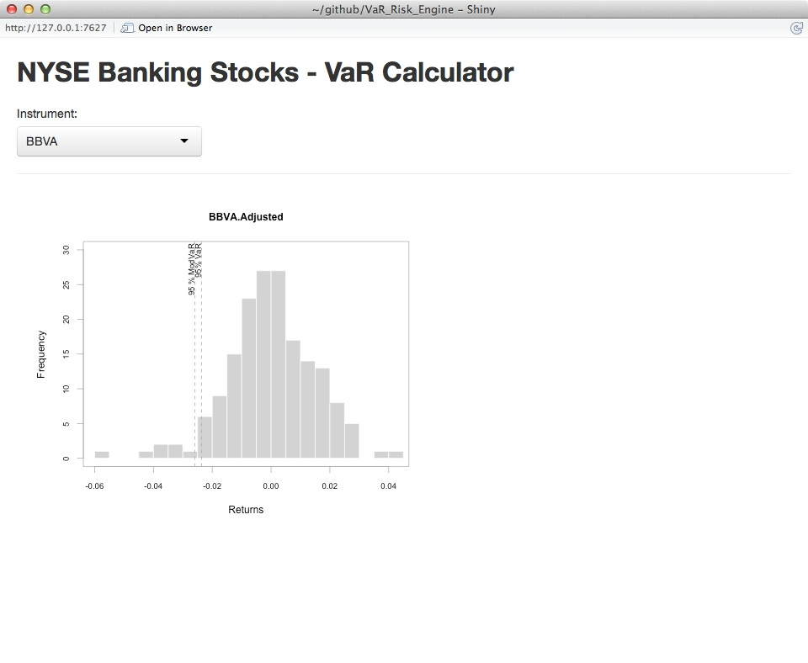

1. <http://www.broadgateconsultants.com/blog/2014/08/31/big-data-analysis-an-example-of-using-r/>
2. <http://en.wikipedia.org/wiki/Value_at_risk>
3. <http://www.futuresmag.com/2010/12/01/var-the-number-that-killed-us>
4. Main sources are Hulls' "Options, Futures and other derivatives" (<http://www.amazon.co.uk/Options-Futures-Other-Derivatives-John/dp/0273759078>) and Bionicturtles' excellent video (<https://www.youtube.com/watch?v=yiyqIEWieEQ>)