HASHCODE

1) When you create a HashMap Java creates 16 "bucket" in memory and index them from 0 to 15

2) When you use "put()" method , Java Create an Integer HashCode and calculates HashCode%16

3) The result of HashCode%16 will be the index to select bucket

4) After selecting bucket java will put the entry into the selected bucket as a node of a linked listsdsss

5) Every node will have 4 parts in it i) Hashcode ii)Key iii)Value iv) 0 Pointer

6) Java makes every hashcode unique but sometimes java can create same HashCodes accidentally, this is called "HasCode Collision"

7) "HasCode Collision"s are common phenomena of hashing functions.

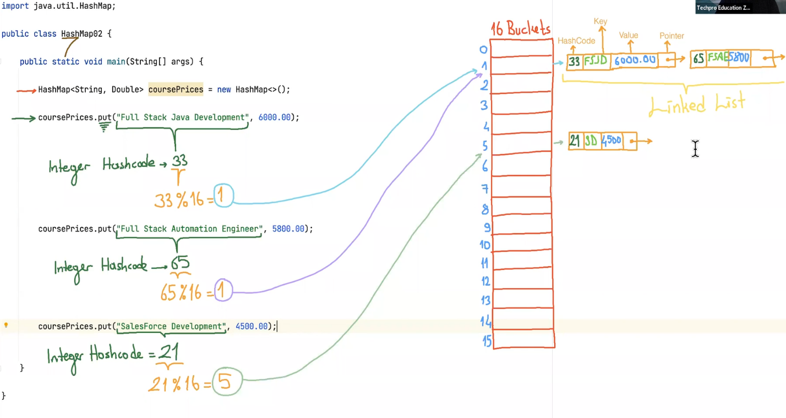8) If the key is "null" hashcode will be zero, thet's why the entry whose key is "null" will be put into bucked whose index is zero.