Simulation TP1 Report

The executable is in dist/main

This TP is to simulate a queue with poisson low (M/M/1 & M/M/s).

first we must enter the population size:





then we enter lambda and mu (you have to calculate it yourself and enter the result):





then the program will calculate all the characteristics of the queue in M/M/1 and M/M/s (from s=1 to s=25 (s is the number of servers)):

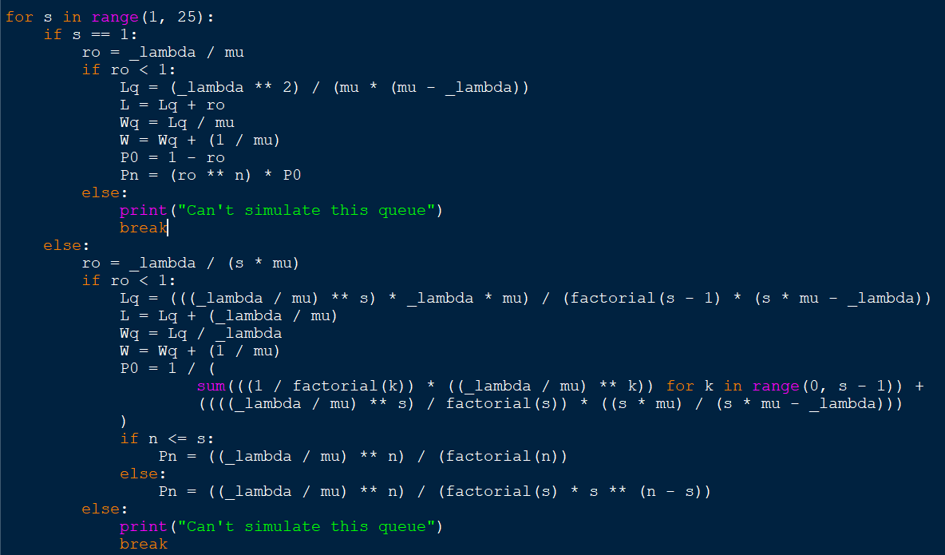

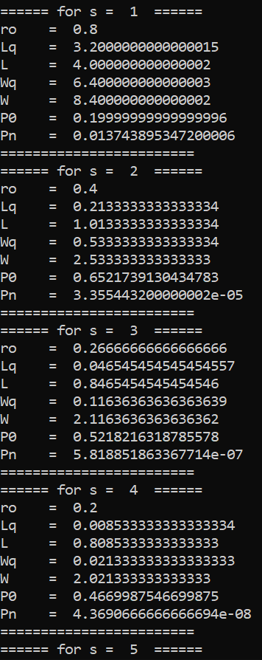

...

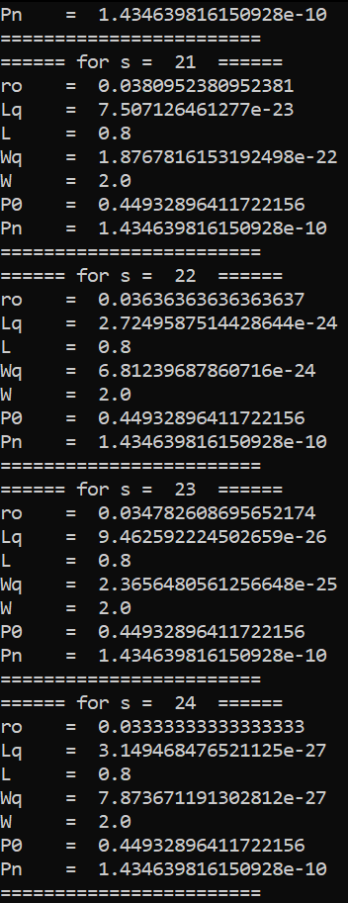

note that in case of ro is equal to or more than 1 or it will just show error message and break



…

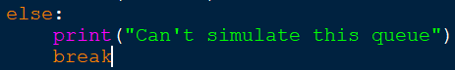

for example if we enter lambda = 0.9 and mu = 0.4, ro will be more than 1

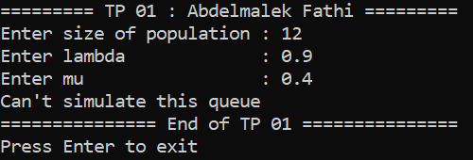

the rest of the code is to show the characteristics and exit the program

you must press enter to exit the program

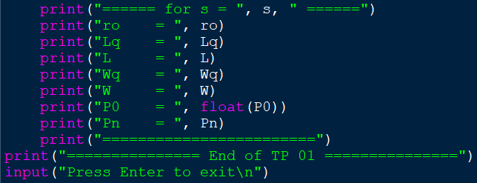

YOUR PC SHOULD BE 64 BIT TO LAUNCH THE EXECUTALBE FILE tp1.exe

End of the report