Simulation TP2 Report

The executable is in dist/main

This TP is to simulate the crossing in an RdP.

first we must create the RdP:

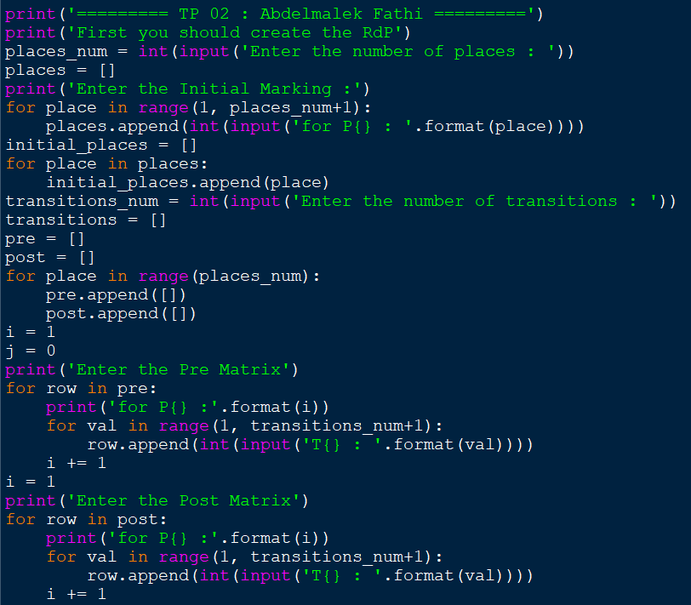

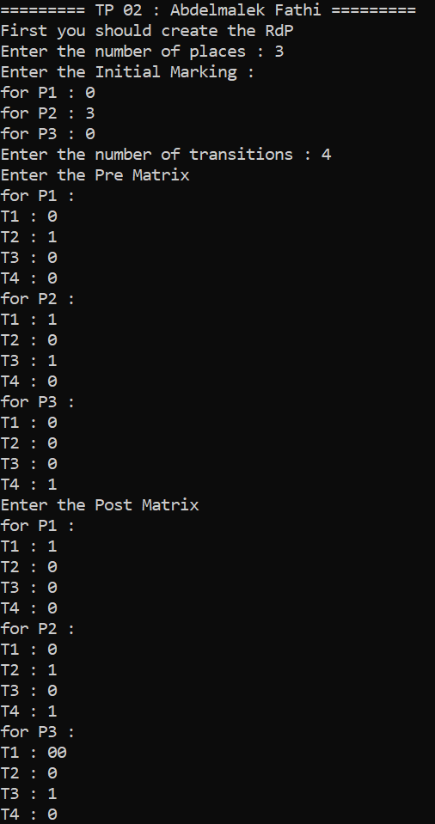

Given a number of places, you should enter the initial marking in an array called places (number of tokens in each place)

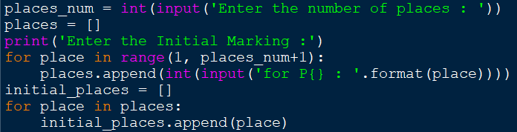

Then we create another array to store the initial marking on it, because we may change the places array in later time.

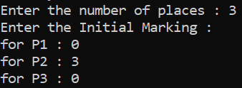

The same for the transitions as (transitions_num)





Then we should implement the pre matrix and the post matrix

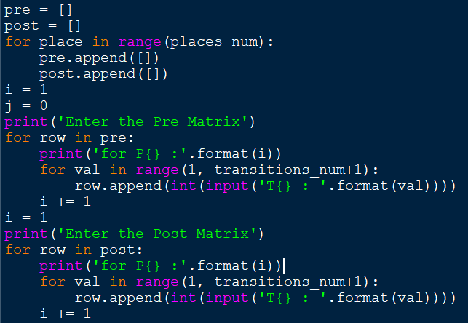

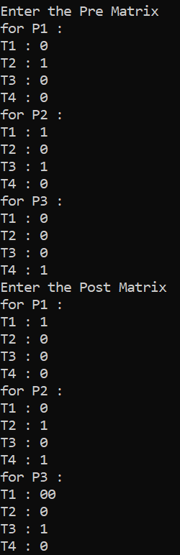

each one of them is an array, and the result is shown like below

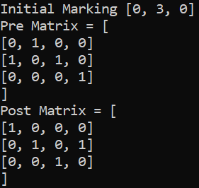

Next we can chose from multiple choices:

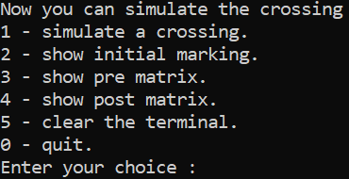

Option 1 is the main target of this TP, is simulate a given crossing, you should enter the crossing like that (1 2 3…) for example (3 4 1 2) the new marking will be [0, 3, 0]

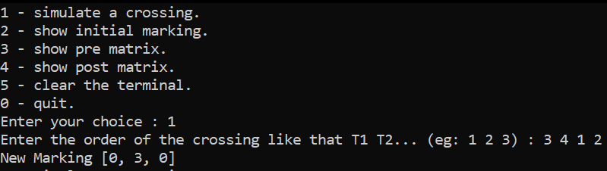

And for (3 4 1) the result will be [1, 2, 0]

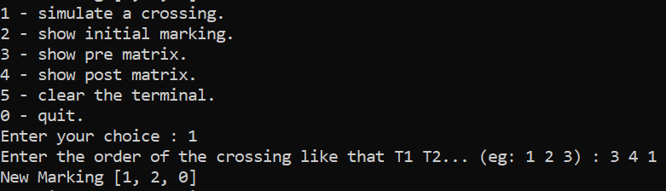

If we enter an invalid crossing order like (2 3) we will get an error message



The code of the option 1:

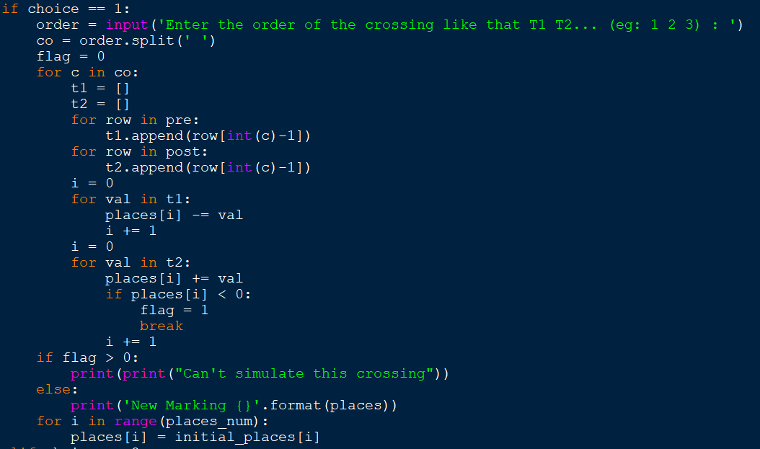

YOUR PC SHOULD BE 64 BIT TO LAUNCH THE EXECUTALBE FILE tp2.exe

End of the report