1. **Create a database called "contact"**

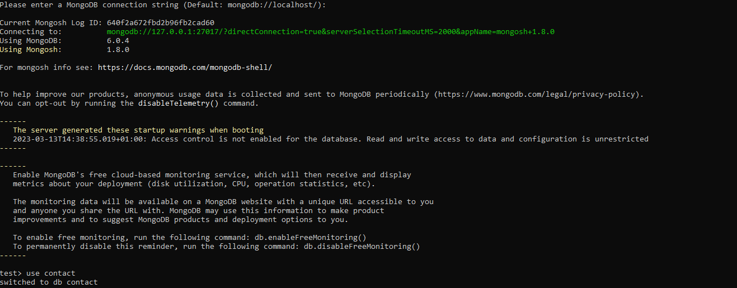

1. Create a collection called "contactlist"

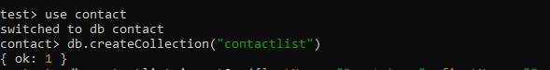

1. Insert these documents  in "contactlist"

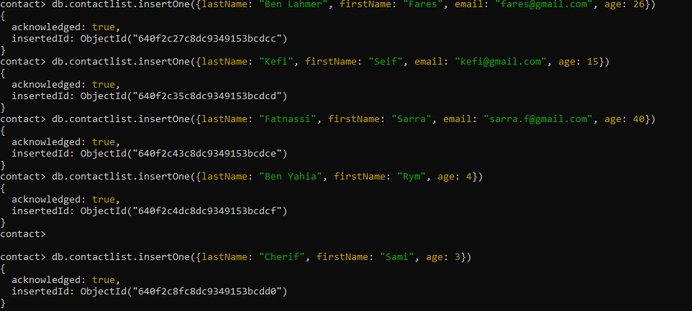

1. Display all the information about only one person using his ID.

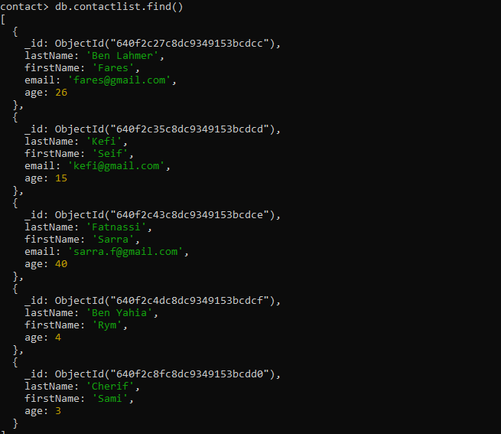

1. **Display all the information about only one person using his ID.**

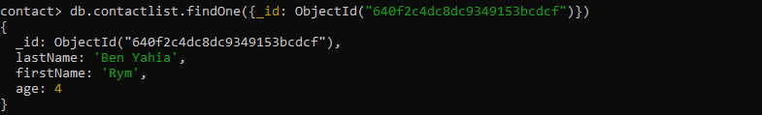

1. **Display all the contacts with an age >18.**

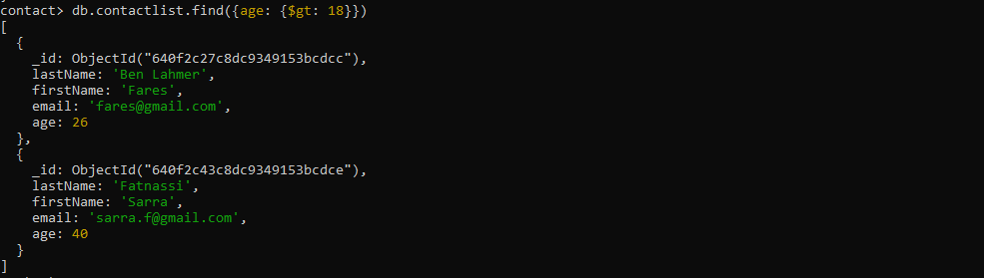

1. **Display all the contacts with an age>18 and name containing "ah".**

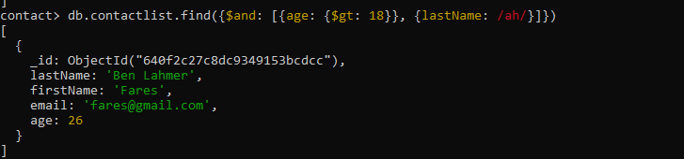

1. **Change the contact's first name from"Kefi Seif" to "Kefi Anis".**

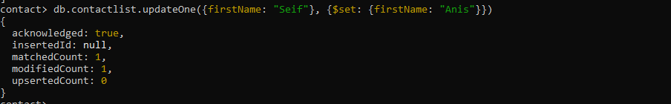

1. **Delete the contacts that are aged under <5.**



1. **Display all of the contacts list.**

