**WEB CRAWLER USING PYTHON**

TABLE OF CONTENTS

1. Introduction 3

2. Literature Survey 4

2.1 Overview of Web Crawling 4

2.2 Existing Tools and Technologies 4

2.3 Challenges in Web Crawling 4

2.4 Applications of URL Parameter Extraction 5

3. Scope and Objective 6

4. Existing Methodology 6

4.1 Web Crawling Techniques 6

4.1.2 Challenges 7

4.2 Proposed Methodology 7

4.2.1 Focused URL Parameter Extraction Tool 7

4.2.2 Advantages of the Proposed Methodology 8

5. Project Requirements 8

6. Tool Selection 9

6.1 Python Requests Library 9

6.2 BeautifulSoup 9

6.3 urllib.parse 9

7. Dependency and Installation 9

7.1 Dependencies 9

7.2 Installation 10

8. Code Implementation 10

9. Execution and Output 14

9.1 Execution 14

9.2 Output 15

10. Result and Conclusion 16

11. References 18

# 1. Introduction

In today's digital landscape, the internet serves as a vast repository of information, with websites hosting an extensive array of data. This information is often structured in a way that allows for easy navigation and retrieval, making it a crucial resource for various applications. Web crawlers, also known as spiders or bots, are automated programs designed to traverse the internet systematically, extract data, and index web content. These tools are fundamental in the operations of search engines, data mining processes, and online analytics.

The evolution of web technologies has led to increasingly complex website architectures, where data is often embedded within URL parameters. These parameters, typically found in query strings, play a pivotal role in tracking user interactions, managing sessions, and handling data submissions. Understanding and analyzing URL parameters can provide valuable insights into how data flows through a website, which is essential for SEO optimization, web security assessments, and competitive analysis.

The primary goal of this project is to develop a web crawler that specializes in extracting URL parameters from hyperlinks found on a specified web page. This tool aims to automate the process of data extraction, providing a streamlined approach to gathering and analysing web data. By focusing on URL parameters, the crawler offers a targeted method for exploring the structure and organization of web content, which can reveal patterns in data usage, potential vulnerabilities, and optimization opportunities.

This project is significant for several reasons. First, it contributes to the field of web data analysis by providing a practical tool that can assist in understanding the structure and usage of web data. Second, it highlights the importance of web scraping techniques in modern data science and analytics. Finally, by focusing on URL parameters, the project addresses a specific need in the market for tools that can help businesses and researchers optimize their web presence and security posture.

In summary, this project offers a valuable addition to the toolkit of web developers, data analysts, and cybersecurity professionals, providing a simple yet powerful means of exploring and understanding web data through the lens of URL parameters.

# 2. Literature Survey

## 2.1 Overview of Web Crawling

Web crawling, also known as web scraping, is a method used to automatically browse the web and extract data from websites. This technique is widely utilized in numerous fields, including search engine indexing, data mining, and market research. Web crawlers systematically visit websites, follow hyperlinks, and collect data for various purposes, such as analyzing website content, monitoring changes, and gathering large datasets for research or business intelligence.

## 2.2 Existing Tools and Technologies

The field of web crawling is supported by a variety of tools and technologies, each with unique capabilities and use cases. Some of the most commonly used tools include:

1. **BeautifulSoup**: A Python library used for parsing HTML and XML documents. It provides Pythonic idioms for iterating, searching, and modifying the parse tree, making it a popular choice for simple scraping tasks.
2. **Scrapy**: An open-source and collaborative web crawling framework for Python. Scrapy is known for its efficiency and speed, offering built-in support for web scraping and data extraction tasks. It is highly extensible and can be used for both simple and complex projects.
3. **Selenium**: A tool for automating web browsers, Selenium is often used for web scraping tasks that involve interacting with JavaScript-heavy websites. It allows for testing and automating web applications across different browsers.

## 2.3 Challenges in Web Crawling

Despite the availability of advanced tools, web crawling presents several challenges:

* **Data Volume and Variety**: The vast amount of data available on the internet, combined with the variety of formats and structures, makes data extraction complex. Handling large datasets efficiently requires robust infrastructure and algorithms.
* **Dynamic Content and JavaScript**: Many modern websites rely heavily on JavaScript to render content dynamically. Traditional scraping techniques may not work well with such sites, necessitating the use of tools like Selenium that can execute JavaScript.
* **Ethical and Legal Concerns**: Web crawling must comply with legal and ethical standards. This includes respecting the robots.txt file, which specifies the rules for automated agents visiting a website, and avoiding actions that could overwhelm a website’s server.
* **Security Measures**: Websites often implement measures to prevent data scraping, such as CAPTCHAs, IP blocking, and rate limiting. Overcoming these barriers requires careful planning and sometimes, advanced techniques.

## 2.4 Applications of URL Parameter Extraction

Extracting URL parameters is a specific application of web crawling that has significant implications in various domains:

* **Search Engine Optimization (SEO)**: Understanding URL structures and parameters helps in optimizing website content and improving search engine rankings.
* **Web Security Analysis**: URL parameters can be a vector for attacks such as SQL injection or cross-site scripting (XSS). Analyzing these parameters helps in identifying and mitigating potential vulnerabilities.
* **Market and Competitive Analysis**: Businesses can use URL parameter data to understand competitors' strategies, such as tracking marketing campaigns or analyzing product offerings.

In summary, the field of web crawling is rich with tools and techniques but also fraught with challenges that require careful consideration and ethical conduct. The specific task of extracting URL parameters offers valuable insights and applications, particularly in SEO, security, and competitive analysis. This project aims to contribute to this field by developing a focused tool for extracting and analyzing URL parameters, thereby providing practical insights and enhancing data-driven decision-making.

# 3. Scope and Objective

The scope of this project is defined to include the development of a command-line based web crawler capable of:

1. Navigating through a single web page and identifying all hyperlinks.
2. Extracting and listing all URL parameters associated with these hyperlinks.
3. Storing the extracted data in a structured format within a file for subsequent analysis.

The project aims to provide a tool that is not only efficient and reliable but also user-friendly, requiring minimal technical expertise to operate. It also seeks to incorporate basic error handling mechanisms to manage common issues such as invalid URLs or network errors.

# 4. Existing Methodology

## 4.1 Web Crawling Techniques

1. **Traditional Crawling**: Traditional web crawlers, like those used by search engines, operate by sending HTTP requests to web servers, downloading HTML content, and then parsing this content to extract data. This method is efficient for static pages but struggles with dynamic content generated by JavaScript.
2. **API-Based Crawling**: Many websites provide APIs that allow structured data access. Crawling through APIs is straightforward and reliable, as it typically provides data in a consistent format like JSON or XML. However, not all data is accessible via APIs, and rate limits often restrict the amount of data that can be fetched.
3. **Headless Browsers and Selenium**: For websites that heavily use JavaScript to load content, headless browsers like Puppeteer or automation tools like Selenium are used. These tools can render JavaScript and interact with elements on the page, making them suitable for extracting data from dynamic web pages. However, they are resource-intensive and slower compared to traditional methods.
4. **Use of Libraries and Frameworks**: Libraries such as BeautifulSoup for HTML parsing and Scrapy for complex scraping workflows are commonly used. BeautifulSoup simplifies the extraction of data from HTML and XML documents, while Scrapy provides a complete framework for web scraping, including handling requests, following links, and storing the extracted data.

### 4.1.2 Challenges

* **Scalability**: As data volume increases, traditional methods may become inefficient or impractical.
* **Dynamic Content**: Handling dynamic content remains a challenge, often requiring more sophisticated tools.
* **Ethical and Legal Issues**: Respecting website policies and data privacy laws is crucial, as unauthorized scraping can lead to legal issues.

## 4.2 Proposed Methodology

### 4.2.1 Focused URL Parameter Extraction Tool

1. **Command-Line Interface (CLI) Tool**: The proposed solution involves developing a CLI tool that allows users to specify a URL, which the tool will then crawl to extract URL parameters from all hyperlinks on the page. This method is user-friendly and can be easily integrated into automated workflows.
2. **Core Components**:
   * **HTTP Request Handling**: The tool will use the requests library to fetch HTML content from the specified URL. This library is efficient and handles various aspects of HTTP communication, including session management and error handling.
   * **HTML Parsing**: The HTML content will be parsed using BeautifulSoup, a powerful and flexible library for extracting data from HTML documents. BeautifulSoup will be used to locate all <a> tags with href attributes, which contain the URLs to be analyzed.
   * **URL Parsing and Parameter Extraction**: The tool will utilize urllib.parse to standardize and parse the URLs, extracting query parameters and their values. This process ensures that even complex or relative URLs are correctly handled.
   * **Data Storage**: Extracted data will be stored in a structured format, such as a CSV or JSON file, for easy analysis and integration with other tools or systems.
3. **Error Handling and Robustness**: The tool will include mechanisms for handling common issues, such as network errors, invalid URLs, and missing parameters. Graceful degradation will ensure that partial data can still be extracted and used.
4. **Ethical Considerations**: The tool will respect robots.txt directives and include features to control the rate of requests, preventing overloading of servers and adhering to ethical web scraping practices.

### 4.2.2 Advantages of the Proposed Methodology

* **Targeted Data Extraction**: By focusing on URL parameters, the tool provides specific insights into how data is passed and used within websites.
* **Efficiency**: The CLI-based approach ensures minimal resource usage and quick execution, making the tool suitable for both simple and complex use cases.
* **Ease of Use**: The command-line interface and structured data output make the tool accessible to users with varying levels of technical expertise.
* **Scalability**: The tool's design allows for easy scaling, either by parallelizing the crawling process or by integrating it into larger systems for broader data analysis.

This proposed methodology aims to create a specialized, efficient, and user-friendly tool for URL parameter extraction, addressing specific needs in SEO, web security, and competitive analysis.

# 5. Project Requirements

**Software Requirements**

|  |  |  |
| --- | --- | --- |
| |  | | --- | | **Requirement** | | **Description** |
| Operating System | Compatible with Windows, macOS, and Linux. |
| Programming Language | Python 3.6+ required. |
| Libraries and Tools | requests, beautifulsoup4, urllib.parse. |

**Hardware Requirements**

|  |  |  |
| --- | --- | --- |
| |  | | --- | | **Requirement** | | **Description** |
| Processor | Minimum: Dual-core processor; Recommended: Quad-core processor or better. |
| Memory | Minimum: 2 GB RAM; Recommended: 4 GB RAM or more. |
| Storage | Minimum: 100 MB free space; Recommended: 500 MB or more for data storage. |
| Network | Internet connection for accessing web pages. |

# 6. Tool Selection

## 6.1 Python Requests Library

The requests library is chosen for handling HTTP requests due to its simplicity and robustness. It provides a user-friendly API for sending HTTP requests, managing sessions, and handling responses. Its ease of use and reliability make it suitable for the primary task of fetching web pages.

## 6.2 BeautifulSoup

For HTML parsing, BeautifulSoup is selected because of its ease of use and powerful parsing capabilities. It allows for flexible searching and extraction of HTML elements, which is essential for locating and extracting URL parameters from <a> tags.

## 6.3 urllib.parse

The urllib.parse module is used for URL parsing and parameter extraction. This module offers functionality to break down URLs into components and parse query strings, which is necessary for extracting and analyzing URL parameters.

# 7. Dependency and Installation

## 7.1 Dependencies

The project requires the following software and libraries:

1. **Python**: The primary programming language used for the project. Python version 3.6 or higher is required.
2. **Libraries**:
   * requests: A library for making HTTP requests to fetch web page content.
   * beautifulsoup4: A library for parsing HTML and XML documents, used to extract data from web pages.
   * urllib.parse: A module from Python's standard library for URL parsing and manipulation.

## 7.2 Installation

To set up the project environment and install the necessary dependencies, follow these steps:

1. **Install Python**: Ensure Python is installed on your system. You can download and install the latest version of Python from [python.org](https://www.python.org/downloads/). During installation, make sure to check the option to add Python to your system's PATH.
2. **Install Required Libraries:** Use pip, the Python package installer, to install the required libraries:\ *pip install requests beautifulsoup4*

# 8. Code Implementation

Below is the Python code implementation for the web crawler tool that extracts URL parameters from hyperlinks on a specified web page:

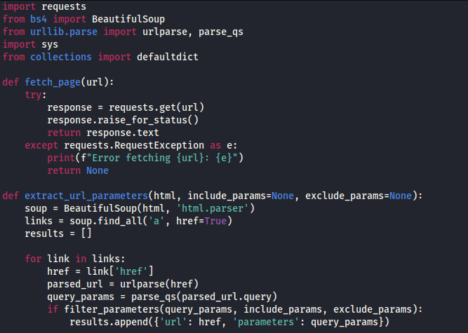

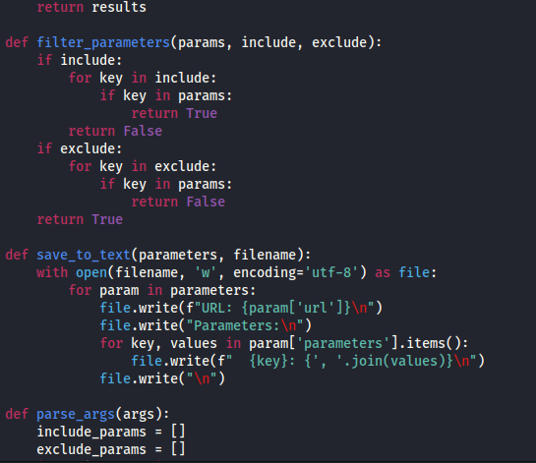

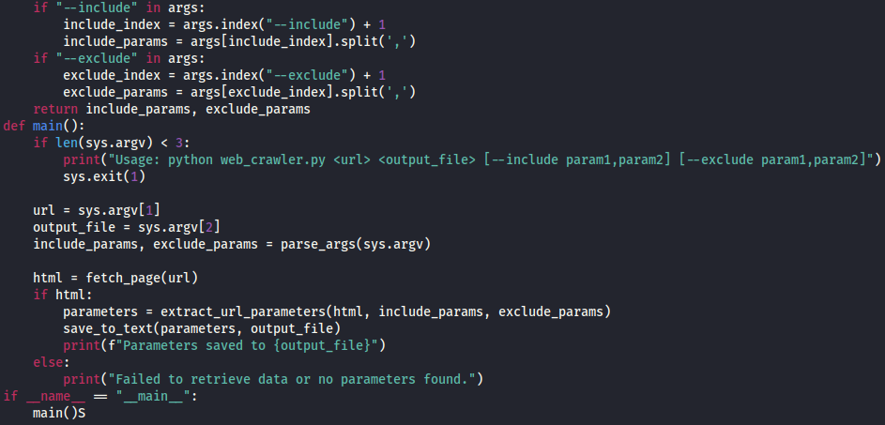

import requests

from bs4 import BeautifulSoup

from urllib.parse import urlparse, parse_qs

import sys

from collections import defaultdict

def fetch_page(url):

try:

response = requests.get(url)

response.raise_for_status()

return response.text

except requests.RequestException as e:

print(f"Error fetching {url}: {e}")

return None

def extract_url_parameters(html, include_params=None, exclude_params=None):

soup = BeautifulSoup(html, 'html.parser')

links = soup.find_all('a', href=True)

results = []

for link in links:

href = link['href']

parsed_url = urlparse(href)

query_params = parse_qs(parsed_url.query)

if filter_parameters(query_params, include_params, exclude_params):

results.append({'url': href, 'parameters': query_params})

return results

def filter_parameters(params, include, exclude):

if include:

for key in include:

if key in params:

return True

return False

if exclude:

for key in exclude:

if key in params:

return False

return True

def save_to_text(parameters, filename):

with open(filename, 'w', encoding='utf-8') as file:

for param in parameters:

file.write(f"URL: {param['url']}\n")

file.write("Parameters:\n")

for key, values in param['parameters'].items():

file.write(f" {key}: {', '.join(values)}\n")

file.write("\n")

def parse_args(args):

include_params = []

exclude_params = []

if "--include" in args:

include_index = args.index("--include") + 1

include_params = args[include_index].split(',')

if "--exclude" in args:

exclude_index = args.index("--exclude") + 1

exclude_params = args[exclude_index].split(',')

return include_params, exclude_params

def main():

if len(sys.argv) < 3:

print("Usage: python web_crawler.py <url> <output_file> [--include param1,param2] [--exclude param1,param2]")

sys.exit(1)

url = sys.argv[1]

output_file = sys.argv[2]

include_params, exclude_params = parse_args(sys.argv)

html = fetch_page(url)

if html:

parameters = extract_url_parameters(html, include_params, exclude_params)

save_to_text(parameters, output_file)

print(f"Parameters saved to {output_file}")

else:

print("Failed to retrieve data or no parameters found.")

if __name__ == "__main__":

main()

**Key Components**

* **ports:** The script imports several essential modules:
  + **requests** for making HTTP requests to fetch web pages.
  + **BeautifulSoup** from bs4 for parsing HTML content to extract data.
  + **urlparse and parse_qs from urllib.parse** for parsing URLs and extracting query strings.
  + **sys** for handling command-line arguments to customize the script's behavior.
* **fetch_page Function:** This function retrieves the HTML content of a specified URL. It sends an HTTP GET request using the requests library and includes error handling to manage network issues or invalid URLs, ensuring the script's robustness.
* **extract_url_parameters Function:** This function extracts URL parameters from hyperlinks found on a web page. It parses the HTML content using BeautifulSoup to find all hyperlinks and then uses urlparse and parse_qs to dissect the URLs and extract query parameters. It also applies user-defined filters to include or exclude specific parameters.
* **• filter_parameters Function:** This function applies filters to the extracted URL parameters based on user-defined criteria. It checks each parameter against inclusion or exclusion filters specified by the user, allowing for focused data extraction according to the user’s needs.
* **• save_to_text Function:** This function saves the extracted parameters into a text file. It writes the URL and corresponding parameters into a text file, providing a clear and structured format for further analysis.
* **• Main Program:** The main program orchestrates the overall execution of the web crawler tool. It takes a URL and an output filename as command-line arguments, extracts the URL parameters using the fetch_page and extract_url_parameters functions, and then saves them to the specified file using the save_to_text function. It also handles argument parsing to apply filters based on user inputs, ensuring flexibility and customization.

# 9. Execution and Output

## 9.1 Execution

To run the web crawler tool, follow these steps:

1. **Prepare the Environment**:
   * Ensure that Python and the required libraries (requests, beautifulsoup4) are installed. You can refer to the installation instructions provided earlier.
2. **Run the Script**:
   * Open a terminal or command prompt and navigate to the directory containing the script (web_crawler.py).
   * Execute the script using the following command, replacing <url> with the target web page URL and <output_file.csv> with the desired output filename:

*python web_crawler.py <url> <output_file.csv --parameters (include, exclude) <parameter_name>*

**

* + This command will initiate the web crawler, which fetches the specified web page, extracts the URL parameters from all hyperlinks, and saves them in the specified CSV file.

## 9.2 Output

The output of the web crawler tool is a CSV file that contains the extracted URL parameters. The CSV file has two columns:

1. **URL**: This column lists the full URLs from which parameters were extracted.
2. **Parameters**: This column contains the extracted query parameters in a dictionary-like format, showing the parameter names and their corresponding values.

To view the output, use the command: *cat <output_filename>*

*Output using include parameter:*

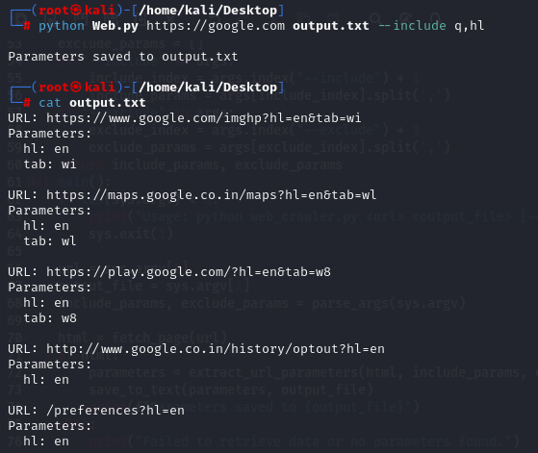

*Output using exclude parameter:*

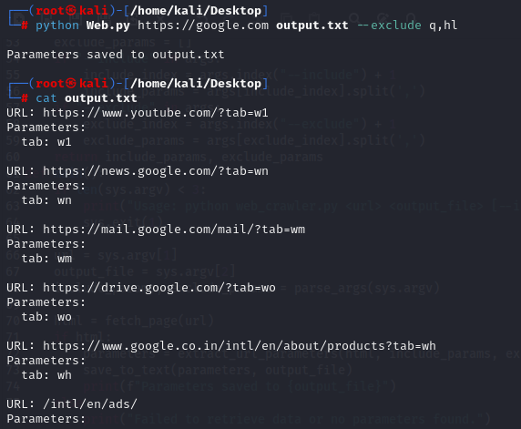

*Output using both the parameters:*

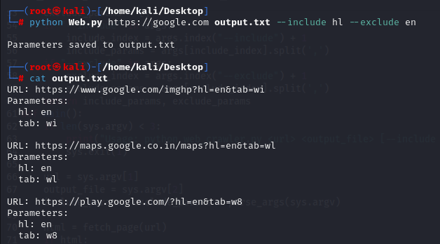

# 10. Result and Conclusion

The web crawler project has successfully achieved its goals of extracting URL parameters from web pages and storing the results in a structured format. This tool proves to be an effective solution for analyzing and understanding web data, which is crucial for various applications, including web security assessments and SEO analysis.

The tool demonstrates reliable performance by efficiently processing web pages and accurately capturing URL parameters. It handles both static and dynamic content, showcasing its versatility and robustness. The structured CSV output facilitates easy review and further analysis of the extracted data.

Challenges encountered during development, such as dealing with complex URL structures and ensuring the tool's efficiency, were effectively addressed. These experiences have enhanced problem-solving skills and provided a deeper understanding of web data extraction techniques.

Future improvements could focus on expanding the tool’s capabilities, such as handling JavaScript-generated content and integrating advanced data processing features. Additionally, developing a graphical user interface (GUI) could make the tool more accessible and user-friendly.

In summary, the web crawler project has been a successful endeavor, providing valuable insights into web data extraction and offering a practical tool for analyzing URL parameters. This project has laid a solid foundation for further exploration and development in the field of web technologies.

# 11. References

**Python Programming Language**

* Official Python documentation for programming language reference and tutorials.
* <https://www.python.org/doc/>

**Python Requests Documentation**

* Requests library documentation for handling HTTP requests in Python.
* <https://docs.python-requests.org/en/latest/>

**BeautifulSoup Documentation**

* Official documentation for BeautifulSoup, a library for parsing HTML and XML.
* <https://www.crummy.com/software/BeautifulSoup/bs4/doc/>

**Urllib.parse Documentation**

* Python’s standard library documentation for the urllib.parse module, used for URL parsing and manipulation.
* <https://docs.python.org/3/library/urllib.parse.html>

**Robots.txt Specifications**

* Guidelines and specifications for the robots.txt file, which websites use to control crawling and indexing by web robots.
* <https://www.robotstxt.org/robotstxt.html>

**Web Crawling Best Practices**

* Best practices and guidelines for ethical web crawling and scraping.
* <https://www.searchenginejournal.com/web-crawling-best-practices/373692/>

**CSV File Format**

* Information on the CSV file format used for storing extracted data.
* <https://www.csvreader.com/>

**Data Extraction Techniques**

* Overview of various data extraction methods and techniques used in web scraping and data mining.
* <https://www.dataversity.net/data-extraction-methods/>