

Table of Contents
Contents
Table of Contents 2
Table of Tables 3
Table of Figures 3
Acknowledgement 5
Executive Summary 5
Introduction 5
1. Analytics and business intelligence 6
1.1. Operational decisions 6
1.2. Tactical decisions 6
1.3. Strategic decisions 6
2. Tools techniques and methodology 7
2.1. Data quality and analytical scope 7
2.2. Choice of methods 7
3. Central tendency and bell curves 8
3.1. Calculation evidence 9
3.2. Monthly charges and data usage 10
3.3. Call minutes and customer tenure 11
3.4. Churn score and distributional interpretation 12
4. Customer type and churn score 13
4.1. Assumptions numerical results and decisions 14
4.2. ANOVA and assumption checks 15
5. Relationships and regression 16
5.1. Hypothesis based normality testing 16
5.2. Graphical checks and correlation hypotheses 17
5.3. Correlation and simple regression results 18
5.4. Correlation heatmap 19
5.5. Correlation and regression test outputs 20
5.6. Interpretation of individual relationships 21
5.7. Multiple regression model 22
5.8. Diagnostics and validation 23
6. Conclusion and recommendations 24
6.1. Validate the decision inputs first 24
6.2. Test targeted retention actions 24
6.3. Evaluate outcomes and maintain the model 24
References 25

Table of Tables
Table 1: Descriptive statistics 9
Table 2: Shapiro Wilk normality tests 17
Table 3: Correlations and separate simple linear regressions 19

Table of Figures
Figure 1: Central tendency calculations 10
Figure 2: Monthly charges with a fitted normal reference curve 11
Figure 3: Data usage with a fitted normal reference curve 11
Figure 4: Call minutes with a fitted normal reference curve 12
Figure 5: Customer tenure with a fitted normal reference curve 12
Figure 6: Churn score with a fitted normal reference curve 13
Figure 7: Churn score distributions by customer type 14
Figure 8: Welch ANOVA and pairwise tests 15
Figure 9: ANOVA variance and rank tests 16
Figure 10: Shapiro Wilk tests for all six variables 17
Figure 11: Normal Distribution checks for all numerical variables 18
Figure 12: Observed relationships with simple regression lines 19
Figure 13: Pearson correlation heatmap 20
Figure 14: Spearman and Pearson tests 21
Figure 15: Separate simple regression tests 21
Figure 16: Multiple regression output 23
Figure 17: Residual and influence diagnostics 24

Acknowledgement
I would like to express my sincere gratitude to Ms. Chethana Hansani Mapa, my lecturer, for her valuable guidance, support and knowledge throughout the Business Analytics module. I appreciate everyone who supported and encouraged me throughout this work.

Executive Summary
This report applies Business Analytics techniques to analyse customer churn in the telecommunication sector using RStudio. Statistical methods such as descriptive analysis, hypothesis testing, correlation and regression are used to identify factors associated with churn and provide suitable recommendations for better business decision making.

Introduction
Customer churn is an important concern in the competitive telecommunication sector. Business Analytics helps organisations analyse customer data and identify useful patterns for decision-making. This report uses the provided telecommunication dataset and RStudio to analyse customer behaviour, identify factors related to churn and support customer retention decisions.

Analytics and business intelligence
Business analytics applies statistical models to data; business intelligence communicates findings through dashboards and decision-support systems (Chen, Chiang and Storey, 2012). Telecom managers can use both to improve retention and control costs.

Operational decisions
Dialog’s digital channels handled 64% of engagements in 2023, versus 58% in 2022 (Dialog Axiata PLC, 2024). Supervisors could use daily volumes and resolution times to allocate agents; retention effects require testing.

Tactical decisions
SLT-Mobitel offers add-ons and recommends upgrades when usage exceeds allowances (Mobitel, n.d.). Tactical managers could identify monthly package mismatches, then pilot reviews and compare retention and margin. This analytical pilot is proposed.

Strategic decisions
Dialog reports 15 analytics and AI projects (Dialog Axiata PLC, 2024). Strategic managers could combine lifetime value, network costs and demand to prioritise investment. Missing geographic and network data prevent infrastructure recommendations here.

Tools techniques and methodology
R 4.6.1 provides reproducible calculations and graphics; RStudio supplies output screenshots. Base R supplies all required statistical functions.
CRISP-DM structures problem definition, data understanding, preparation, modelling, evaluation and monitored deployment. Its iterative approach allows unexpected data-quality findings to trigger re-examination before deployment (Martínez-Plumed et al., 2021).

Data quality and analytical scope
The CSV has 5,000 rows, seven variables, no missing values and no duplicate rows. All records were retained. Charges remain in USD as specified; R imports “customer type” as “customer.type”.
Three issues require clarification: 4,975 target values exceed 1, invalidating the probability label; 4,826 complaint values are fractional; and customer types match score thresholds perfectly. Scores remain uncalibrated, complaints are treated as a measure, and group provenance requires verification.

Choice of methods
mean(), median(), table() and sd() summarise centre and spread; dnorm() draws reference curves. shapiro.test() and qqnorm() assess normality. oneway.test() compares means under unequal variances; aov() provides conventional ANOVA. cor.test() tests associations; lm() estimates separate and adjusted relationships. Scatterplots assess form, the heatmap reveals shared information, and residual plots and held-out predictions evaluate model adequacy.
Tests use 5% significance and two-sided alternatives where applicable. P-values measure neither hypothesis probabilities nor practical importance (Wasserstein and Lazar, 2016). Missing identifiers, dates and sampling information prevent verification of independence and representativeness.

Central tendency and bell curves
Mean measures the arithmetic average, median the ordered midpoint, mode the most frequent value, and standard deviation the spread.
Table 1: Descriptive statistics
Variable | Mean | Median | SD | Observed range
Charges USD | 70.56 | 70.82 | 28.87 | 20.02–119.99
Data GB | 29.65 | 29.79 | 12.65 | 1.00–58.70
Call minutes | 141.54 | 142.26 | 59.69 | 20.00–284.22
Tenure months | 36.55 | 36.72 | 20.58 | 1.04–71.99
Churn score | 5.20 | 5.18 | 1.78 | 0.00–10.00

Charges and tenure have no unique mode because all values occur once. Modes are 1 GB (four records), 20 call minutes (eight records) and churn score 10 (five records). These sparse boundary modes poorly represent typical customers.
Figures 2–6 use observed means and standard deviations. Their imposed bell shape does not establish normality; Section 5 tests that assumption.
Executed R analysis supplies every figure and table. Out-of-range curve tails are not forecasts.

Calculation evidence
The median averages the two middle records; modes follow frequencies.
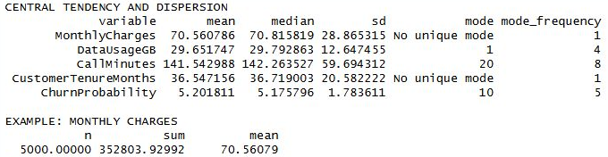
Figure 1: Central tendency calculations
$$Mean monthly charges = \frac{352803.92992}{5000} = 70.56079 USD$$

Monthly charges and data usage
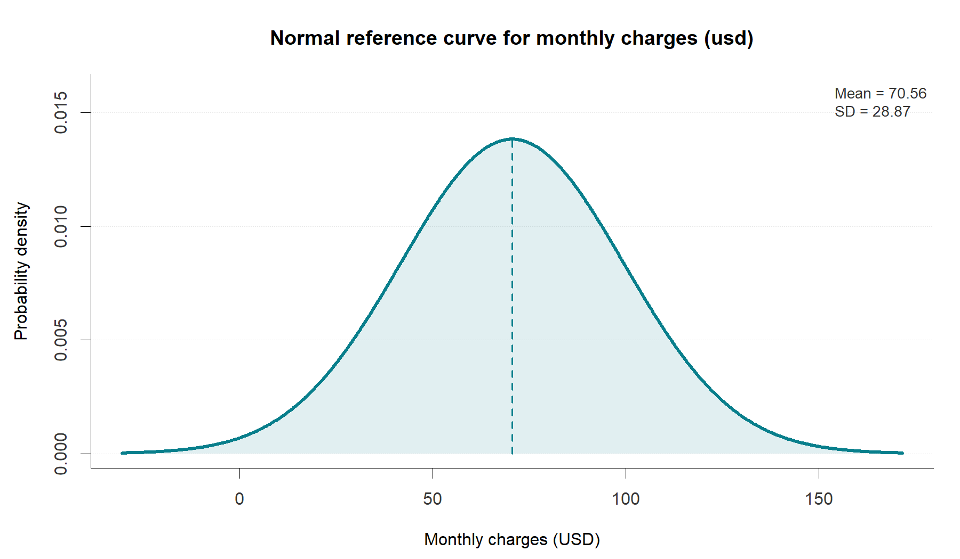
Figure 2: Monthly charges with a fitted normal reference curve
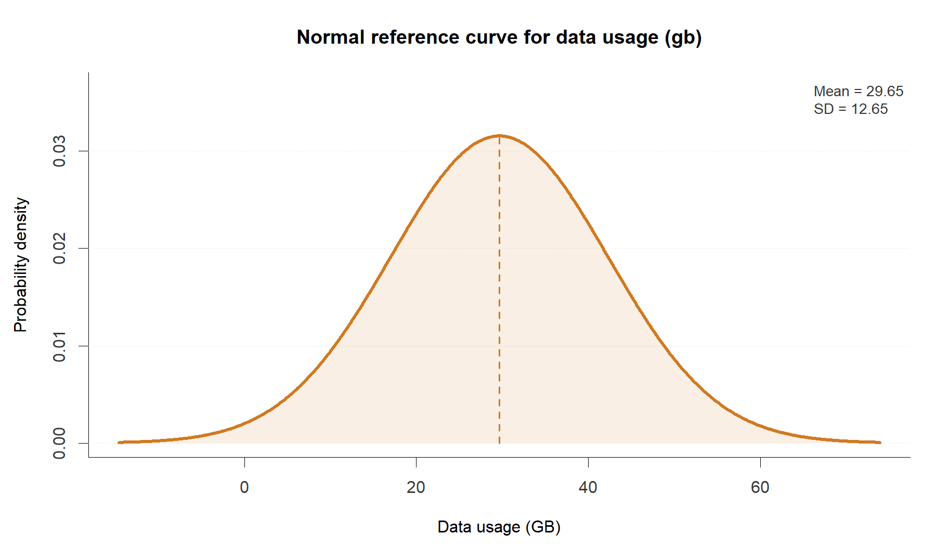
Figure 3: Data usage with a fitted normal reference curve
Monthly charges average USD 70.56 (SD 28.87), supporting affordability reviews across tariff levels. Data usage averages 29.65 GB (SD 12.65), suggesting varied allowance needs. Normality checks assess departures from these reference shapes.

Call minutes and customer tenure
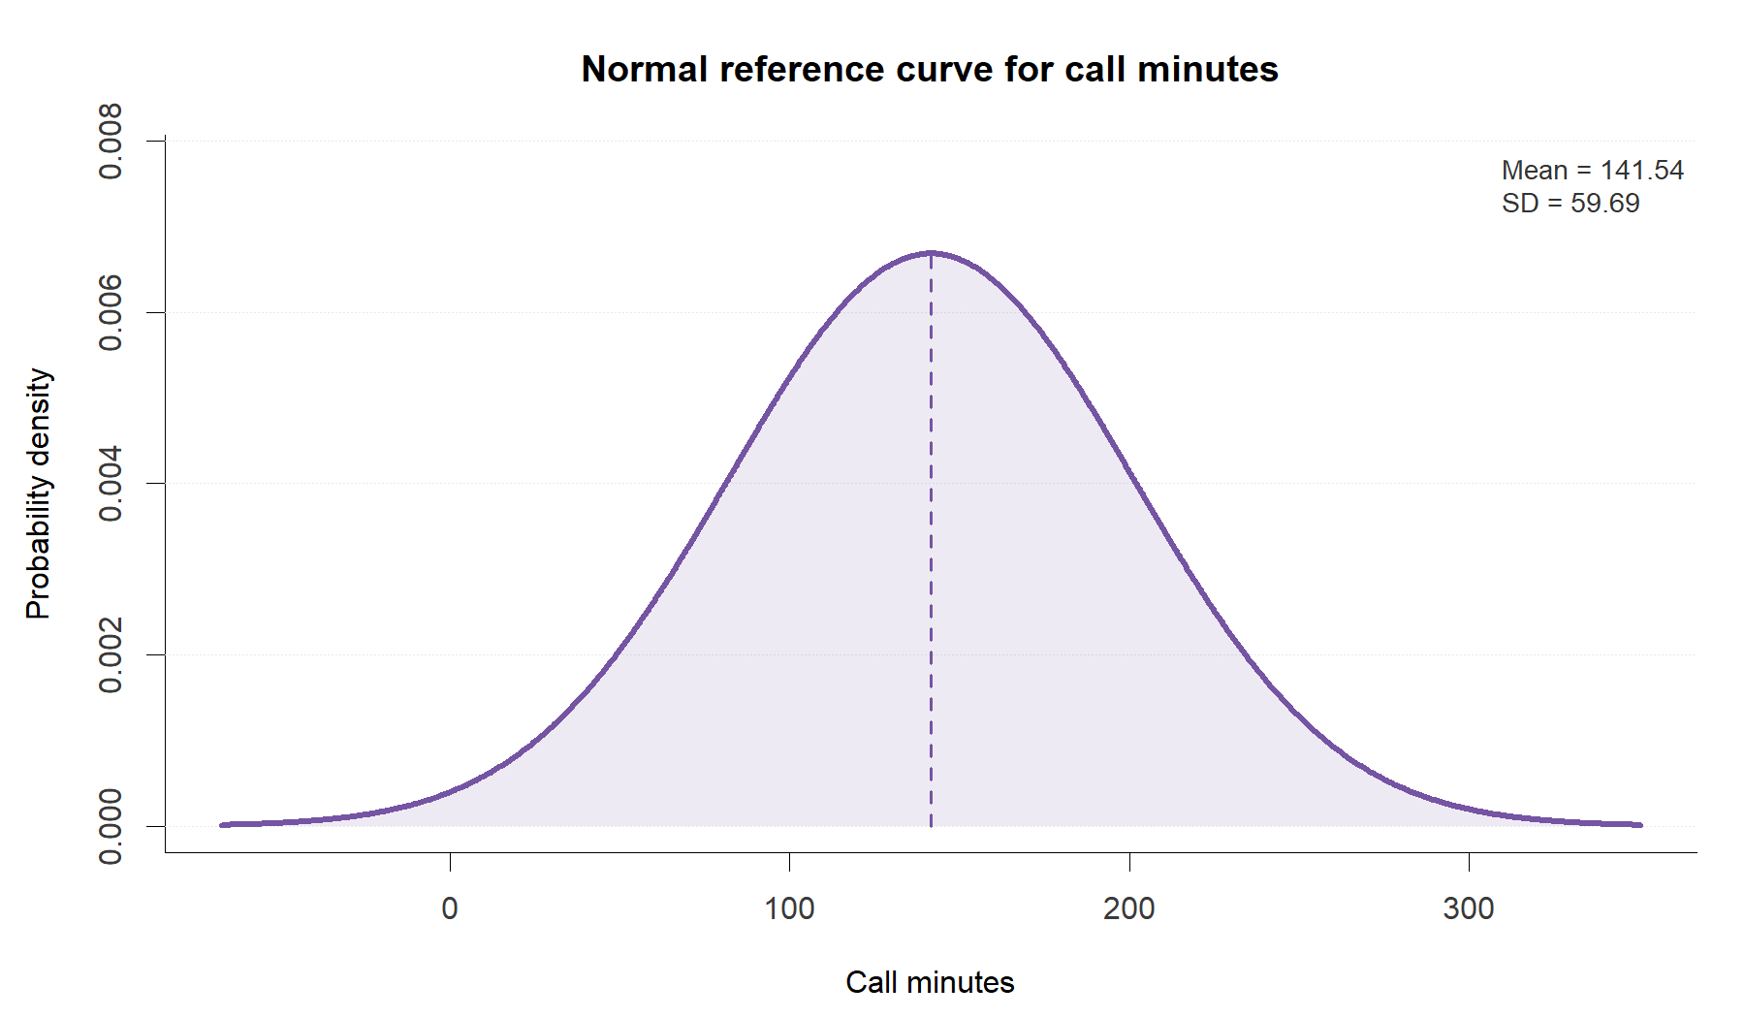
Figure 4: Call minutes with a fitted normal reference curve
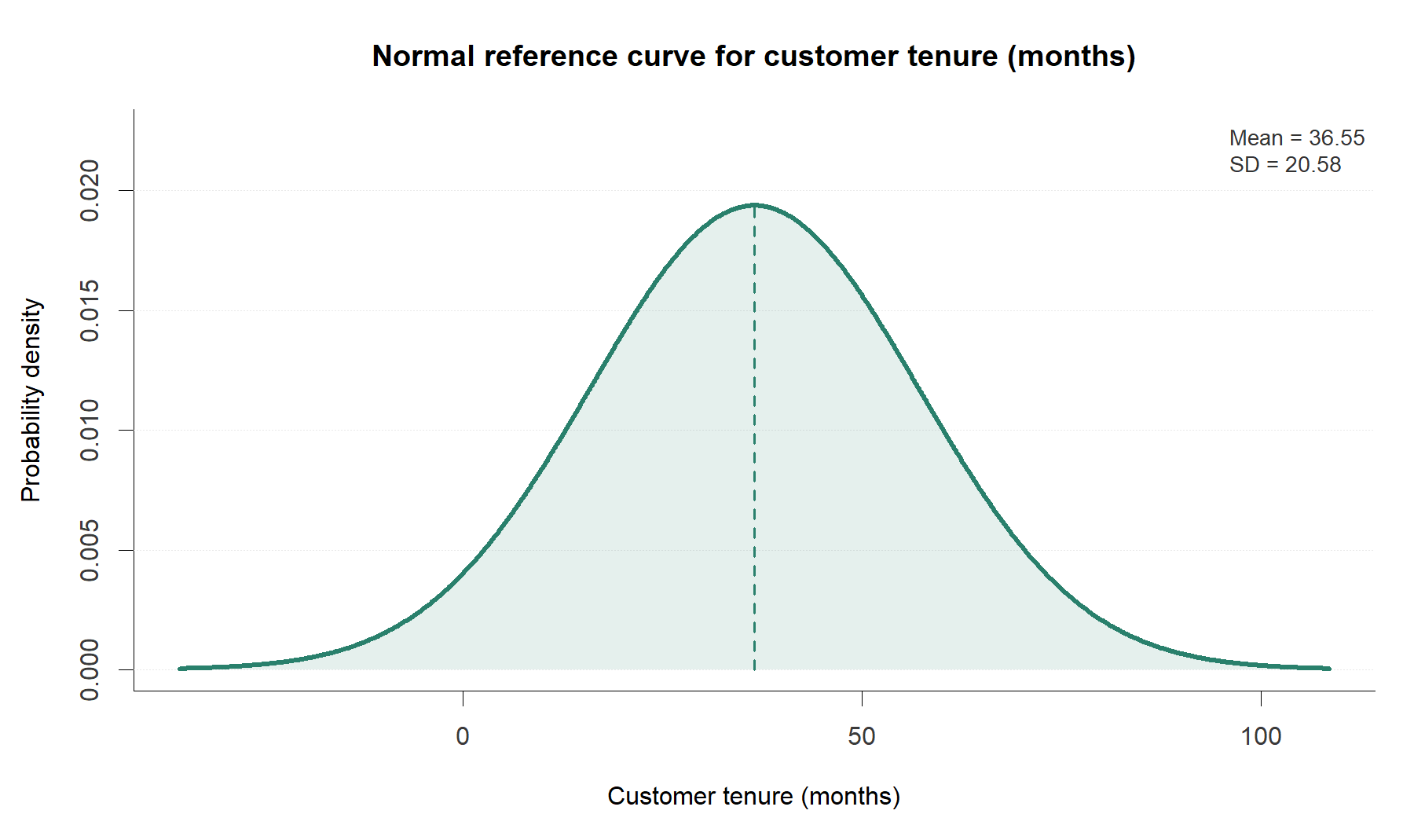
Figure 5: Customer tenure with a fitted normal reference curve
Calls average 141.54 minutes (SD 59.69); tenure averages 36.55 months (SD 20.58), spanning approximately 1–72 months. Retention reviews should distinguish onboarding problems from established subscribers’ needs.

Churn score and distributional interpretation
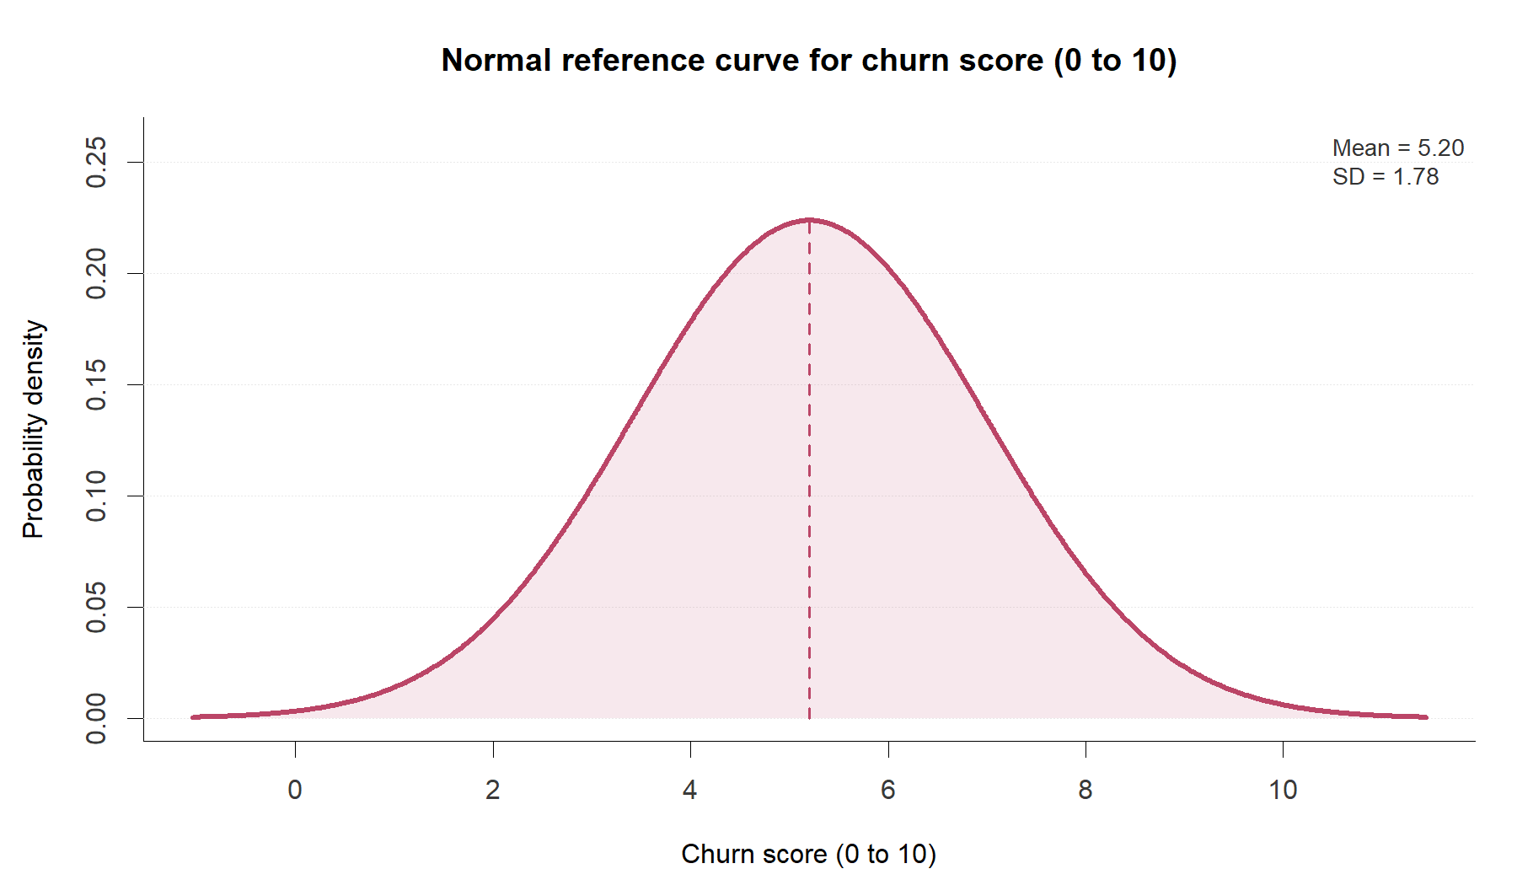
Figure 6: Churn score with a fitted normal reference curve
Churn score averages 5.20, with median 5.18 and SD 1.78. Its central quantiles fit normality more closely than charges or tenure, although Shapiro–Wilk rejects normality. Mode 10 occurs only five times.
A score of 5.20 does not imply 52% churn. No observed departure outcome or validated probability mapping exists; findings describe score variation.

Customer type and churn score
Compare mean churn scores across customer types. $H_{\text{0}}\text{: }μ_{\text{Individual}}\text{ = }μ_{\text{Business}}\text{ = }μ_{\text{VIP}}$. $H_{\text{1}}$: at least one population mean differs. The significance level is $\text{α = 0.05}$.
Individual customers number 907, with mean 2.612 and SD 0.687; Business customers number 1,936, with mean 4.569 and SD 0.567; VIP customers number 2,157, with mean 6.858 and SD 0.982. 95% mean confidence intervals are 2.568–2.657, 4.544–4.594 and 6.817–6.900, conditional on independent sampling.
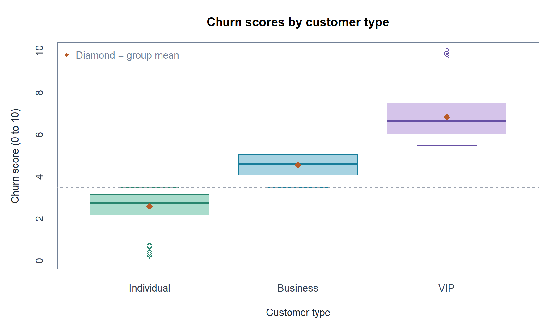
Figure 7: Churn score distributions by customer type
Diamonds show means; dotted lines mark 3.5 and 5.5. VIP has the highest mean and variability; category provenance requires verification.

Assumptions numerical results and decisions
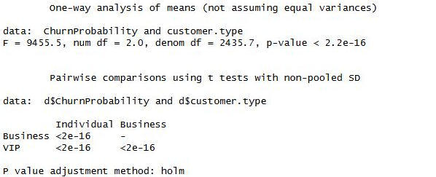
Figure 8: Welch ANOVA and pairwise tests
Brown–Forsythe rejects equal variances, $\text{F(2, 4997) = 243.2}$, $\text{p < 0.001.}$ Therefore use Welch ANOVA (Welch, 1951): $\text{F(2, 2435.7) = 9455.5}$, $\text{p < 0.001}$: reject $H_{\text{0}}$. Holm-adjusted pairwise Welch tests identify differences between all three pairs (each adjusted $\text{p < 0.001}$). Mean differences are 1.957 for Business minus Individual, 2.289 for VIP minus Business and 4.246 for VIP minus Individual.
Group normality tests reject normality (all $\text{p < 0.001}$); large samples support mean comparisons. Ordinary ANOVA gives $\text{F(2, 4997) = 10209.99}$, $\text{p < 0.001}$, with descriptive $η^{2}\text{ = 0.803.}$ Kruskal–Wallis also rejects equal rank distributions, $χ^{2}\text{(2) = 4277.6}$, $\text{p < 0.001.}$ This rank test cannot resolve invalid grouping.
Scores below 3.5 identify Individual customers, 3.5–5.5 Business customers, and above 5.5 VIP customers, reproducing all labels. This suggests possible target-derived grouping without proving its origin. Verify categories against independent account records before allocating retention budgets by segment.

ANOVA and assumption checks
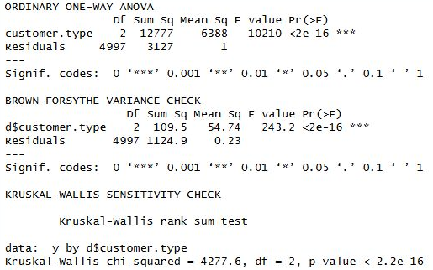
Figure 9: ANOVA variance and rank tests

Relationships and regression

Hypothesis based normality testing
For each numerical variable, $H_{\text{0}}$ states that its population distribution is normal; $H_{\text{1}}$ states that it is not normal. Shapiro–Wilk tests use all 5,000 observations. Every p-value is below 0.05, so normality is rejected for all six variables, including the complaint measure.
Table 2: Shapiro Wilk normality tests
Variable | W | p value
Charges | 0.955477 | 1.438 × 10⁻³⁶
Data usage | 0.975913 | 2.855 × 10⁻²⁸
Call minutes | 0.973380 | 1.519 × 10⁻²⁹
Tenure | 0.953151 | 2.627 × 10⁻³⁷
Complaints | 0.987934 | 2.847 × 10⁻²⁰
Churn score | 0.996875 | 1.038 × 10⁻⁸

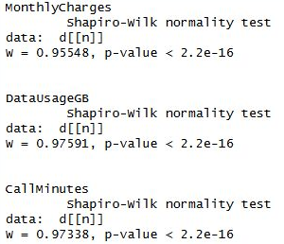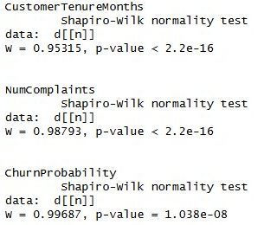
Figure 10: Shapiro Wilk tests for all six variables
Interpret normality tests alongside graphics (Ruxton, Wilkinson and Neuhäuser, 2015). Large samples detect small departures; failure to reject would not prove normality.

Graphical checks and correlation hypotheses
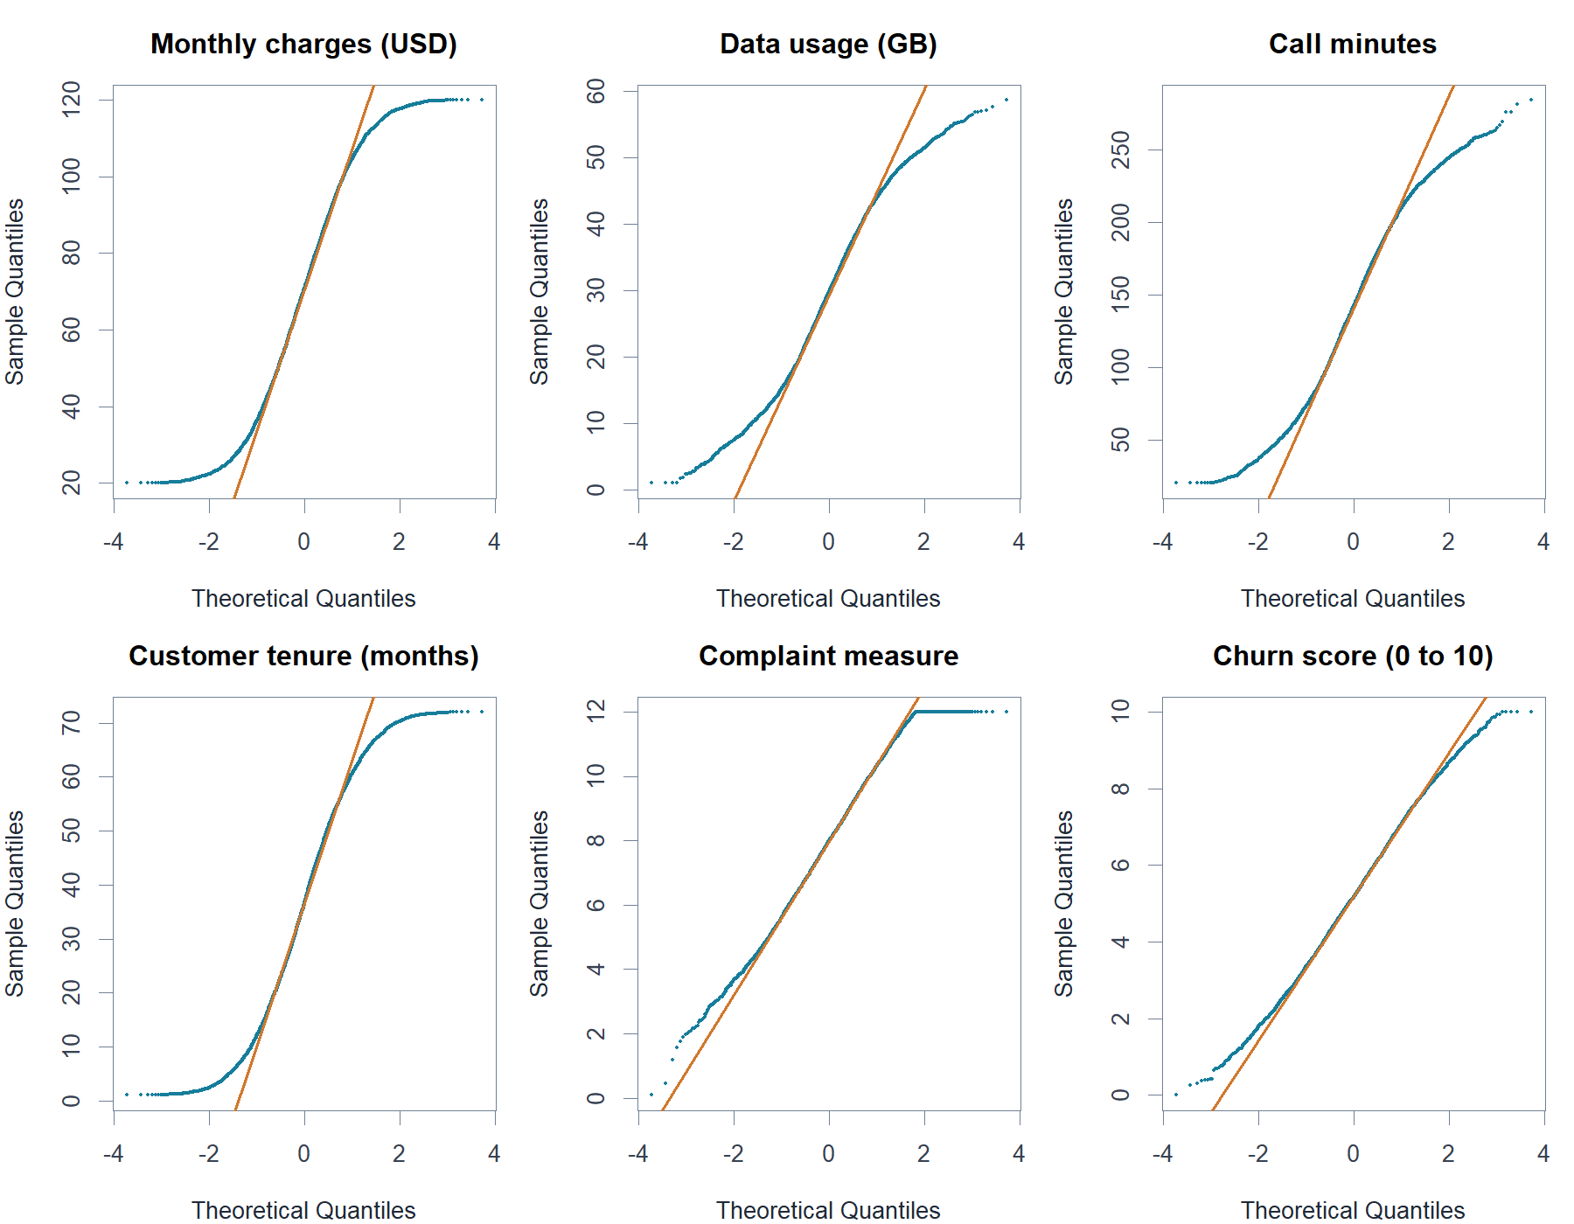
Figure 11: Normal Distribution checks for all numerical variables
For each predictor X, $H_{\text{0}}$: population Spearman $ρ_{\text{s}}\text{(X, churn score) = 0}$; $H_{\text{1}}$: $ρ_{\text{s}}\text{ ≠ 0}$. Spearman assesses monotonic associations without normal marginals (Schober, Boer and Schwarte, 2018). Ties use average ranks and asymptotic p-values; Holm adjustment controls the family of five comparisons.
Exclude ChurnProbability as a predictor to avoid self-correlation and leakage. Pearson provides a sensitivity comparison.

Correlation and simple regression results
Table 3: Correlations and separate simple linear regressions
Predictor | Spearman ρs | Pearson r | Simple slope | Simple R²
Charges | 0.638 | 0.639 | 0.03951 | 0.409
Data usage | 0.614 | 0.613 | 0.08645 | 0.376
Call minutes | 0.614 | 0.612 | 0.01828 | 0.374
Tenure | −0.570 | −0.576 | −0.04995 | 0.332
Complaints | 0.560 | 0.566 | 0.45668 | 0.320

All five Spearman tests remain significant after Holm adjustment (adjusted $\text{p < 0.001}$); reject each $H_{\text{0}}$. All separate simple-regression slopes also have $\text{p < 0.001.}$ Underflow produces zero output; report p-values as bounds.
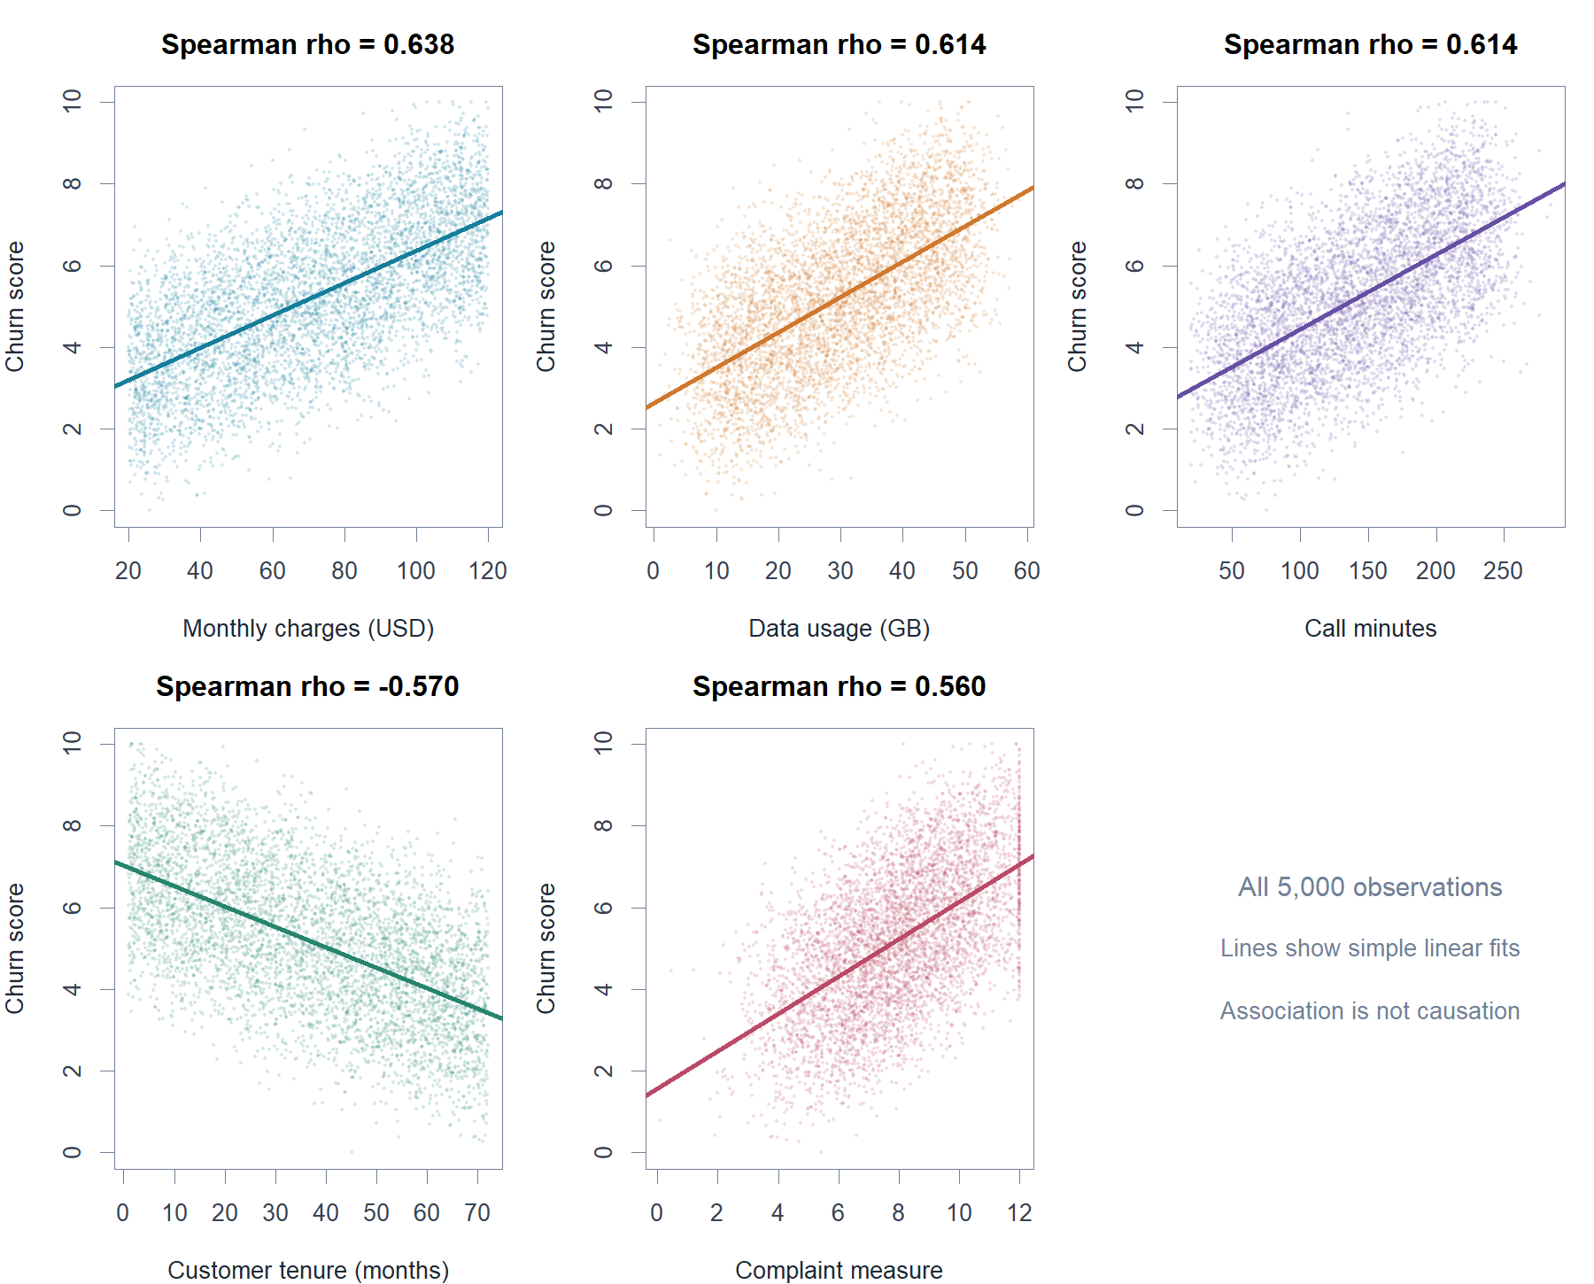
Figure 12: Observed relationships with simple regression lines

Correlation heatmap
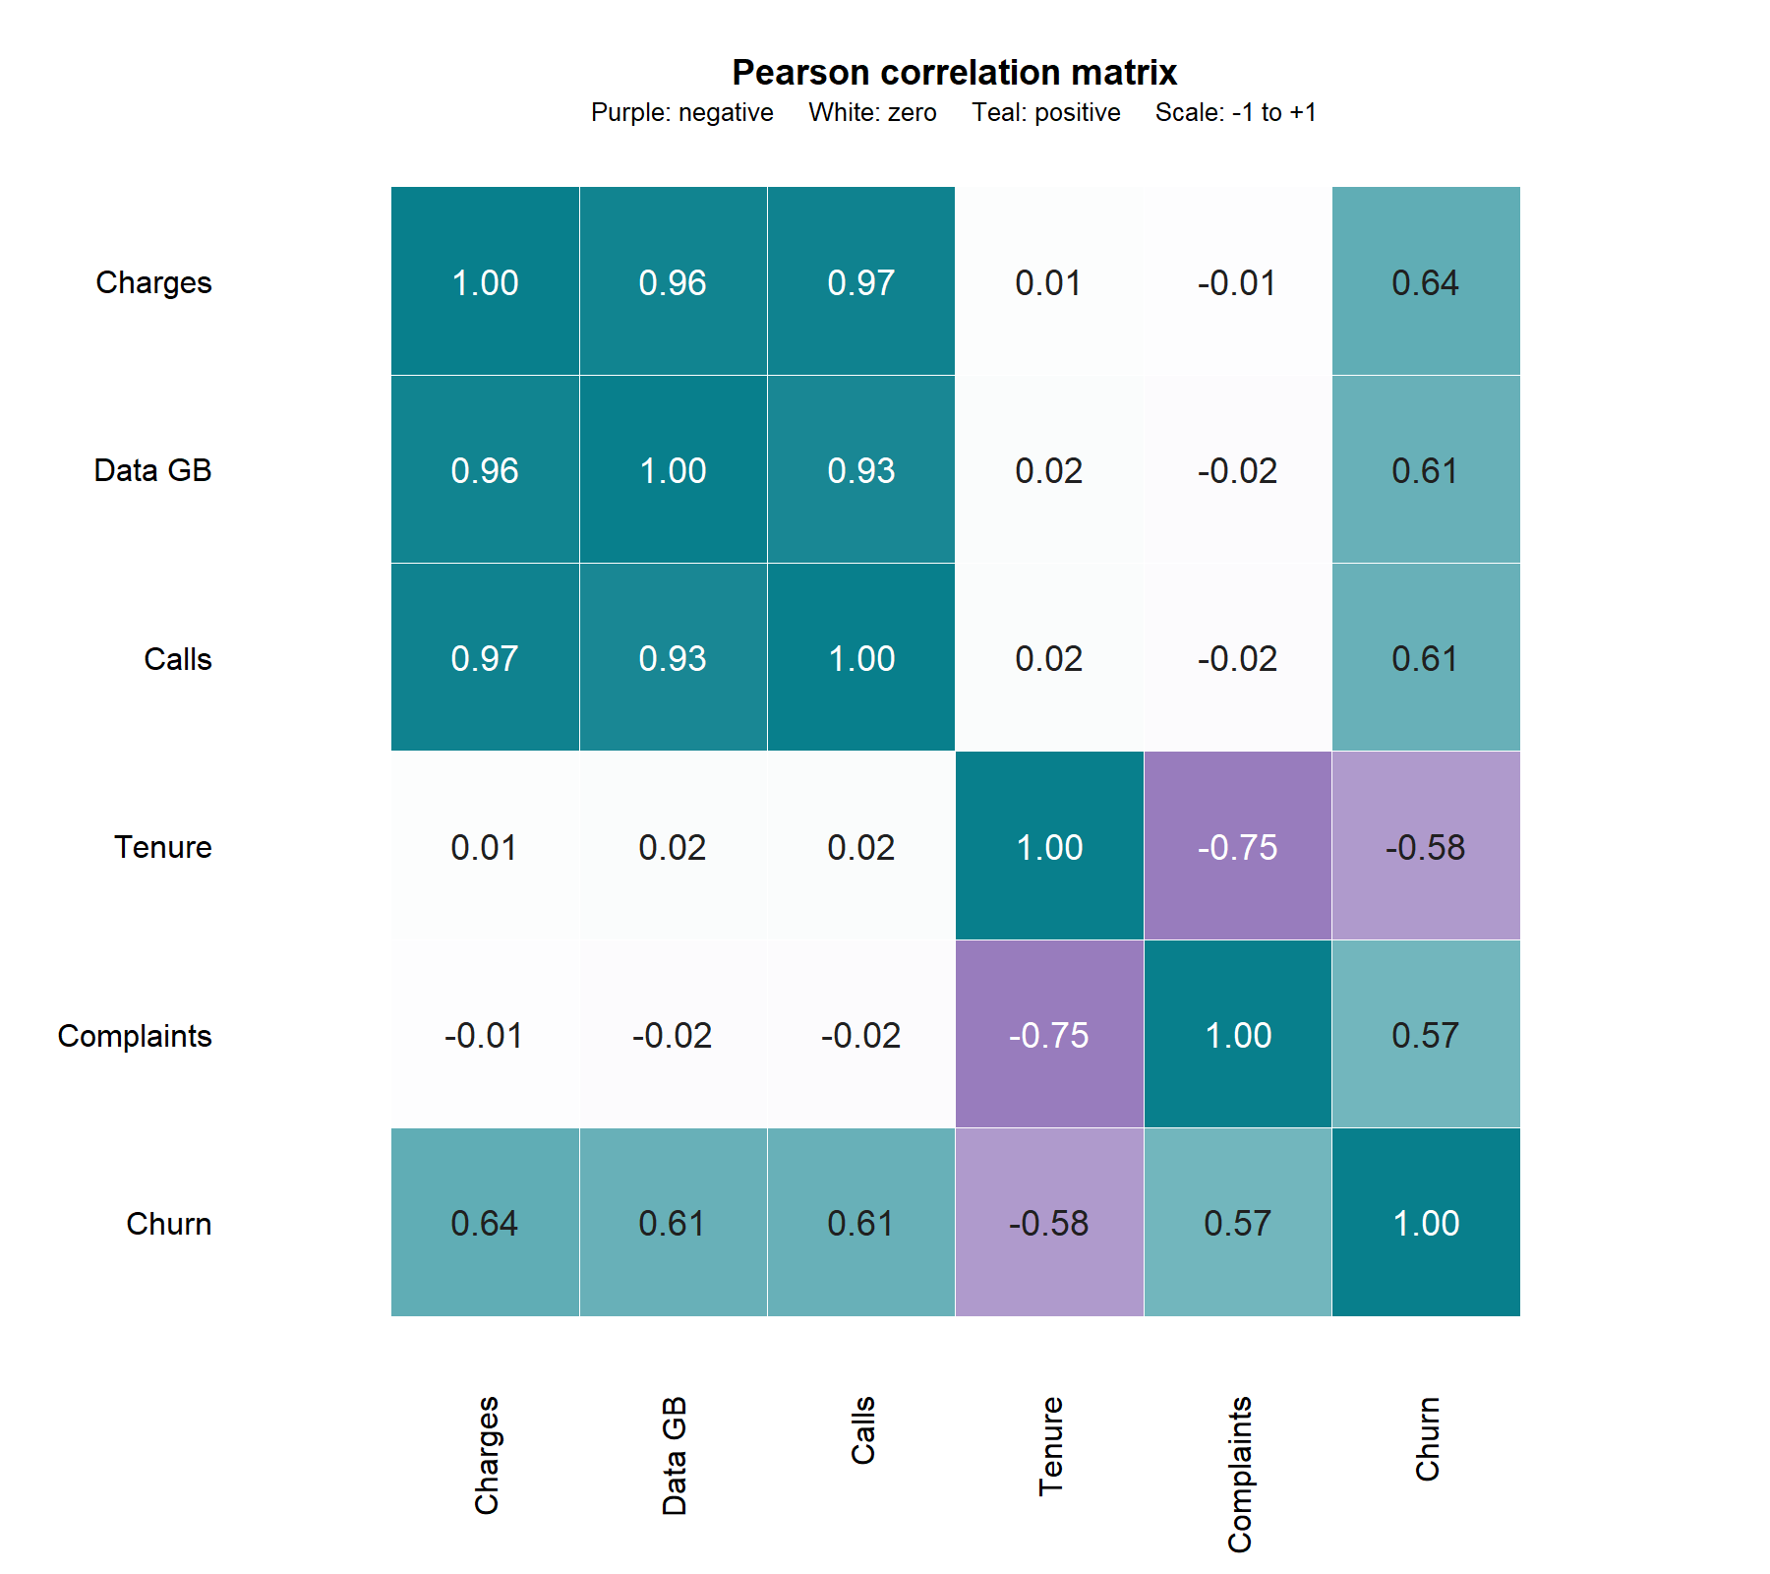
Figure 13: Pearson correlation heatmap
Charges correlate strongly with data (0.960) and calls (0.968), anticipating multicollinearity. Tenure–complaints correlation is −0.750. Colours indicate association, not causation.

Correlation and regression test outputs
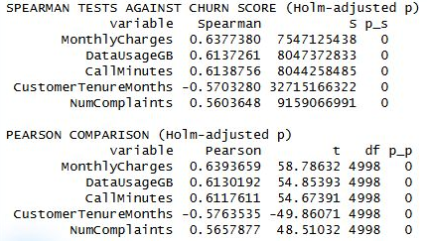
Figure 14: Spearman and Pearson tests
Pearson’s conventional test of zero linear correlation assumes independence and bivariate normality. Spearman remains primary; all Pearson comparisons have Holm-adjusted p < 0.001.
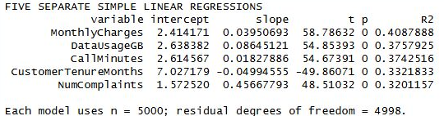
Figure 15: Separate simple regression tests
Simple regressions test zero versus nonzero slopes; all reject at 5%.

Interpretation of individual relationships
$$\text{score = 2.4142 + 0.03951 × charges}$$
Charges show the strongest rank association (0.638), explaining 40.9% of score variation. Affordability reviews merit testing; these results do not establish effects of price reductions.
$$\text{score = 2.6384 + 0.08645 × GB}$$
Data usage correlates positively (0.614), explaining 37.6% of variation. Package reviews may help, although strong correlation with charges limits separate interpretation.
$$\text{score = 2.6146 + 0.01828 × minutes}$$
Call minutes correlate positively (0.614), explaining 37.4% of variation. Investigate plan suitability and call quality without assuming usage causes dissatisfaction.
$$\text{score = 7.0272 - 0.04995 × months}$$
Tenure correlates negatively (−0.570), explaining 33.2% of variation. Investigate onboarding support; survivorship and unmeasured differences preclude causal conclusions.
$$\text{score = 1.5725 + 0.45668 × complaint measure}$$
Complaints correlate positively (0.560), explaining 32.0% of variation. Investigate unresolved service problems; fractional values prevent interpreting one unit as one literal complaint.

Multiple regression model
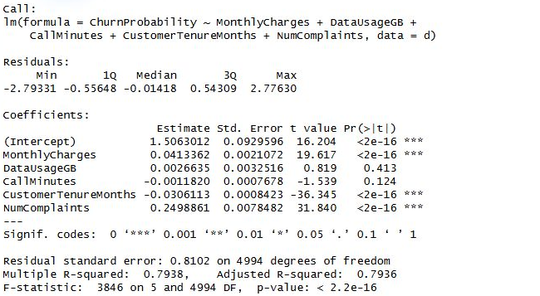
Figure 16: Multiple regression output
Multiple regression estimates conditional mean churn score from all five predictors:
$$\begin{aligned}\hat{Y}\text{ = 1.5063 + 0.04134 Charges + 0.002664 DataGB} \\ \text{- 0.001182 Minutes - 0.03061 Tenure + 0.24989 Complaints}\end{aligned}$$
The statistical model is $\text{Y = }β_{\text{0}}\text{ + }\sum_{\text{j = 1}}^{\text{5}}{β_{\text{j}}X_{\text{j}}} + ε$, with error ε. Overall $H_{\text{0}}$: all five slopes equal zero. The model gives $\text{F(}\text{5, 4994) ≈ 3846}$, $\text{p < 0.001}$, so reject $H_{\text{0}}$. $R^{2}\text{ = 0.7938}$ and adjusted $R^{2}\text{ = 0.7936}$ indicate explained score variation, not classification accuracy.
Holding the other variables constant, USD 10 higher charges corresponds to 0.413 higher score; 12 more months of tenure corresponds to 0.367 lower score; and one complaint-measure unit corresponds to 0.250 higher score. These three adjusted slopes are significant ($\text{p < 0.001}$). Data usage ($\text{p = 0.413}$) and call minutes ($\text{p = 0.124}$) are not significant at 5%. This does not prove no relationship.

Diagnostics and validation
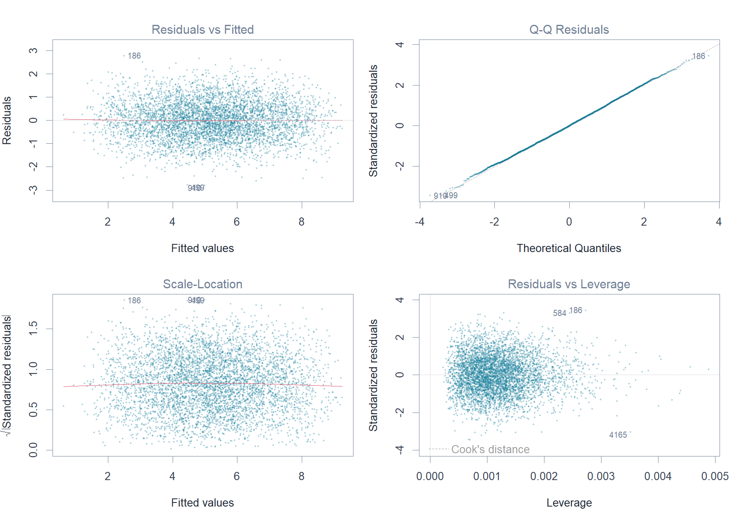
Figure 17: Residual and influence diagnostics
Residual plots show no pronounced curvature or funnel pattern. Residual Shapiro–Wilk $\text{W = 0.9995}$, $\text{p = 0.207}$, does not reject normality. Maximum Cook’s distance is 0.0054. HC3 robust standard errors retain the significance decisions.
VIFs of 28.17 (charges), 12.88 (data) and 16.00 (calls) reveal strong multicollinearity, weakening separate adjusted estimates. The negative call coefficient is not evidence of protection against churn.
A 4,000/1,000 training/test split (seed 2026) gives RMSE 0.816, MAE 0.652 and R² 0.796, versus baseline RMSE 1.809. Temporal validation against observed departures remains necessary.

Conclusion and recommendations
Charges, tenure and complaints remain significant jointly. The model explains 79.4% of score variation, without establishing actual churn probabilities or causal effects.

Validate the decision inputs first
Validate target and complaint definitions, category construction and dates against independently recorded customer types and departure outcomes before deployment.

Test targeted retention actions
Pilot faster complaint resolution, package reviews for high-charge customers and early subscription check-ins. Assign owners, comparison groups and decision dates to test whether these actions improve retention.

Evaluate outcomes and maintain the model
Randomly compare pilots with usual service using departures, satisfaction and retained margin. Prespecify sample sizes and follow-up; report confidence intervals and profitability (Verbeke et al., 2012).
Deploy validated dashboards with restricted access and monitoring for calibration and drift. For observed binary churn, compare logistic regression with alternatives using predictors recorded before outcomes.

References
Chen, H., Chiang, R.H.L. and Storey, V.C. (2012) ‘Business intelligence and analytics: From big data to big impact’, MIS Quarterly, 36(4), pp. 1165–1188. Available at: https://www.jstor.org/stable/41703503 (Accessed: 3 October 2026).
Dialog Axiata PLC (2024) Annual report 2023. Available at: https://s3.ap-southeast-1.amazonaws.com/dlg.dialog.lk/s3fs-public/2024-05/dialog-axiata-plc-annual-report-2023.pdf (Accessed: 3 October 2026).
Martínez-Plumed, F., Contreras-Ochando, L., Ferri, C., Hernández-Orallo, J., Kull, M., Lachiche, N., Ramírez-Quintana, M.J. and Flach, P. (2021) ‘CRISP-DM twenty years later: From data mining processes to data science trajectories’, IEEE Transactions on Knowledge and Data Engineering, 33(8), pp. 3048–3061. https://doi.org/10.1109/TKDE.2019.2962680.
Mobitel (n.d.) Welcome aboard. Available at: https://www.mobitel.lk/welcome-aboard (Accessed: 3 October 2026).
Ruxton, G.D., Wilkinson, D.M. and Neuhäuser, M. (2015) ‘Advice on testing the null hypothesis that a sample is drawn from a normal distribution’, Animal Behaviour, 107, pp. 249–252. https://doi.org/10.1016/j.anbehav.2015.07.006.
Schober, P., Boer, C. and Schwarte, L.A. (2018) ‘Correlation coefficients: Appropriate use and interpretation’, Anesthesia & Analgesia, 126(5), pp. 1763–1768. https://doi.org/10.1213/ANE.0000000000002864.
Verbeke, W., Dejaeger, K., Martens, D., Hur, J. and Baesens, B. (2012) ‘New insights into churn prediction in the telecommunication sector: A profit driven data mining approach’, European Journal of Operational Research, 218(1), pp. 211–229. https://doi.org/10.1016/j.ejor.2011.09.031.
Wasserstein, R.L. and Lazar, N.A. (2016) ‘The ASA’s statement on p-values: Context, process, and purpose’, The American Statistician, 70(2), pp. 129–133. https://doi.org/10.1080/00031305.2016.1154108.
Welch, B.L. (1951) ‘On the comparison of several mean values: An alternative approach’, Biometrika, 38(3–4), pp. 330–336. https://doi.org/10.1093/biomet/38.3-4.330.

